Technology Implementation Results and Conclusions

Bridge Introduction

Additional Information

# Case Study: Deterioration due to Structural Response

## Bridge Introduction

### Motivation

The bridge presented in this case study was constructed in 1983. It was selected for study due to its numerous performance issues with the goal of determining the efficacy of SHM and NDE technologies.

While the bridge was not rated structurally deficient, functionally obsolete, or posted for any load restrictions, the observed level of deterioration gave the owner reason to be concerned for its continued performance.Furthermore, some of the deterioration appeared to have been caused by the structure’s response to traffic loads.

Structural identification with load testing was performed in an effort to quantify the impact of the deterioration on bridge performance and identify how bridge behavior may have contributed to certain instances of damage.

### Bridge Description

The system is composed of two adjacent bridges, each a four-span, steel multi-girder bridge with a cast-in-place deck. The bridge serves more than 100,000 vehicles per day and serves as a major link to the George Washington Bridge.

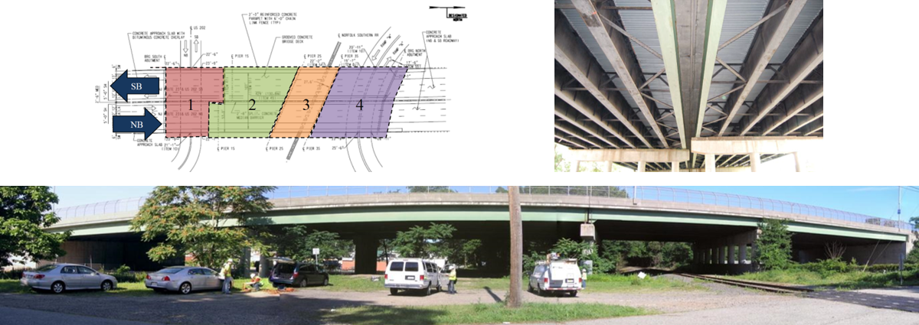

The following performance issues were observed:

The bridge exhibited fatigue cracks in the girder webs at the wind bracing connections.

* The exterior bearings were heavily corroded.

One bearing had a broken pintel allowing it to rotate (about its vertical axis). Deteriorated joints permitted water to drain on top of the pier caps and bearings.

The pier cap exhibited a large crack.

Soil erosion had led to approach settlement, resulting in a bump at the bridge entry.

* Large traffic induced vibrations were reported.

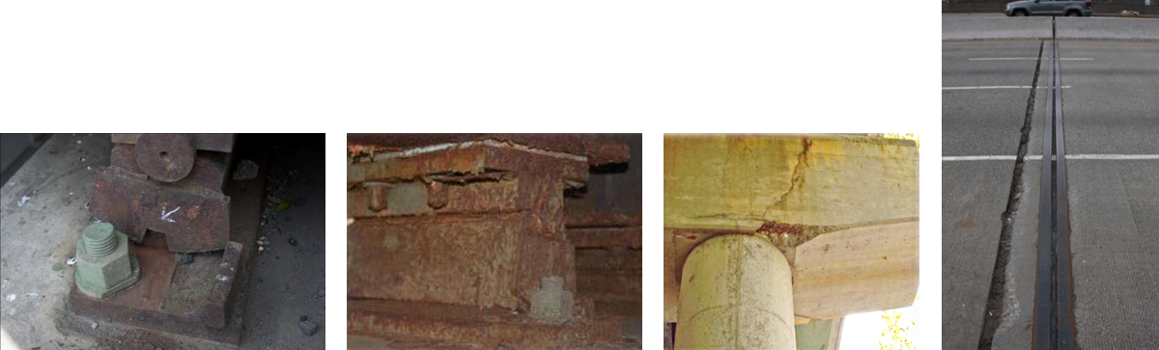

Drexel University, 3141 Chestnut Street, Philadelphia, PA 19104, © All Rights Reserved. **Version 3.0**

Bridge Introduction

Results and Conclusions

Additional Information

Technology Implementation

# Case Study: Deterioration due to Structural Response

## Technology Implementation

### Description

The bridge was evaluated using operational monitoring, impact testing, and proof-level static load testing. Finite element models were also extensively used to provide a more complete understanding of the behavior of the bridge and to identify influential mechanisms.

Preliminary operational monitoring was conducted by recording the bridge response (strain, displacement and acceleration) under normal traffic conditions.

The impact test was performed by impacting the deck with an instrumented sledgehammer, while recording acceleration at many distributed locations. The data obtained from the dynamic tests can be analyzed to extract the dynamic properties of the structure (shapes and frequencies of natural modes of vibration) which can be used to calibrate a finite element model of the bridge.

The static load test consisted of placing loaded dump trucks on the bridge up to the proof-level load while recording the bridge response (strain and displacement). In some cases the responses can be used directly to describe the bridge’s capacity and behavior. The responses can also be compared with FE model predictions and used to calibrate the model.

### Methods

Thirty-one (31) accelerometers were used to capture bridge motion. The accelerometers were installed on the bottom flange of girders six and eight, while the remainder of the sensors were installed on the top of the deck. These accelerometers were used to record the bridge motion under operational conditions as well as due to controlled impacts. The impact test was performed by impacting the deck with a 25 pound instrumented sledge (load cell) at 20 locations. Impacts generally induced forces between 4 and 5 kips with broadband frequency input.

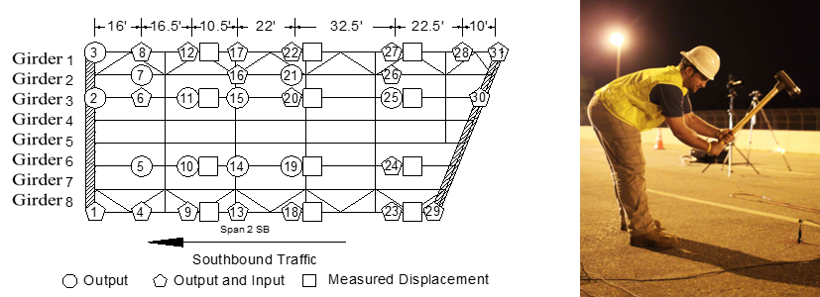

Twenty (20) displacement gauges were installed on the girder bottom flanges. Strain gauges with a gauge length of 1” were welded on the girders, diaphragms and wind bracing. At several locations on the girders multiple strain gauges were placed along the girder elevation in order to capture the strain profile along the girder cross-section. A clip gauge was also installed across the crack on the pier cap to monitor its width.

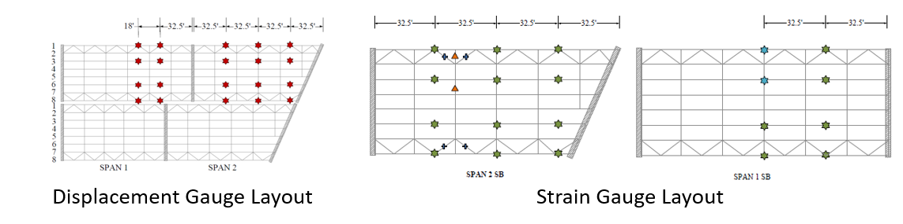

Load was supplied by six tridem dump trucks, both empty and filled. Load levels progressed from 87 kips (3 empty trucks) to 460 kips (6 full trucks).

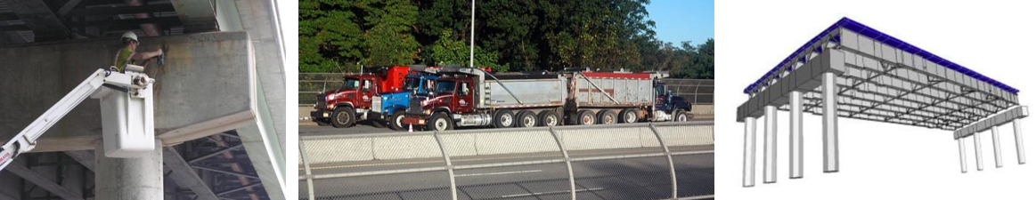

An element-level FE model was constructed based on bridge geometry and assumed material properties provided by construction documents. This type of model employs both one-dimensional (beam elements) and two-dimensional elements (e.g. plate or shell elements) to model girders/diaphragms and deck, respectively. Rigid links are used to enforce compatibility between elements while maintaining accurate geometry. The model was calibrated separately from the three different tests (operational monitoring, impact test, and load test).

Drexel University, 3141 Chestnut Street, Philadelphia, PA 19104, © All Rights Reserved. **Version 3.0**

Bridge Introduction Technology Implementation

Results and Conclusions

Additional Information

# Case Study: Deterioration due to Structural Response

## Results & Conclusions

The data gathered during the dynamic test was used to identify the bridge’s natural modes of vibration. During operational monitoring, bridge vibrations with relatively large amplitudes (peak acceleration of 0.4g) were recorded, thus corroborating inspectors' reports of excessive vibrations.

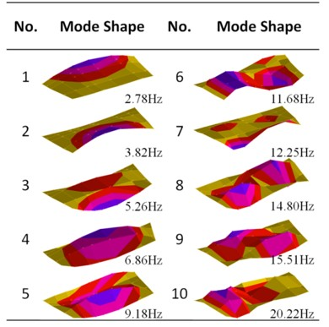

The measurements gathered during the static load test showed that the bridge behaved in amostly linear fashion. The small amount of nonlinearity in the response can be attributed to small

shifts in load distribution rather than plastic deformation of the girders. The bridge was therefore shown to be capable of safely carrying loads up to proof-level.

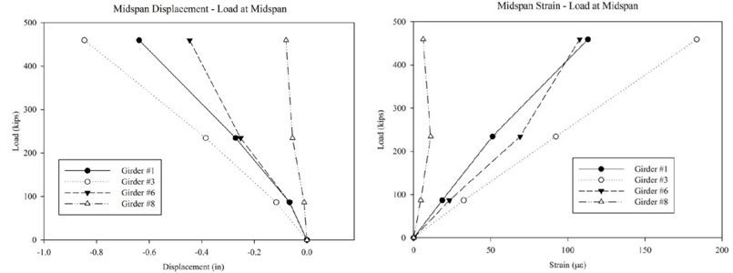

The FE model was updated with both the dynamic data (frequencies and mode shapes), and the static data. Both methods yielded models that were in close agreement and were consistent with test results.

The response from the clip gauge spanning the piercap crack showed that the crack experienced movement during the load test. However, that portion of the piercap is loaded by Girder #1 which supports the sidewalk region and thus is not expected to carry much of the live load. After examining the documents that detail rebar layout, it was discovered that the top layer of bars were not properly developed and therefore the piercap was constructed with insufficient capacity.

An FE model was leveraged In order to further understand the causes of the piercap crack. Dynamic simulations showed that the asymmetric geometry of the span results in an asymmetric first mode of vibration for which the region over girder #1 experiences greater deformation than the other side. Under normal traffic conditions,

The moving vehicles excite the mass of the bridge, causing it to vibrate. This vibration amplifies the bridge response. It is therefore postulated, that due to the asymmetric nature of the bridge’s geometry, the induced bridge vibration causes asymmetric dynamic amplification, and in this case resulted in forces transmitted to the piercap in excess of its available capacity, ultimately leading to a crack.

### Summary

Wind bracing did not contribute to structural stiffness or strength capacity. They were, however, the cause of fatigue cracks and should therefore be removed.

The corroded bearings were not significantly affecting bridge performance, but their ability to maintain bridge stability in the future is uncertain. FE simulations showed that any bearing replacements must be able to accommodate bi-directional movement.

The large crack in the piercap can be attributed to improper rebar detailing. Dynamic amplification also contributed and provides explanation for why the crack appeared only on one piercap when improper rebar detailing could be found on other piercaps.

The perceived excessive vibrations can be attributed to the bump at the beginning of the bridge caused by approach settlement.

Drexel University, 3141 Chestnut Street, Philadelphia, PA 19104, © All Rights Reserved. **Version 3.0**