Current Guidance Shortcomings of Current Guidance Overview of Best Practices

Common Scenarios

## Load testing for rating

### Common Scenarios

The use of load tests to develop a load rating is employed in cases where current practice fails to provide a reliable rating. In general this can occur due to bridge complexity, missing information about the bridge system, or in cases where conventional ratings are suspected to provide overly conservative load ratings. More specifically, the most common application scenarios for load tests to produce ratings are:

**Bridges that Do Not Rate Using Conventional Approaches** – This is perhaps the most common scenario and involves cases where conventional load rating procedures are suspected of being overly conservative. In these cases owners are faced with a decision: implement a load posting,restrict truck traffic, retrofit the bridge to increase its capacity, or perform a load test with refined load rating analysis to obtain a more accurate and less conservative load rating. Given the implications of load restrictions (especially related to emergency vehicle mobility) and the cost of retrofitting, owners may opt for load testing in the hope of discovering that the bridge’s load rating is sufficient.

**Bridges with Missing Documentation** – In these cases owners are required to develop load ratings for bridges in which some critical information is missing. In many cases this occurs with older reinforced concrete bridges and concrete encased steel girder bridges in which important details (reinforcement layout or size, girder dimensions, etc.) are not readily apparent through visual inspection. In such cases a combination of NDE techniques and destructive material tests are generally used in conjunction with load testing to estimate a load rating.

**Bridges Subjected to Super-Loads** – To ensure the safe transport of super-loads, owners may opt to perform load testing to clearly establish the load-carrying capacity of the bridge. Certainly this may be carried out if the movement of a super-load is coupled with the two scenarios discussed above, but also may be used to better understand the performance of load-carrying mechanisms. Examples include composite action in bridges designed as non-composite and the participation of barriers and sidewalks in carrying loads.



Drexel University, 3141 Chestnut Street, Philadelphia, PA 19104, © All Rights Reserved. **Version 3.0**

Shortcomings of Current Guidance

Common Scenarios

Current Guidance

Overview of Best Practices

## Load testing for rating

### Current Guidance

The AASHTO Manual for Bridge Evaluation guides the inspection, analysis and calculations for determining load rating and for reviewing overload permit applications (AASHTO 2011). Load ratings in conjunction with inspection findings are expected to assist in determining a need for posting, strengthening or closure of a bridge. Load rating may be based on approximate or refined methods of analysis unless load testing is leveraged. In an approximate method of analysis, the bridge is modeled as a line-girder, with its share of loading assigned based on the distribution factors used in design. In the case of refined analysis, the stiffness of each element of a bridge needs to be explicitly represented in an analytical model, and finite element modeling (FEM) has become quite common. However, without an analysis model that reflects the as-is dimensions, conditions, movement systems, continuity and supports, the results of load rating analyses may have unacceptable levels of uncertainty.

To address situations where analytical load ratings may not provide acceptable results, Section 8 of the AASHTO Manual for Bridge Evaluation provides guidance for load testing as an alternative load rating approach. Specifically, the Manual defines two types of load tests:

**Diagnostic Test** – A diagnostic test is used to modify a rating developed through an analytical model. As a result, a key requirement for the use of a diagnostic test is that a model of acceptable accuracy be developed for the bridge in question. In a typical application, the model is used to estimate the strain at the critical (governing) location under a single truck. The strain at this critical location caused by the same truck used in the analysis is then measured during a load test. The model output is corrected by multiplying its results by the ratio of measured-to-predicted response, thus bringing the prediction at the critical location into agreement with the measurement (see the following section for a discussion of shortcomings of this approach).

**Proof Test** – Proof tests involve the application of large load levels, with successful performance being defined as a lack of damage to the structure. These tests are carried out without the need of an analytical model as the load rating is derived from the largest load resisted without damaging the bridge. According to the AASHTO Manual for Bridge Evaluation MBE, during a proof test “a bridge is subjected to specific loads, and observations are made to determine if the bridge carries these loads without damage. The proof test is terminated when: (a) a predetermined maximum load has been reached, or (b) the bridge exhibits the onset of nonlinear behavior or other visible signs of distress.”

Drexel University, 3141 Chestnut Street, Philadelphia, PA 19104, © All Rights Reserved. **Version 3.0**

Common Scenarios Current Guidance

Shortcomings of Current Guidance

Overview of Best Practices

## Load testing for rating

### Shortcomings of Current Guidance

Perhaps the most significant shortcoming of the current load testing guidance is that it is simply not employed very often. For example, a recent NCHRP study (Hearn 2014) found that approximately 600 bridges within the US have been rated through load testing procedures. While this may sound like a significant number, it pales in comparison the approximately 60,000 that are currently posted throughout the US. It is certainly possible that owners simply do not believe that there is additional load-carrying capacity associated with many of these bridges, and thus decide not to invest in a load test. On the other hand, given the significant disparity between the number of posted bridges and those subjected to load testing, it certainly appears that owners simply do not perceive load testing to provide value commensurate with its cost. Certainly costs will continue to drop as sensing, data acquisition, and the expertise needed to leverage these tools become more common, but it is also important to understand and address the current shortcomings of load testing to increase the benefits of load testing. Along these lines, there are two specific shortcomings of current load testing procedures that the authors believe need to be addressed before more widespread load testing can be expected: (a) safety concerns during proof tests, and (b) the reliability of load ratings derived from diagnostic tests.

#### Reliability of Load Ratings Obtained from Proof Tests

For proof tests, the Manual indicates that “a bridge is subjected to specific loads, and observations are made to determine if the bridge carries these loads without damage. The proof test is terminated when: (a) a predetermined maximum load has been reached, or (b) the bridge exhibits the onset of nonlinear behavior or other visible signs of distress.” It is envisioned that the proof load will correspond to a live load that will bring the bridge to a rating of 1. To provide the same level of safety inherent in LRFD, the live-load is increased by factor of typically 40%-55%. Proof load testing of bridges is called for when the calculated load ratings are low and the field testing may provide higher ratings. A second scenario is in the case of bridges that cannot be load rated analytically because some of the details or configurations are not documented and cannot be accessed for direct measurement and appraisal (e.g. undocumented components encased in concrete).

The proof load testing procedures described by the Manual implicitly disregard the temporal changes in capacity of the bridge system, assuming that capacity will remain constant. This, however, is extremely misleading. Even if a bridge may pass a proof-load test one day, it may fail under a lesser load at a later date. Not all mechanisms that contribute to load distribution and/or enhance the capacity of the structure will remain constant through all seasons and certainly not throughout the life-cycle of a bridge. Furthermore, bridge owners may wish to deliberately exclude some mechanisms. For example, AASHTO guidelines specify that the effects of the barriers are not to be included. The contribution of certain elements or mechanisms to load rating cannot be discounted or excluded unless they are accurately quantified. The results from a load test alone (often just beam flexural strain responses) are insufficient for achieving this.

#### Reliability of Load Ratings derived from Diagnostic Tests

The bridge shown in Figures 1 and 2 was rated based on the measured bridge response (i.e. all mechanisms included). This rating (first column of Table 3) shows that the bridge offers nearly ten times the rating factor for a “design truck”, but provides no guarantee of that capacity at a future date. To provide a more conservative rating that is representative of the structure when some mechanisms become ineffective, a field-calibrated FE model was employed. Those parameters that were influential to the load rating and uncertain or may lose effectiveness over time were made inactive in the model for rating.

Because the structure has integral abutments and piers, the boundary conditions exhibited considerable rotational stiffness. Over time, concrete cracking and changing earth pressures could cause that stiffness to diminish. Therefore, the rotational stiffness was removed from the model. Furthermore, the bridge owners did not wish to rely on the capacity provided by the concrete encasement, so the stiffness and load capacity provided by the encasement was also removed. Finally, as per AASHTO guidelines, contributions by the barriers and sidewalks were excluded. The final rating (last column) is much less than that directly obtained from test results, but comes with a level of confidence that this structure will maintain this level of capacity well into the future.

As it has been shown for this particular bridge, many structures should be expected to possess a number of influential and yet uncertain mechanisms, some of may be inappropriate to include in load rating. Given that load distribution and capacity mechanisms may significantly vary between different types of bridges, load rating results from this particular bridge cannot be simply extrapolated to other structures (i.e. same increase in load rating of FEM over a single line girder model).

Safety Concerns during Proof Load Testing

The AASHTO Manual indicates that “during a proof load test, the loads must be applied incrementally and the response measured until the desired load is reached or until the test is stopped if the bridge response exhibits the start of nonlinear behavior or other visible signs of distress.” It is envisioned that the proof load will correspond to a live load that will bring the bridge to a rating of 1. To provide the same level of safety inherent in LRFD, the live-load is increased by factor of typically 40%-55%.

The concept of proof-load testing guiding the Manual appears to be the same one that was followed in ancient Rome – if the bridges safely carried the proof-level live load, it should remain safe under future applications of that load. This, however, is extremely misleading since even if a bridge may pass a proof-load test one day it may fail under a lesser load at a later day. Destructive testing of decommissioned concrete or steel bridges to failure have revealed bridge capacities 10-20 times that of a rating truck, governed by many mechanisms that are activated at various load levels, some of which may even make the bridge appear stiffer. However, the failure modes of aged and deteriorated bridges were all controlled by deterioration and damage, and failures were triggered through highly unusual and unexpected behaviors and mechanisms.

It follows that performing a safe proof-load testing of a bridge, especially one with unknown characteristics, requires a much greater understanding of a bridge than envisioning it as a line-girder. A test strategy should be developed based on analytical modeling and simulation of the actual 3D geometry, together with all of the mechanisms that may govern the primary and secondary load transfer paths, and how any of the local member or connection details may affect these mechanisms. The kinematics of the bridge under various load levels will drive the instrumentation. Unless a bridge is carefully modeled for simulating its behavior under realistic proof- level loads – typically much greater than just 1.5 times a rating vehicle – to explore under which load level the bridge may change its load resisting mechanisms and all probable failure mode(s), a proof-load test should not be recommended. It is critical to identify the mechanisms that contribute to a structure’s capacity in order to properly and safely design the load increments, load positions, the instrumentation, data acquisition, communication and visualization. Without a real-time feedback and visualization of critical bridge responses under load, safety may not be assured. The capacity of a bridge is ultimately the capacity of the system, including the approaches, superstructure, substructure, foundations, soil and other attributes of the site. If load

testing focuses only on the superstructure at one instant in time, and the uncertainty associated with all the other elements of the bridge system is ignored, a proof-level load test should not be advised for load rating. Structural identification (St-Id) concept provides the framework for capturing and considering these effects by integrating engineering heuristics and historical data.

Drexel University, 3141 Chestnut Street, Philadelphia, PA 19104, © All Rights Reserved. **Version 3.0**

# [Virtual Lab (../index.html)](http://vlab.asklab.tk/VirtualLab/index.html)

Common Scenarios Current Guidance Shortcomings of Current Guidance

Overview of Best Practices

## Load testing for rating

### Overview of Best Practices

#### Structural Identification – A Guiding Framework

The term structural identification (St-Id) is an adaptation of the system identification concept from systems and control engineering to structural engineering of constructed systems. Douglas and Reid were early pioneers in applying the St-Id concept to characterize the lateral response characteristics of highway bridges by pull-release testing (1982). Gobel, Shultz and Commander leveraged a version of the St-Id concept for testing bridges under crawl loads since 1989 (1991). The writer has led an ASCE expert committee that issued a state-of-the-art report on St-Id (2013). The ASCE Committee formulated a 6-step iterative process, summarized below, to construct, calibrate and utilize a finite element model to characterize the mechanisms that influence the load effects such as intrinsic forces, live loads, corresponding internal actions and the responses of all the critical elements of the bridge system. The St-Id process ensures that any field test is planned, designed and performed competently and safely. Furthermore, it can be leveraged beyond the load rating to provide additional insight on the behaviors of bridge system and thus increase the value of the load test such as to design effective maintenance, repair and/or retrofit for the bridge. Each of the Steps of St-Id is described in the following:

#### Step 1 – Observation and Conceptualization

Establish clear objectives for the St-Id effort and identify critical constraints. Collect and evaluate the reliability of all available legacy data and missing information by meeting with the bridge owner and visiting the bridge. Objectives that are in addition to load rating, such as how to effectively repair or retrofit the bridge, or an evaluation of the substructure and foundations for safety and scour may be included. Given that the ability to reuse foundations and substructure could save as much as 50% of the cost of constructing a new bridge, there may be compelling reasons for St-Id as long as these objectives are considered and included in this first stage of planning.

#### Step 2 – A Priori Modeling and Simulation

Observe the bridge system and measure selected conditions and properties to conceptualize the system for a-priori modelling. This includes checking the dimensions, sampling and coring to verify material properties, scanning for rebar details, and boring to evaluate the soil conditions. The data and insight from these studies will help construct a 3D FE model that will simulate the important structural mechanisms. A model-builder must have experience with FE modelling, as well as an understanding of the kinetics and kinematics of the constructed system by actual on-site visits and observations. It is important to note that an infinite number of FE models can be constructed that are geometrically consistent with the structure, but may still fall short of accurately capturing the behavior of the structure. Given that the model should simulate all movements, restraints, joint and member deformations and mechanisms such as composite action or lack of, and continuity between spans and or approaches as well as any soil pressures, selecting the right mesh resolution and element choices is imperative.

Furthermore, boundary conditions and connectivity between elements must be considered and modelled effectively. The FE model below was constructed by reducing the girders to beam elements, modelling the deck and sidewalk with shell elements. Geometry was retained by connecting the elements with link elements which enforce relationships between degrees of freedom of the connected nodes. Boundary conditions are modeled as rotational and translational springs. The bridge represented by the below FE model has foundations resting on rock. While the rock was not explicitly modeled, it was included with springs beneath the foundation with stiffness corresponding to the stiffness of the rock. While some modeling decisions are obvious, others will require assumptions that must later be assessed and validated with the results from field testing.

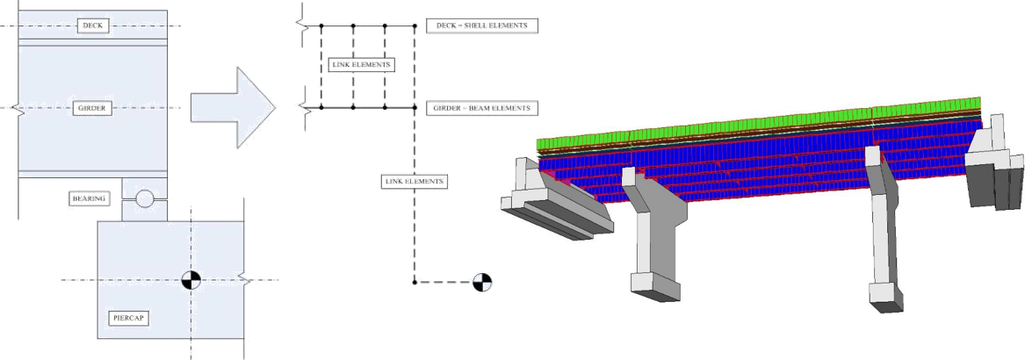

#### Step 3 – Experimental Program Design and Execution

Instrument the bridge to perform operational monitoring of critical temperatures, strains, rotations or tilts and displacements in addition to accelerations. For a typical bridge span, a sensor density corresponding to 12 to 24 sensors would be recommended. It is important to have redundancy and a variety of sensors with appropriate gage lengths, sensitivity and accuracy. Sensor selection and location should be driven by the responses required to meet the established objectives.

The load test is performed by positioning a number of trucks to incrementally increase load levels up to the target proof load level. It is desirable to repeat operational monitoring following the load test. The load test will require extensive planning, rehearsals and execution by specialized engineers who will continuously monitor bridge responses in real-time as load is applied. Load levels in excess of 2 times the legal load during a proof load test may be required to activate all of the critical response mechanisms of a bridge while insuring a reliable signal-to-noise ratio for all sensors. This is quite different from the recommendations of the AASHTO Manual suggesting load levels of about 1.5 times the rating load. If a bridge exhibits any signs of distress such as cracking or yielding at less than 2.5 times the rating load, such a bridge should indeed be posted or decommissioned. It is desirable to include strain and tilt measurements of the substructures during such a test. Measurements by leveraging one or more core holes drilled from the top of the deck all the way to the bottom of the footings may provide a definitive documentation of the foundation and soil conditions and may help to infer any scour risk through the rigid body displacements and/or rotations.

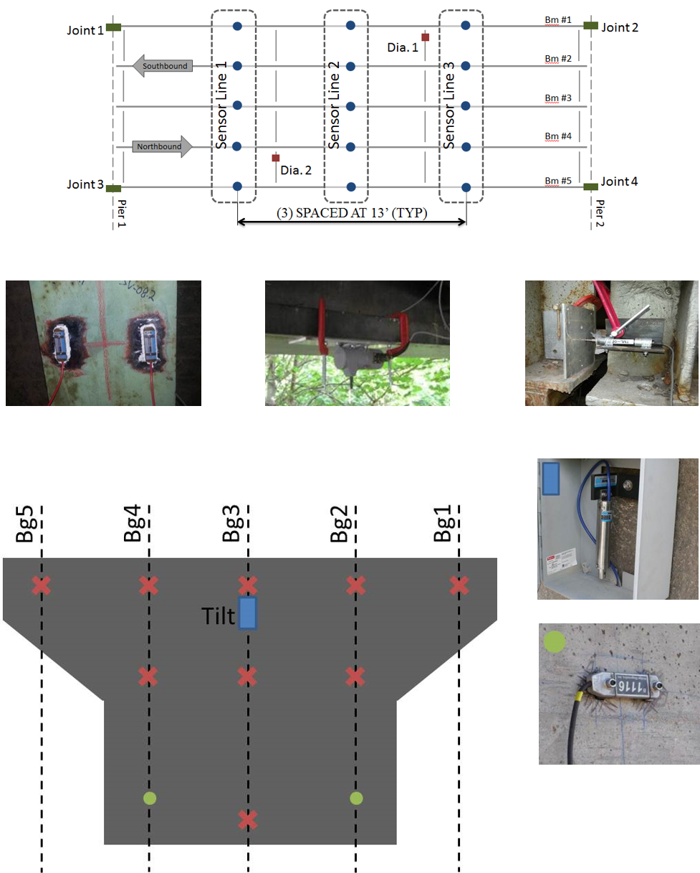

#### Step 4 – Data Analysis and Interpretation

The metadata, operating and proof load test data as well as images are evaluated, synchronized and data quality is verified before archival. Data is visualized and interpreted for patterns and response quantities. This will start during the experiment in-situ to identify and rectify issues and mistakes. For example, real-time data interpretation should be compared to model predictions and any discrepancies should be evaluated to determine if the predicted failure modes and ultimate capacity should be revised along with subsequent load cases. Especially, the linearity of the structure and the critical elements should be continuously monitored to identify members that may approach cracking or yielding.

#### Step 5 – Model Updating/Calibration

Modify, validate and finalize the a-priori FE model by calibrating it with selected data sets from the operational monitoring and load test. A critical issue is making sure that the model is complete (i.e. the model can explicitly simulate all of the critical loading and response mechanisms and especially the measured kinematics at the supports and boundaries of the bridge). The bridge dynamic characteristics, such as frequencies and mode shapes that may be extracted from operating responses, displacements, tilts and strains will constitute possible data sets that are used to calibrate and then validate the FE model. Due to the large number of parameters to calibrate (material properties and dimensions of all elements as well as all joint, bearing, connection and boundary properties, including those at foundations) and the competing effect of some parameters, one cannot expect a unique calibrated model. However, if a model is calibrated to mimic all of the measured input-output or load-response relations of the bridge with acceptable level of discrepancy, it may be considered suitable to serve the established objectives of St-Id.

#### Step 6 – Model Preparation and Rating

A properly calibrated or validated model can be confidently leveraged to accomplish the objectives of St-Id. The calibrated model is especially powerful when used to identify mechanisms contributing to the bridge’s actions and the corresponding capacity. There are numerous mechanisms providing stiffness and contribute to the capacity of a bridge at the time of load testing, but these contributions may diminish or disappear under different environmental conditions or after several years. These may include but are not limited to: composite action between deck and girders, diaphragms, concrete and soil stiffness and conditions, contributions of sidewalks and barriers, locked movement systems, arching action of a slab, etc.

Although the FE model is often used to compute a load rating, it can be further leveraged to simulate other loading scenarios and to gain a better understanding of the structural characteristics of the bridge. The natural frequencies can be analyzed in an effort to reveal the influence of the superstructure vibrations on deck deterioration or substructure durability. Seismic loading can be simulated to help inform the owner of the risk of damage or failure in the event of an earthquake. Long term loading, such as differential temperature and settlement effects may be simulated. Fatigue-life may be estimated based on operational monitoring and measured responses. Repair sequencing can be examined to ensure construction activities do not pose a risk of damaging other elements in the bridge. A more detailed description of the structural identification process can be found elsewhere, but the above discussion sufficiently summarizes the process. Given that a load test may be executed at the same cost but without following a St-Id framework and missing the reliability and benefits outlined above, all owners are advised to demand load testing by following the St-Id framework.

Drexel University, 3141 Chestnut Street, Philadelphia, PA 19104, © All Rights Reserved. **Version 3.0**