# [Virtual Lab (../index.html)](http://vlab.asklab.tk/VirtualLab/index.html)

Technology Implementation Results and Conclusions

Bridge Introduction

Additional Information

## End-of-Life Performance Case Study

### Bridge Introduction

#### Motivation

The bridge presented in this case study was constructed in 1939 and rehabilitated in 1970. The steel girders and floor beams exhibited extensive corrosion and was posted for three (3) tons. Given its condition it was slated for replacement, but that replacement could take up to a decade before completion. The owner was therefore presented with the challenge of maintaining the continued safe operation of the bridge while minimizing the required investment in rehabilitation measures.

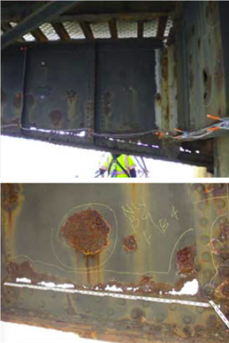

Furthermore, the owner wished to investigate the possibility of removing the load posting.

With these objectives, the bridge owner elected to have a monitoring system installed and the bridge evaluated using a diagnostic load test and refined FE modeling.

The goal of these evaluations was to determine the ability of the structure in its current state to safely carry loads, and what interventions might be necessary to ensure safe operation of the structure for its remaining service life.

#### Description

The structure consists of 57 spans, one of which featuresa 98 foot double leaf bascule span over the navigable channel. For 16 of the spans, the structure is comprised of two haunched steel plate girders which serve as the major load path of each span, while floor beams as well as tertiary members carry the load presented by the cast-in-place deck to the main girders. Another 40 spans are supported by reinforced concrete t-beams.

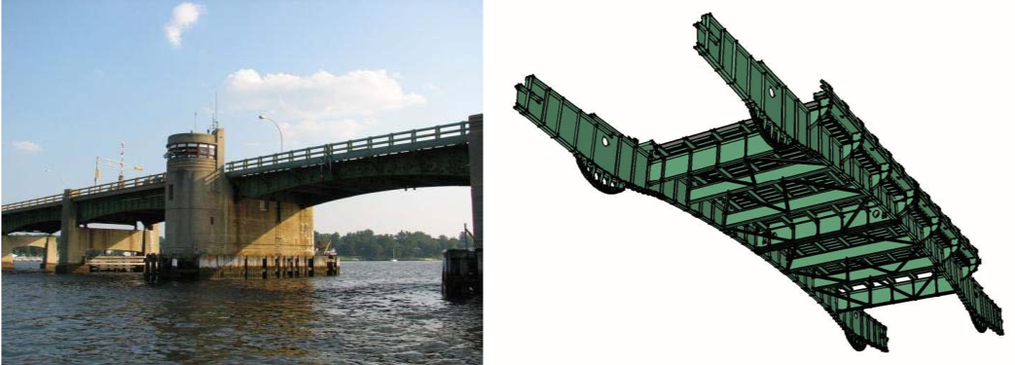

#### Condition

Inspection of the structure revealed extensive corrosion of many of the steel members and spalling of the concrete tee-beams leaving rusted re-bars exposed. There was severe section loss of the floor beam bottom flanges and in several locations the corrosion had left large holes in the steel web plates.

The bridge was listed as structurally deficient and functionally obsolete.

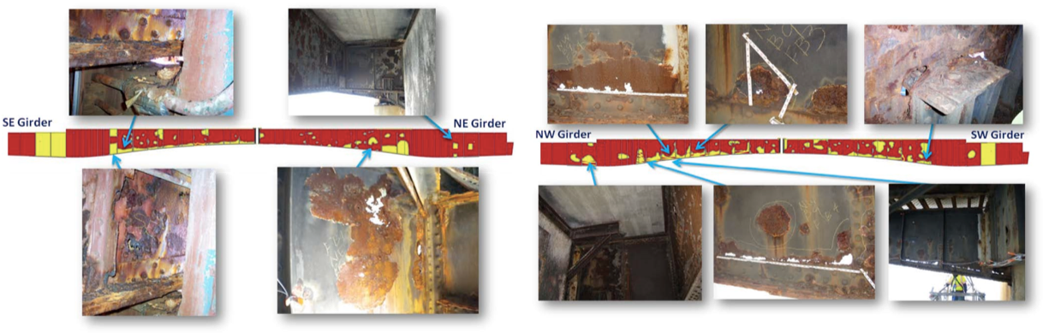

Structural identification was necessary to determine the impact of the observed deterioration on the bridge’s load carrying capacity.

Bridge Introduction

Results and Conclusions

Additional Information

Technology Implementation

## End-of-Life Performance Case Study

### Technology Implementation

#### Description

The bridge was evaluated with static load testing. Diagnostic level loads were placed on the bridge in order to validate the predictions of the refined FE model. The load was applied in several configurations using two 36 ton tri-axle dump trucks. The girders on the bascule span were deemed to be the most critical members of the structure and therefore were the selected recipients of testing. Each bascule girder was instrumented to track the critical strain responses under the applied loads.

#### Methods

Visual inspection reports indicated that the north leaf of the bascule span exhibited more significant deterioration and was therefore selected to receive a denser instrumentation distribution. The general goal of the instrumentation was twofold: (1) identify and quantify the load sharing of the four bascule girders to inform the performance of both the live load bearings and the magnitude of shear transfer between the spans, and (2) quantify the strain distributions within the most deteriorated elements to identify whether strain compatibility exists. Given the objectives and the budget constraints, the north leaf was instrumented with 22 strain gages, while the south leaf was instrumented using 10 strain gages.

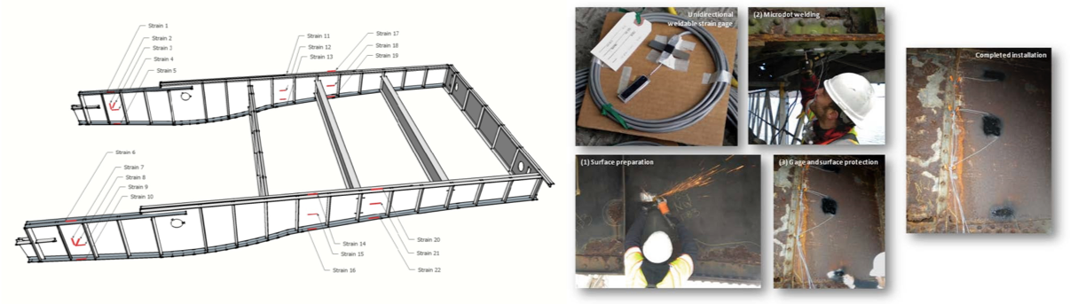

The load test was carried out with two tri-axle dump trucks. They were placed on the bridge with different fill levels and at several locations to provide incremental load levels from 18 tons (single truck) to 72 tons (two trucks). Before the static cases were started, the trucks were run back and forth over the bridge with traffic to gather benchmark data of operational response under moving loads and to ‘loosen’ up the bridge in case any appreciable stick-slip conditions existed. Next, traffic was stopped for 15 minute intervals and the static load

cases were carried out. Throughout the experimental program, strain levels were monitored to ensure the bridge remained safe and undamaged. The responses were well within the expected bounds and at levels consistent with the predictions of the refined FE model.

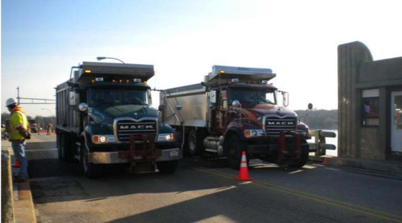

The FE model was constructed based on measured bridge geometry and assumed material properties. The primary elements (main girders, floor beams, and deck) were modeled with 4-node quadrilateral shell elements. This allowed for accurate simulation of out-of-plane and torsional effects as well as allowed the measured deterioration to be accurately mapped to the model. The reported deterioration was included in the model by modifying the stiffness of elements in the regions of deterioration according the reported level of section loss. This approach essentially reduces the moment of inertia and cross sectional area in accordance with the amount of section loss. For areas where 100% section loss was noted, entire shell elements were removed in the corresponding region. The resulting model was further refined by calibrating it based on the test results.

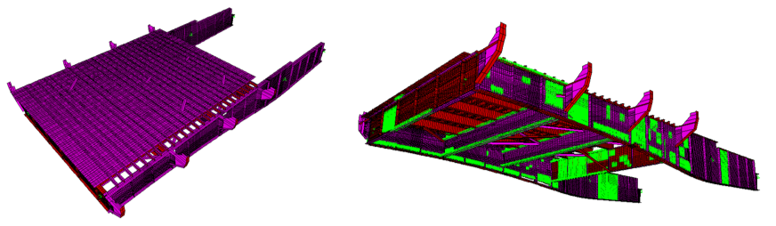

Drexel University, 3141 Chestnut Street, Philadelphia, PA 19104, © All Rights Reserved. **Version 3.0**

Bridge Introduction Technology Implementation

Results and Conclusions

Additional Information

## End-of-Life Performance Case Study

### Results & Conclusions

Comparison of strain readings at the different load levels revealed that the bridge behaved linearly throughout the entire test. Furthermore, it was found that all instrumented cross sections exhibited a linear distribution of strain, indicating that in spite of the heavy deterioration, strain compatibility was maintained through the web. Furthermore, strain readings confirmed that shear transfer was occurring through the mechanism that locks the two bascules together when fully closed.

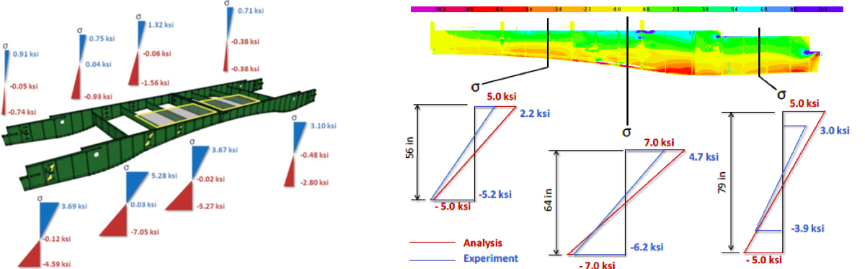

The FE model was initially calibrated using strain readings from operational monitoring. Following the conclusion of the static truck load test, the strain readings from the test were compared with the values obtained with the refined FE model. The measured strains/stresses compared reasonably well and demonstrated that the FE model in all cases was conservative, and no further modifications of the FE model were required. This observed conservatism is likely a result of geometric simplifications made during the construction of the FE model. Specifically, the refined FE model neglected the contribution of the vertical stiffeners on the girders and the contribution of the bridge railing and sidewalks.

Load ratings, utilizing the experimental load test results, were calculated in accordance with the guidelines presented in NCHRP report 234 “Manual for Bridge Rating through Load Testing” (1998). This approach utilizes a ratio of “theoretical” strain and measured strain. This ratio is then modified by a series of empirical factors that takes into account the frequency of visual inspection, fracture critical details, extrapolation of test results to higher loads, and the engineer’s knowledge of the behavior of the structure and their evaluation and explanation of the load test results.

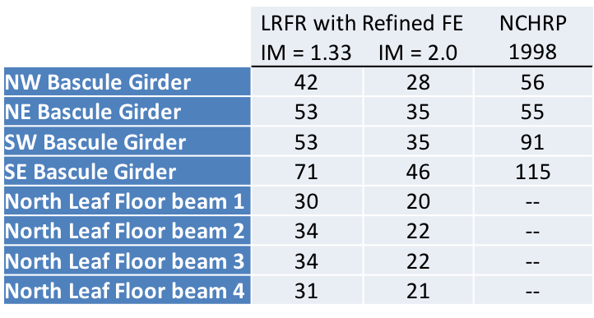

To more completely bound the structural behavior of this bridge, an extreme case of structural deterioration was simulated by removing the webs of a section of the bascule girders and representing only the flanges and stiffeners (Vierendeel truss). The analyses with this model revealed that even as a Vierendeel truss, the main girders were able to carry two 30 ton trucks (without any load and resistance factors).

#### Summary

The majority of deterioration evident on this bridge is located in the webs of members. In spite of this, experimentation and simulation have shown that the remaining material and stiffeners are still capable of effectively transferring load to the flanges (i.e. strain compatibility).

The safe load carrying capacity of this bridge exceeded 25 tons. However, given the extensive deterioration, it was recommended that the owner only raise the posting to 10 tons until repairs were completed and a long-term monitoring system was installed.

This long term monitoring system should be design to (1) capture the influence and effectiveness of any repairs/retrofit during their installation, (2) track responses directly related to key vulnerabilities, (3) capture the actual live load environment the bridge is exposed to under normal operating conditions, and (4) develop a baseline of performance that can be used for comparative purposes for the rest of the life of the bridge.

Drexel University, 3141 Chestnut Street, Philadelphia, PA 19104, © All Rights Reserved. **Version 3.0**