Technology Implementation Results and Conclusions

Bridge Introduction

Additional Information

# Case Study: Steel Multi-Girder

## Bridge Introduction

### Motivation

This steel multi-girder bridge was constructed in the 1980s.

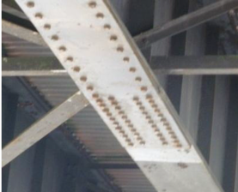

In the late 1990s during a routine load rating it was discovered that the flange transitions near the quarter-span of the girders had been located too far from the supports.

As a result, there was a portion of the girder, just outside the transition that did not rate.

To mitigate this issue, a series of cover plates were bolted to this region.

Approximately 10 years later, during a subsequent routine load rating, it was discovered that these cover plates were not fully developed at the critical location, due to an insufficient number of bolts.

Given the costs already sunk into the retrofit and recent repainting of the bridge and its extremely low ADT and ADTT, the owner was interested in developing a more accurate load rating in the hope that no additional intervention would be needed to avoid posting.

### Description

The bridge presented in this case study is comprised of four simply-supported spans, all with a skew angle of 49 degrees. It was the two longest spans, which each have a length of 147 feet, that failed to rate and thus were the focus of this study. Each span is composed of six (6) welded plate-girders and a cast-in-place deck.

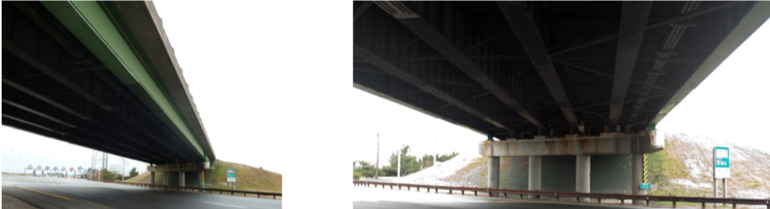

Due to capacity issues, in 1997, steel retrofit plates were bolted to the bottom flange of the girders within Spans 2 and 3 at the first bottom flange transitions. Since these plates were installed without shoring, they are only active in resisting live load effects. Furthermore, these cover-plates were installed with too few bolts to achieve full development and failed to rate using conventional methods.

In order to examine the influence of these issues on the bridge’s continued performance, a detailed load rating of these bridges was performed using refined modeling techniques calibrated by a diagnostic load test.

Drexel University, 3141 Chestnut Street, Philadelphia, PA 19104, © All Rights Reserved. **Version 3.0**

Bridge Introduction

Results and Conclusions

Additional Information

Technology Implementation

# Case Study: Steel Multi-Girder

## Technology Implementation

### Description

The bridge was evaluated by performing a diagnostic load test, whereby a static load is placed on the bridge and responses recorded to characterize the load distribution. The responses are compared with FE model predictions and used to validate or calibrate the model.

A diagnostic load test differs from a proof-level load test in that the load is less than the proof-level load. While this method does not allow for direct inference of bridge capacity, it does allow for accurate characterization of load distribution as long the load is large enough to cause appreciable response (e.g. >1/10” displacement). Loads should be applied incrementally and bridge responses should be continuously monitored during the loading activities to ensure no damage of the bridge occurs (i.e. non-linear response).

### Methods

Two trucks, each with a weight of 65 kips were used for this test.

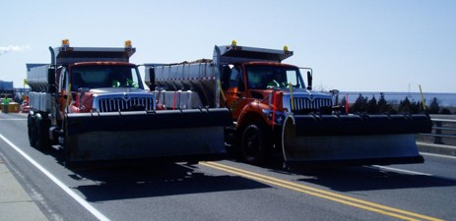

Displacement was monitored on each girder in the middle of span 2 and at the location of the problematic cover plate. Strain was also recorded at mid-span on the girder bottom flanges, and near the cover plates at three locations along the girders height, allowing for the development of the strain profiles and calculation of the neutral axes. A total of 8 displacement gauges and 22 strain gauges were installed on the bridge. Their locations were chosen to capture maximum responses and responses in the area of interest (cover-plate detail).

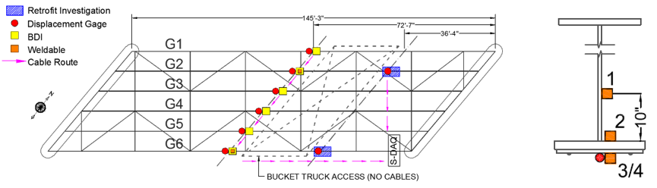

An element-level FE model was constructed based on bridge geometry and assumed material properties provided by construction documents. This type of model employs both one-dimensional (beam elements) and two-dimensional elements (e.g. plate or shell elements) to model girders/diaphragms and deck, respectively. Rigid links are used to enforce compatibility between elements while maintaining accurate geometry.

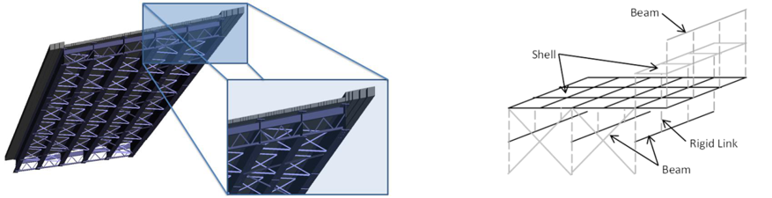

Drexel University, 3141 Chestnut Street, Philadelphia, PA 19104, © All Rights Reserved. **Version 3.0**

Bridge Introduction Technology Implementation

Results and Conclusions

Additional Information

# Case Study: Steel Multi-Girder

## Results & Conclusions

Strain in the bottom flange was compared to that in the cover-plate at several locations in the region of the problematic cover-plate. These measurements were found to be nearly equal, thereby indicating that the beam is effectively transferring force to the cover-plate, which can be therefore considered adequately developed.

Furthermore, experimentally determined distribution factors showed that a girder will experience, at most, 33% of the applied load (total response) indicating that the structure is efficiently transferring load to adjacent girders.

The test loading scenarios were simulated with the FE model and compared to the experimental results. The FE predictions closely agreed with the field results without requiring any modifications. This validation process ensured the FE model was representative of the real structure, and any subsequent simulations could be trusted.

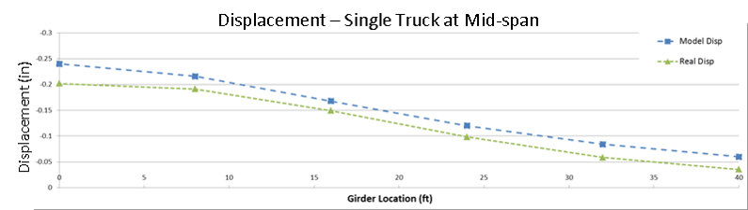

The validated FE model was used to simulate dead load and live load effects for computing a refined load-rating. The resulting dead-load and live load responses and rating factors were compared to those obtained using conventional single-line girder analysis as summarized the following table (for Service II).

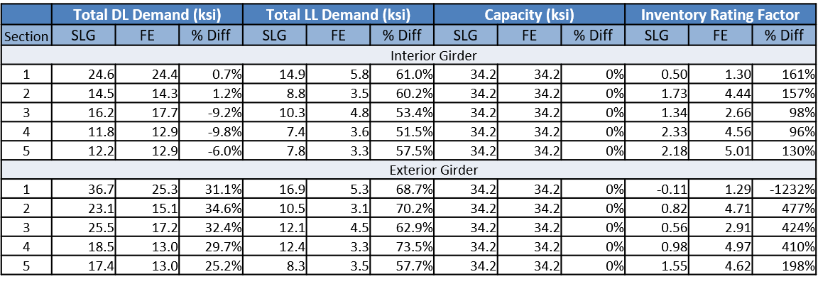

Sections Key:



### Summary

Through the use of refined modeling, validated through static (truck load) test results, it was determined that the load rating was greater than 1.0

The increase in load rating was caused by a decrease in girder force effects that resulted from more accurately estimating the load sharing between girders

The reduction in girder force effects was significant enough that the bridge rated for legal loads even without the retrofit cover plates

Had such a study been undertaken in the late 1990s when the original issue was discovered, significant savings could have been acheived

Drexel University, 3141 Chestnut Street, Philadelphia, PA 19104, © All Rights Reserved. **Version 3.0**