Technology Implementation Results and Conclusions

Bridge Introduction

Additional Information

# Case Study: RC T-Beam

## Bridge Introduction

### Motivation



The bridge presented in this case study was constructed in 1930. In the ensuing years, the plans for this structure were lost due to flooding of storage facilities and thus the reinforcement details are unknown (save for some understanding of design and construction practices common in 1930).

The structure had an inventory rating of 0.9 for HL-93 and as a result was posted for 37 tons. Since this posting essentially corresponds to common legal loads, it would not normally pose any management challenges to the owner, or have any appreciable influence on mobility.

However, in this case, the bridge was part of a designated heavy-load corridor that was put in place to improve the economic competitiveness of local industries that were critical to the region. As a result, this particular bridge was effectively blocking the implementation of the heavy-load corridor and negating any positive influence it could have on local industries.

Given these circumstances, the owner wished to raise the permitted load level and remove all postings by electing to do a more detailed load rating of these bridges using refined modeling techniques calibrated by field measurements (proof-level static load test and dynamic test)

### Description

This bridge features three simply-supported spans with a skew of approximately 18° and carries three lanes. Each span has a length of 48 feet, and an overall width of 48 feet when measured parallel to the skew. The structure is composed of six reinforced-concrete T-beams with a cast-in-place deck. The first span is over dry ground, the second is over Smithers Creek, and the third is over a small side street.



### Condition

This bridge exhibited substantial deterioration, typically concentrated around the two central piers. There was spalling along the height of the pier, on the underside of the pier cap, and at the beam seat locations, with exposed and corroded rebar. The middle span appeared to have shifted laterally, possibly from lateral loads experienced during a flood. However, no physical damage of the span was observed. Numerous cracks were observed in the beams and at the beam-diaphragm interfaces However, these cracks were small and, for its age, the bridge was appraised to be in excellent condition. Inspections indicated no signs of scour or other foundation-related problems.

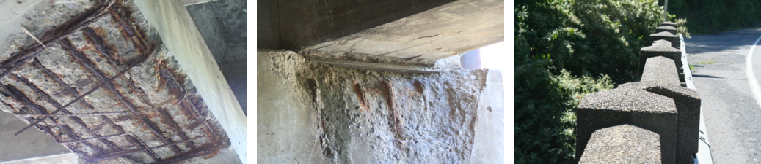

The uncertainty associated with this bridge’s performance due to the observed deterioration necessitated a thorough understanding of the bridge’s behavior.

Drexel University, 3141 Chestnut Street, Philadelphia, PA 19104, © All Rights Reserved. **Version 3.0**

Bridge Introduction

Results and Conclusions

Additional Information

Technology Implementation

# Case Study: RC T-Beam

## Technology Implementation

### Description

The bridge was evaluated using static load testing methods as well as with dynamic testing. The static load test consisted of placing loaded dump trucks on the bridge while recording the bridge response (strain and displacement). These responses can be directly compared with FE model predictions and used to calibrate the model.

The dynamic test consisted of a multiple input, multiple output impact test whereby the deck was impacted with an instrumented sledgehammer, and acceleration was recorded at many distributed locations. The measurements obtained from the dynamic test were subsequently analyzed to extract the dynamic properties of the structure (shapes and frequencies of natural modes of vibration) which can be used to calibrate a finite element model of the bridge.

### Methods

The NCHRP Manual for Bridge Rating Through Load Testing indicated that for this structure and the state legal truck of 40 tons, a proof load of 200 kips per lane (600 kips total) would be required. The test therefore required positioning 6 tri-axle dump trucks capable of being loaded to 100 kips each on the bridge. The bridge was loaded incrementally from 100 kips to 604 kips. Strain was recorded at 30 locations and displacement at 18 locations.

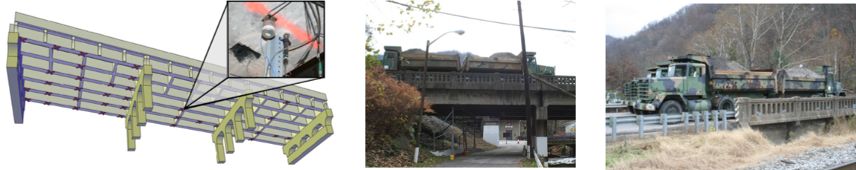

The dynamic test was performed by impacting the deck with a 25 pound instrumented sledge (load cell) at 37 locations. Impacts generally induced forces between 4 and 5 kips with broadband frequency input. Acceleration was recorded by accelerometers installed on the bottom of the girders at 38 different locations.

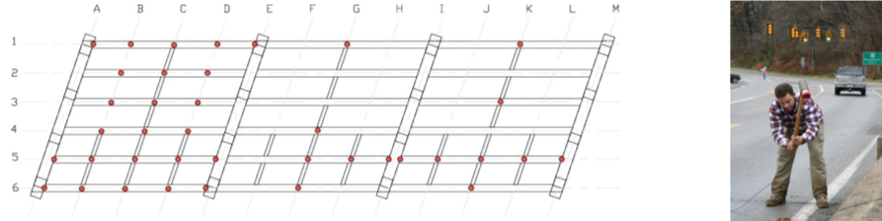

The impact locations were chosen so that the measured vibration responses would have a dense spatial resolution and to vary the spatial characteristics of the input excitation. The former consideration is important for resolving different mode shapes from the vibration measurements, while the latter is important for exciting different vibration modes. Modal processing of the resulting data was used to identify the bridge’s natural modes of vibration.

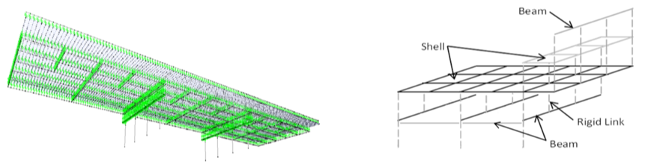

An FE model was constructed based on measured bridge geometry and assumed material properties. The model was calibrated by iteratively adjusting model parameters to bring the FE model into better agreement with the observed experimental data. Since the impact of girder cracks were the main source of uncertainty, the moments of inertia of the beams were chosen as the parameters to be adjusted in the calibration process.

Drexel University, 3141 Chestnut Street, Philadelphia, PA 19104, © All Rights Reserved. **Version 3.0**

Bridge Introduction Technology Implementation

Results and Conclusions

Additional Information

# Case Study: RC T-Beam

## Results & Conclusions

The measurements gathered during the static load test showed that the bridge behaved linearly thereby indicating that the bridge did not experience appreciable yielding or damage at loads up to proof-level.

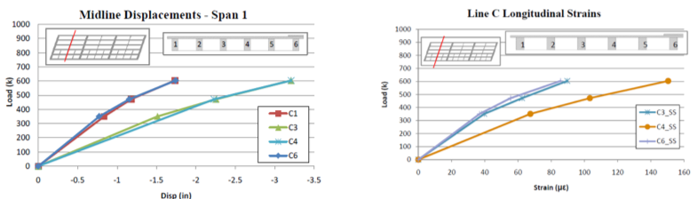

The data gathered during the dynamic test was used to identify the bridge’s natural modes of vibration.

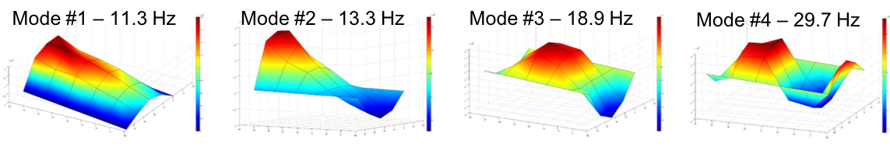

The displacements measured during the load test were compared to those predicted by the FE model. The initial model only required small changes in the moments of inertia of the beam elements to bring it into agreement with the experimental data. The natural modes of vibration predicted by the calibrated model were compared to those obtained from the experimental data and found to already be in close agreement. Therefore, no further calibration of the FE model was required.

The FE model was used to compute the demands due to dead load and Strength 1 design live loads for the purposes of computing load ratings (LRFR). The ratings were computed with both the preliminary model and the calibrated model. Ratings were also calculated directly from proof-load test results in accordance with the guidelines presented in NCHRP report 234 “Manual for Bridge Rating through Load Testing” (1998).

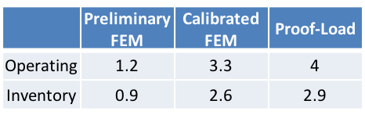

### Summary

This study employed the use of refined models calibrated through both dynamic and static (truck load tests with total force of 600 kips) test results

Through these studies, it was determined that the load rating of the bridge was over 3 times that predicted by conventional approaches

The increase in load rating was caused by the significant transverse stiffness of the T-beam superstructure (and significant load sharing between girders), which resulted in a large decrease in live load girder force effects

Given the significant reserve capacity of the superstructure system uncovered through these experiments, the owner elected to remove the posting and allow trucks designated for the heavy-load corridor

Drexel University, 3141 Chestnut Street, Philadelphia, PA 19104, © All Rights Reserved. **Version 3.0**