Technology Implementation Results and Conclusions

Bridge Introduction

Additional Information

## Case Study: Steel Multi-Girder Bridge

### Bridge Introduction

#### Motivation

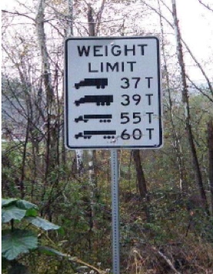

The bridge presented in this case study was constructed in 1954. The bridge served as a key link, connecting numerous mines to the highway system. As such, it saw considerable heavy truck traffic that was transporting mined material. At the time of testing, the structure was recorded as being structurally deficient and was posted for load, although the posting limits were close to legal limits.

As a result of this exposure and the observed deterioration of the deck and other

components, the owner wished to quantify the level of performance that the bridge could still deliver. This was accomplished by performing structural identification in conjunction with a proof-level load test.

#### Bridge Description

This structure is a 3-span, simply-supported steel stringer bridge with a cast-in-place composite concrete deck. The center span is approximately 52 feet long with 2 rows of internal diaphragms oriented perpendicular to the girders. The two external spans are approximately 20 feet long and have diaphragms only at the supports. The out-to-out width is 35 feet. The southern end of the center span rests on steel rocker bearings, while the northern end rests on pinned bearings. These bearings are supported by reinforced concrete hammerhead piers.

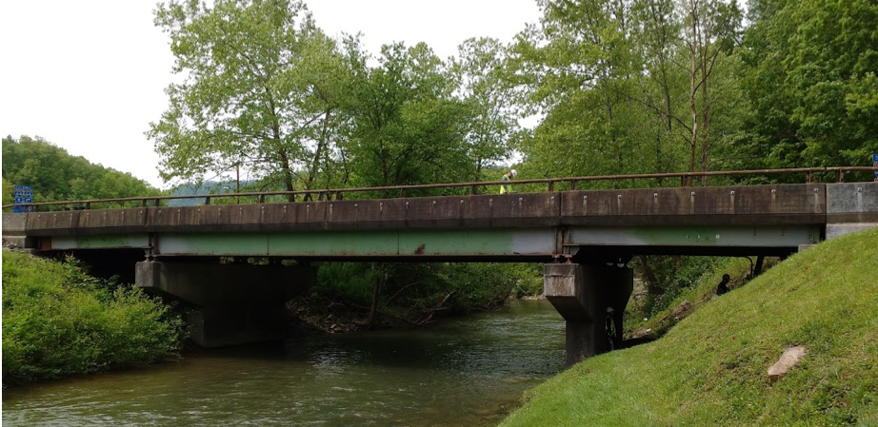

Several bearings were heavily corroded. In these areas, the bottom flanges of the girders also showed considerable corrosion, as already indicated in past inspection reports. This corrosion was likely due to the failure of deck seals in the expansion joints. Furthermore, a bearing on the northern exterior span over the pier was observed to have lost connection to the superstructure. While this “floating” bearing was not a threat to bridge stability, it was indicative of the significant corrosion of the bearing system. The hammerhead piers exhibited signs of efflorescence and some cracking and spalling beneath the bearings. There were also areas on the ends of the hammerhead that have had repairs performed as evidenced by newer concrete.

The deck showed signs of shear failure where concrete had broken off as deep as the top layer of reinforcement. Several regions also evidenced deck repairs and patching. It is postulated that the failure of the deck was, in part, due to the braking forces from trucks as they came to a stop at the stop sign at the end of the bridge. It is also possible that the 7” deck as indicated in construction drawings is insufficient to provide durability and adequate reinforcement cover. The underside of the deck had spider web cracking and some efflorescence.

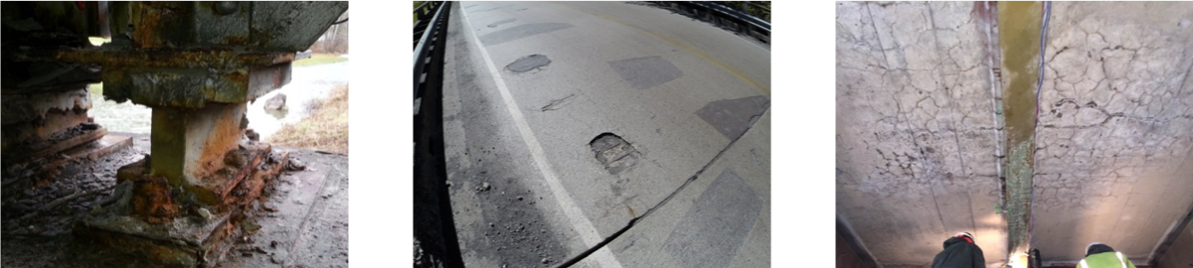

Drexel University, 3141 Chestnut Street, Philadelphia, PA 19104, © All Rights Reserved. **Version 3.0**

Bridge Introduction

Results and Conclusions

Additional Information

Technology Implementation

## Case Study: Deterioration due to Structural Response

### Technology Implementation

#### Description

The bridge was evaluated using proof-level static load testing The proof-level load test is performed by placing loaded trucks on the bridge such that the total imposed weight is at or above a proof-level as defined by the AASHTO Manual for Bridge Evaluation, and recording the subsequent bridge response (strain and displacement). These responses can be used directly to describe the bridge’s capacity and behavior. The proof- level is greater than the design load so as to provide the same safety targets implicit in LRFR rating procedure.

Structural identification was also performed utilizing the data gathered during the static load test and in conjunction with finite element modeling. The FE models are able to provide a more complete understanding of the behavior of the bridge and to identify influential mechanisms. The accuracy of the FE model can be validated by comparing the recorded bridge responses to model predictions and adjusting model parameters as necessary to bring model predictions in line with measured responses.

Impact testing was also performed to provide further information for FE model calibration. The impact test is performed by impacting the deck with an instrumented sledgehammer, while recording acceleration at many distributed locations. The data obtained from the dynamic tests can be analyzed to extract the dynamic properties of the structure (shapes and frequencies of natural modes of vibration) which can be used to calibrate an FE model.

#### Methods

Instrumentation efforts focused on the center span, where strain and displacement gauges were installed on the underside of the bridge at 17 locations.

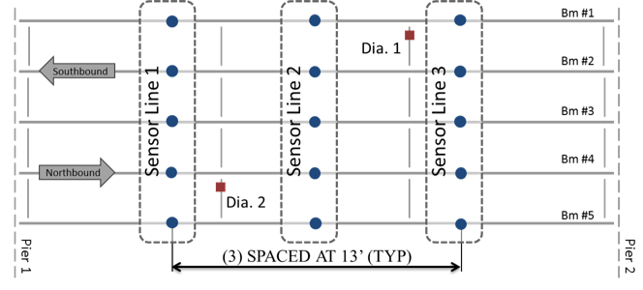

The strain gauges were welded onto the bottom flanges while the displacement gauges (string potentiometers) were clamped onto the bottom flange. A total of 36 strain gauges and 15 displacement gauges were installed.

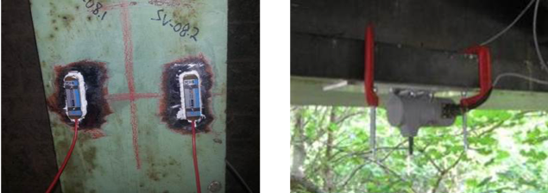

The trucks were filled to varying levels to provide a variety of load levels. A total of eight load stages were performed ranging from a single empty truck to four fully loaded trucks totaling 299 kips. This incremental loading ensures that the structure can be safely monitored for any unexpected behavior or non-linear deformation.

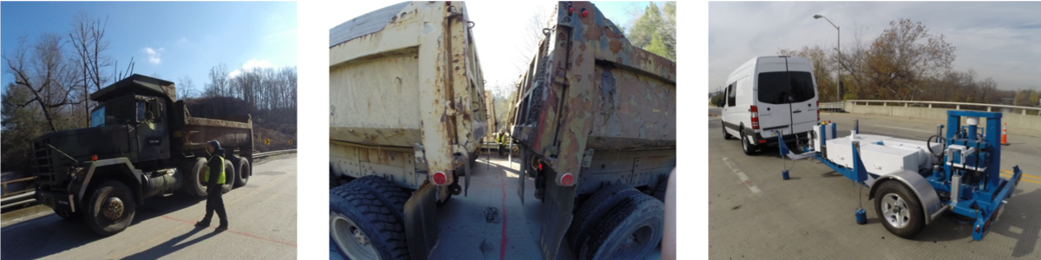

The impact test was performed with the THMPR system which provided impacts with force levels around 25,000 lbs. and contained a usable frequency band of approximately 0-65 Hz. Impacts were performed at 11 locations while acceleration of the bridge was recorded at 19 evenly distributed locations.

An element-level FE model was constructed based on bridge geometry and assumed material properties provided by construction documents. This type of model employs both one-dimensional (beam elements) and two-dimensional elements (e.g. plate or shell elements) to model girders/diaphragms and deck, respectively. Rigid-links are used to enforce compatibility between elements while maintaining accurate geometry.

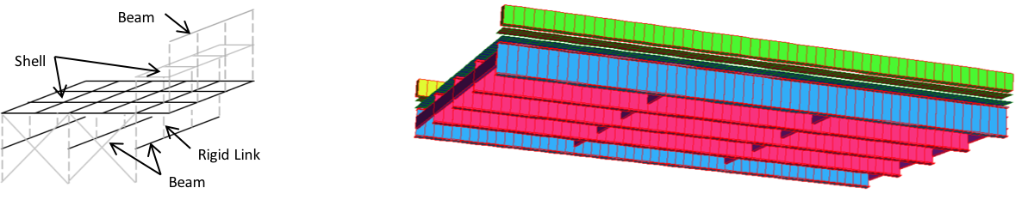

Drexel University, 3141 Chestnut Street, Philadelphia, PA 19104, © All Rights Reserved. **Version 3.0**

# [Virtual Lab (../index.html)](http://vlab.asklab.tk/VirtualLab/index.html)

Bridge Introduction Technology Implementation

Results and Conclusions

Additional Information

## Case Study: Deterioration due to Structural Response

### Results & Conclusions

Under the load case with maximum load (4 fully loaded trucks) a peak displacement of -0.289 inches was recorded at mid-span. The peak strain of 206.7 microstrain occurred at the same location in the bottom flange. This strain corresponds to an approximate bottom flange stress of 6 ksi.

To perform linearity checks, load levels were varied: empty, half-filled, and full. The plot of displacement vs. load shows that the mid-span remains predominantly linear through the load levels. A small amount of stiffening can be observed in some girders, which can be attributed to an increase in load transfer through mechanisms that were only engaged under higher level loads as would be expected in a large structure such as this, as the load distributing mechanisms are numerous and varied and may engage to varying levels as the load level is varied.

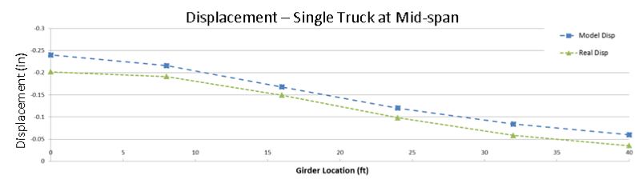

These results indicate that the proof level was reached without the structure experiencing any distress and therefore has a passing load rating. Furthermore, in spite of the apparent deck deterioration, the structure is still able to effectively distribute loads laterally to adjacent girders, thereby reducing the demand on any single girder. During the load test and for the many truck configurations, no girder ever experienced more than 50% of the imposed load.

The data gathered during the dynamic test was used to identify 10 of the bridge’s natural modes of vibration.

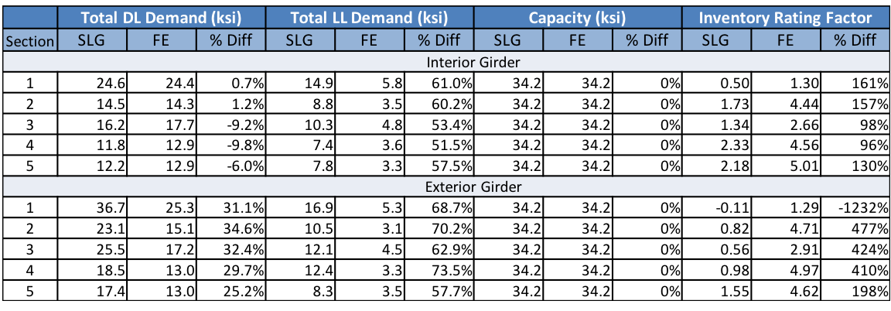

The FE model was calibrated using modal parameters (mode shapes and frequencies) obtained from the impact test. The modulus of elasticity of the sidewalks, barriers, and diaphragms were adjusted during the calibration process, as well as the degree of composite action between the deck and girders and the rotational stiffness at the bearings. As a result of the calibration, the mode shapes and frequencies predicted by the FE model differed from experimental results by not more than 7% and the FE model was therefore deemed sufficiently representative of the real structure. The model was then leveraged to compute refined load ratings.



#### Summary

In spite of the evident deterioration, the structure is capable of carrying legal load levels as evidenced by the successful proof-level load test. The load posting can be removed.

The conservatism of the structure can be attributed to its ability to effectively distribute load as revealed by the bridge responses during the load test and through the use of refined FE modeling.

The deterioration of the structure, while not immediately threatening to its capacity, is a concern for the ongoing health of the bridge if allowed to continue. Repair of the deck and deck seals and corroded bearings was therefore recommended.

Drexel University, 3141 Chestnut Street, Philadelphia, PA 19104, © All Rights Reserved. **Version 3.0**