Technology Implementation Results and Conclusions

Bridge Introduction

Additional Information

# Concrete Encased Steel Girder Case Study

## Bridge Introduction

### Motivation



A series of bridges with concrete-encased steel girders, constructed in the 1920s and 30s were determined to require posting based on conventional, single-line girder rating procedures.

These bridges had historically been rated using "Engineering Judgement" and were allowed to operate for 80 to 90 years without load restrictions. Although these bridges had extremely low ADT and ADTT, the recommended posting would limit the mobility of emergency vehicles and thus increase the response times to the surrounding community.

In addition, given the low traffic volumes, expensive retrofits or complete replacements were difficult to justify, especially considering their track record of good performance. Given these drivers, the owner elected to do a more detailed load rating of these bridges using refined modeling techniques calibrated by field measurements.

### Description

The structure presented in this case study is a simply supported, two span bridge with a skew of 60 degrees. It has concrete encased steel I-Beams with a cast-in-place deck. It had a posted weight limit of 20 tons. NBI listed it as having an ADT of 200. With a sufficiency rating of 46.0, the bridge was evaluated as "Not Deficient."

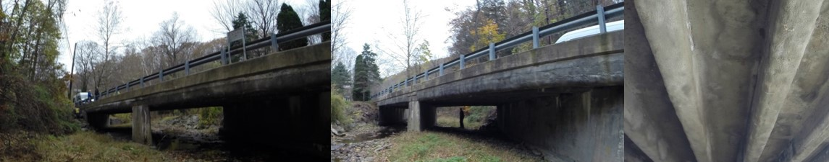

Both spans were measured as 41'-6" span length and a roadway width of 22'-6". Each span carries type-2 strong post guide rails over a curb measuring 6.5"x14" on either side of the roadway. The overall deck thickness was estimated to be approximately 16" with a 2.75" overlay. Each span has eight (8) concrete encased steel I-beams spaced at 3'-3" with overall dimensions of 22"x12". Each girder has what appears to be 1-2" of shotcrete applied to the surface of the original concrete encasement with apparent cracking. The presence of shotcrete over the original concrete encasement may imply that some deterioration of the encasement was present.

Bridge Introduction

Results and Conclusions

Additional Information

Technology Implementation

# Concrete Encased Steel Girder Case Study

## Technology Implementation

### Description

The bridge was evaluated using vibration testing methods. The bridge was dynamically excited at several locations on the deck surface using a broad-band impact force, and its corresponding vibration responses were measured using accelerometers that were also located on the deck. The combined input-output vibration measurements were subsequently analyzed to extract the dynamic properties of the structure (shapes and frequencies of natural modes of vibration) which were then used to calibrate a finite element model of the bridge.

### Methods

The THMPR™ system was used to perform MIMO (multi-input; multi-output) impact testing.

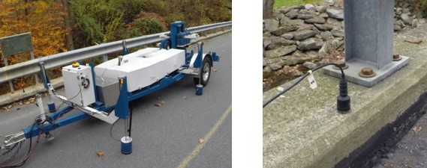

A total of six stationary reference accelerometers were used for each of the two spans. The references were temporarily attached to the bridge curbs using adhesive at the quarter-span, mid-span, and three-quarter span locations along each side. The reference accelerometers remained at the same locations on the deck throughout the vibration testing and were used to link together the vibrations measured by THMPR's local sensor array of six accelerometers. The reference accelerometers were cabled to GPS synchronized data acquisition systems along each shoulder and out of the way of traffic.

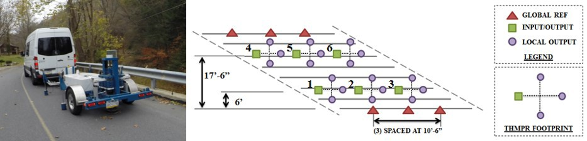

A total of six impact locations per span were selected for the test: (1) at quarter span in the right lane, (2) at mid-span in the right lane, (3) at three-quarter span in the right lane, (4) at quarter span in the left lane, (5) at mid-span in the left lane, and (6) at three-quarter span in the left lane. The impact locations were chosen so that the measured vibration responses would have a dense spatial resolution and to vary the spatial characteristics of the input excitation. The former consideration is important for resolving disparate mode shapes from the vibration measurements, while the latter is important for exciting different vibration modes.

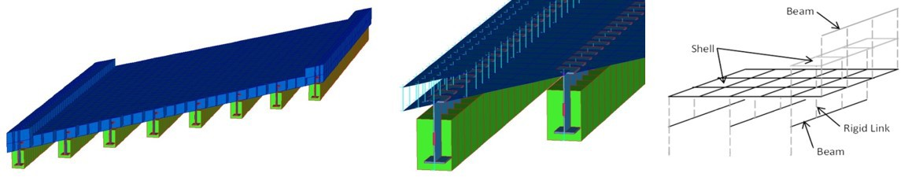

An element-level FE model was created based on available bridge geometry information. The model was calibrated for each span by iteratively adjusting model parameters to bring the model into better agreement with the observed experimental data. All chosen parameters were globally active across the entire model. The deck and encasement stiffness parameters were updated by adjusting the modulus of elasticity of the concrete material used in the model. Composite action was updated by adjusting the stiffness of the composite action links. Boundary rotational stiffness about the transverse axis normal to the girder lines represented the degree of fixity of the bearings.

Bridge Introduction Technology Implementation

Results and Conclusions

Additional Information

# Concrete Encased Steel Girder Case Study

## Results & Conclusions

Modal processing of the gathered acceleration data yielded five modes of vibration. The shapes and frequencies are given below.

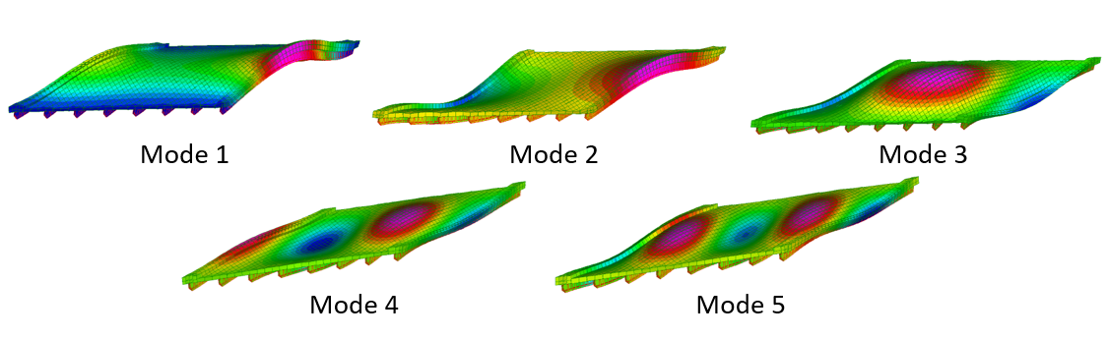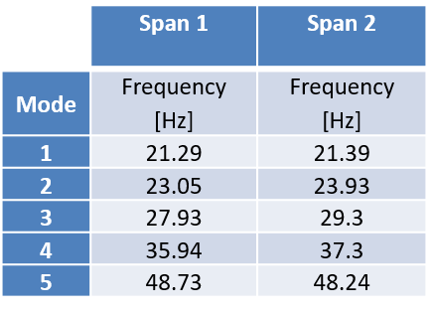

The calibrated FE model agreed well with experimental results and with minor modifications the calibrated model was obtained.

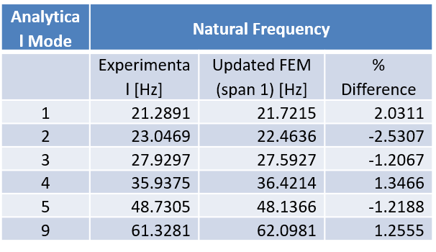

The updated FE model was used to compute the demands due to dead load and Strength 1 design live loads. The controlling demands and Strength 1 Inventory ratings from the calibrated FE model as well as from a standard single-line girder model are compared below.

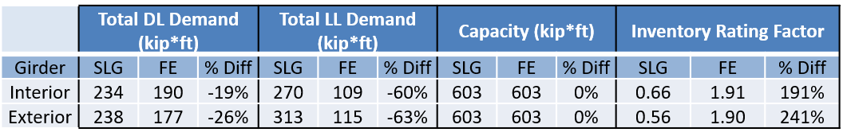

### Summary

The use of refined modeling approaches, calibrated based on field measurements, resulted in load ratings above 1.0 and allowed the owners to forego load posting

The increase in load rating was caused by a decrease in girder force effects that resulted from more accurately estimating the load sharing between girders

This reduction in girder force effects is larger for smaller girder spacing and larger skews (owing to the increased conservatism of distribution factors for these configurations).