ECUADOR Range Maps

Steps:

1. Convert EPSF Files to TIFF Format (***200*** or 400 DPI ?). Estimated 20-30 hours to do this 1 by 1 for 1800 images (images must be very similar or another geo-referencing session may be needed).
2. Geo-rectify using Batch file and previously registered image. Nominal time (2 hours ?).
3. Use existing MASK01 Grid to get 1 where data exists in new registered images (value <255) and mask is == 1. Turn everything else to 0. Write Python Script that does this repeatedly (8-12 hours conservative estimate).

Steps already taken (to get to this point).

1. Georeference Image of Gray Tinamou (1 hour) to Ecuador Shapefile (WGS84 UTM Zone 17S).

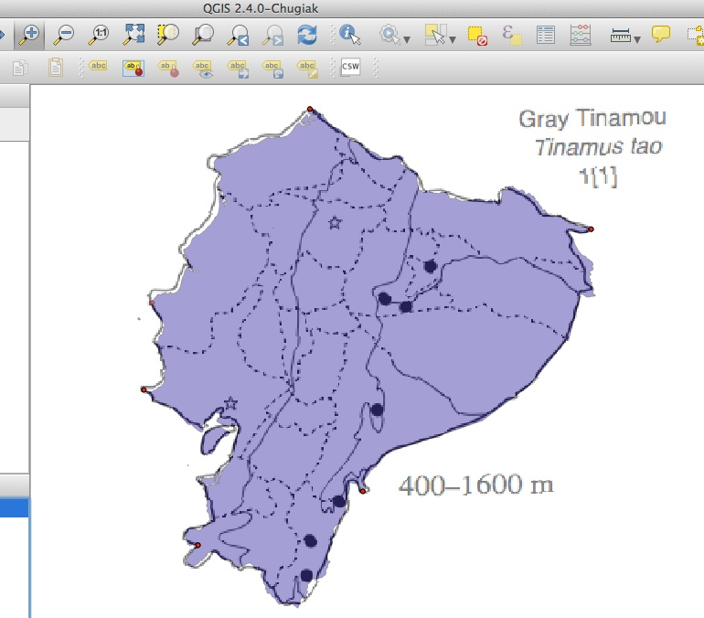

2. Write Batch File to batch geo-reference / geo-rectify images (gdal_translate and gdal_warp) (5 hours).

3. Create Vector Mask to eliminate areas unwanted in creation of the final mask.

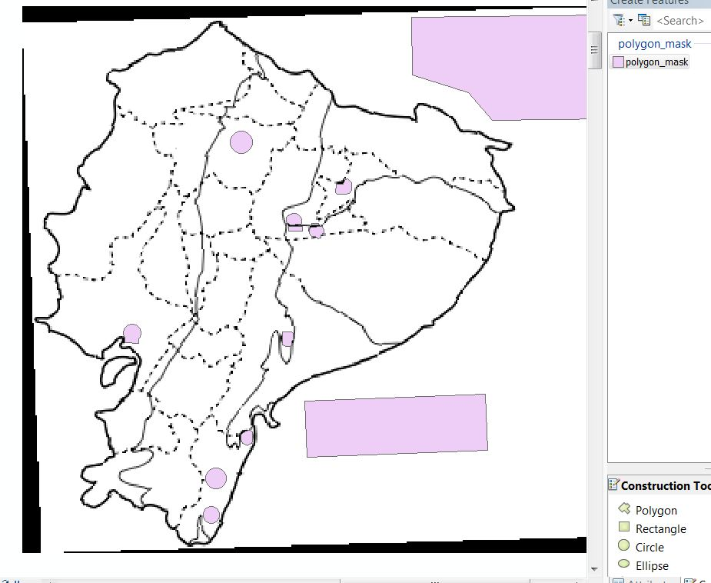

4. Use initial vector mask to create a grid with NoData in excluded areas.

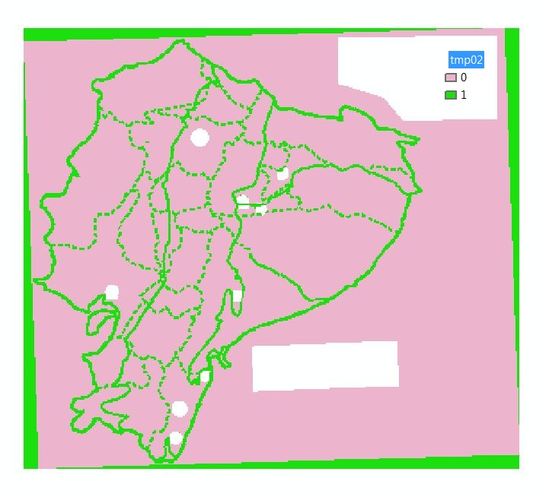

5. Convert Result of #4 to vector for further editing (Editing Step - 2 hours).

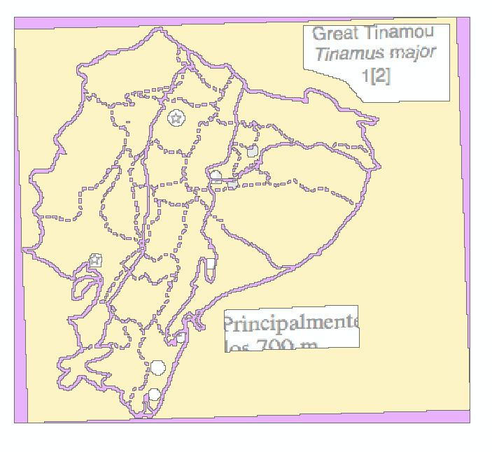

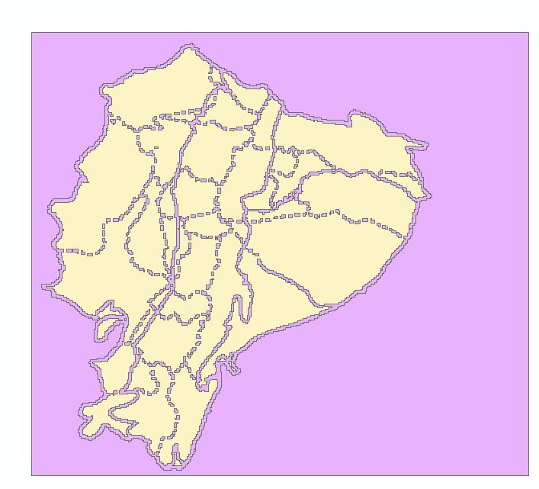

Finished Vector

6. Convert finished Vector to GRID format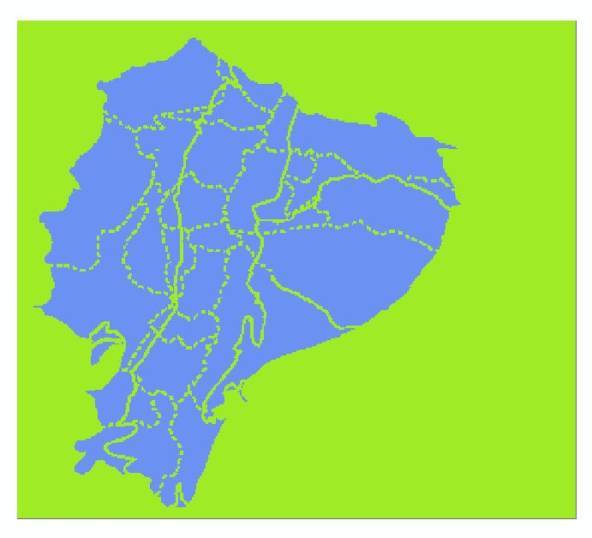

NEXT STEP. Write Python (arcpy) script and run on all georeferenced images (run time negligible; perhaps 5 hours of managing scripts). This is step 3 in the list of steps above.