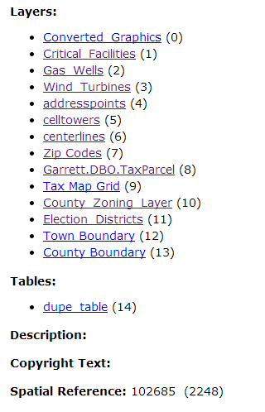

CURRENTLY SET AS ALWAYS VISIBLE:

1, 4, 5, 6, 8

Not Used:

0, 12, 13