Report for the OOP Project

Alexandre Marotte

Thomas Baudu

Jean-Baptiste Corre

Victor Fauchard

Audrey Chanty

Tristan Geron

SUMMARY

Introduction……………………………………………………………………………………2

Explanation of our code …………………………………………………………………2

Our work…………………………….………………………………………………………….3

The encountered difficulties…………………………………………………………..3

Conclusion………………………………………………………………………………………4

***Introduction***

To conclude our semester in POO, we were asked to code an application named VGC. This application is designed for a school to manage different tasks, and to simulate a student portal. We had to manage different options of this application by creating and visualizing different bunches of tasks like login as an administrator with Super Privileges or Faculty Login with Privileges for students or Student Login with Privileges, that permits to see details about them. In this work, we had to fulfill three additional tasks, among:

* Manage academic calendar
* Manage exams, assignments, and results (optional)
* Manage student attendance (optional)
* Manage Network
* Manage course lesson plan
* Manage Timetable (optional)
* Management of fees paid (optional)

We decided to complete the management of tuition fees and management of the Timetable. We were inspired to continue the realization of implementing exams, assignments and results. We also managed the student’s attendance.

***Explanation of our code***

Firstly, we decided to work on the tuition fees. We decided in our codes to enable the possibility to make a payment in several times or paying the total at once. We were inspired by our own students’ portal where we have the choice of this kind of payment. For this part we worked on two classes: payment and students. We wrote our functions in the Payment class with 3 functions. BeginningPayment : asks with what particular kind of payment the student want to deal with the tuition fees. Then, CashPayment and SeveralTimesPayment these two functions allow you to pay the cost.

It was unthinkable for us not to do the management of Timetable. In a portal student, the TimeTable is a major thing. We managed to make our code fits with different classes like students, teachers and administration because it fits for each structure. Like students use their timetable to know their class schedule. Teachers used it to know when they gave lessons and for what classes. The administration used the timetable to schedule each course.

We choose to manage the use of student attendance because it brings many notions together. Attendance was used as a function in three classes particularly. We wrote a particular function named “Attendance” which was used by the teacher to tell if a student was there or not during his courses.

The student and administration were able to see if the student was there or not during the courses.

We also created a function named SeeClassAttendance which can allow administration to remove an absence or not for the student, thanks to a function named Remove absence.

Our team decide to take as a last option the managements of exams, assignments and the graduation of those.

This interfered with three classes particularly, but it’s also linked with other classes. A student received a grade, each matter is evaluated with assignments and grades. The teacher is the one who evaluate students and is in charge to report those grades on their portal. The administration can take a look on the student profil and take notice of their grade.

Our work is approximately 800 lines of code and it contains 13 classes, they are linked. We used a lot of foreach, which is a loop especially for Lists.

***Our work***

Generally, we are very pleased of our work. It has been a very rewarding work for all of us. In this part we are going to explain how we worked for this project. To begin with, we all lived in the same student residence during those 3 months in Ireland except Tristan Geron who was still in France. We have experimented a geographic flexibility especially with Tristan thanks to Github and our other electronics devices to realize the code.

The use of Github has changed our methods of work. It has a lot simplified our methods to work when one of us wanted to change something in our code or write a part of it himself. Our way to work was basically the same every week. We used to meet on Sunday to make a weekly appointment and the rest of the week everyone worked as they wanted. As an example, when one of us wanted to work he had to pull the work of other to be aware of the work situation. Then we worked on what we wanted and pushed our code, everyone then receiving it.

We haven’t done a distribution of labour. Everyone did a part we choosed at first and when we were working together, we informed others orally about what we were working on and the advancement of it. We focused our work on 4 classes particularly which were: student, administration, teacher, program. It was useful for us to work together because it helps us to get to know each other, and we knew that we can count on each other. We didn’t establish a special hierarchy to work, everyone in the group had special skills. Looking back on our work, this project has brought a better working atmosphere. For some of us, it has also been an important gain of time and brought flexibility. Another big thing was the shared responsibility: each of us had a role in this work, and it was a driving force.

***The encountered difficulties***

We also met some difficulties in our work. Firstly, we spend a lot of times on the work of others. The work in group was an advantage but it was also in certain case an important problem.

At the end of the project, it was complicated because there were more classes and more code on each class. We had to adapt to the ways other called their functions and variables. The most difficult part to code was the Teacher Menu, as I explained it before we had to handle different work and different types of code. Even though Github was a real discovery for us, getting it right was a bit complicated at the start of the project.

Another problem we have met in the beginning of the project was the fact that we didn’t really know where and how to start, we had to focus on a lot of information. We tried to make plans of actions to be sure to understand well the process and the subject of the work. One difficulty we may have encountered was the difficulty of the code. It gathered a lot of notions and required an important experience in the language of C#.

***Conclusion***

To conclude, this work was very interesting, we find the subject very realistic and it has helped a lot for coding. We think that we have made a pretty good job. It has help us to develop essential qualities to work in group. According to our opinions, this project has brought together various notions that we could study in data structure or POO like the UML diagram, link to work with Github in POO and the study of class, different type of list in Data structure.

***ANNEX***

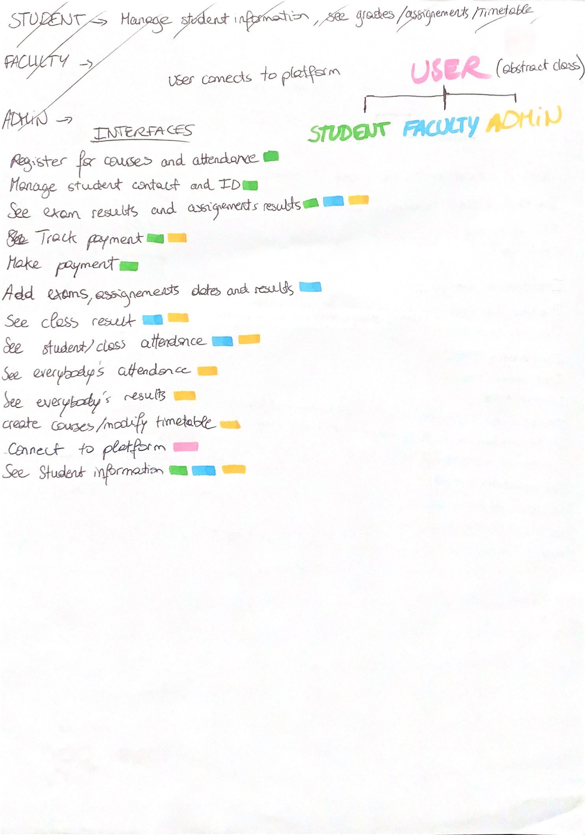

*Above a photo of a plan we made for a better understanding of the subject*