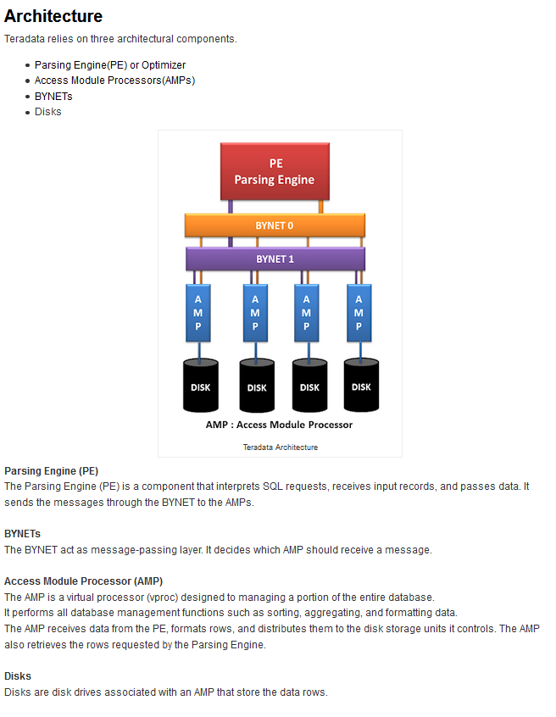

Source : http://www.teradatawiki.net/2013/09/Teradata-Architecture.html