California State University, San Bernardino
School of Computer Science & Engineering
CSE572 F2015 – Database Systems
LAB 03 – Single-Row Functions -REVISED
All lab exercises in this course will be using HR database tables. For this lab exercise, you will be using
HR.EMPLOYEES table.
Before doing the exercises below, create a subdirectory LAB03 under your CSE572 directory. Make
sure that you are in LAB03 subdirectory so that all text files that you save will be stored in this subdirectory.
1. Create a query to display for each employee, the employee number, last name, salary, and
salary increased by 15% and expressed as a whole number. Label the column New Salary. Save
your SQL statement in a text file named LAB03_1.sql. Run your query.
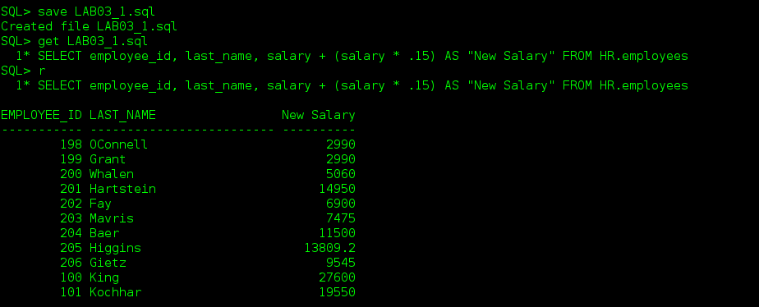

2. Modify your query LAB03_1.sql to add a column that subtracts the old salary from the new
salary. Label the column Increase. Save your SQL statement in a text file named LAB03_2.sql.
Run this revised query.
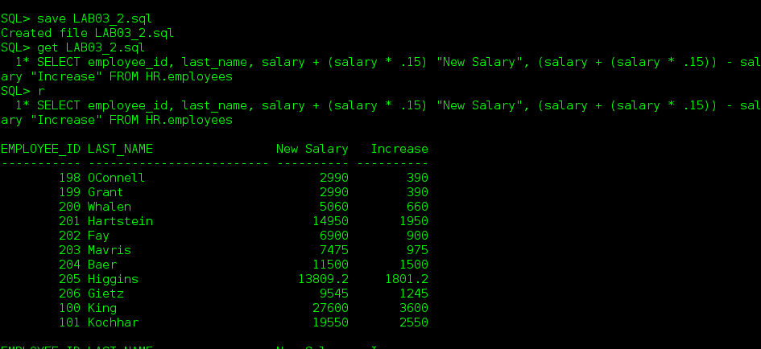
3. Create a query to display the employee’s last name with the first letter capitalized and all other
letters lowercase, and the length of the names, for all employees whose name starts with J, A,
or M. Give each column an appropriate label. Sort the results in descending order by
employee’s last name. Save your SQL statement in a text file named LAB03_3.sql. Run your
query.
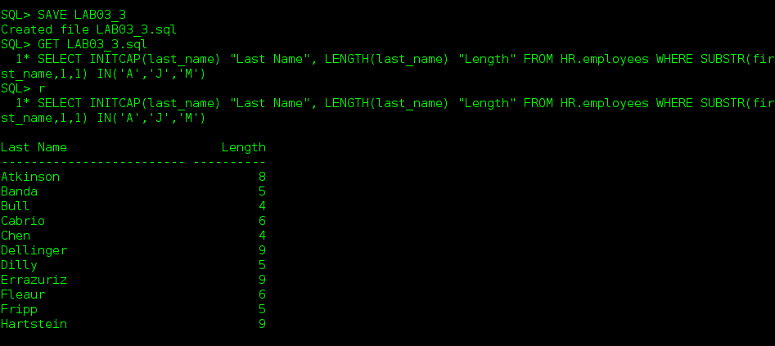
4. For each employee, display the employee’s last name, and calculate the number of months
between today and the date the employee was hired. Label the columns MONTHS_WORKED.
Order the results by the number of months employees. Round the number of months up to the
closest whole number. Save your SQL statement in a text file named LAB03_4.sql. Run your
query.
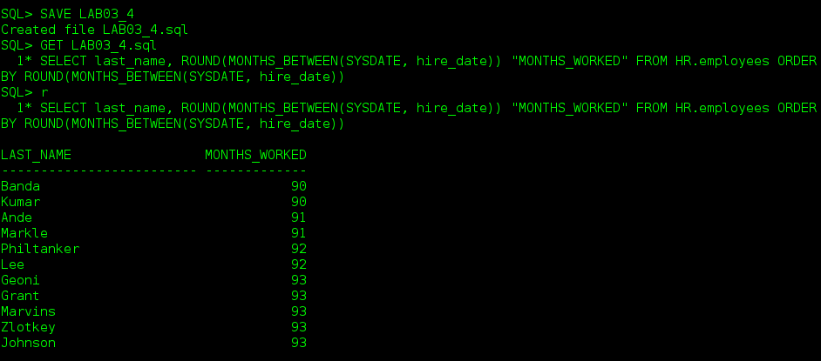
5. Write a query that produces the following for each employee:
<employee last name> earns <salary> monthly but wants <3 times salary>. Label the column
Dream Salaries. Save your SQL statement in a text file named LAB03_5.sql. Run your query.
Example Output
Dream Salaries
King earns $24,000.00 monthly but wants $72,000.00.
…
Getz earns $8,300.00 monthly but wants $24,900.00.
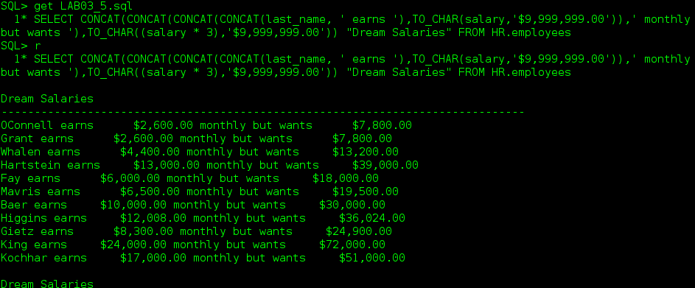
6. Create a query to display the employee’s last name, hire date, and salary review date, which is
the first Monday after six months of service. Label the column REVIEW. Format the dates to
appear in the format similar to “Monday, the thirty-first of July, 2000.” Save your SQL
statement in a text file named LAB03_6.sql. Run your query.
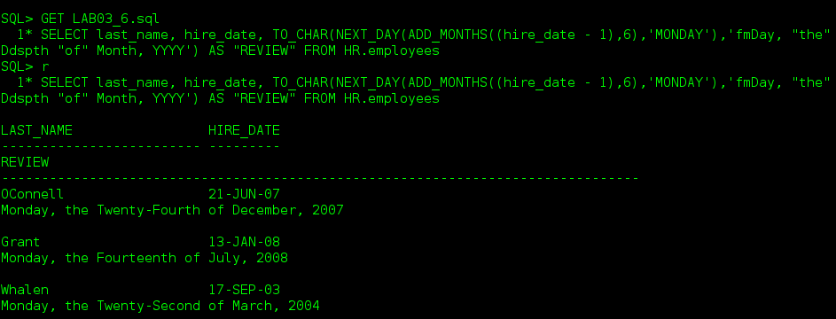
If the date six months later happens to fall on a Monday then the NEXT_DAY() will go to the next Monday after that. That Monday would be the first Monday six months later so I used hire_date -1 to catch that Monday. This way if a review date falls on a Monday that day will be the review day rather than the Monday the following week.
7. Create a query to display the last name , hire date, and day of the week on which the employee
started. Label the column DAY. Order the results by the day of the week starting with Monday.
Save your SQL statement in a text file named LAB03_7.sql. Run your query.

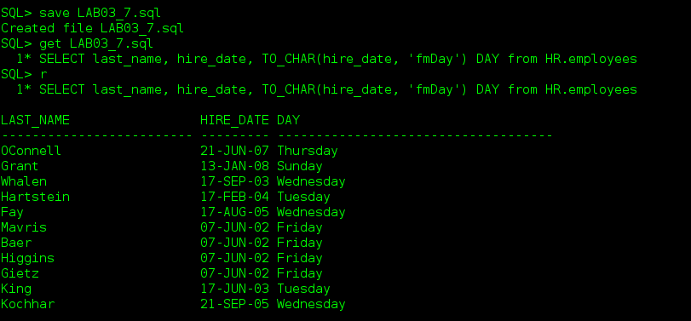
8. Create a query to display the last name and commission amount for every employee who earn
commission. If an employee does not earn commission, put “No commission.” Label the
column COMM AMT. Save your SQL statement in a text file named LAB03_8.sql. Run your
query.

9. Choose only one from 9A or 9B below.
9A. Using the DECODE function, write a query that displays the grade of all employees based on
the value of the column JOB_ID, as per the following data:
9B. Using the CASE syntax, write a query that displays the grade of all employees based on the
value of the column JOB_ID, as per the following data.

