**Repeater App Manual**

**By John Diczhazy**

***Description:***

In Amateur Radio (Ham Radio), a repeater is a station that re-transmits the signals of other stations in order to give them greater range. As a newly minted Amateur Radio enthusiast with a FCC granted Technician license, you are restricted to mainly the VHF/UHF frequency ranges, also called Bands. VHF/UHF frequencies are line of site and do not propagate over the horizon by bouncing off the Ionosphere, like HF or shortwave signals.

In order to get around the VHF/UHF short propagation obstacle, repeater stations are constructed typically in areas of high elevation to extend the transmission and reception of these signals. The nearest Amateur Radio repeater, call sign N8BC, is mounted on top of Lake Hospital Tripoint Facility in Concord Ohio. The site was chosen as it is the highest elevation in Lake County.

Repeater N8BC is maintained by LCARA (Lake County Amateur Radio Association). Lake Health has an agreement with LCARA to provide wireless communications in the event of a natural or man-made disaster that takes out conventional forms of communications, like landline phone, cellular phone, and terrain data.

Amateur Radio communications on the VHF/UHF bands are typically done with low powered (under 5 Watts) “walkie talkie” style handhelds and mobile CB like transceivers mounted in vehicles. In order to communicate with a repeater, you must program specific parameters into your handheld or mobile transceiver in order to trigger it.

Repeater App is a database that contains the parameters required to communicate with a repeater. Each repeater and its parameters will be a separate row in the **repeater_table** of the SQLite database.

Repeater App has a Master/Detail interface. Preferences are accessed via Detail by clicking on the button with the Android Robot icon.

***Launching the Repeater App:***

1. Click on the Repeater App icon to launch. The icon is a black abstract picture of an antenna on a white background surrounded by a blue circle.

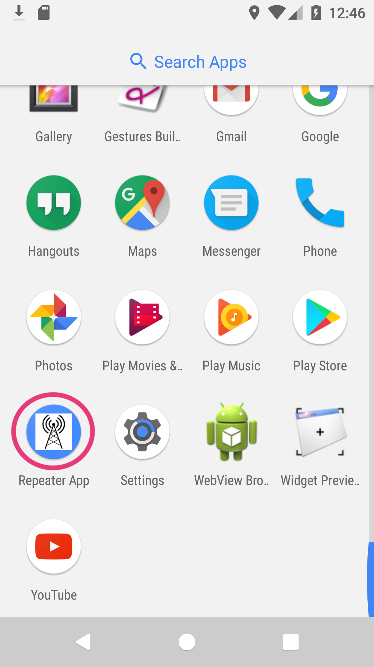

***Adding Repeater Entries:***

1. When launched for the first time, the Repeater App will not contain any repeater entries and will look blank.

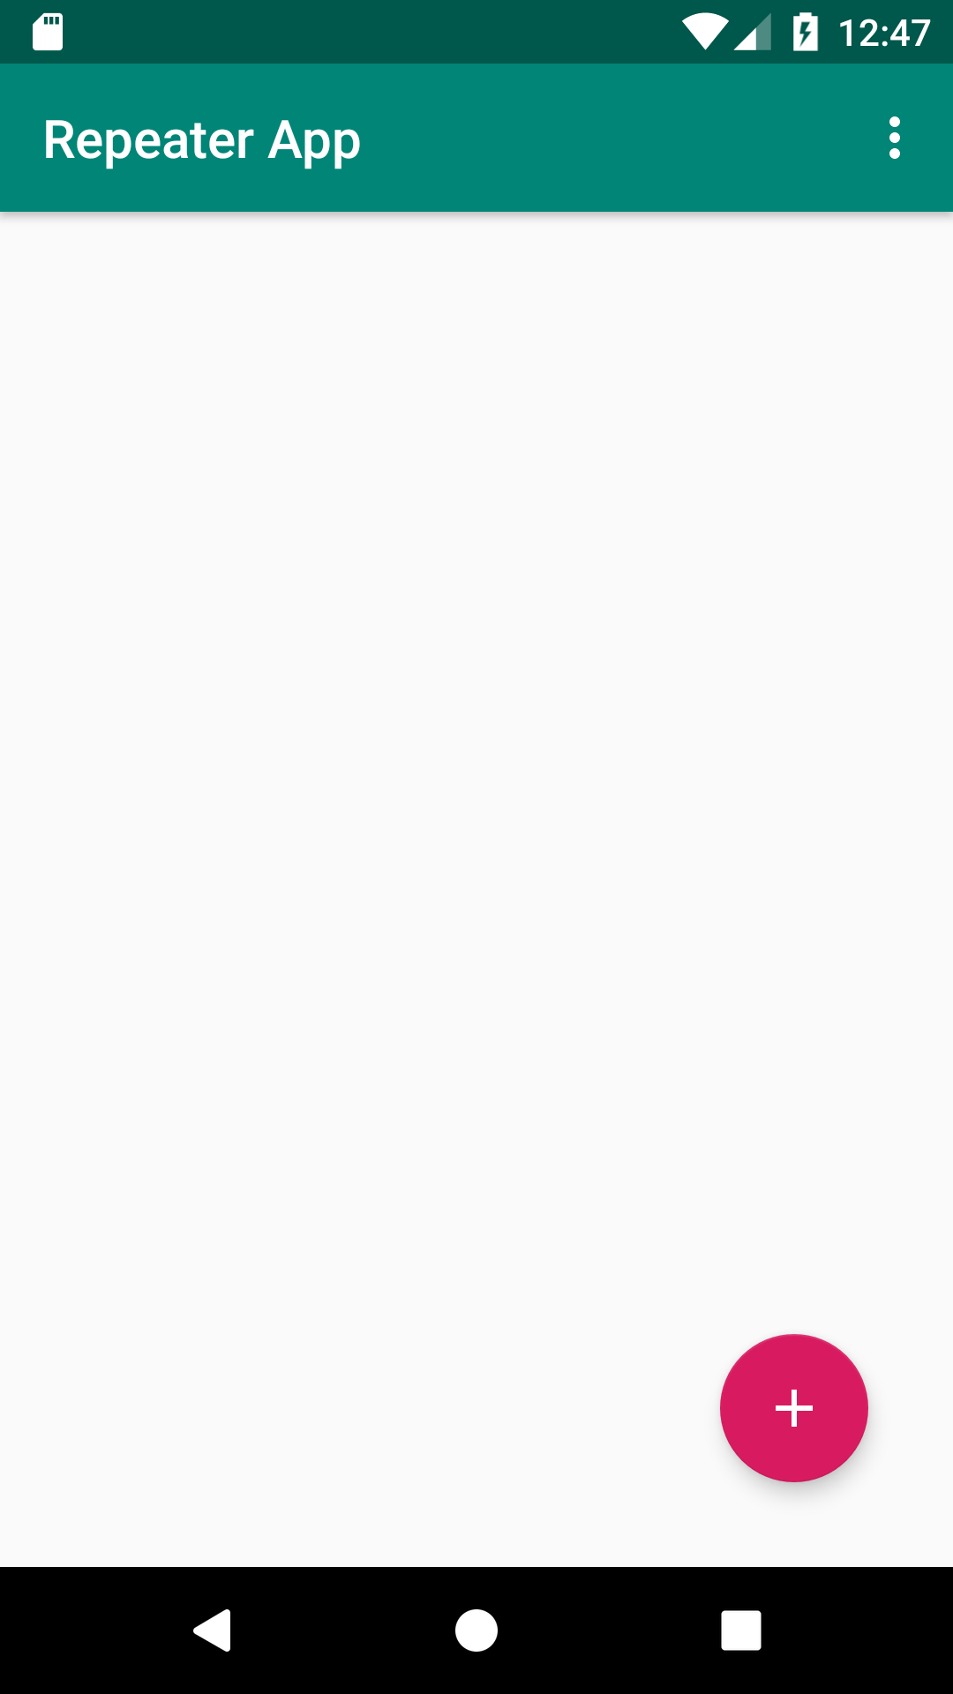

1. Click on the Floating Action Button to add a new repeater entry. The Floating Action Button is a red button with a plus sign in the lower right-hand corner of the Repeater App.

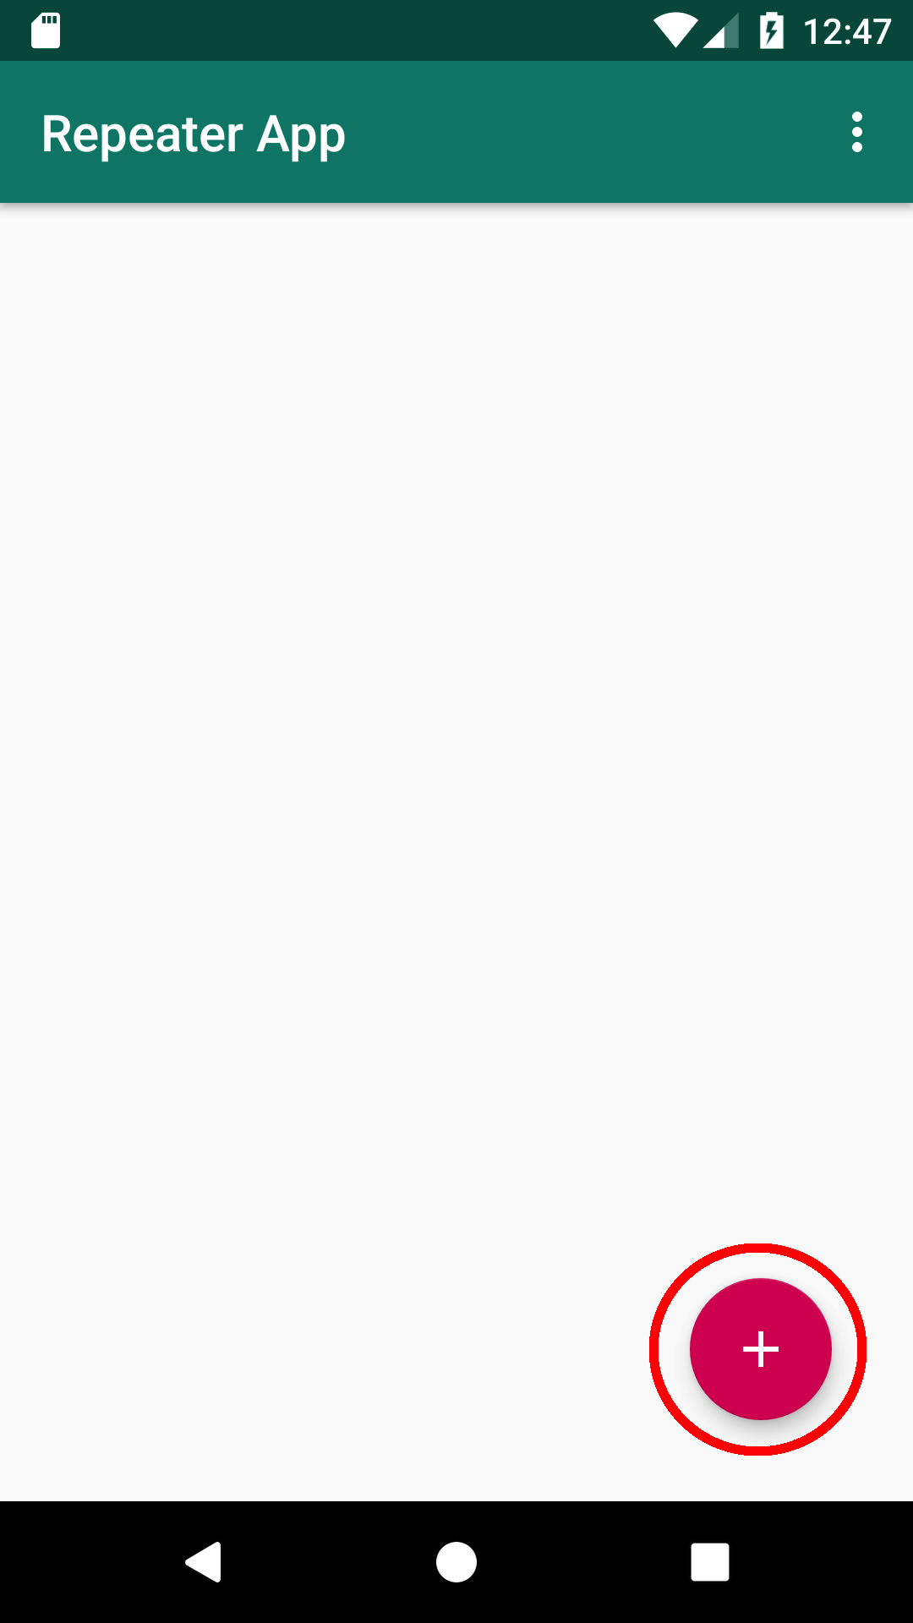

1. Enter the repeater’s parameters in Detail then click on the Floppy Disk icon, this will save your entry.

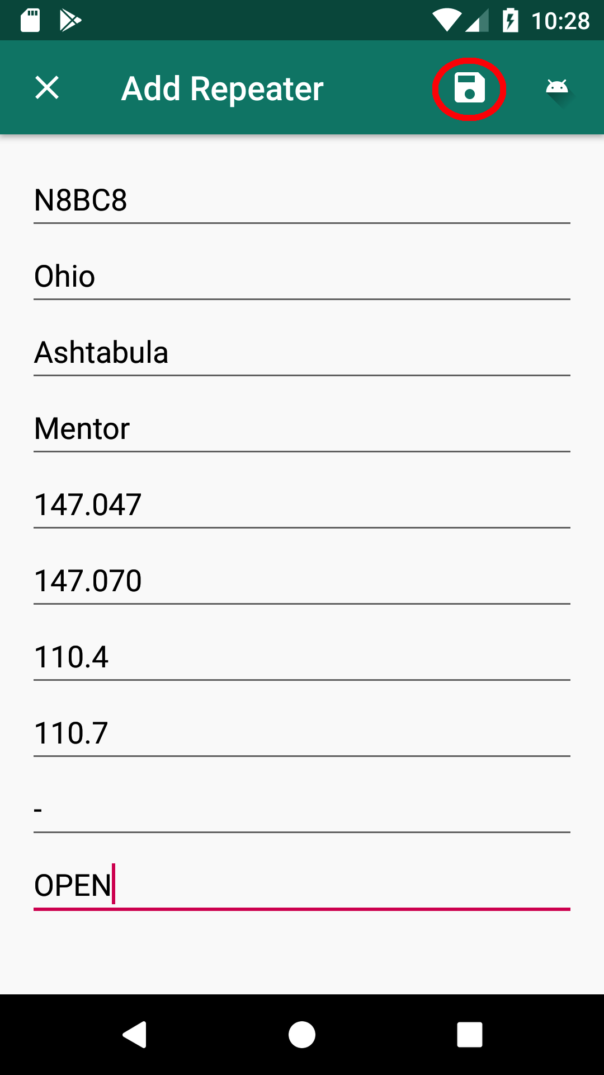

1. All Edit Text fields in the Detail must be filled in, otherwise, you will receive a Toast warning and the save will be unsuccessful.

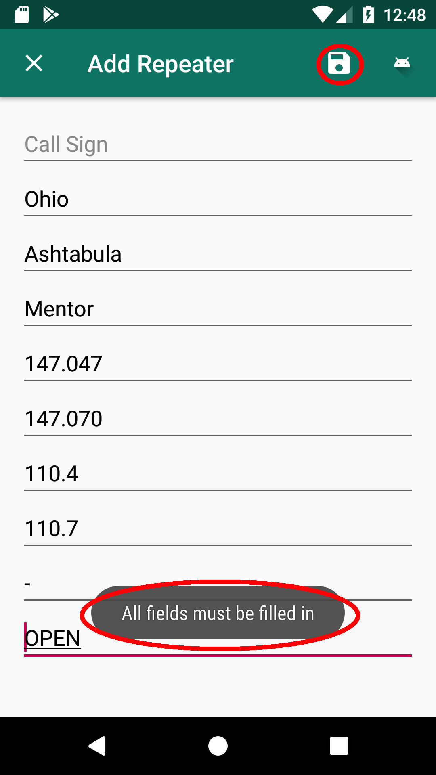

1. If the Repeater entry save is successful, you will be returned to Master and you will see a Toast indicating a successful save.

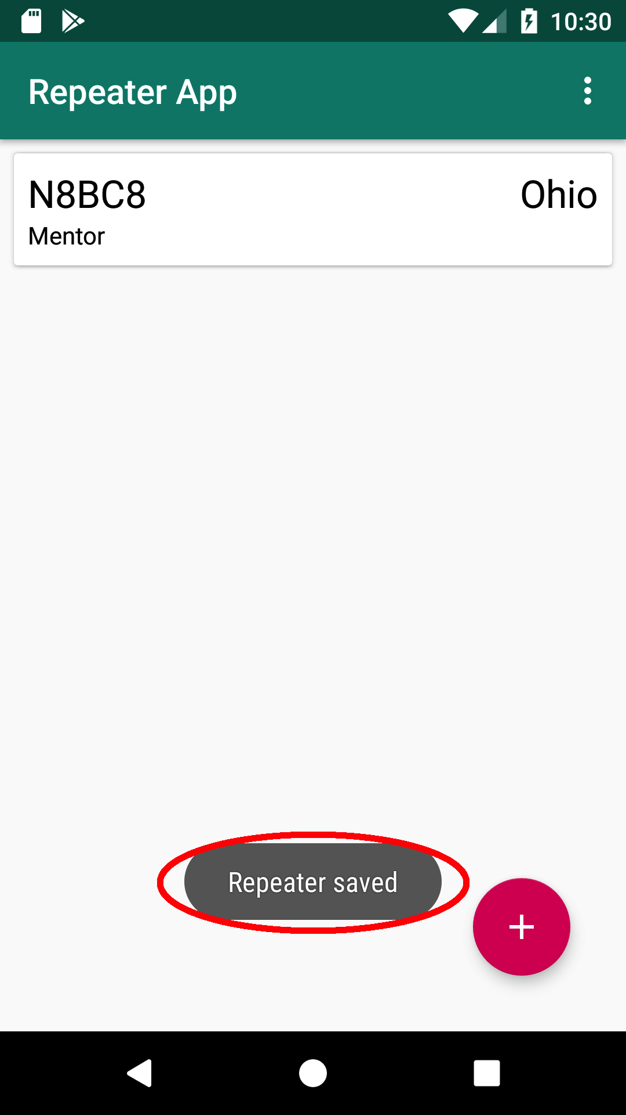

1. Repeater entries are sorted by state in alphabetical order.

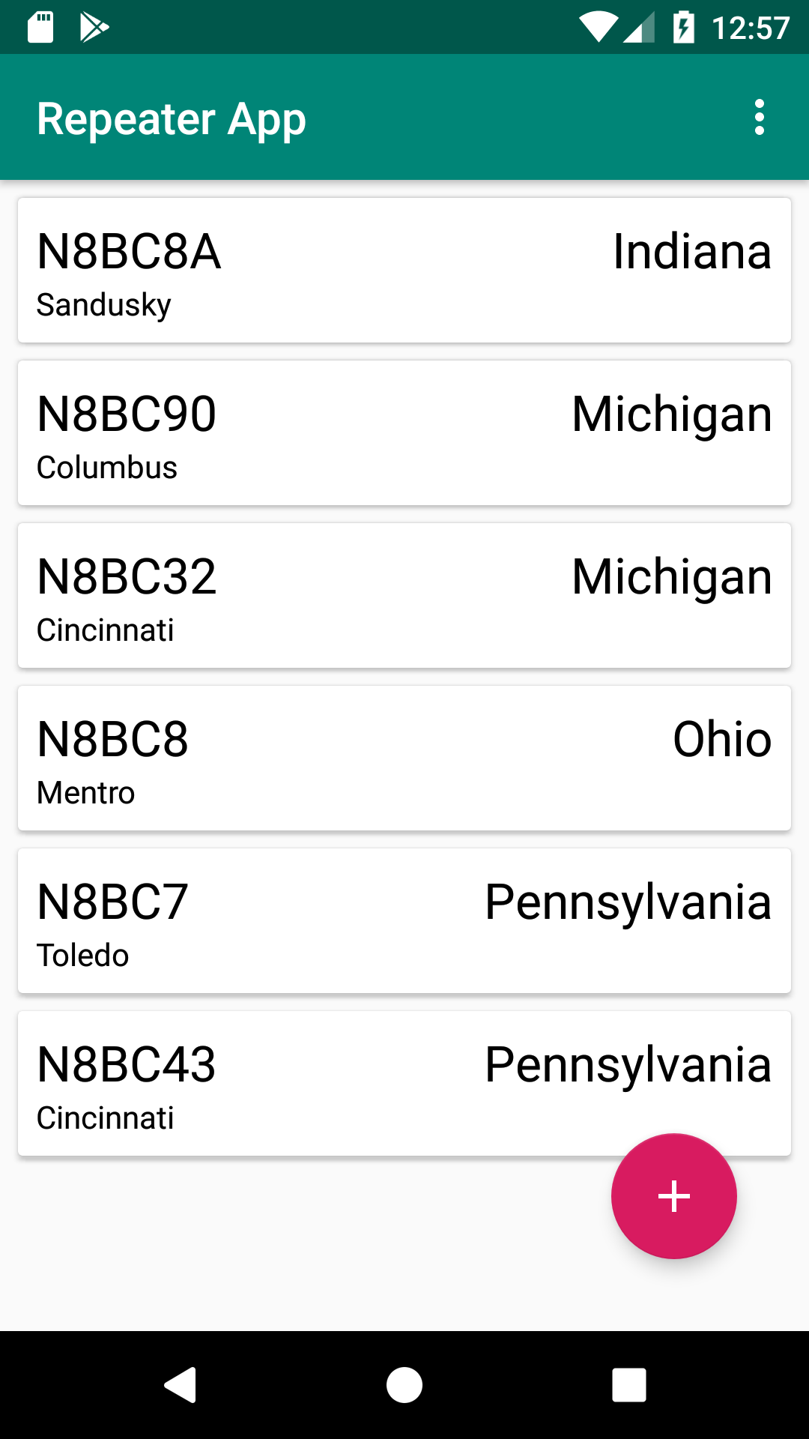

***Retrieving Repeater Parameters:***

1. Click on a repeater entry by a call sign in Master to see its parameters.

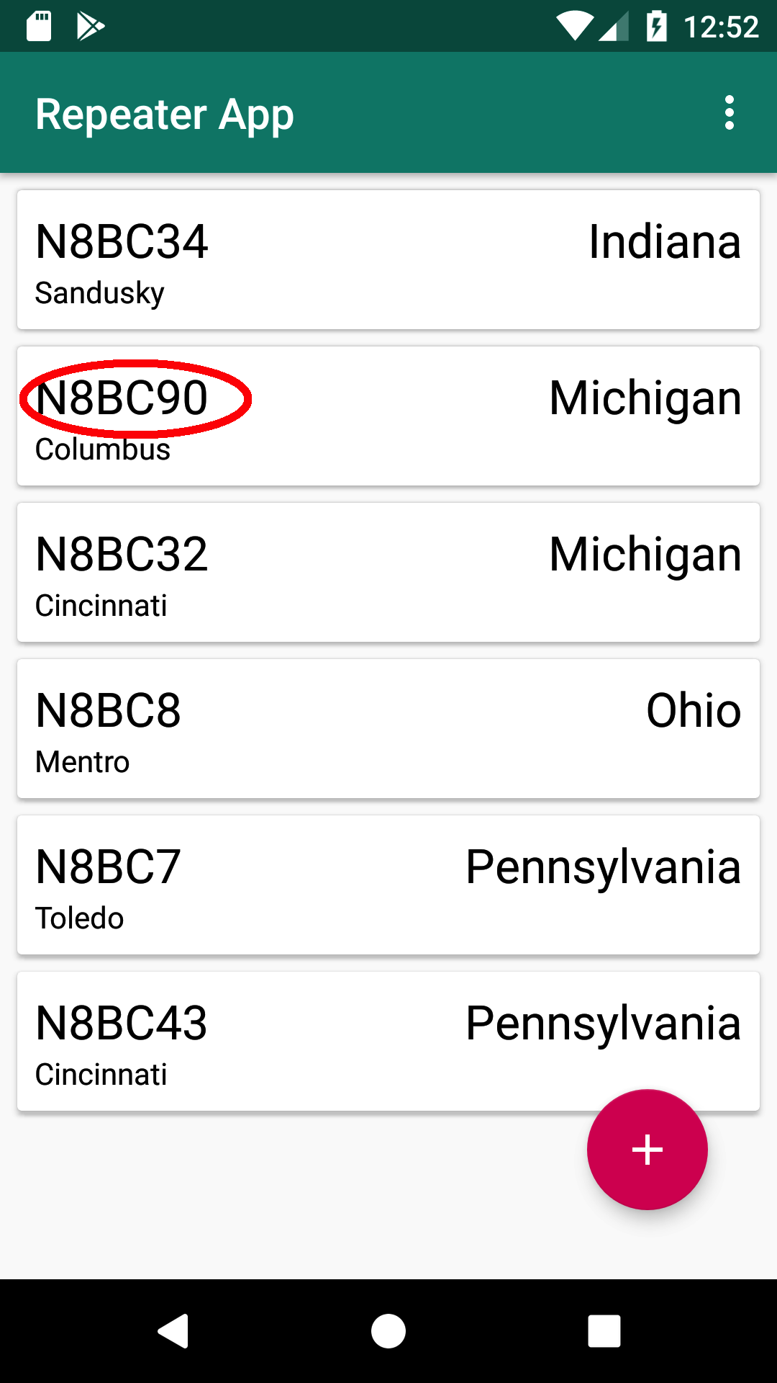

1. This will take you to the repeater Detail.

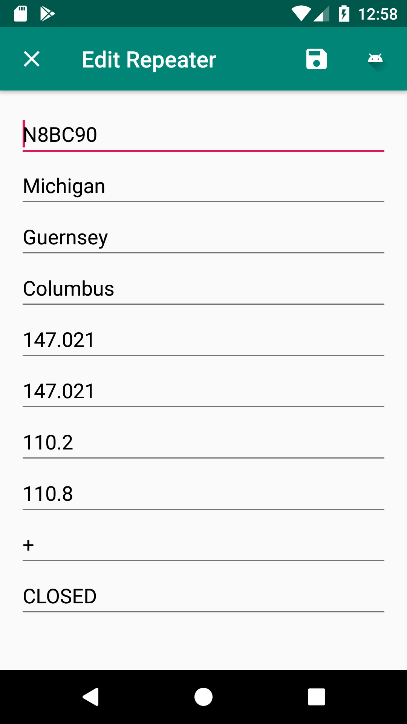

1. Click on the X in the upper left-hand corner to get back to the Master.

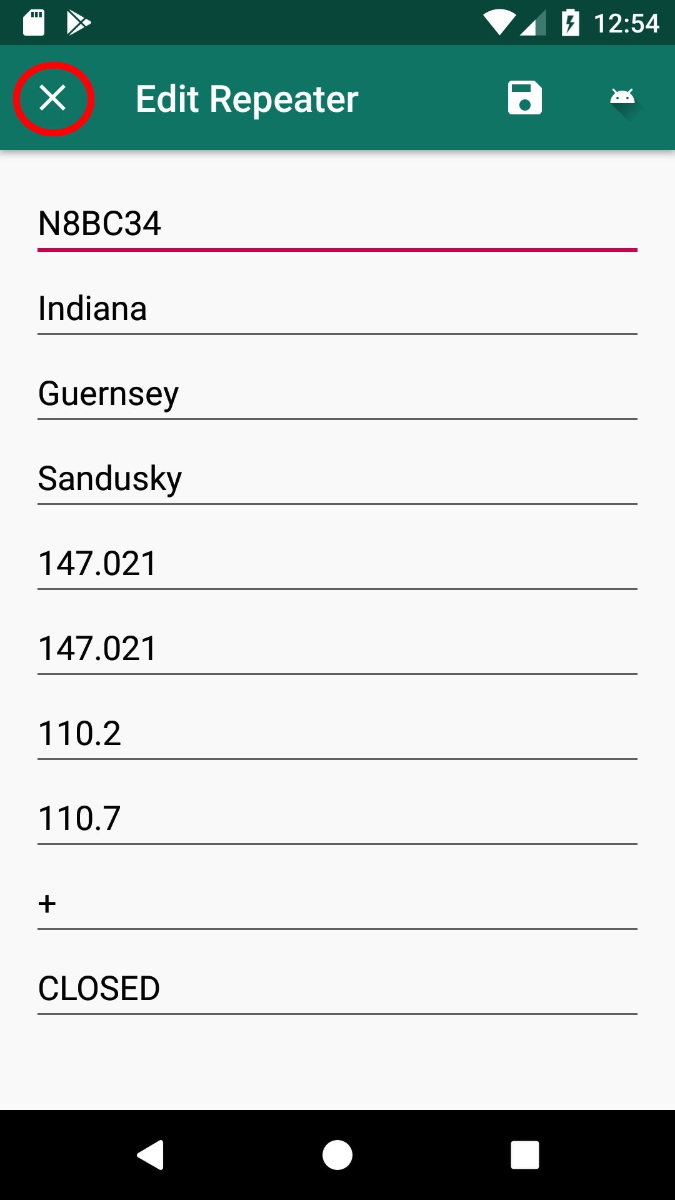

***Modifying a Repeater Entry:***

1. Click on a repeater entry by call sign in Master to Edit.

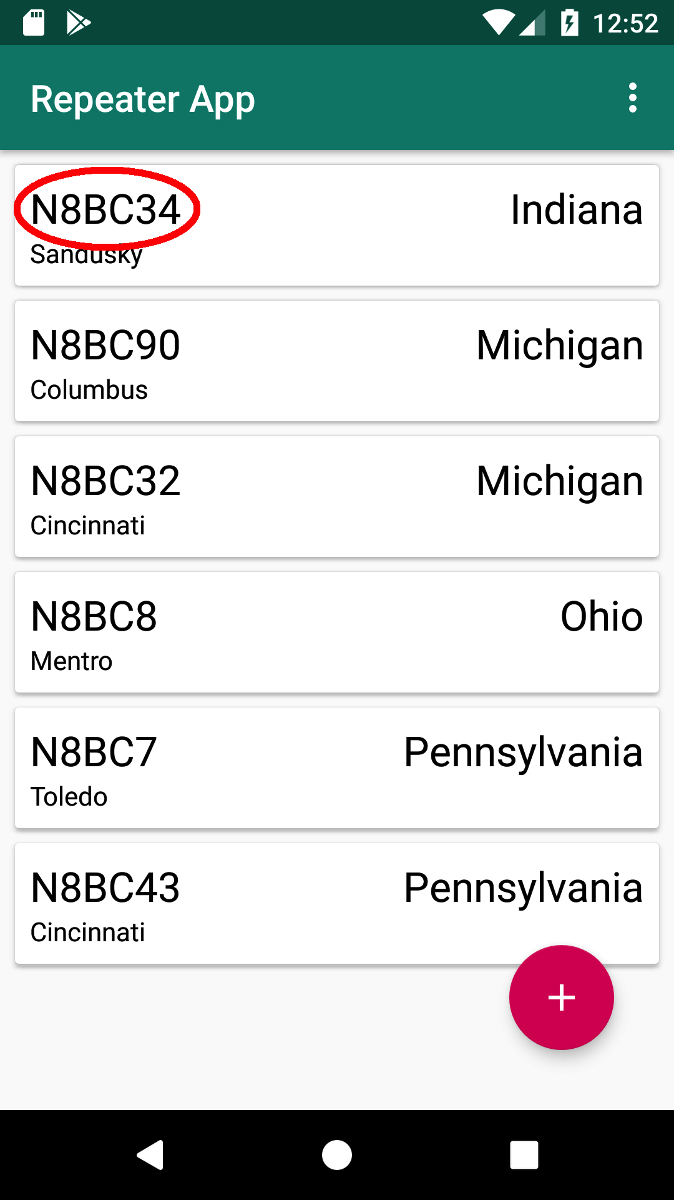

1. Make the required changes in Detail then click on the Floppy Disk icon; this will save your Repeater entry.

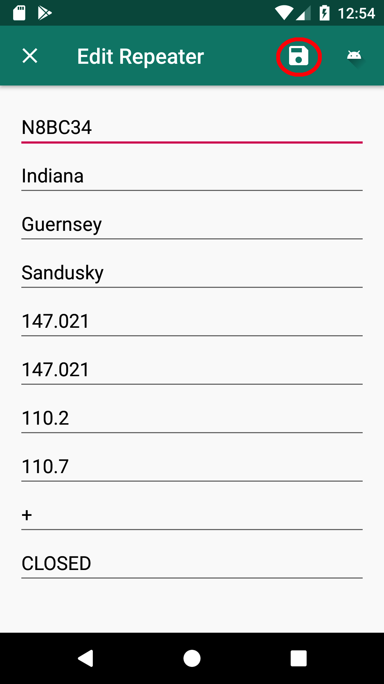

1. All Edit Text fields in Detail must be filled in; otherwise, you will receive a warning in a Toast message.

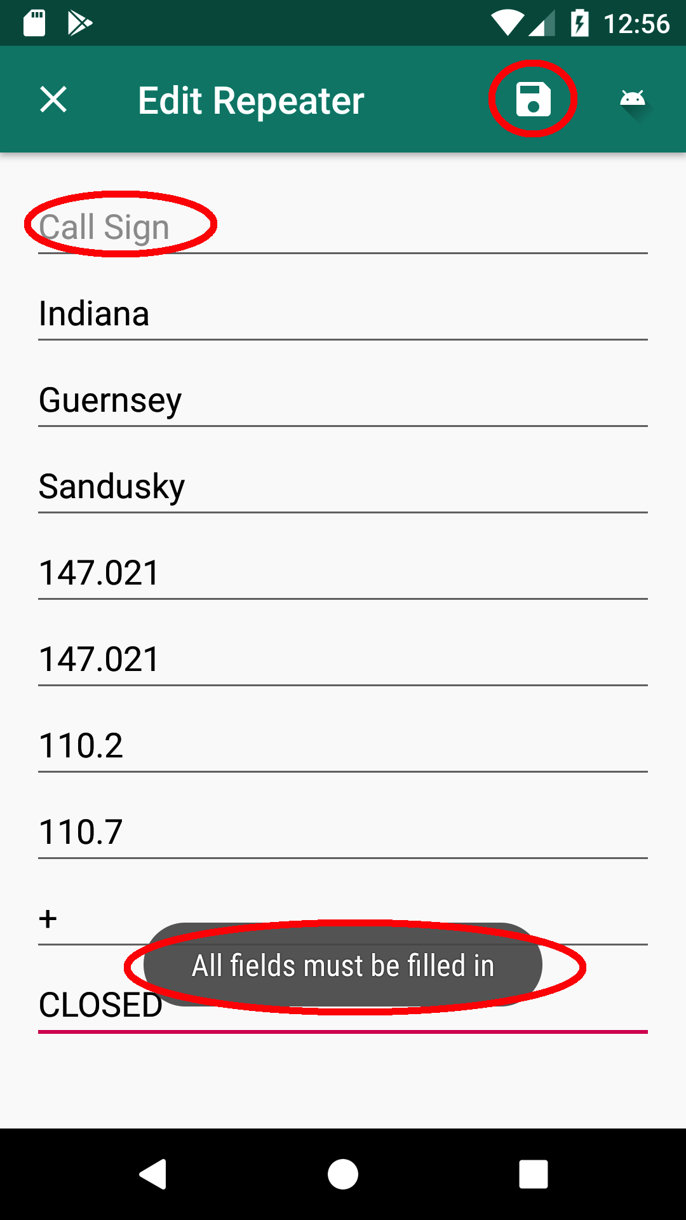

1. If the Repeater edit is successful, you will be returned to Master and you will see a Toast indicating a successful update.

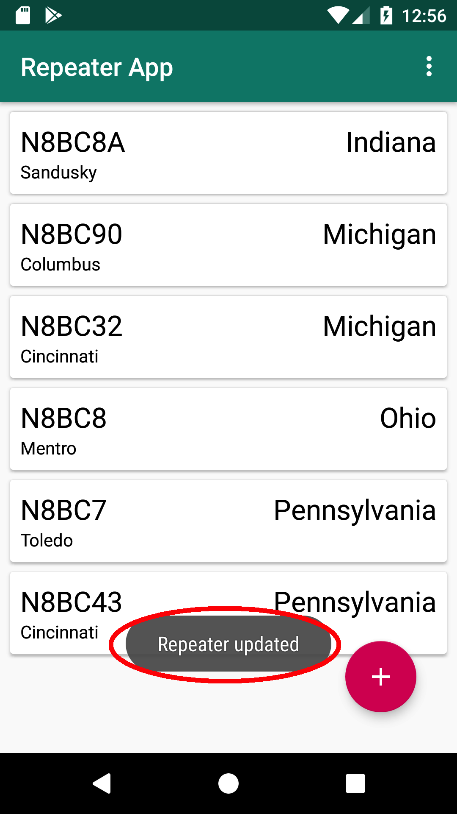

***Deleting a Repeater Entry:***

1. In Master, swipe left or swipe right on a repeater that you wish to delete.

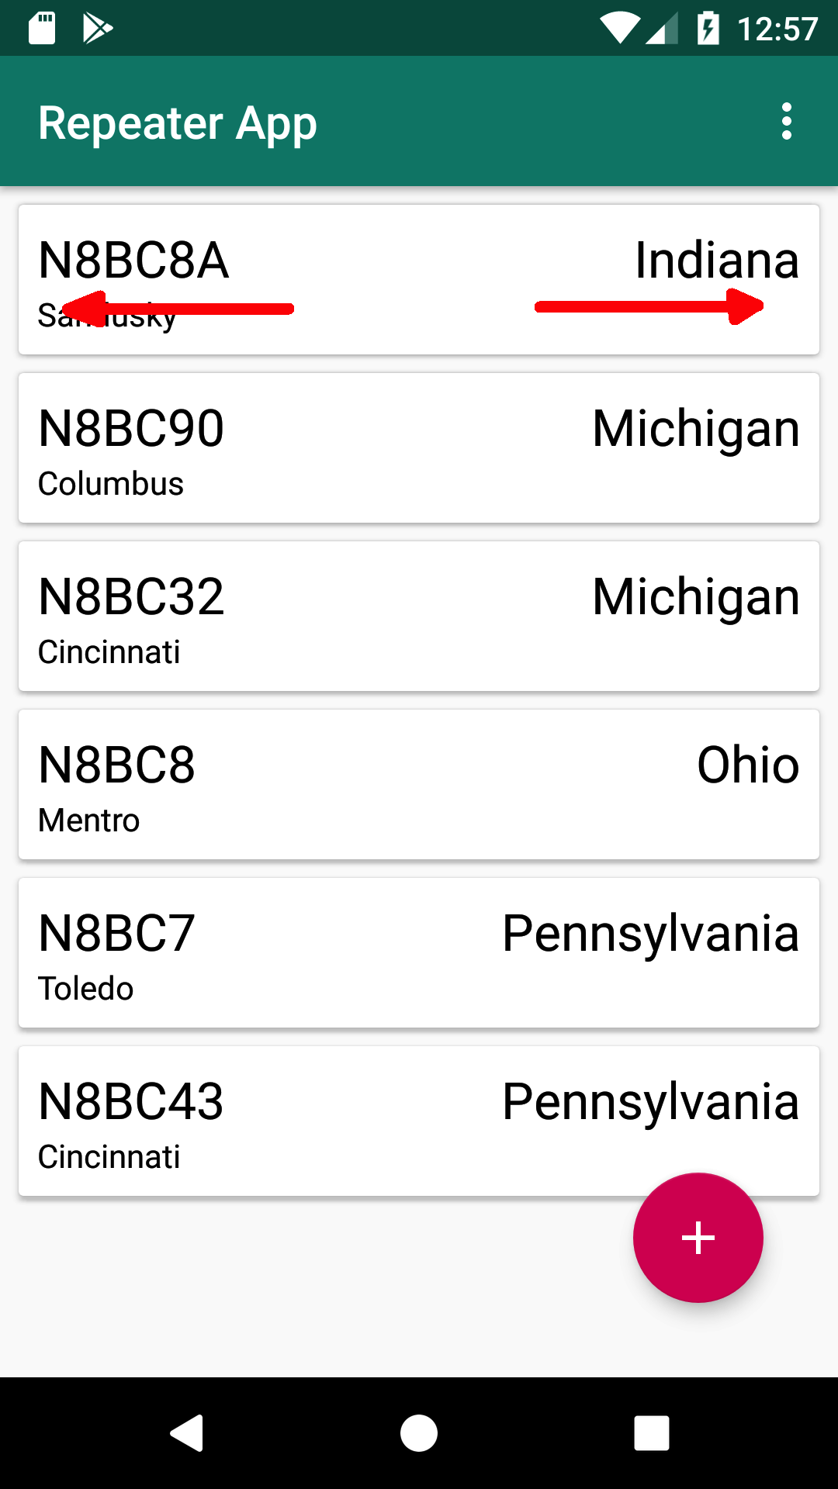

1. You will need to confirm deletion in the Alert Dialog. Click on the Delete button. Click on the Cancel button if you want to abort deletion.

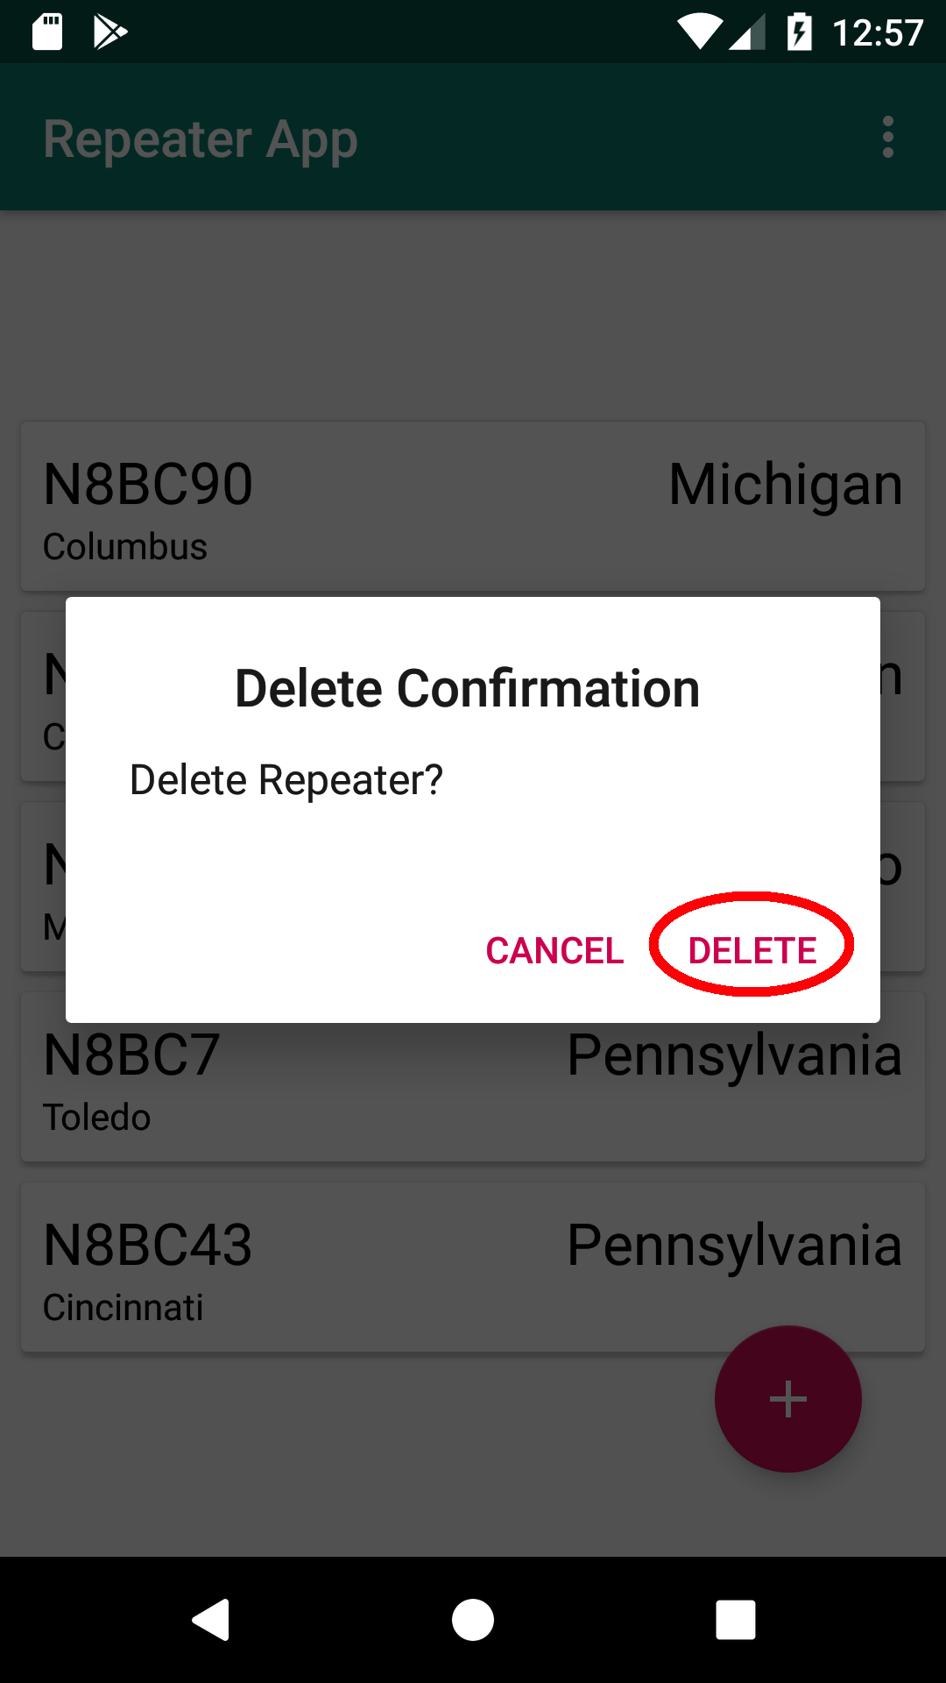

1. You will see a Toast message upon successful deletion.

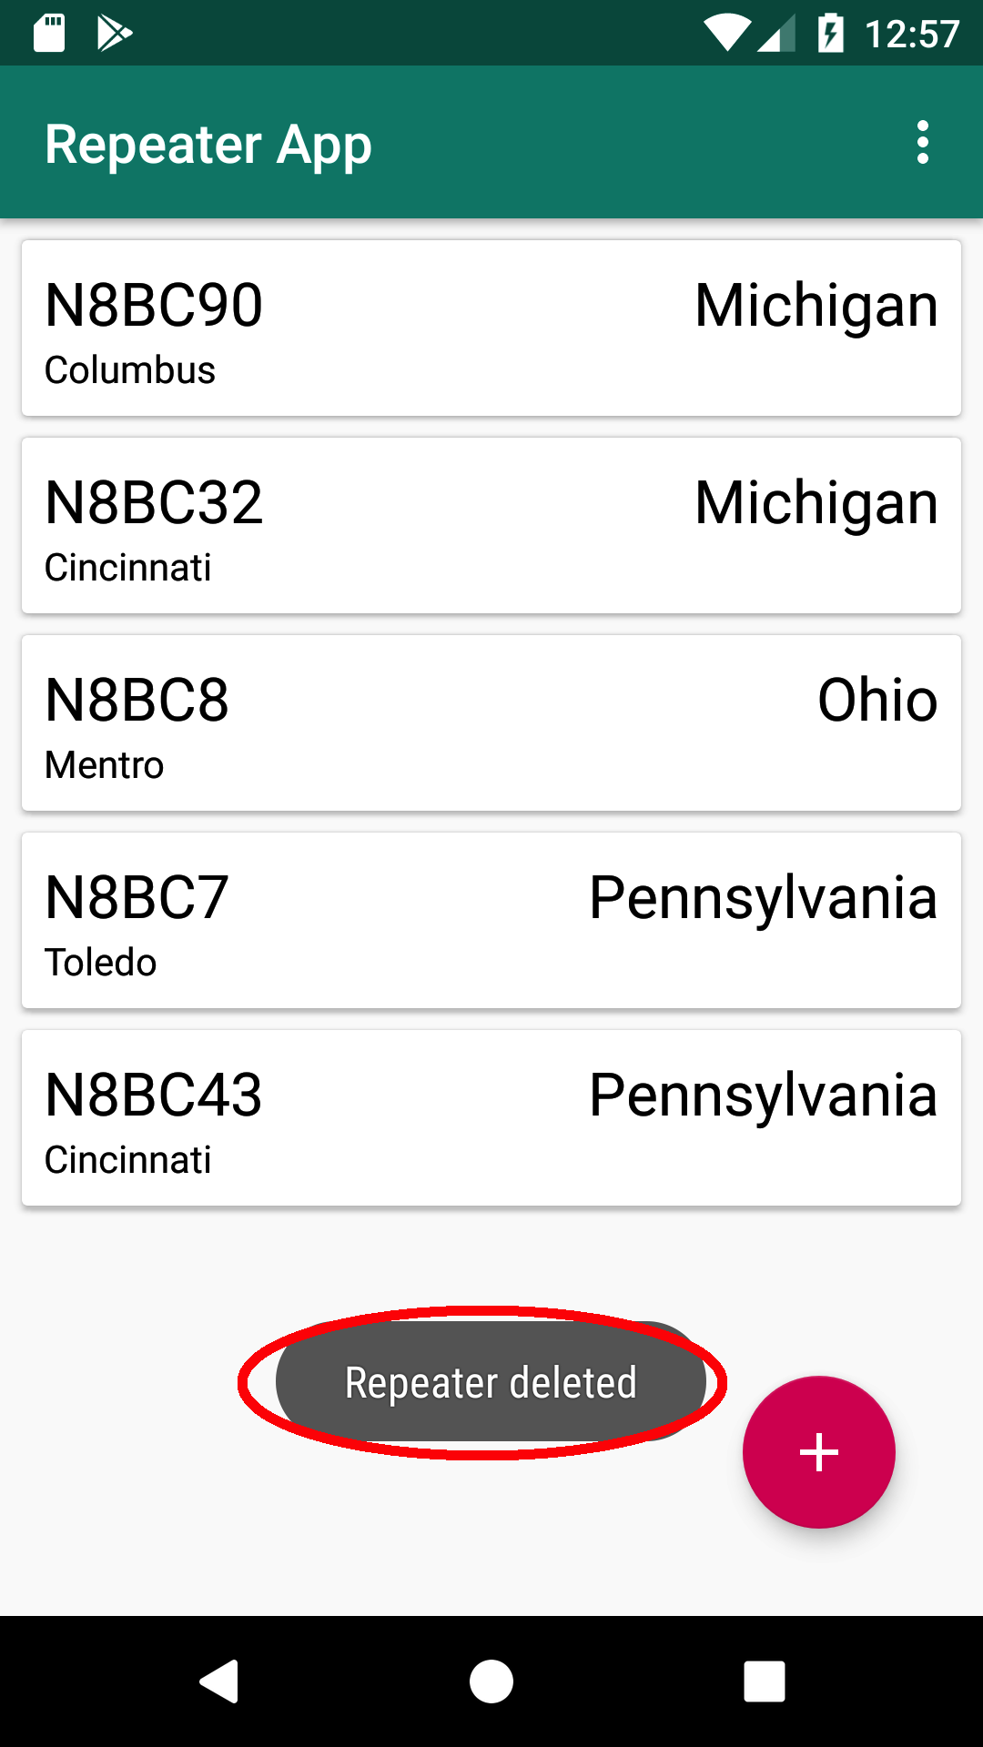

***Changing User Preferences:***

Description: The Repeater App text color of the call sign can be changed to the desired color. In addition, the text color of the other repeater parameters can be changed as well. The text color changes will be reflected in both Master and Detail. The user Preferences scene is accessed via the Detail scene**. In order to access the Detail scene, you must have at least one repeater entry.**

1. Click on a repeater entry in Master.

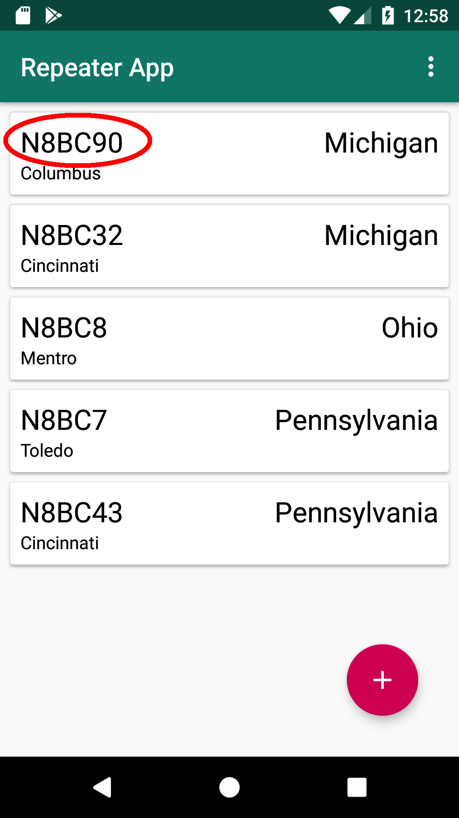

1. This will take you to Detail. Click on the button with the Android Robot icon.

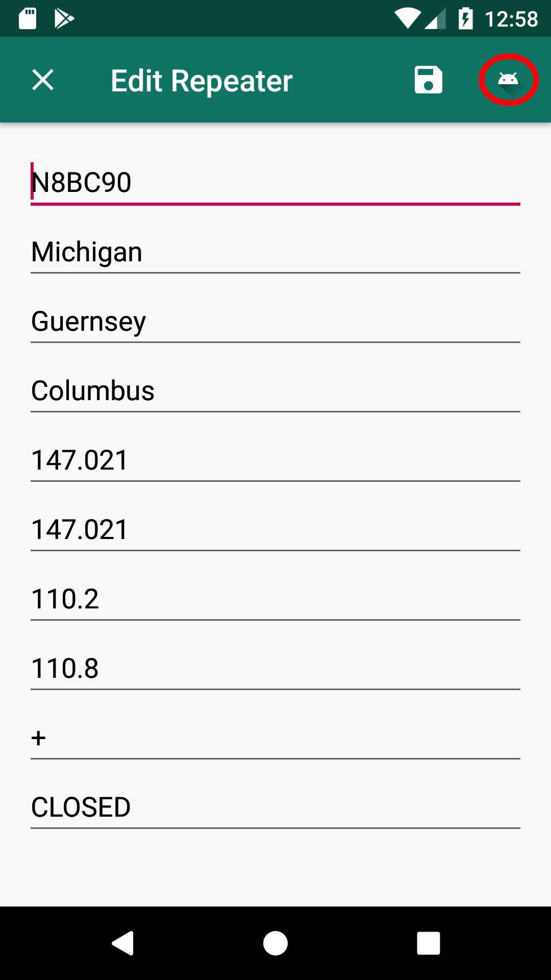

1. This will take you to Preferences.

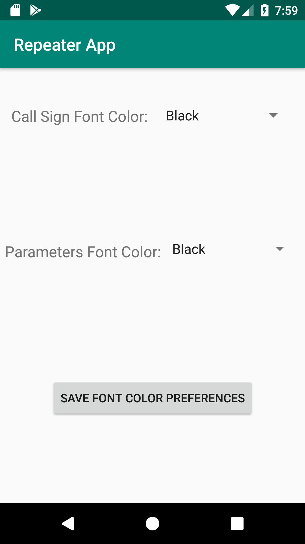

1. In the Preferences scene, use the Spinners to select the desired Call Sign and Parameter Font Colors then click on the Save Font Color Preferences button. In the example, Magenta was chosen for the Call Sign Font Color and Green as the Parameter Font Color.

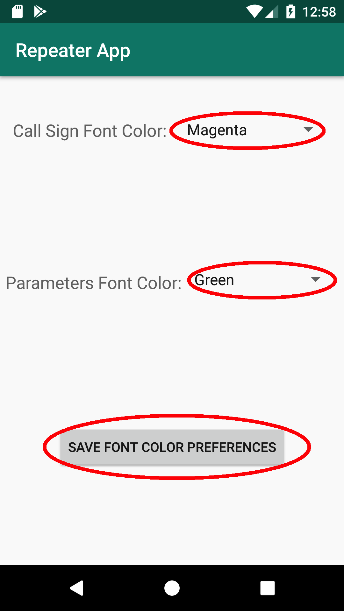

1. You will be taken back to Detail. A Toast will indicate that the Preferences were saved. Notice the changes in font color.

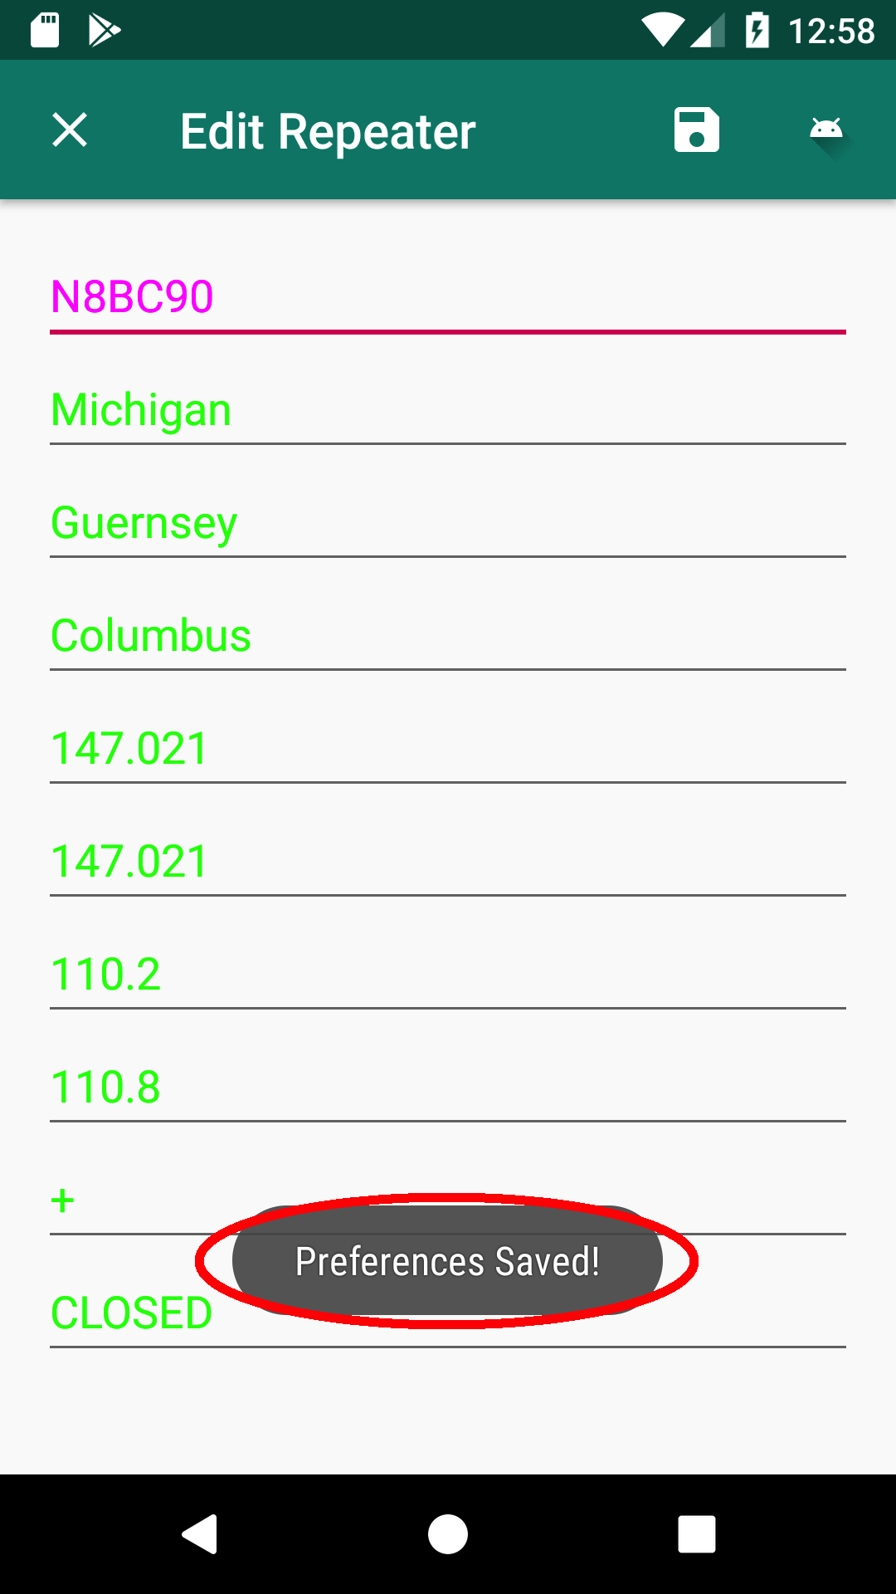

1. Click on the X button in the upper left-hand corner of Detail.

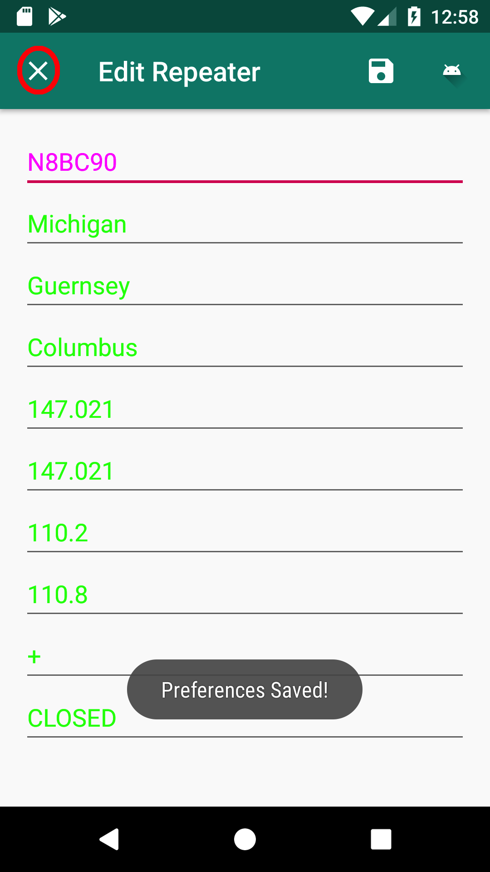

1. Notice in Master the Call Sign font color will now be Magenta, City and State parameters will have a font color of Green.

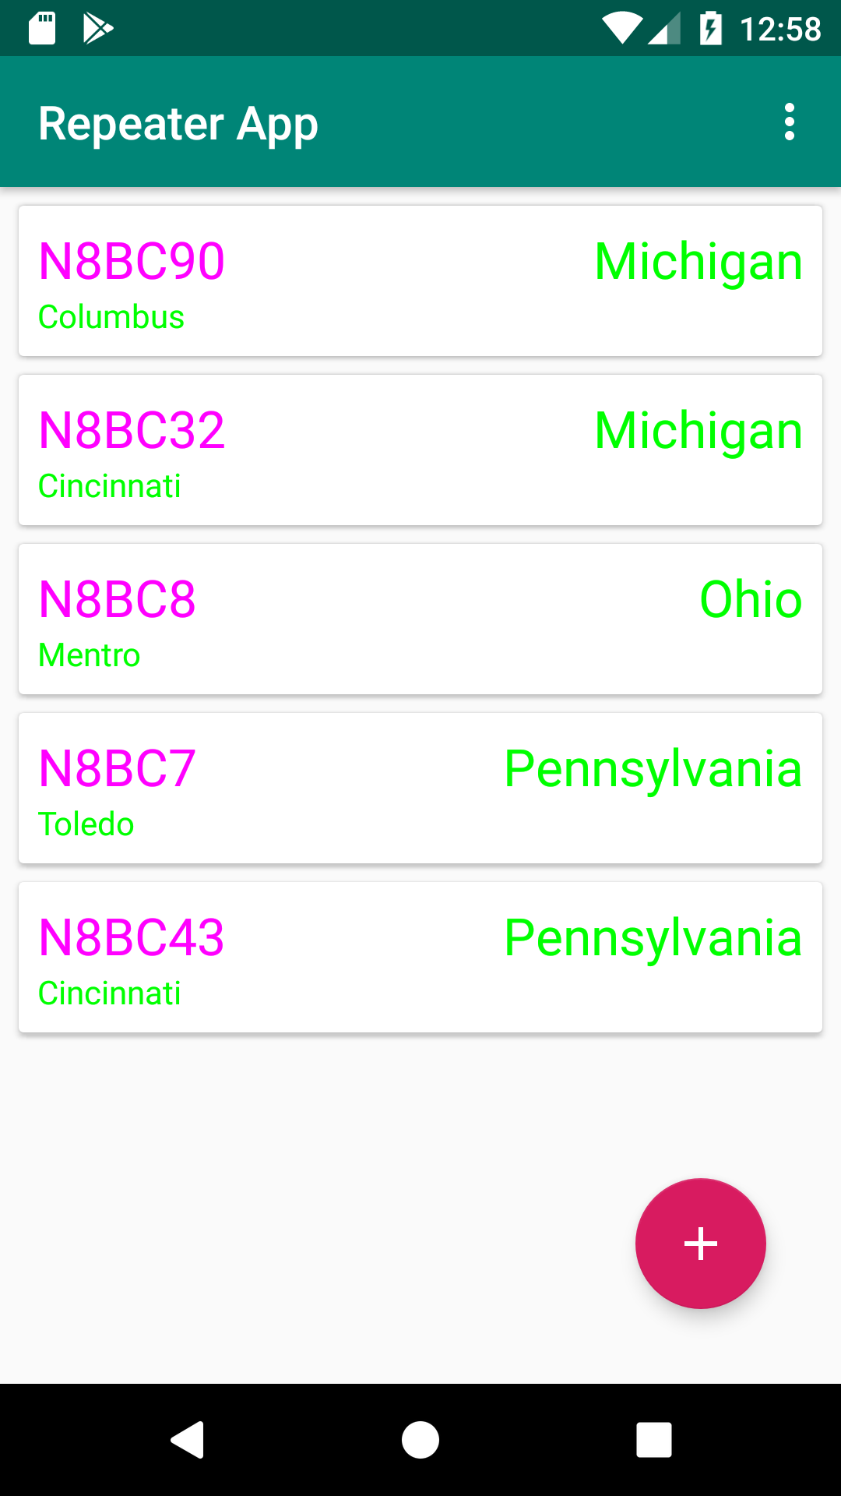

***Deleting ALL Repeater Entries:***

Description: It may be desirable to remove all repeater entries from the Repeater App.

1. In Master, click on the three dots in the upper right-hand corner.

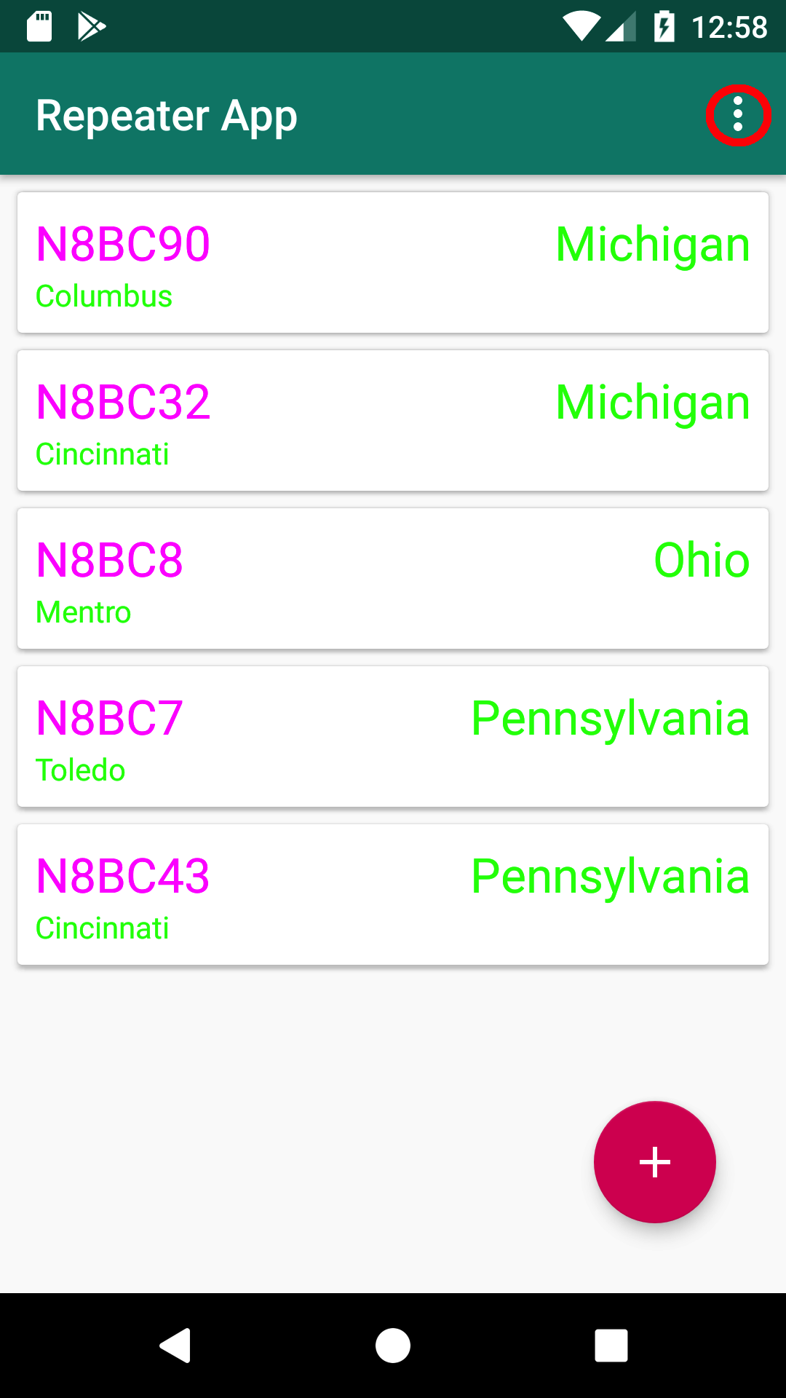

1. Click on “Delete All Repeaters”.

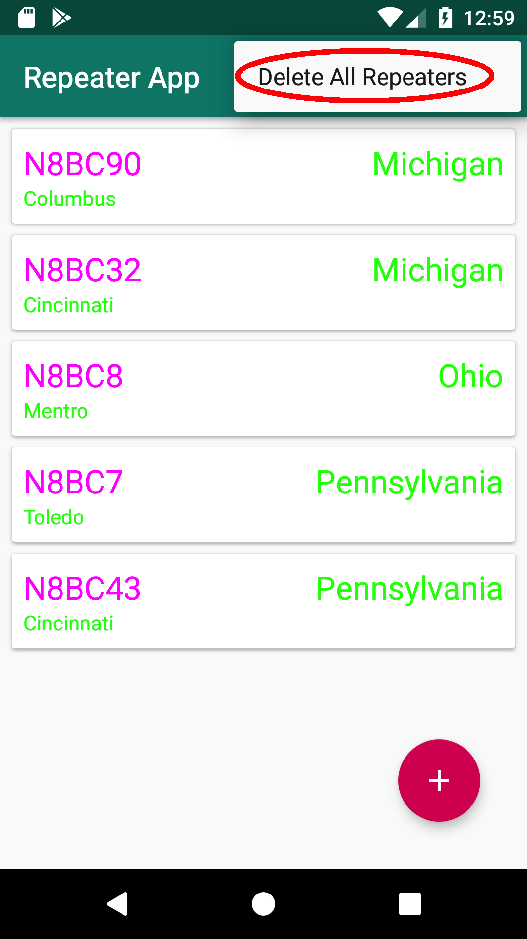

1. Click on the Delete button in the Delete Confirmation window to delete all Repeaters. Click on the Cancel button to abort deletion.

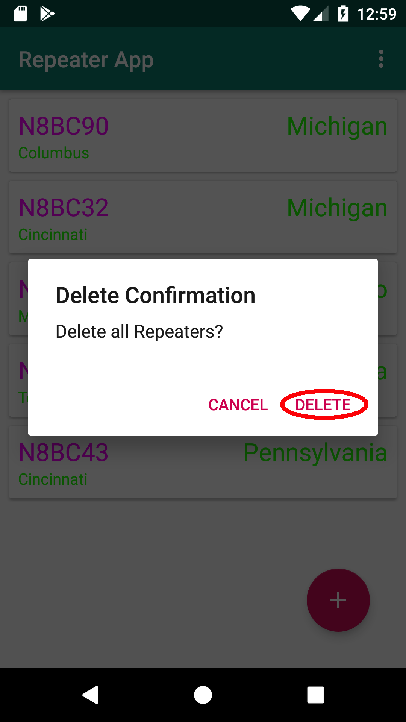

1. If successful, a Toast will confirm that all repeaters have been deleted.

