I’m going to take the example of Damien’s first species, Ceratina fimbriata Roig-Alsina, 2013
- I’ll start with a straight Google search
  - In this case, probably because it’s such a recent name, it was easier and I got a ResearchGate paper right away… but not the right one.
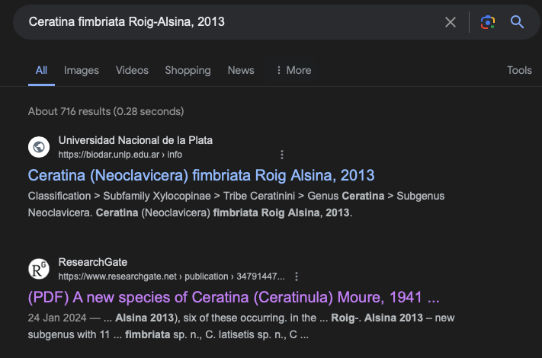
  - IT does, however, cite the right paper
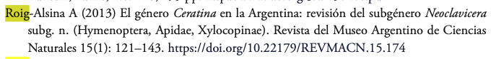
  - I can follow the doi and download the paper, search the species name and find the materials examined. In this case, it was a single holotype:
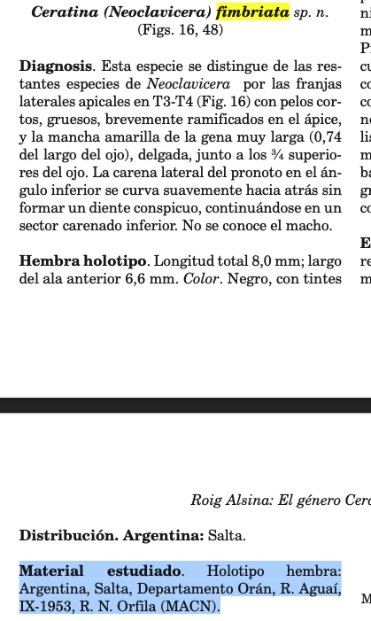
  - I’ll make sure to SAVE the papers that I find
  - I’ll also enter in the data to the spreadsheet — you can add notes, if you want, to the right.

So, maybe that was too easy, let’s do the next one, which is older. — Lasioglossum leucorhinus (Cockerell, 1926)
- I’ll start with a Google search… Nothing immediately comes up.
- I can quickly look in this OneDrive — https://uowmailedu-my.sharepoint.com/:f:/g/personal/jdorey_uow_edu_au/Ek3Yw0q89HZHk5gJLebWGbABUrmMKPlvcVdh4T8rSFF6UA?e=WCMa8n of some bee keys that I already have saved and look in the Cockerell folder… Keeping in mind that the authority is in brackets so its name was changed (I know probably from Halictus)
  - I so far have one paper from 1926… I’ll start with a text search, but double check manually (not all are text-searchable or correct). I might also remove the gender ending “us” in case the gender has changed… no luck! It’s not there.
  - I had a quick Scopus search (without authority), no luck
  - I’ll have a quick search on Discover Life, no luck. Remove the gender… for some reason that has changed so it’s actually Lasioglossum leucorhinum (Cockerell, 1926) (but don’t change the species name in the list, I’ll match it back no problem). Sometimes there’s a map, but here it says the species is from Australia…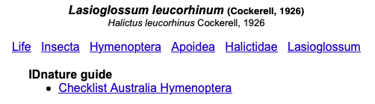
  - I happen to know that this year, Ken Walker revised the Australian Lasioglossum (Parasphecodes), so that’s a good place to start looking — I have that paper under the Halictidae folder.
  - It’s a new synonym of Lasioglossum (Parasphecodes) hilactus 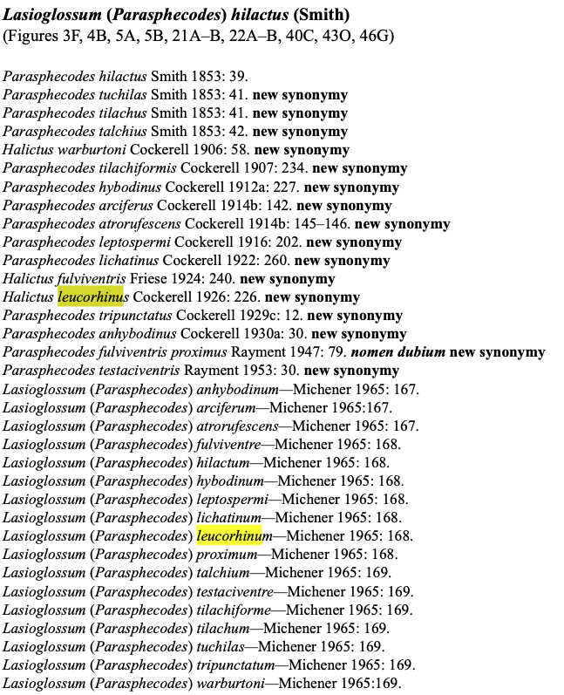
  - 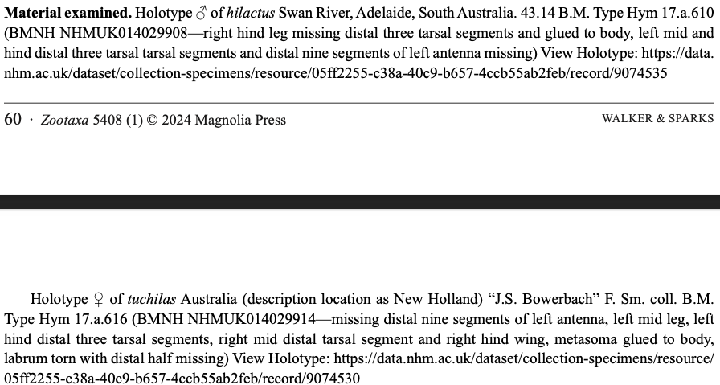
…
…
  - 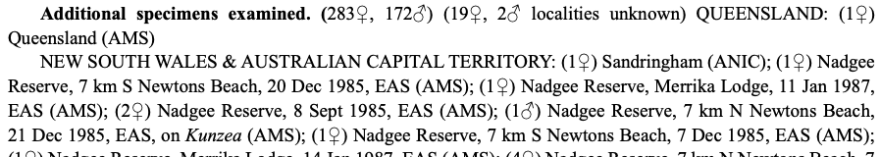
…
…
  - There are 17 synonomised holotypes… plus Ken examined 283 females and 172 males (Ken is very thorough and very kind to summarise the text for us! N = 472! Very few taxonomists will be so kind (sadly he didn’t have all of this in a .csv format already though).
  - LETS IMAGINE that I didn’t know this and could not find this paper or it hadn’t come out yet…
  - The next place I’d search is the Biodiversity Heritage Library for the original description (Well, maybe I’d go back and make sure that changing the species name hadn’t lost me papers), but let’s say I already did that…
  - I’ll go to https://www.biodiversitylibrary.org and search “Theodore Cockerell” I might do the advanced search and enter the year. Or you can search the author and select a range-date on the LHS column…
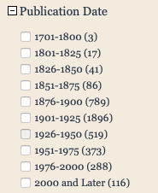
  - Here’s the advanced search: https://www.biodiversitylibrary.org/search?SearchTerm=&tinc=A&lname=Cockerell%2c+Theodore+D.+A.&yr=1926&subj=&lang=&col=&nt=&ntinc=A&txt=&txinc=A&SearchCat=T&stype=C&return=ADV#/titles
  - There’s one bee paper, but it’s not there…
  - I’d then go back to a broad Google search and see if I can find the title of the paper, but honeslty I’m having trouble with this one… However, being an Australian bee, we can look on the Australian Faunal Directory and wouldn’t ya, know there it is!
https://biodiversity.org.au/afd/taxa/Lasioglossum_%28Parasphecodes%29_leucorhinum, probably thanks to Ken Walker — Halictus leucorhinus Cockerell, T.D.A. 1926. Descriptions and records of bees. CXII. Annals and Magazine of Natural History 9 18: 216-227 [Date published 31/12/1926] [226].
  - First link on google is blocked, but it’s on SciHub! Not that I’d ever look there of course. 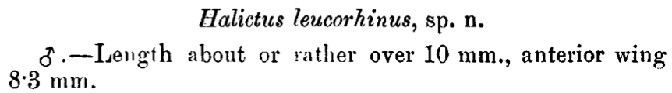
It was described from one male. No wonder it was synonymised.
  - Anyway, we know better now, so I’d have entered in the other data that we found earlier
  - Sometimes you need SciHub for papers like those in Zootaxa, btw. But if they are to orecent they may not be up yet.
Damien, here are those data for you to enter
 | scientificName | n | doiORurl | publicationYear
1 | Ceratina fimbriata Roig-Alsina, 2013 | 1 | https://doi.org/10.22179/REVMACN.15.174 | 2013
2 | Lasioglossum leucorhinus (Cockerell, 1926) | 472 | https://doi.org/10.11646/zootaxa.5408.1.1 | 2024

