N-rate Timing

first draft

Jesse Puka-Beals

3/23/23

# Key points

* We applied N at different rates and timings to IWG stands over 10 site-years and collected yield, plant height and lodging data.
* We observed serious lodging in only 1 site-year, and observed lower lodging when N was applied at lower rates and further away from harvest (i.e. fall vs. spring or summer). Lodging was negatively correlated with plant height ()
* For both cumulative and yearly yield response to nitrogen rate, a quadratic relationship fit the data best, suggesting there may be an optimal N rate.
* Combined across all site-years, yields were higher when N was applied in the fall versus in the spring or when split with a summer application.
* Of sites where we tracked yield over three years, we failed to reject the Ho that cumulative yields differed among stands that received different N rates and timings.
* The relationship between N rate and timing is complex to measure in field experiments. Site conditions can greatly change the amount of N that becomes available to the plant, especially when applied as urea on the soil surface. More field trials are required to capture the variability of yield response to N rate and timing.
* The optimal fertility program is likely site specific and possibly year specific.
  + Some sites like Staples responded strongly to N, where other sites showed no response (NDSU, R100).
  + In the second year, fertilizing in the fall was better than fertilizing in the spring, but there was no consistent effect in the first or third year.

# Methods

Our dataset is unbalanced because design was not consistent across sites. First we try to see a consistent response across site-years, then we may analyze each site seperately.

We have 10 site-years, more than enough to be a random effect

| location | year | n |
| --- | --- | --- |
| NDSU | 2020 | 16 |
| NDSU | 2021 | 16 |
| R100 | 2018 | 54 |
| R100 | 2019 | 54 |
| Staples | 2018 | 54 |
| Staples | 2019 | 54 |
| Staples | 2020 | 54 |
| V17 | 2019 | 16 |
| V17 | 2020 | 16 |
| V17 | 2021 | 16 |

### Text - all sites

Table for site conditions, weather by month

Table for GPS points, soil type, row spacing, planting date and rate

Table for

#### Staples

#### V17

#### R100

#### NDSU

### Statistical analysis

Data was analyzed in R and we intend to provide the code used (R Core Team 2022).

Response variables were inspected for outliers using boxplots and no values were removed for being unreasonable.

Where linear models were fit, response variables were normally distributed.

We fit linear models and linear mixed effect models to subsets of data based on the hypothesis being tested (Bates et al. 2015).

If a model was comparing the relationship between two continuous variables, we first fit models to determine which function best fit the relationship. We would rely on the locally estimated regression to inform which linear regression candidates and the best fits were simply and (Wickham et al. 2019). Models were ultimately selected based on AIC.

A global model for a data subset of fewer than 4 locations in Bates et al. (2015) syntax where * specifies a full factorial combination and (1|block) specifies a separate y-intercept for each block. We are modeling nRate as a first order polynomial for simplicity, but often the model was improved when nRate was a second order polynomial.

A global model for the dataset spanning 4 years and 4 locations in lme4 syntax (Bates et al. 2015). The (1|location/year/block) specifies the nesting random effects where block is within year and within location. We are modeling nRate as a first order polynomial for simplicity, but often the model was improved when nRate was a second order polynomial.

We would first fit global models which would contain a full factorial combination of all fixed effects. This model would often be overfit and require the removal of parameters. If the fit was singular, we would remove random effects that explained zero variance, sometimes shifting to a simple linear model. If the model was rank deficient, we would test whether we could reject the Ho that the coefficient of a given parameter was zero using ‘Anova’ (Fox and Weisberg 2019). If we failed to reject the Ho, we would remove those parameters from the model and rerun the model.

After non-significant parameters were removed from the global models, coefficients were tested again using ‘Anova’ (Fox and Weisberg 2019). Estimated marginal means were calculated across groups where there was no interaction (Lenth 2022). We calculated 95% confidence intervals and assigned groups to different levels of the fixed effect using an alpha of 0.05 and a tukey adjustment (Hothorn, Bretz, and Westfall 2008).

# Lodging

Understanding lodging is not a primary objective of this experiment, this data was only collected as a covariate if there happened to be a lot of lodging.

In general, if lodging is above 6, the yield data is questionable.

Only R100 and V17 showed lodging, and only R100 had severe lodging to the point where the yield data probably is not very accurate.

## R100

R100 only had N applied in the second and third year.

Lodging only occurred in the stands third year of production.

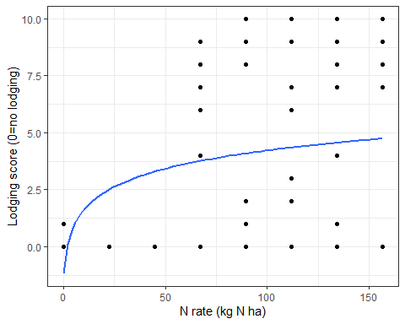

We observe a general increase in lodging as nitrogen rate increases. We fit a logistic curve since lodging cannot be greater than 10 and we expect as we increase N rate more lodging will get closer to 10. This curve is obviously not perfect.

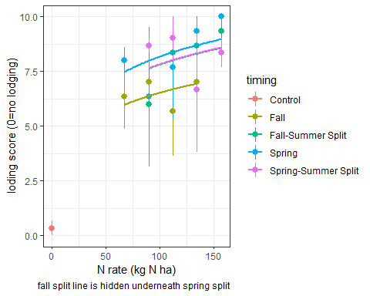

Here we are fitting a logistic regression with a y intercept of zero because we assume at 0N there is no lodging (as shown with control plots) and that lodging score will increase as nitrogen rate increases but that lodging will never exceed 10. The takeaway from this figure is that there is no lodging at 0N and that you see less lodging when you apply in fall and more when you apply in spring and summer.

### Analysis

Analysis of Variance Table  
  
Response: lodging  
 Df Sum Sq Mean Sq F value Pr(>F)   
log(n.total + 1) 1 3109.08 3109.08 428.8900 <2e-16 ***  
timing 5 19.87 3.97 0.5481 0.7388   
log(n.total + 1):timing 3 18.84 6.28 0.8664 0.4655   
Residuals 45 326.21 7.25   
---  
Signif. codes: 0 '***' 0.001 '**' 0.01 '*' 0.05 '.' 0.1 ' ' 1

We reject Ho that the rate of nitrogen does not impact lodging.

We fail to reject Ho that timing has an impact on lodging.

# Plant height

Plant height is also not a measurement of primary interest.

To what extent does plant height relate to lodging in R100?

## R100 year 3

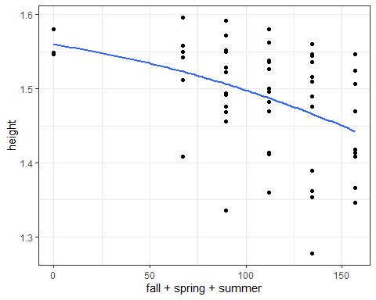

We observe an overall trend of decreasing plant height as N rate increases, modeled best quadratically.

Analysis of Variance Table  
  
Response: height  
 Df Sum Sq Mean Sq F value Pr(>F)   
poly(n.total, 2) 2 0.050934 0.0254669 5.4217 0.007609 **  
timing 4 0.035753 0.0089383 1.9029 0.125627   
Residuals 47 0.220770 0.0046972   
---  
Signif. codes: 0 '***' 0.001 '**' 0.01 '*' 0.05 '.' 0.1 ' ' 1

We reject Ho that nrate does not impact height

We fail to reject Ho that timing has no effect on plant height

We have learned from R100 in it’s third stand age that as nrate increases, there is an increase in lodging and a decrease in plant height. To what extent are they correlated?

lodging height  
lodging 1.0000000 -0.4993655  
height -0.4993655 1.0000000

We observe a pearson correlation coefficient of -0.5 between height and lodging. This is considered between a moderate and strong correlation.

# Yield

## Cumulative

Cumulative yield of kernza stands after 3 years of N fertilizer. We are subsetting dataset, Only V17 and Staples meet this criteria (6 site years). We sum across stand.age to create a cumulative yield and a cumulative amount of N applied, then divide both values by 3 to get a yearly yield~N response.

### Quadratic linear model, yield response to N

[1] 1020.782

[1] 1000.713

Analysis of Variance Table  
  
Response: yield.cum  
 Df Sum Sq Mean Sq F value Pr(>F)   
poly(cumn, 2) 2 2696949 1348475 12.438 2.607e-05 ***  
Residuals 66 7155387 108415   
---  
Signif. codes: 0 '***' 0.001 '**' 0.01 '*' 0.05 '.' 0.1 ' ' 1

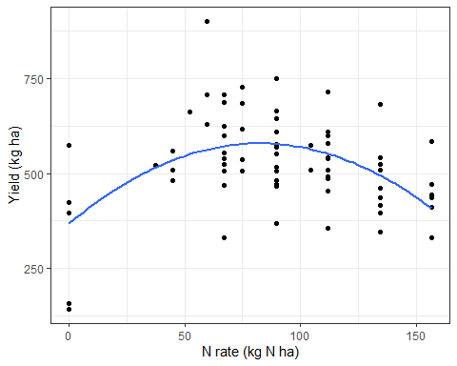

We reject the Ho that N rate does not impact yield

Quadratic model provides the best fit

Analysis of Variance Table  
  
Response: yield.cum  
 Df Sum Sq Mean Sq F value Pr(>F)   
poly(cumn, 2) 2 2011131 1005565 12.0239 0.0001701 ***  
location 1 2181936 2181936 26.0901 2.065e-05 ***  
timing 2 284394 142197 1.7003 0.2009473   
poly(cumn, 2):location 2 114253 57126 0.6831 0.5132778   
poly(cumn, 2):timing 3 186149 62050 0.7419 0.5360498   
location:timing 2 71804 35902 0.4293 0.6551831   
Residuals 28 2341662 83631   
---  
Signif. codes: 0 '***' 0.001 '**' 0.01 '*' 0.05 '.' 0.1 ' ' 1

We reject Ho that N rate and location do not impact yield

We fail to reject the Ho that timing does not impact yield

### Quadratic linear mixed effect model

Here we have our fixed effect of cumulative N, timing and a random effect of block. Since we only have two sites, location is treated as a fixed effect.

Analysis of Deviance Table (Type II Wald chisquare tests)  
  
Response: yield.cum  
 Chisq Df Pr(>Chisq)   
poly(cumn, 2) 0.5868 2 0.7457   
timing 4.0312 2 0.1332   
location 27.2054 1 1.829e-07 ***  
poly(cumn, 2):timing 2.8742 3 0.4114   
poly(cumn, 2):location 1.1353 2 0.5669   
timing:location 0.8907 2 0.6406   
poly(cumn, 2):timing:location 0   
---  
Signif. codes: 0 '***' 0.001 '**' 0.01 '*' 0.05 '.' 0.1 ' ' 1

We fail to reject Ho that yield does not differ N rate or timing

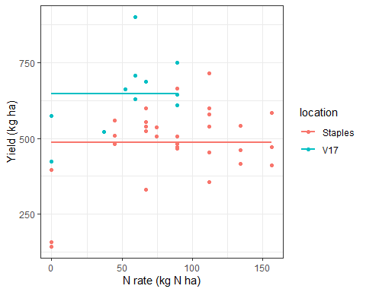

TAKEAWAY: We applied N at differing rates and timings over 3 years at two locations. We cannot reject the Ho that the amount of N and the timing of N do not impact the cumulative yield over the 3 years when modelled as a fixed effect model. Personally, I would say our data suggests at around 60 kg N ha per year results in best grain yields and then adding more N has no effect. When modeled as a simple quadratic linear model, we can make this conclusion, but when modelled as a mixed effect model we cannot.

## Yearly performance

We are using all site years except third stand age of R100 due to high lodging.

How does N timing and N amount correlate with yield in a given year?

### Full model, site-years as random

We reject Ho that stand.age, timing and nitrogen rate do not impact yield

Here we have subsetted data so we have removed instances where a timing was Fall but no fall N was applied. We only start doing this here because this is the first time we are looking at timing across years at each year.

#### Nitrogen rate on yield

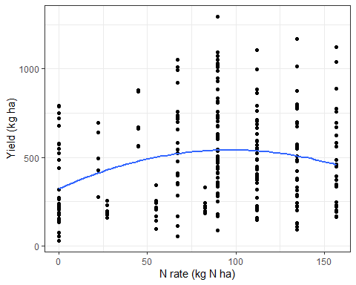

We previously learned the relationship between N rate and yield is best modelled quadratically and then we rejected Ho that nitrogen rate does not impact yield. Here we are visualizing the subsetted data used in the model.

#### Timing on yield

Estimated marginal means across N rate timings from a mixed effect model of yield as a function of nitrogen rate, timing and stand.age across 9 site-years. No interactions were detected among nitrogen rate, timing and stand age, but main effects were detected from timing

| timing | emmean | CI | n |
| --- | --- | --- | --- |
| Fall | 610 a | 246-975 | 32 |
| Control | 570 ab | 229-912 | 32 |
| Fall-Spring Split | 507 ab | 156-858 | 12 |
| Fall-Summer Split | 505 b | 141-870 | 48 |
| Spring | 456 b | 83-828 | 96 |
| Spring-Summer Split | 420 b | 54-785 | 48 |

We reject the Ho that yields were the same regardless of timing. Applying in the fall was estimated to have a higher grain yield than when split in the spring, summer or applied alone in the spring.

Since the dataset is unbalanced, we reported estimated marginal means, 95% confidence intervals and the number of data points within each timing used in the model.

### Full model, location as fixed effect

We have 4 locations and there is a rationale to model them as fixed effects. This puts a lot of stress on our model by cutting it up by n rate, timing, stand age and location. We end up making a lot of meaningless comparisons and need to reduce the comparisons we make in order to prevent a rank deficient model.

We ran a full factorial model, then would remove interaction terms that were insignificant and rerun the model.

we removed R100 from the dataset (site years = 8) because it only had one stand age after we removed third stand age for lodging and when stand.age is modelled as a fixed effect the R100 data doesn’t provide any utility to testing those hypotheses

Analysis of Deviance Table (Type II Wald chisquare tests)  
  
Response: yield  
 Chisq Df Pr(>Chisq)   
poly(n.total, 2) 10.7538 2 0.004622 **   
timing 36.3076 5 8.243e-07 ***  
stand.age 425.5273 2 < 2.2e-16 ***  
location 156.3313 2 < 2.2e-16 ***  
poly(n.total, 2):timing 4.0963 7 0.768623   
poly(n.total, 2):stand.age 7.5965 4 0.107527   
timing:stand.age 14.8525 8 0.062079 .   
poly(n.total, 2):location 2.2606 3 0.520119   
timing:location 2.4905 2 0.287867   
stand.age:location 39.9292 3 1.103e-08 ***  
poly(n.total, 2):timing:stand.age 2.1166 10 0.995366   
poly(n.total, 2):timing:location 0   
poly(n.total, 2):stand.age:location 2.0729 4 0.722358   
timing:stand.age:location 0.3926 2 0.821752   
poly(n.total, 2):timing:stand.age:location 0   
---  
Signif. codes: 0 '***' 0.001 '**' 0.01 '*' 0.05 '.' 0.1 ' ' 1

Analysis of Deviance Table (Type II Wald chisquare tests)  
  
Response: yield  
 Chisq Df Pr(>Chisq)   
poly(n.total, 2) 17.991 2 0.000124 ***  
timing 32.370 5 5.018e-06 ***  
stand.age 390.718 2 < 2.2e-16 ***  
location 163.091 2 < 2.2e-16 ***  
stand.age:location 76.858 3 < 2.2e-16 ***  
---  
Signif. codes: 0 '***' 0.001 '**' 0.01 '*' 0.05 '.' 0.1 ' ' 1

Change in yield over stand.age was different, Staples when down in year 2 and V17 went up. We will need to separate by location or stand age.

#### Slice by stand age

It would be interesting to know if there is an ideal N rate or timing in year 1 and then a different one in year 2 or year 3, but Ho could not be rejected in year 1 and there were location*timing interactions in year 3.

Slicing by second stand age yielded the only interesting results.

Analysis of Deviance Table (Type II Wald chisquare tests)  
  
Response: yield  
 Chisq Df Pr(>Chisq)   
poly(n.total, 2) 14.3748 2 0.000756 ***  
timing 30.0587 5 1.436e-05 ***  
location 118.6736 2 < 2.2e-16 ***  
poly(n.total, 2):timing 4.1718 6 0.653435   
poly(n.total, 2):location 2.9520 3 0.399092   
timing:location 0.5350 2 0.765288   
poly(n.total, 2):timing:location 0   
---  
Signif. codes: 0 '***' 0.001 '**' 0.01 '*' 0.05 '.' 0.1 ' ' 1

Estimated marginal means across N rate timings from a mixed effect model of yield in second year kernza stands as a function of nitrogen rate, timing and location. No interactions were detected among nitrogen rate, timing and location, but main effects were detected from timing

| timing | emmean | CI | n |
| --- | --- | --- | --- |
| Fall | 768 a | 677-860 | 16 |
| Fall-Summer Split | 722 ab | 615-829 | 12 |
| Fall-Spring Split | 670 abc | 518-821 | 4 |
| Control | 638 abc | 346-929 | 11 |
| Spring | 585 bc | 503-667 | 31 |
| Spring-Summer Split | 520 c | 413-627 | 12 |

TAKEAWAY: across 8 site-years, second year yields were higher when N was applied in the fall versus in the spring or a spring summer split. They were also higher in the Fall summer split compared with the spring summer split

#### slice by site

Lastly, we can slice by site and do an independent analysis for each site. This is what Dominic did and I did in my exploratory data analysis.

The main takeaway is we see a great response from staples but not much beyond that site.

R100 had lodging and is weird because treatments were started till year 2. V17 was kinda limited in a good range of nitrogen rates and NDSU didn’t show much response because it was hot and dry when they put down their urea and they only did a spring timing. The messyness of these sites may be better shown in the combined analysis of all site years.

##### Staples

Analysis of Deviance Table (Type II Wald chisquare tests)  
  
Response: yield  
 Chisq Df Pr(>Chisq)   
poly(n.total, 2) 11.1970 2 0.003703 **   
stand.age 317.2548 2 < 2.2e-16 ***  
timing 33.8945 4 7.833e-07 ***  
poly(n.total, 2):stand.age 6.8114 4 0.146200   
poly(n.total, 2):timing 3.6056 6 0.729878   
stand.age:timing 12.9043 7 0.074475 .   
poly(n.total, 2):stand.age:timing 1.9117 10 0.996973   
---  
Signif. codes: 0 '***' 0.001 '**' 0.01 '*' 0.05 '.' 0.1 ' ' 1

Beautiful main effects and no interactions

| stand.age | observed_mean | tukey |
| --- | --- | --- |
| 1 | 754.4952 | a |
| 2 | 528.7498 | b |
| 3 | 257.7972 | c |

| timing | observed_mean | tukey |
| --- | --- | --- |
| Fall | 541.0500 | a |
| Fall-Summer Split | 535.4278 | ab |
| Spring | 513.0013 | abc |
| Spring-Summer Split | 464.6167 | bc |
| Control | 232.2756 | c |

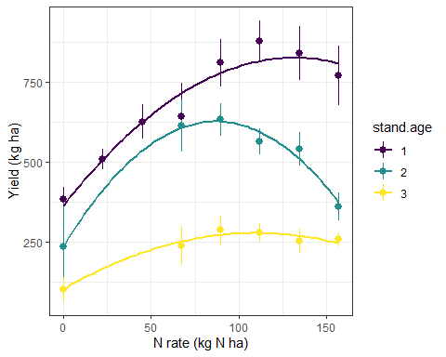

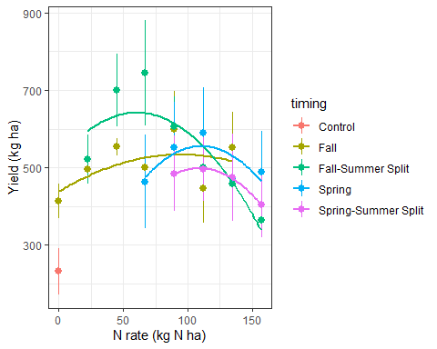

A lot of interesting interpretations here and options for extrapolation

Bates, Douglas, Martin Mächler, Ben Bolker, and Steve Walker. 2015. “Fitting Linear Mixed-Effects Models Using Lme4.” *Journal of Statistical Software* 67 (1): 1–48. <https://doi.org/10.18637/jss.v067.i01>.

Fox, John, and Sanford Weisberg. 2019. *An R Companion to Applied Regression*. Third. Thousand Oaks CA: Sage. <https://socialsciences.mcmaster.ca/jfox/Books/Companion/>.

Hothorn, Torsten, Frank Bretz, and Peter Westfall. 2008. “Simultaneous Inference in General Parametric Models.” *Biometrical Journal* 50 (3): 346–63.

Lenth, Russell V. 2022. *Emmeans: Estimated Marginal Means, Aka Least-Squares Means*. <https://CRAN.R-project.org/package=emmeans>.

R Core Team. 2022. *R: A Language and Environment for Statistical Computing*. Vienna, Austria: R Foundation for Statistical Computing. <https://www.R-project.org/>.

Wickham, Hadley, Mara Averick, Jennifer Bryan, Winston Chang, Lucy D’Agostino McGowan, Romain François, Garrett Grolemund, et al. 2019. “Welcome to the Tidyverse.” *Journal of Open Source Software* 4 (43): 1686. <https://doi.org/10.21105/joss.01686>.