Method #1

Man Made Waterbodies Identified in the National Lake Assessment
“Man Made” waterbodies from the 2007, 2012, and 2017 NLA layers were selected, made into features, and exported:
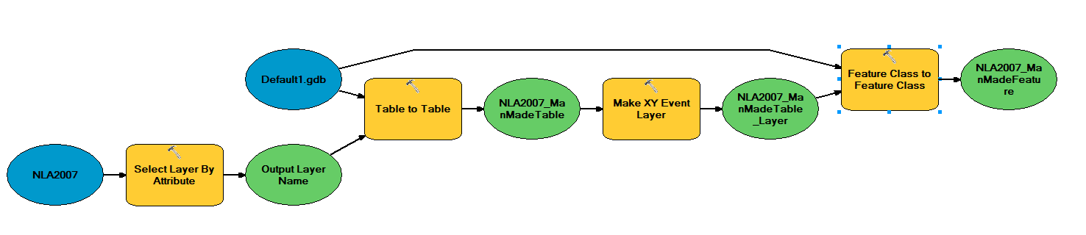
Three NLA datasets were merged and identical records with the same ‘COMID’ were deleted:
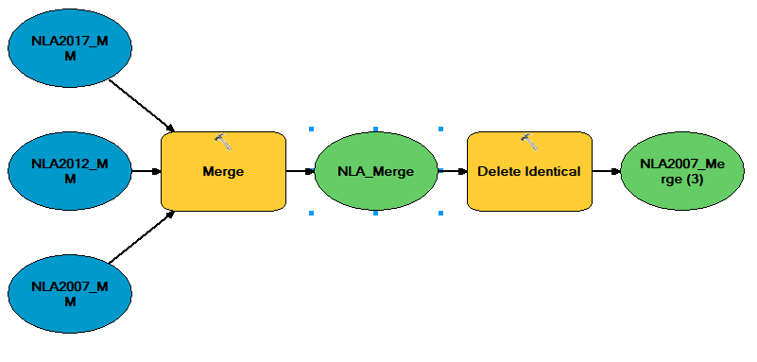
NHDPlus v2.1 ‘NHDWaterbody’ polygon intersecting a NLA point feature was selected and exported. Note: Spatial selection was used instead of an attribute join (on COMID) because there seemed to be issues with the quality of the COMID: approx. 20% of the NLA COMIDs had no match to the NHDWaterbody’s COMIDs. The few NLA points with no associate spatial intersection to the NHDWaterbody layer were manually reviewed and selected.
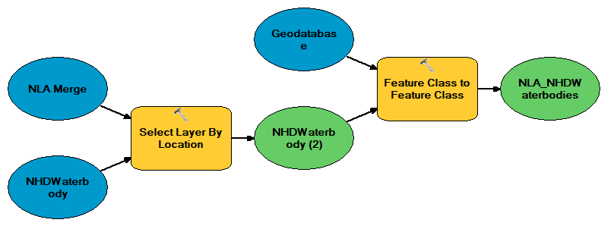

Method #2

Dataset: NHD Waterbodies identified as “Reservoirs”
Waterbodies in the NHDPlus v2.1 with an FTYPE “Reservoir” or “Reservoir” in the GNIS Name were selected.
>>> arcpy.SelectLayerByAttribute_management('NHDWaterbody', 'NEW_SELECTION', "FTYPE = 'Reservoir' OR GNIS_NAME LIKE '%Reservoir%'")

Method #3

Distance of Waterbodies to the National Inventory of Dams dataset

There is no common identifier linking a dam from the NID (https://nid.sec.usace.army.mil/ords/f?p=105:1::::::) to an associated NHDPlus Waterbody. However, a dam point feature located within a NHD waterbody assumes association. Based on this logic, a spatial selection method was used to identify dams with their associated reservoir. Although the plurality of dams are spatially within a reservoir polygon, some dams are within a certain distance of a potentially associated waterbody. Below is the distribution of distances of nearest NHD Waterbodies to every ~90,000 dams.

If a NHD Waterbody (FTYPE=Lake/Pond only) was within 100m of a dam that waterbody was selected, and association was assumed:
>>> arcpy.GenerateNearTable_analysis('NID', 'NHDWaterbodies', r'C: \NearT', '1000 Meters', 'NO_LOCATION', 'NO_ANGLE', 'CLOSEST', '0', 'PLANAR')
Selected all Waterbody near feature FID IDs >=100—export results.

Method #4

NID and Waterbody Name Match
For Waterbodies <100m and >=1000m from a NID point a naming matching method was used. Note: There is no similar naming convention between the Waterbody GNIS Name and the NID Dam Name (i.e. NID Dam Name = ‘Fort Thomas Dam’ NHD Waterbody = ‘Thomas Lake’; near distance = 854 m). Also, the majority of Waterbodies do not have an associated GNIS Name. To match dams with similar waterbody names (i.e. Fort Thomas Dam and Thomas Lake) the following method was used in Excel:
- Create Pivot table- Row field=COMID and Vale field =minimum near distance
(if one waterbody was closest to two or more dams, this selected the closest dam to the associated waterbody)
- Create UID with concated COMID and near distance. VLookup to add dam record ID and dam name and GNIS Name
- For waterbodies >100and<=1000m removed the words in the GNIS Name column:
Dam
Lake
Pond
of
the
,
(This avoids matching a dam with the word “the” to a waterbody with the word “the”)
- For the Dam Name and GNIS name columns→Text to Column→Space Delimited (Separated the first four words in for the GNIS Name and Dam Name into 4 columns each).
- IF OR statement that permutates each individual word of the NID Name with every other individual word in the GNIS Name:

=IF(OR(NID WORD 1=GNIS NAME WORD 1,NID WORD 1=GNIS NAME WORD 2,NID WORD 1=GNIS NAME WORD 3,NID WORD 1=GNIS NAME WORD 4,NID WORD 2=GNIS NAME WORD 1,NID WORD 2=GNIS NAME WORD 2,NID WORD 2=GNIS NAME WORD 3,NID WORD 2=GNIS NAME WORD 4,NID WORD 3=GNIS NAME WORD 1,NID WORD 3=GNIS NAME WORD 2,NID WORD 3=GNIS NAME WORD 3,NID WORD 3=GNIS NAME WORD 4,NID WORD 4=GNIS NAME WORD 1,NID WORD 4=GNIS NAME WORD 2,NID WORD 4=GNIS NAME WORD 3,NID WORD 4=GNIS NAME WORD 4),”Match”,”No Match”))

Merge
For each of the four datasets created and described above, a column was created: “Method”—describing which method the Waterbody was derived from; either “NLA”, “Distance”, “Name”, “FTYPE & GNIS Name”.
The four datasets were then merged into a single dataset:
>>> arcpy.Merge_management('NameMethod;DistanceMethod;NLA;FTYPE', r'C:\Merge', 'COMID "COMID" true true false 4 Long 0 0 ,First,#,NameMethod,COMID,-1,-1,DistanceMethod,COMID,-1,-1,NLA,COMID,-1,-1,FTYPE,COMID,-1,-1;FDATE "FDATE" true true false 8 Date 0 0 ,First,#,NameMethod,FDATE,-1,-1,DistanceMethod,FDATE,-1,-1,NLA,FDATE,-1,-1,FTYPE,FDATE,-1,-1;RESOLUTION "RESOLUTION" true true false 7 Text 0 0 ,First,#,NameMethod,RESOLUTION,-1,-1,DistanceMethod,RESOLUTION,-1,-1,NLA,RESOLUTION,-1,-1,FTYPE,RESOLUTION,-1,-1;GNIS_ID "GNIS_ID" true true false 10 Text 0 0 ,First,#,NameMethod,GNIS_ID,-1,-1,DistanceMethod,GNIS_ID,-1,-1,NLA,GNIS_ID,-1,-1,FTYPE,GNIS_ID,-1,-1;GNIS_NAME "GNIS_NAME" true true false 65 Text 0 0 ,First,#,NameMethod,GNIS_NAME,-1,-1,DistanceMethod,GNIS_NAME,-1,-1,NLA,GNIS_NAME,-1,-1,FTYPE,GNIS_NAME,-1,-1;AREASQKM "AREASQKM" true true false 8 Double 0 0 ,First,#,NameMethod,AREASQKM,-1,-1,DistanceMethod,AREASQKM,-1,-1,NLA,AREASQKM,-1,-1,FTYPE,AREASQKM,-1,-1;ELEVATION "ELEVATION" true true false 8 Double 0 0 ,First,#,NameMethod,ELEVATION,-1,-1,DistanceMethod,ELEVATION,-1,-1,NLA,ELEVATION,-1,-1,FTYPE,ELEVATION,-1,-1;REACHCODE "REACHCODE" true true false 14 Text 0 0 ,First,#,NameMethod,REACHCODE,-1,-1,DistanceMethod,REACHCODE,-1,-1,NLA,REACHCODE,-1,-1,FTYPE,REACHCODE,-1,-1;FTYPE "FTYPE" true true false 24 Text 0 0 ,First,#,NameMethod,FTYPE,-1,-1,DistanceMethod,FTYPE,-1,-1,NLA,FTYPE,-1,-1,FTYPE,FTYPE,-1,-1;FCODE "FCODE" true true false 4 Long 0 0 ,First,#,NameMethod,FCODE,-1,-1,DistanceMethod,FCODE,-1,-1,NLA,FCODE,-1,-1,FTYPE,FCODE,-1,-1;ONOFFNET "ONOFFNET" true true false 2 Short 0 0 ,First,#,NameMethod,ONOFFNET,-1,-1,DistanceMethod,ONOFFNET,-1,-1,NLA,ONOFFNET,-1,-1,FTYPE,ONOFFNET,-1,-1;PurpCode "PurpCode" true true false 2 Text 0 0 ,First,#,NameMethod,PurpCode,-1,-1,DistanceMethod,PurpCode,-1,-1,NLA,PurpCode,-1,-1,FTYPE,PurpCode,-1,-1;PurpDesc "PurpDesc" true true false 254 Text 0 0 ,First,#,NameMethod,PurpDesc,-1,-1,DistanceMethod,PurpDesc,-1,-1,NLA,PurpDesc,-1,-1,FTYPE,PurpDesc,-1,-1;MeanDepth "MeanDepth" true true false 8 Double 0 0 ,First,#,NameMethod,MeanDepth,-1,-1,DistanceMethod,MeanDepth,-1,-1,NLA,MeanDepth,-1,-1,FTYPE,MeanDepth,-1,-1;LakeVolume "LakeVolume" true true false 8 Double 0 0 ,First,#,NameMethod,LakeVolume,-1,-1,DistanceMethod,LakeVolume,-1,-1,NLA,LakeVolume,-1,-1,FTYPE,LakeVolume,-1,-1;MaxDepth "MaxDepth" true true false 8 Double 0 0 ,First,#,NameMethod,MaxDepth,-1,-1,DistanceMethod,MaxDepth,-1,-1,NLA,MaxDepth,-1,-1,FTYPE,MaxDepth,-1,-1;MeanDUsed "MeanDUsed" true true false 8 Double 0 0 ,First,#,NameMethod,MeanDUsed,-1,-1,DistanceMethod,MeanDUsed,-1,-1,NLA,MeanDUsed,-1,-1,FTYPE,MeanDUsed,-1,-1;MeanDCode "MeanDCode" true true false 75 Text 0 0 ,First,#,NameMethod,MeanDCode,-1,-1,DistanceMethod,MeanDCode,-1,-1,NLA,MeanDCode,-1,-1,FTYPE,MeanDCode,-1,-1;LakeArea "LakeArea" true true false 8 Double 0 0 ,First,#,NameMethod,LakeArea,-1,-1,DistanceMethod,LakeArea,-1,-1,NLA,LakeArea,-1,-1,FTYPE,LakeArea,-1,-1;Area_Ha "Area_Ha" true true false 8 Double 0 0 ,First,#,NameMethod,Area_Ha,-1,-1,DistanceMethod,Area_Ha,-1,-1,NLA,Area_Ha,-1,-1,FTYPE,Area_Ha,-1,-1;Min_of_NEAR_DIST "Min of NEAR_DIST" true true false 8 Double 0 0 ,First,#,NameMethod,Min_of_NEAR_DIST,-1,-1,DistanceMethod,Min_of_NEAR_DIST,-1,-1;Dam_Name "Dam Name" true true false 8000 Text 0 0 ,First,#,NameMethod,Dam_Name,-1,-1,DistanceMethod,Dam_Name,-1,-1;Record_ID "Record ID" true true false 4 Long 0 0 ,First,#,NameMethod,Record_ID,-1,-1;Shape_Length "Shape_Length" false true true 8 Double 0 0 ,First,#,NameMethod,Shape_Length,-1,-1,DistanceMethod,Shape_Length,-1,-1,NLA,Shape_Length,-1,-1,FTYPE,Shape_Length,-1,-1;Shape_Area "Shape_Area" false true true 8 Double 0 0 ,First,#,NameMethod,Shape_Area,-1,-1,DistanceMethod,Shape_Area,-1,-1,NLA,Shape_Area,-1,-1,FTYPE,Shape_Area,-1,-1;Method "Method" true true false 20 Text 0 0 ,First,#,NameMethod,Method,-1,-1,DistanceMethod,Method,-1,-1,NLA,Method,-1,-1,FTYPE,Method,-1,-1')

Identical COMID records were removed:
>>> arcpy.DeleteIdentical_management("Reservoir_Merge","COMID",,)

Method 5

NHD Area Inundation
Using the NHDPlus Area layer, FTYPE = 'Inundation Area' was selected and exported.
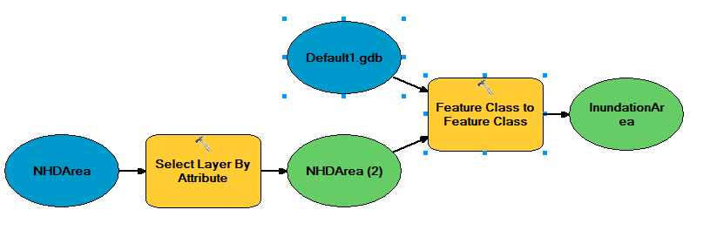
Spatially select InundatedAreas if they share a line segment with Reservoir feature:
>>> arcpy.SelectLayerByLocation_management('NHDArea', 'SHARE_A_LINE_SEGMENT_WITH', 'Reservoir_Merge', '#', 'NEW_SELECTION', 'NOT_INVERT')

Method 6

Navigable waterways
Navigable waterways spatial data came from the HIFLD (https://hifld-geoplatform.opendata.arcgis.com/datasets/navigable-waterway-network-lines/data?geometry=-100.357%2C32.430%2C-79.450%2C35.616)
Any NHDArea with an FTYPE=’StreamRiver’ that was within the navigable waterway layer was selected.

