Clustering Analysis and Anomaly Detection

As outlined in our initial project proposal, our team examined the Traffic Volume Counts (Historical) dataset from NYC Open Data using various exploratory data analysis (EDA) techniques to better understand traffic behavior across New York City's roadway network. Specifically, we implemented K-Means clustering to identify distinct traffic patterns and Z-score–based anomaly detection to spot unusual traffic events. These methods helped uncover underlying traffic trends and potential disruptions that could impact operational decisions and predictive modeling.

The main goal of this analysis was to segment roads and intersections with similar traffic behavior and to detect abnormal traffic volumes that might indicate disruptions such as construction, accidents, or signal malfunctions.

K-Means Clustering of Traffic Profiles

To understand daily traffic behavior, we used K-Means clustering on hourly traffic data. K-Means groups observations by similarity, here to identify locations with similar 24-hour traffic patterns. It found four clusters, each with a different traffic profile. While overall patterns were similar, clusters differed mainly by traffic intensity and peaks. Consistent patterns across clusters included: lowest volumes late night/early morning (0–5), sharp increase around 6–8 AM, stabilization midday (10–14), a late afternoon/early evening peak (4–6 PM), and a gradual decline late evening. These patterns reflect typical urban commuting, driven by work and economic activity.

Cluster Interpretations
Cluster | Traffic Volume Level | Typical Daily Pattern | Likely Road Type | Operational / Business Implications
Cluster 0 | Low traffic volume | Small increases during morning and evening commute periods; overall low activity throughout the day | Residential streets, local roads | Requires minimal traffic management. Monitoring may focus on localized disruptions such as construction or school-related traffic.
Cluster 1 | Moderate traffic volume | Clear morning and evening commuting peaks with moderate midday activity | Secondary arterial roads or neighborhood connectors | Important for distributing traffic between residential areas and major corridors. May benefit from optimized traffic signal timing.
Cluster 2 | High traffic volume | High traffic levels throughout the day with strong evening peaks and sustained midday traffic | Major arterial roads, highways, commuter routes | Critical infrastructure requiring advanced monitoring, congestion mitigation strategies, and potential adaptive traffic management.
Cluster 3 | Medium-high traffic volume | Pronounced commuting peaks with sustained activity during midday hours | Commercial corridors, busy urban avenues | Supports both commuting and commercial activity. Traffic management strategies must balance congestion reduction with economic activity.

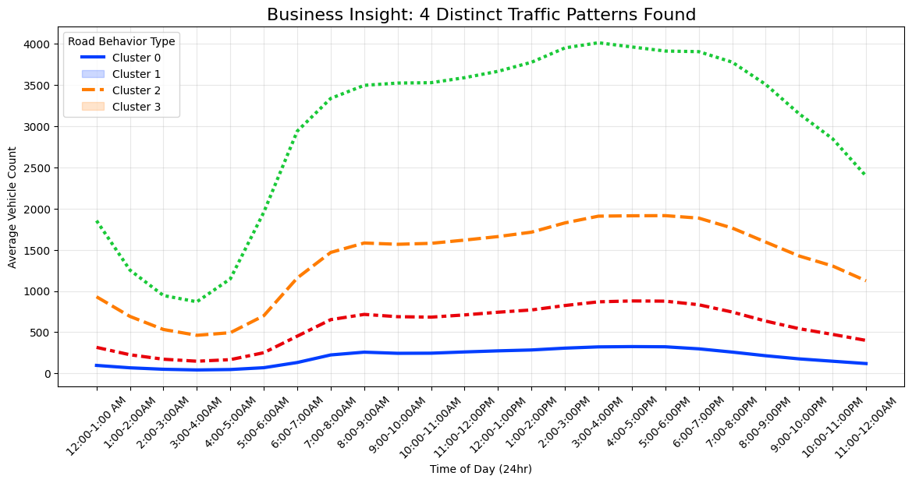
Figure 1 Average hourly traffic volume by cluster illustrating distinct traffic intensity levels and daily commuting patterns.

Business Implications of Traffic Clustering

The clustering results show that roads should not all be managed the same. Grouping roads by traffic behavior enables targeted strategies. Low-volume roads need minimal intervention, while high-volume arterials require advanced monitoring. This segmentation helps planners allocate resources and tailor policies to each road type.

Z-Score–Based Anomaly Detection
In addition to clustering, we implemented Z-score anomaly detection to identify unusually high or low traffic volumes relative to typical patterns.
The Z-score measures how far a given observation deviates from the mean:  Z = (X − μ) / σ | Where:  X = observed traffic volume  μ = average traffic volume  σ = standard deviation
Observations with |Z| > 3 were flagged as anomalies, indicating traffic volumes that are statistically unusual compared to historical patterns.

Observations from the Anomaly Analysis

The anomaly detection showed most traffic was normal, but some unusual events were found, especially early mornings when low baseline traffic makes small increases seem large. Possible causes include road closures, construction, accidents, special events, or signal issues. Fewer anomalies happen during peak hours, but those occurring could indicate major disruptions.

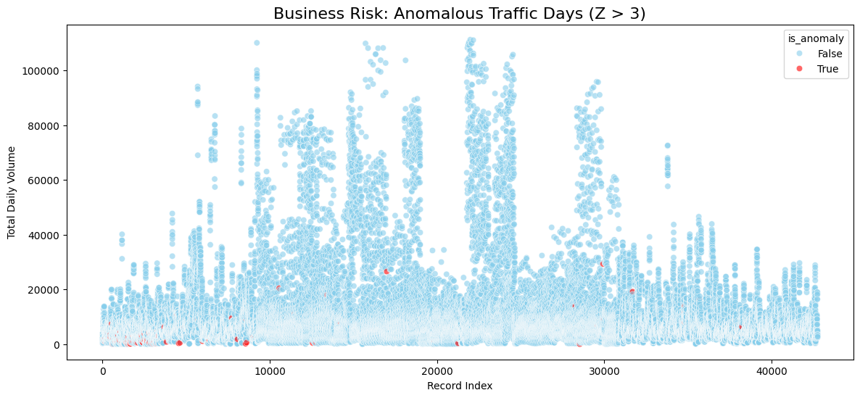
Figure 2 : Traffic anomaly detection using Z-scores (|Z| > 3). Red points indicate traffic volumes that deviate significantly from historical expectations.

Role of These Methods in the Overall Modeling Pipeline
Both clustering and anomaly detection offered valuable insights early in the data analysis. Clustering identified traffic categories in the roadway network, aiding feature engineering and model segmentation for future predictions. Anomaly detection spotted rare events that suggest disruptions, supporting real-time monitoring systems. Together, these techniques deepened understanding of the dataset and laid the foundation for developing models to forecast traffic and identify congestion risks across the network.

