SoMeme

Mobile Project Design Document

## Prepared by: Jon Beharrell, Robert Taylor, Ryan Forrester, and Ian Mori

## Date Submitted: Monday, January 26, 2015

Description

The development team for this project will be constructing a mobile application based on the SoMeme web application. SoMeme is a social media site for people to congregate and express themselves freely online. This will not be a mobile version of the website but more so a separate mobile app that would give the user the main functionality, without having to go to the website itself.

Users have the ability to sign up and login/logout of the application as they would on the website. Though the user will not be able to create a meme, once logged in they will be able to view, comment, like/dislike, and save memes that other users have created. The creation of a meme through the app will eventually will be added, but due to time constraints will not be implemented. Users will also be able to share any meme through social media sites. We plan to be able to integrate with Twitter so that we can share a meme to user’s Twitter accounts.

The application will access the main server’s database in order to display the necessary information on the screen. There will also be a local database that will be connected to a ‘favorites’ feature. This feature will store a reference to which memes the user has ‘favorited’ to a local database on the phone. The user will also have the option to download a meme onto their phone by clicking on a download button.

As the project grows additional functionality may be added, such as creating a meme, camera/storage access and private messaging. The initial application will only be available for android devices; there will be consideration for expansion to other devices such as iOS and Windows in the future.

Primary Functions

**Signup**

New users will be able to sign up to use the application. The signup process will require the user to enter an email, username, and a password. Secondary information such as full name, age, gender, and location can also be provided by the user.

**Login/Logout**

Users who already have an account can login using their username and password. A user will also be asked if they would like their login information to be remembered so they aren’t require to enter it every time they open the application. Additionally, users can logout of their account to prevent someone else from going through their account.

**View**

Users will be able to view the existing memes that were created from the main website. The application will connect to the database on the server to retrieve the content. There will be different sorting methods for the memes such as newest and top liked meme. Memes can be arranged by different time frames including weekly, monthly, and yearly.

**Comment**

Logged in users will have the option to comment on existing memes. Commenting will write to the database on the server. Any inputs will be sanitized before being written to the database. Users will also be able to comment on any existing comments.

**Like/Dislike**

Logged in users will be able to like or dislike a picture as well as comments. Liking and disliking comments and pictures will affect the way the content is displayed. Higher liked pictures will be displayed near the top of the page the same way that higher liked comments will be displayed near the top, depending on the sorting method.

**Share on Twitter**

Users will be able to share a meme through Twitter. This option will connect to the users twitter account and post the image they which to share as a tweet.

**Save Image Locally**

User will be able to save an image to their local pictures by hitting a download button. The image will be downloaded to their devices local storage.

**Favorite**

Users will be able to ‘favorite’ a meme. ‘Favoriting’ a meme gives the user easier access to view the image by adding to their ‘favorites’ tab. Data about the ‘favorited’ memes will be stored in a local database on the device. This data will allow the app to look up the image on the server to display to the user.

Secondary Functions

**Create Memes**

Users will be able to upload an image to the application and apply text to it. The image can then be downloaded to their local storage as well as uploaded to the database on the server.

**Access Camera**

Users can access their camera by clicking on a button. They can take a picture to use for our application.

**Private Messaging**

Logged in users will be able to send private messages to other users and check their own private messages.

**Point System**

A point system will keep track of all the points a user accumulates through their comments and memes. This would be used to see who posts the best comments and memes.

Interface Design

**Login**

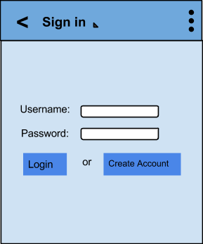

Here the user is presented with a page to either login with their existing account or create a new account. This will query the database and verify the account details to ensure the correct user is logged in. Once the information is filled out, the Login button is clicked, and validation has passed, the user will be able to access their saved content and favorites.

**Sign Up**

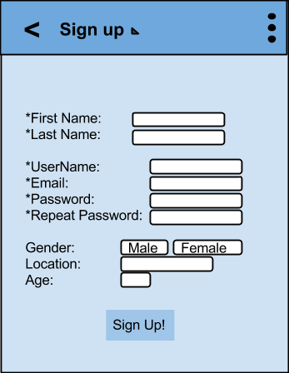

This will be the page for creating a new user account. The user will fill in a form with their details which will be validated and then stored in the database upon submittal. The user can cancel and return to the home screen or create a new account.

**View One (Multiple Pictures)**

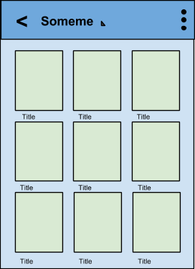

Here the user will be able to view memes that have been created and submitted on the main website. Users will be able to view these in closer detail and download a copy to their device. Users will also be able to comment and like/dislike a meme which can be noted on the following screen mock-up.

**View Two (Single Picture)**

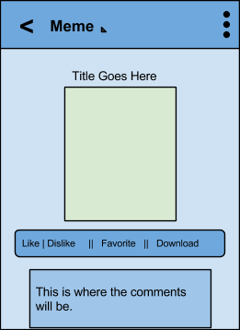

This will be the detailed view of the meme when it is tapped on from the previous page. This will give users the ability to comment on a meme, like/dislike a meme, favorite a meme, and download a meme. Future iterations may include the ability to upload and create memes, but that is secondary functionality that would be considered later. Users can use the web application to create content.

**Comment Section Display**

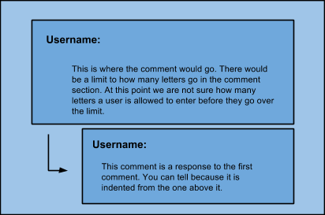

This is a more detailed view of the comments section. The comments will be stored in the database as well and will be displayed here according to the user’s choice. The comments will be stored by most likes or up votes.

**Favorites**

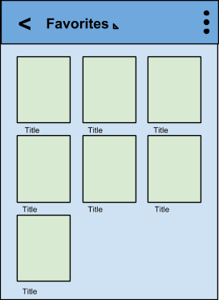

This will be the collection of favorites a user accumulates. Here they can click on them to view them in detail and view the comments as noted earlier. The user will be able to logout if they choose so at any time and they will also be able to share their favorites with their friends through Twitter.

**Dropdown Menu View**

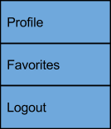

This is the menu that comes up when you click the overflow button in the top right-hand corner. This will bring up the more important or commonly used features of the web application. The user will be able to go to their profile, see their favorites, and will be able to logout.