**Color Palette**

**Selected Google Fonts**

**<link href="https://fonts.googleapis.com/css2?family=Averia+Serif+Libre:wght@300;400;700&family=EB+Garamond:wght@400;500;600;700;800&display=swap" rel="stylesheet">**

**EB Garamond**

**Interview**

What is your name?

* Cecilia Boettcher

When and where were you born?

* I was born on February 19th, 1985, in Lagos, Nigeria but immigrated with my family to the US when I was 2 years old.

Where have you lived?

* Georgia, Nigeria, Minnesota, South Dakota, Nebraska, Chile, and South Korea. I moved back to Atlanta in January 2020 to be closer to my family.

What are your favorite hobbies?

* Eating foods from different cultures and traveling.

What is your favorite food?

* My favorite food is Naengmyeon which is a cold Korean soup

What is your favorite place you have visited?

* London

What did you like about visiting your favorite place?

* I enjoyed the food, transportation, and the walkability of the city. There are lots of places to visit within walking distance of you can hop on the tube to get anywhere you want to go within 15 minutes. One of my favorite memories is waking up early to walk to a restaurant a block from my hotel to eat bangers and mash.

Where would you like to travel next?

* I want to travel back to South Korea to see my friend that lives there and eat the authentic Korean dishes. I also plan on traveling to Japan while I am close.

What is your highest level of education?

* Masters in Accounting from Liberty University

Do you have any other degrees? If so, what are they?

* Yes I have a BA in International Management from Gustavus Adolphus and most recently a BS in Computer Science from South Dakota State University. I am currently taking a C sharp class from a community college to brush up on my coding skills.

What was your first job out of college?

* I worked as a multicultural recruitment coordinator.

Did you like this role?

* Yes because it allowed me to travel but I really wanted to spend some time living in another country so I decided to move to Korea to teach English.

Did you like teaching English in Korea?

* I loved it but I only had a contract for a year and a half

What drew you to Computer Science?

* The income and stability of the job market

What was the most valuable lesson you learned from your education?

* Look into the income of what jobs you could pursue with your major to make sure you will be able to survive on that income before taking out loans and pursuing a degree

Where do you work and how long have you worked there?

* FiveSixTwo for 8 months

What is your current job title?

* Software Development Engineer in test, also known as QA Automation.

What professional accomplishment are you most proud of?

* Transitioning from a manual QA tester at Hayneedle to my current role in QA Automation in 2 years

What is your favorite thing about your career or industry?

* Constantly learning new things and being able to code each day.

What do you hope to accomplish in your career?

* I want to move into a role as a Software Engineer

**Bio**

Cecilia was born in Lagos, Nigeria but moved to Atlanta, Georgia when she was two years old. She has also lived in South Dakota, Nebraska, South Korea, and Chile. It’s no coincidence that Cecilia’s favorite hobbies are traveling and trying foods from different cultures.

Out of all the places Cecilia has visited, London England was her favorite travel destination. She particularly enjoyed the food, walkability, and public transportation because she can find something to do within walking distance or by taking a short trip on the tube. It also doesn’t hurt that she found a restaurant near her hotel that served her favorite English breakfast, bangers and mash.

Although bangers and mash are near the top of Cecilia’s list of breakfast foods, her favorite food is a Korean soup called Naengmyeon. Naengmyeon is served cold, but it is packed with flavor. Some of the main ingredients include a cold beef broth, noodles, brisket, scallions, and radishes. Cecilia is looking forward to eating this again soon during her next travel destination when she visits her friend in South Korea.

When Cecilia isn’t busy traveling or trying new foods, she is busy pushing herself to learn new things. Cecilia is a lifelong learner, obtaining a bachelor's degree in international management from Gustavus Adolphus, a master’s degree in accounting from Liberty University, and most recently, a bachelor's degree in computer science from South Dakota State University.

Cecilia’s career began as Multicultural Recruitment Coordinator after earning her degree in international management. She enjoyed that role because it allowed her to travel but she always wanted to live abroad so she decided to take a leap of faith and move to Korea to become an English teacher. Although she loved this experience, her contract had ended so she decided to pursue new opportunities, so she began pursuing her degree in computer science.

Cecilia began working as a Manual QA tester at Hayneedle, an e-commerce furniture company, but set her sights on learning QA automation. One of her proudest work accomplishments is working her way into her current role as a Software Development Engineer in Test at FiveSixTwo within 2 years. Cecilia’s next goal is working towards becoming a Software Engineer after completing some additional schooling.

**Wireframe**

**Inspiration document**

One of my favorite things about the United States is that we are a melting pot of different cultures and people. My family has been living in the United States for 4 generations, so I really enjoyed learning about Cecilia’s experience immigrating from Nigeria to the US. I decided to incorporate the hex color green from Nigeria’s flag as one of the colors in my color palette to represent her heritage.

Like Cecilia, I also enjoy trying different foods from different cultures, so I was inspired to learn a little bit more about what her favorite food Naengmyeon was and the ingredients that are used to prepare it. I found a recipe online that listed the main ingredients of the traditional dish and found a royalty free image of the dish which I will include on the website.

Like Cecilia, I am also a lifelong learner and am inspired by others who pursue multiple degrees. She inspired me to pursue a degree in software development because I have been unhappy in my current field and have seen firsthand what her job is like while we have both been working from home.

Cecilia is a very driven person and has always gone after her ambitions. It is a trait that I admire in her. After learning she worked as a recruiter as one of her first professions out of college I was surprised so I went to her linked in page to learn a little bit more about the role. After learning it required a lot of travel, which is one of her favorite hobbies, it seemed fitting and made me admire her more because she was able to enjoy a hobby while working.

**3 images related to Cecilia’s hobbies**

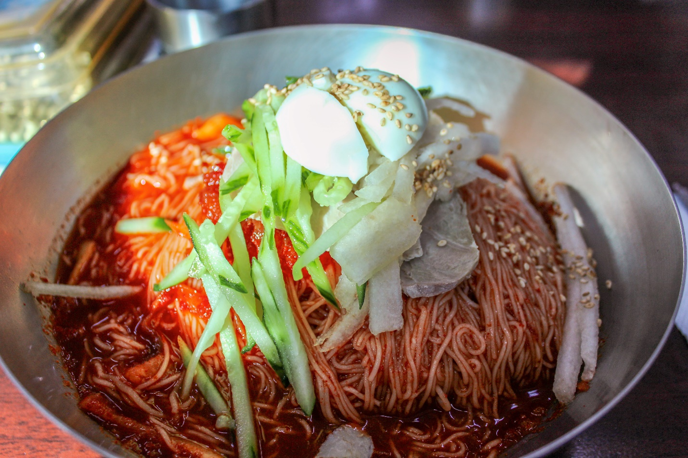





**3 images related to Cecilia's experience:**





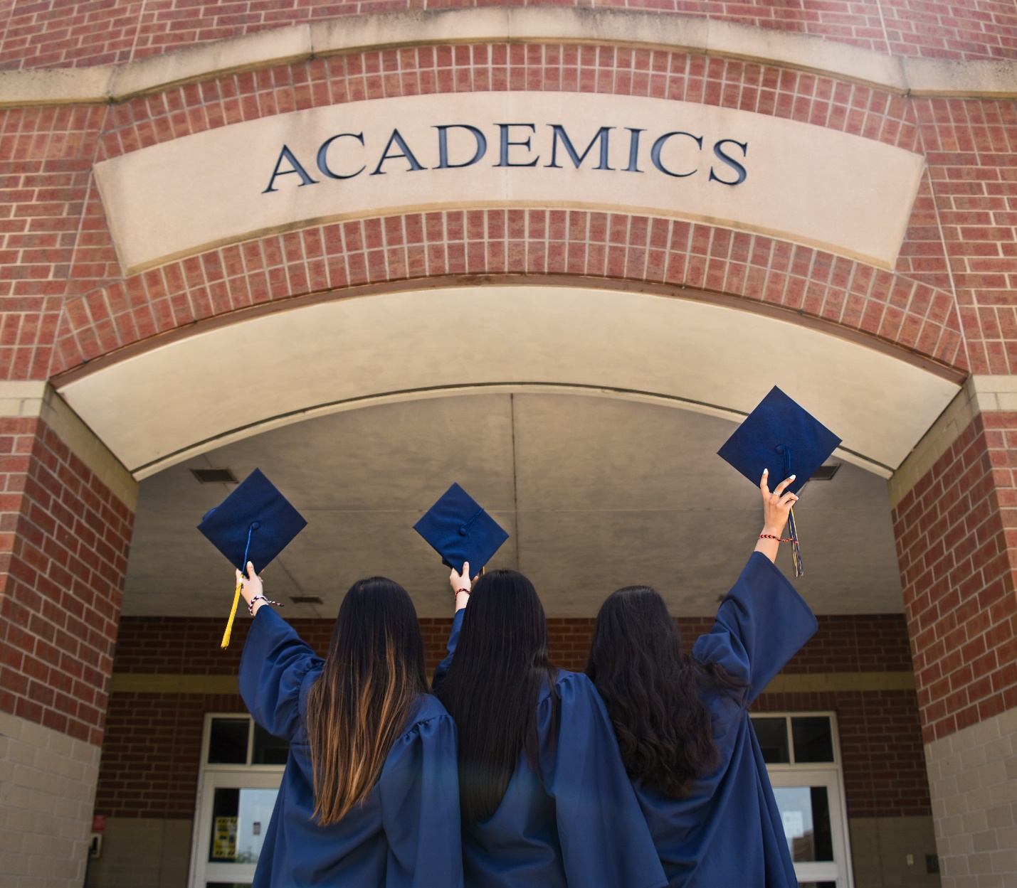

**A picture of your subject:**

