A Brief Sketch of TEALsim June 5, 2025 jbelcher@mit.edu
John Belcher, Andrew McKinney, Philip Bailey, Michael Danziger, Pierre Poignant, Ying Cao, Ralph Rabat, Mesrob Ohannessian
The MIT Center for Educational Computing Initiatives
Contents
THE FIGURE 2
BASIC LINKS: 3
SKETCH: 4
The Electrostatic Pendulum Same Sign application 4
Populating the Scene with 3D objects 5
The Engine 5
Populating the Scene with Interacting Electromagnetic Objects 6
The Dynamics 7
The Arc Constraint 8
Adding Electric Field Lines 9
Creating the Energy Graph and Calculating the Energies 9
User Interface and Interaction 10
THE CHARGING BY INDUCTION APPLICATION 11
THE ELECTROSTATIC ZOO APPLICATION 11
ELECTROSTATIC PLAYGROUND 12
A PROBLEM FOR THE ELECTROSTATIC PENDULUM APPLICATION 12

THE FIGURE
In the code we will be looking at ElectrostaticPendulumSameSign.java, the appearance of the application when it is running is:
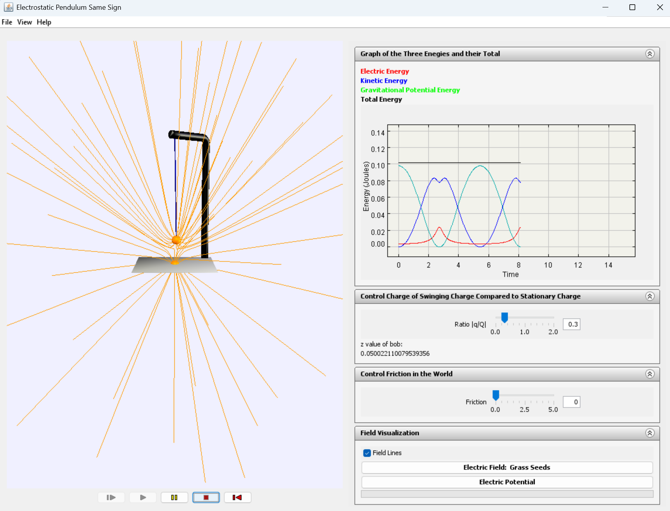
Execution and view control are explained by clicking on the “Help” button:
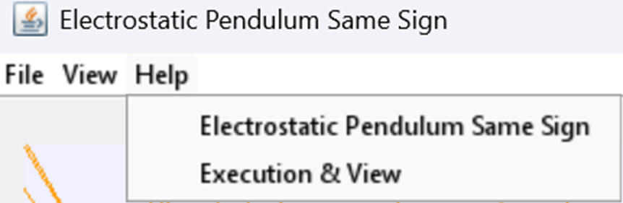
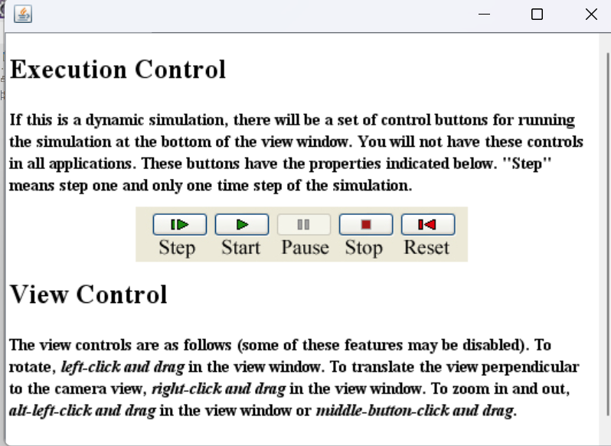

We will refer to the above figure as we go through the code. A physics problem with this application is given in the last section of this pdf.

In the left panel, we have two electromagnetic charges of the same sign (by convention, orange is positive, and blue is negative), along with their field lines. Electric field lines are always orange, and magnetic field lines are always blue (there are none shown here). The swinging charge is affected by gravity and the repulsion of the fixed charge, fixed in the center of the base, and by a friction proportional to and opposite its velocity. It is constrained to move along the arc of a circle whose radius is the pendulum length. We have imported a .3DS max file into the scene, which models the support and the base of the pendulum. We also have a native 3D object in the scene, which is the pendulum itself, made with a cylinder primitive.

In the right panel, we have a graph showing the kinetic energy of the pendulum bob, its gravitational potential energy, the electrostatic interaction energy, and the total energy. Below the graph we have a user interaction slider to set the ratio of the charge of the swinging charge to that of the fixed charge. Next, we have a slider to set the friction that the swinging charge feels (initially set to zero). Next, we have buttons which will create a line integral convolution graph, displayed in the left-hand panel, for either the electric field or the electric potential.

BASIC LINKS:
The TEAL project was initially funded by the d'Arbeloff Fund for Excellence in MIT Education, iCampus, and MIT. The Principal Investigators were John Belcher, Peter Dourmashkin, and David Litster. TEAL ran for about three years (June 2000 to June 2003), after which support was assumed by the MIT Physics Department. A brief description of the project is given at this archived site. It was controversial at the time, as explained at this link.
The over-arching motivating factor for TEAL’s development (at all levels of the Institute) was the high failure rate in freshmen physics courses, which was historically around 10-15% from at least 1971 until the advent of TEAL. In comparison, the failure rate in the other MIT General Institute Requirements has historically been around 5%.
For this reason, the MIT Physics Department and the Institute were willing to put substantial resources into the TEAL project, including the construction of two $1.5 million TEAL rooms, as well as substantial resources from the d'Arbeloff Fund and iCampus, channeled through The Center for Educational Computing Initiatives (CECI). CECI has been subsequently absorbed into MIT Open Learning. The first TEAL room is 26-152.
The TEAL visualization software, TEALsim, has a github site
https://github.com/jbelcher-mit/TEALsim.git
The applications are available for download and execution at
https://web.mit.edu/8.02t/www/TEALsim/
Very preliminary documentation can be found at:
https://web.mit.edu/jbelcher/www/TEALsim/TEALsimDoc.doc
https://web.mit.edu/jbelcher/www/TEALsim/TEALsimDoc.pdf
The documentation above describes how to download the code base from github, what version of Java you need, and how to install and run the code in Eclipse.
https://web.mit.edu/jbelcher/www/TEALsim/TEAL_Physics_Math.doc
https://web.mit.edu/jbelcher/www/TEALsim/TEAL_Physics_Math.pdf
The documentation above is a guide to mathematics and physics used in TEALsim (for example, the magnetic fields of a circular ring of current in terms of elliptical integrals and the Buhirsch (1965) code to compute those elliptical integrals).

SKETCH:

The Electrostatic Pendulum Same Sign application
I am going to sketch how this software is put together by going through the high-level java routine that creates a swinging electrostatic pendulum application, a YouTube video of which you can find at this link:
https://www.youtube.com/watch?v=S4N9fn7cOOU
You can run the application itself on a Windows machine by going to the link below and downloading the jar files (click on “Guide to Starting Simulation” to see what you need to have installed on your Windows machine, then click on “Start Java3D Simulation” )
https://web.mit.edu/8.02t/www/TEALsim/visualizations/electrostatics/pendula/same/same.htm
Unfortunately, this online application does not have the full “Help” options, in that it does not have the Execution and View panel in “Help” that I refer to in the FIGURE section above.
You can find java code for this high-level creation process online at
https://github.com/jbelcher-mit/TEALsim/blob/main/TEALsim/java/src/tealsim/physics/em/ElectrostaticPendulumSameSign.java
TEALsim is designed as a framework for authoring, presenting, and controlling simulations related to topics in classic electromagnetism. The goal of TEALsim is twofold: first, it aims to provide a relatively simple, “API-style” interface, such that non-expert programmers can produce full-featured interactive electromagnetic simulations from the ground up, including all aspects of visualization, user interface and public posting, with minimal exposure to the inner workings of the system. Second, it offers a flexible framework for more experienced programmers to extend and expand the functionality of the system to suit their specific needs.

Populating the Scene with 3D objects
Lines 93 and 94 of our ElectrostaticPendulumSameSign.java code create a native object (a cylinder with a length of the pendulum of 20 and a radius of 0.1 in Java3D units):
ShapeNode ShapeNodeNative01 = new ShapeNode();
ShapeNodeNative01.setGeometry(Cylinder.makeGeometry(32, .1, lengthPendulum));
The direction in which the axis of this cylinder is oriented is initially set to Vector3d(1.,0.,0.), but during execution its direction is continuously adjusted at every time step to point from the top of the support structure to the position of the swinging charge (see line 397 in public void nextSpatial() { )).
In lines 76 through 86, we import the ArmBase.3DS model (created in max 3ds) and position it in the scene.

The Engine
The TSimulation interface (java.src.teal.sim.simulation.TSimulation) defines the requirements for a complete interactive simulation, collecting all the components that make up the entire user experience. Typically, this includes: a simulation engine (java.src.teal.sim.engine.TSimEngine), a Viewer (java.src.teal.render.viewer.Viewer), the UI elements, and all the objects being simulated or otherwise displayed in the Viewer. SimEM (java.src.teal.physics.em.SimEM) is an example of a class that implements TSimulation. It incorporates the EMEngine (java.src.teal.physics.em.EMEngine) and a Java 3D viewer and provides the basis for all electromagnetic simulations.

Line 46 of the code shows that our upper-level java program ElectrostaticPendulumSameSign.java extends simEM.

public class ElectrostaticPendulumSameSign extends SimEM {
When we add electromagnetic objects to the scene, as we do just below, the Engine knows about all those objects, and if they are “moveable” (see below) it will apply a Runge-Kutta time integration, using the electromagnetic forces from all the other electromagnetic objects in the scene, including from ones that are not moveable (for example a constant background magnetic field).

Populating the Scene with Interacting Electromagnetic Objects
We have two electromagnetic objects in this scene, a swinging charge and a stationary charge. Lines 49 through 51 instantiates these charges, and a third dummy charge for obscure reasons which I do not explain. The dummy charge does not participate in the scene.

// instantiate the electromagnetic objects
PointCharge swingingCharge;
PointCharge fixedCharge;
PointCharge dummyCharge;

A PointCharge is an example of an electromagnetic object, see the code here:

https://github.com/jbelcher-mit/TEALsim/blob/main/TEALsim/java/src/teal/physics/em/PointCharge.java

Line 30 of this code is:

public class PointCharge extends EMObject implements HasCharge, GeneratesE, GeneratesP {

Any electromagnetic object has methods that compute the electromagnetic fields it produces at any point in space, given its location. Also, look at lines 335 through 348 of this routine:

public Vector3d getExternalForces() {
Vector3d externalForces= super.getExternalForces();
Vector3d temp= new Vector3d();
if (isMoveable()) {
temp.scale(charge_d, ((EMEngine)theEngine).getEField().get(position_d, this)); // F=qE
externalForces.add(temp); // force from EField
temp.scale(Math.abs(charge_d), ((EMEngine)theEngine).getPField().get(position_d, this));
externalForces.add(temp); // Pauli repulsion
temp.cross(velocity_d,((EMEngine)theEngine).getBField().get(position_d,this));
temp.scale(charge_d);
//System.out.println("q vxB force" + temp);
externalForces.add(temp); // q vxB force
}
return externalForces;
}

This code computes the total forces on the charge due to all other electromagnetic objects in scene (but not due to itself) from the Lorentz force 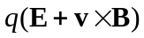 and the Pauli Force (which is always a repulsion at close distances, varying like inverse distance to the fifth power, I think). This information is used in the Runge-Kutta to get the acceleration vector of a given object and used to update the velocity at each time. The velocity is of course used to update the position of the object.

The Dynamics
To calculate the dynamical evolution of a scene, TEALsim uses a fourth order Runge-Kutta code that originally came from Numerical Recipes. The code is here:
https://github.com/jbelcher-mit/TEALsim/blob/main/TEALsim/java/src/teal/math/RungeKutta4.java
The properties of the swingingCharge are set in lines 137 to 154 of the ElectrostaticPendulumSameSign.java code:

swingingCharge = new PointCharge();
swingingCharge.setRadius(pointChargeRadius);
swingingCharge.setMass(5.0);
swingingCharge.setCharge(6);
swingingCharge.setID("swingingCharge");
swingingCharge.setPickable(false);
swingingCharge.setColliding(true);
swingingCharge.setGeneratingP(true);
// the actual position of this charge is set in private void resetPointCharges
// which is called before execution begins
swingingCharge.setPosition(new Vector3d(0.,0., 0.));
swingingCharge.setMoveable(true);
swingingCharge.setConstrained(true);
sccx = new SphereCollisionController(swingingCharge);
sccx.setRadius(pointChargeRadius);
sccx.setTolerance(0.1);
sccx.setMode(SphereCollisionController.WALL_SPHERE);
addElement(swingingCharge);

This charge moves (as set in the swingingCharge.setMoveable(true) statement). Its position is updated at each time-step by the Runge-Kutta scheme, under the influence of gravity, friction, and the presence of the other charge. The similar statement for the fixed charge is line 115, fixedCharge.setMoveable(false), which means this charge does not participate in the Runge-Kutta dynamic integration.

Here we are only going to talk about linear motion, but the Engine can also rotate electromagnetic objects, for example rotating a magnetic compass in a background magnetic field. See for example

https://web.mit.edu/8.02t/www/TEALsim/visualizations/magnetostatics/torqueOnCurrents/wireandmagnetapp/wireandmagnetapp.htm

Note that we also have collision controllers for these charges, code that I don’t understand.

In the pendulum example, we are integrating six dependent variables for the swinging charge (vector position and velocity). If we had made the fixed charge moveable, we would have twelve independent variables. If you look at THE CHARGING BY INDUCTION APPLICATION described below, it handles 240 dependent variables for 40 charges.

The Arc Constraint
The constraint that the moving charge move in the arc of a circle is set in line 210 and 211 of the ElectrostaticPendulumSameSign.java code:

ArcConstraint arc = new ArcConstraint(new Vector3d(.0,heightSupport,0.), new Vector3d(0.,0.,1.), lengthPendulum);

If you look at the code for this constraint at

https://github.com/jbelcher-mit/TEALsim/blob/main/TEALsim/java/src/teal/sim/constraint/ArcConstraint.java

lines 83 to 86 essentially kill the radial component of the total force. Line 68 of this code

public Vector3d getReaction(Vector3d position, Vector3d velocity, Vector3d action) {

has in the argument Vector3d action, where the action consists of all the electromagnetic forces summed over all the electromagnetic objects that generate fields, the friction, and gravity, as well as something called the Pauli Force, which is always a repulsion at close distances, varying like inverse distance to the fifth power, I think.

Adding Electric Field Lines
A field line manager is instantiated at line 70:

FieldLineManager fmanager = null;

The field lines for the swinging charge and the fixed charge are set up in lines 219 through 243.

Creating the Energy Graph and Calculating the Energies
We now return to the part of the ElectrostaticPendulumSameSign.java code that produces the top right panel in the figure above. This is somewhat complicated I think because the original author of the code, Michael Danziger, was using a “Hack to get around not adding graph as element”. But in any case, lines 159 to 163 set up the graph bounds and labels
graph = new Graph();
graph.setXRange(0., 15.);
graph.setYRange(-0.005, .14);
graph.setXLabel("Time");
graph.setYLabel("Energy (Joules)");
The XRange is the time range, originally from 0 to 15 Java3D time units (the size of the time step is set in line 298 of the code, theEngine.setDeltaTime(.02)). The graph has the property that once it reaches the end of the initial time range it resets to the left and continues plotting. I am pretty sure that the TEALsim code relies on a plotting package called Ptolemy https://ptolemy.berkeley.edu/java/ptplot/ and that is downloaded when you download the TEALsim jars, but I don’t know what version or much about how it works.
In addition, lines 180 to 198 of ElectrostaticPendulumSameSign.java create an eGraph object
eGraph = new ElectrostaticPendulumTwoBodyEnergyPlot();
which uses several methods to connect to objects in the scene:
eGraph.setPlotValue(0);
eGraph.setBodyOne(swingingCharge);
eGraph.setBodyTwo(fixedCharge);
eGraph.setIndObj(theEngine);
Using this information about objects in the scene, lines 105 to 120 of ElectrostaticPendulumTwoBodyEnergyPlot() calculates the four energies we are plotting in the upper panel, see the code in:
https://github.com/jbelcher-mit/TEALsim/blob/main/TEALsim/java/src/teal/plot/ElectrostaticPendulumTwoBodyEnergyPlot.java

User Interface and Interaction
The execution and view interface are explained in FIGURE above. It appears in the “Help” menu of the application, which will also give information about the purpose of the application. This “Help” information is added to the scene in lines 305 to 332 of ElectrostaticPendulumSameSign.java .
The friction slider on the bottom right-hand side of the FIGURE is instantiated on line 56:
PropertyDouble frictionSlider = new PropertyDouble();
Its properties are set in lines 264 and 273:
// properties of the slider to control the amount of friction in the modelfrictionSlider.setText("Friction");
frictionSlider.setMinimum(0.);
frictionSlider.setMaximum(5.);
frictionSlider.setPaintTicks(true);
frictionSlider.addPropertyChangeListener("value", this);
frictionSlider.setValue(0.0);
frictionSlider.setVisible(true);
As the program executes, new values of the friction are adjusted if appropriate in lines 416 to 426 in public void propertyChange(PropertyChangeEvent pce) {.
The charge ratio slider on the bottom right-hand side of the FIGURE is instantiated on line 249 and its properties are set in lines 250 through 262.
The Line Integral Convolution controls in the bottom right-hand side of the Figure are created in lines 67 and 68 and associated lines of code:
// create the line integral convolution graph
protected FieldConvolution mDLIC = null;

THE CHARGING BY INDUCTION APPLICATION
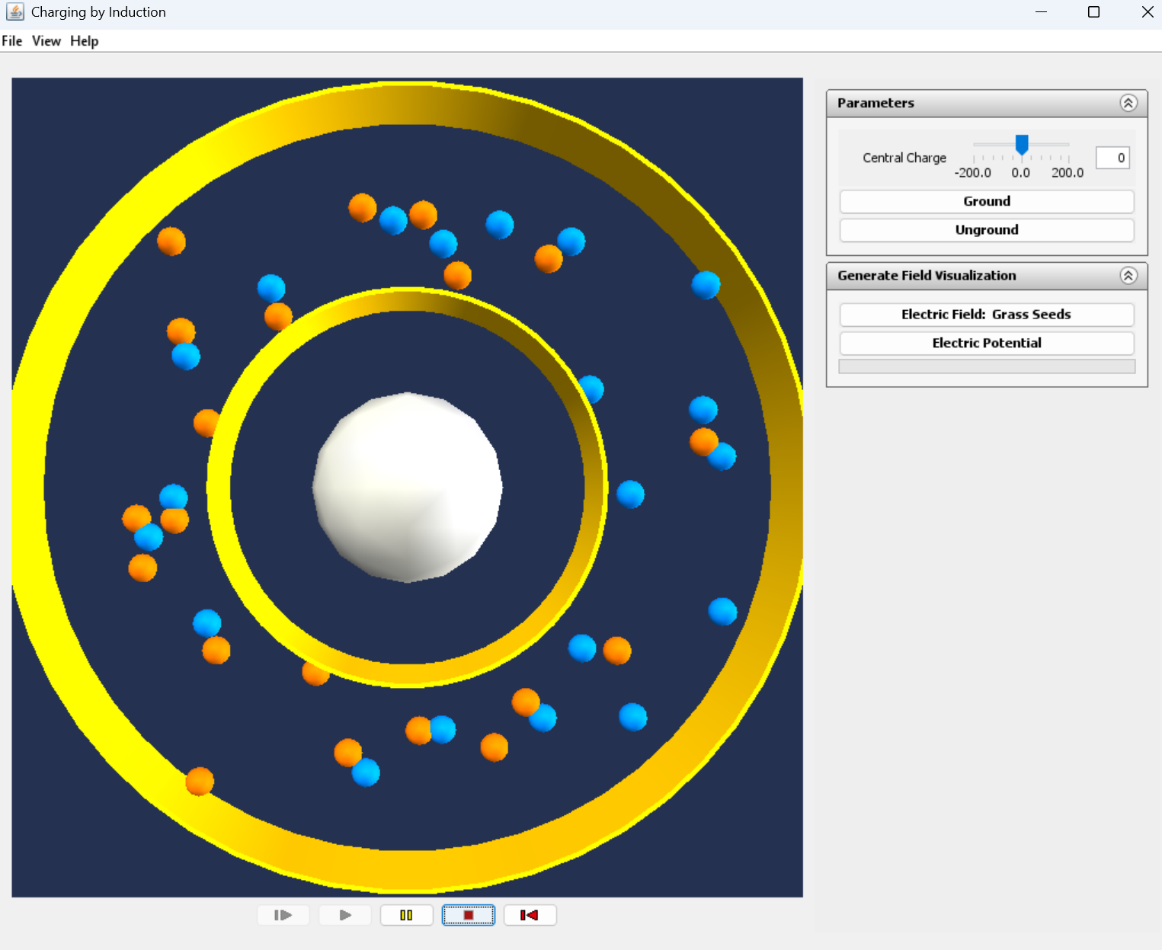

We mention this application because it shows that TEALsim can handle many charges. See the link below for a YouTube preview or to download the application. There are forty charges in this scene, for a total of 240 dependent variables! There are also collision controllers to handle collisions with the walls in the scene.

https://web.mit.edu/8.02t/www/TEALsim/visualizations/electrostatics/ChargingByInduction/chargebyinductionPentagon/chargebyinductionPentagon.htm

THE ELECTROSTATIC ZOO APPLICATION
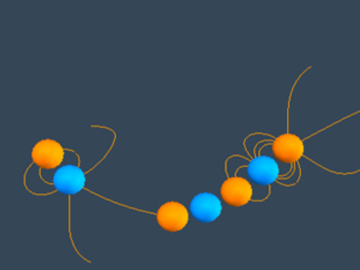

We mention this application because it shows that TEALsim add and subtract as well as interact with charged particles dynamically in a scene. The user can “pick” a charge, which will pull it out of the Runge-Kutta integration stack, then move it around, and then “unpick” the charge and the charge is returned to the integration stack. This can be useful pedagogically. See the link below for a YouTube preview or to download the application.

https://web.mit.edu/8.02t/www/TEALsim/visualizations/electrostatics/InteractingCharges/zoo/zoo.htm

ELECTROSTATIC PLAYGROUND
Dr. Scott Greenwald of the MIT Media Lab has created a virtual reality application similar to some of the applications in TEALsim. See https://www.media.mit.edu/projects/vr-physics-lab/people/ . See also the abstract at https://repository.isls.org/bitstream/1/1761/1/997-1000.pdf .

A PROBLEM FOR THE ELECTROSTATIC PENDULUM APPLICATION

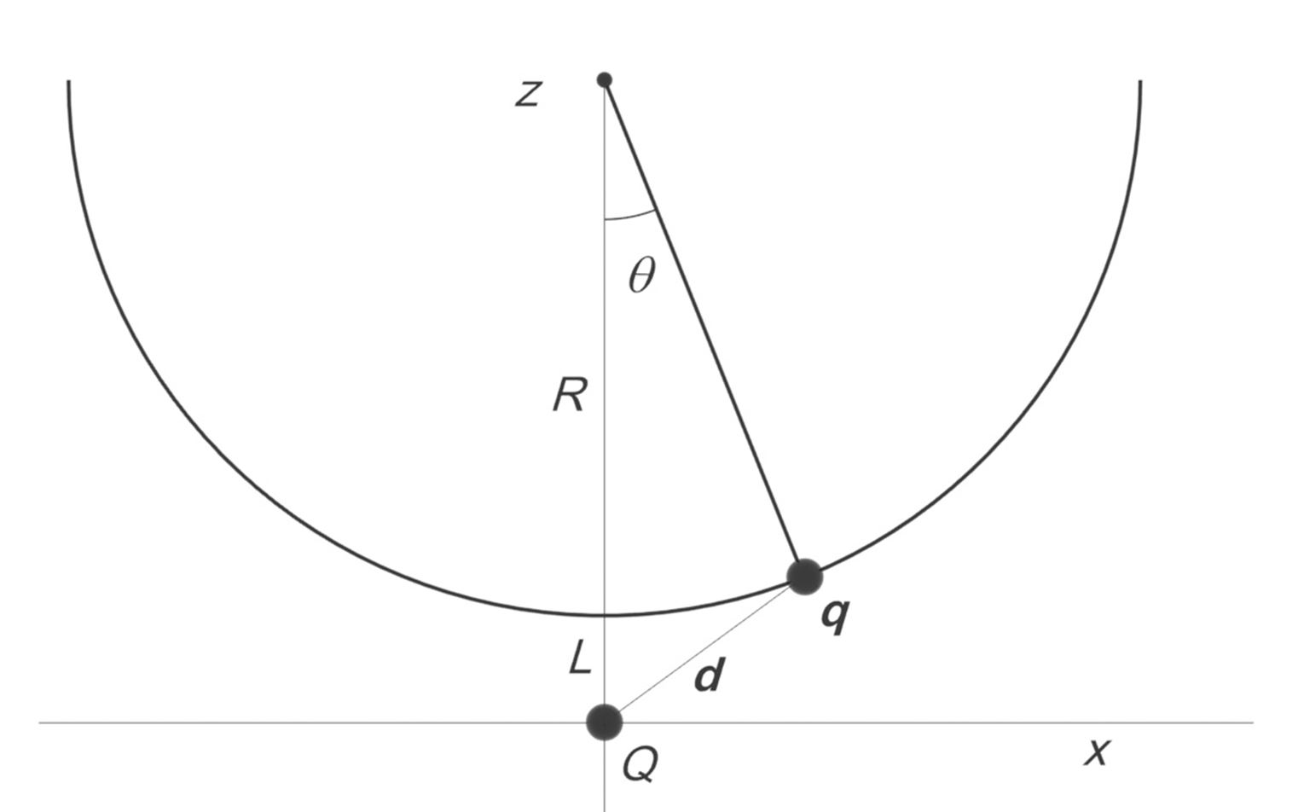

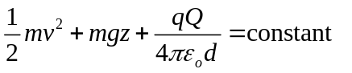
A charge q is located at 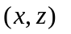 in the presence of a stationary charge of the same sign Q sitting at the origin. The charge q swings on a pendulum of radius R under gravity. When the charge q is at the bottom its swing it is a distance L just above the charge Q.

The charge q is released at rest from the position 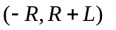. It ends up at rest just above the stationary charge Q.

(a) Use conservation of total energy to determine the ratio q/Q for this to happen, in terms of the parameters of the problem.

Solution to (a):

Conservation of energy:

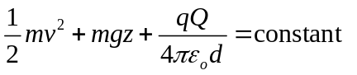

Because it is located on a circle of radius R whose center is at 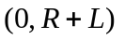, we must have

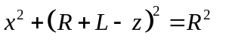
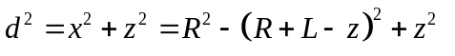
So conservation of energy becomes:
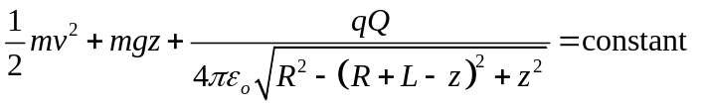
We evaluate the constant at t = 0, when the charge is at 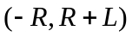 with zero velocity:
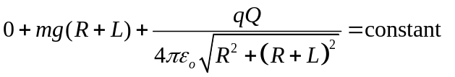
So we can now rewrite equation (1.4) as
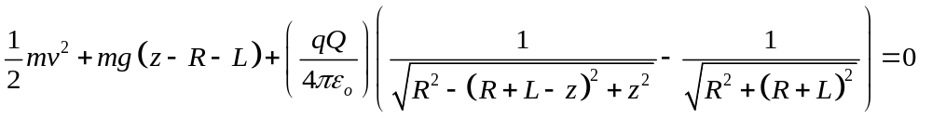
For the velocity to be zero at 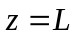, we must have therefore
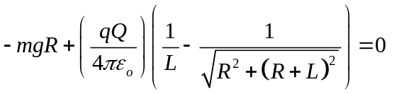
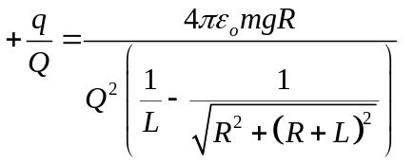
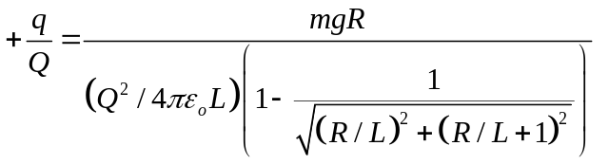

(b) For the purposes of our problem, assume that the height of the support is 25 cm, and the length of the pendulum is 20 cm, so the distance L is 5 cm. The mass of the bob with the swinging magnet is 5 g. The stationary charge has a value of 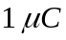 Using equation 1.10, calculate the value of the charge of the swinging charge q that will just bring the pendulum to rest when it Is vertical. Remember to convert your units to MKS before calculating.
Answer:
Solution to (b):
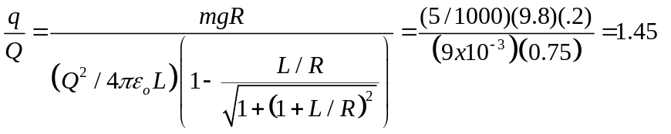
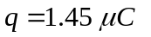

(c) Suppose we reverse the sign of q. The charge q will now arrive at the bottom of its swing with additional energy because of the electrostatic attraction in this situation. With no charge, the speed of the charge at the bottom of the swing is 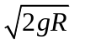. If we want the charge in this new circumstance to arrive at the bottom of its swing with 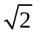times this “no charge” speed (that is, with twice the kinetic energy), what now is the value of 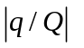?
Solution to (c):
Our new energy equation is
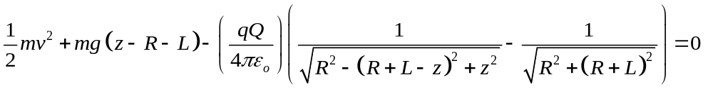
For the speed to be 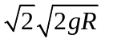 at 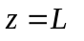we must have at
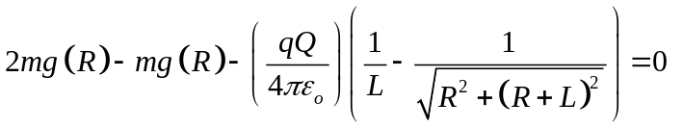
Or
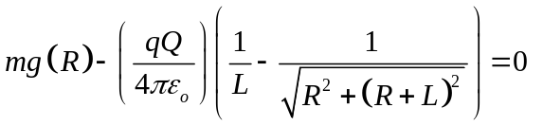
This equation is the same as equation (1.8), so the absolute value of the ratio q/Q does not change from part (a).

