Nama : Rahma Fitri Asriani

NIM : 11551201988

**Hasil run program**

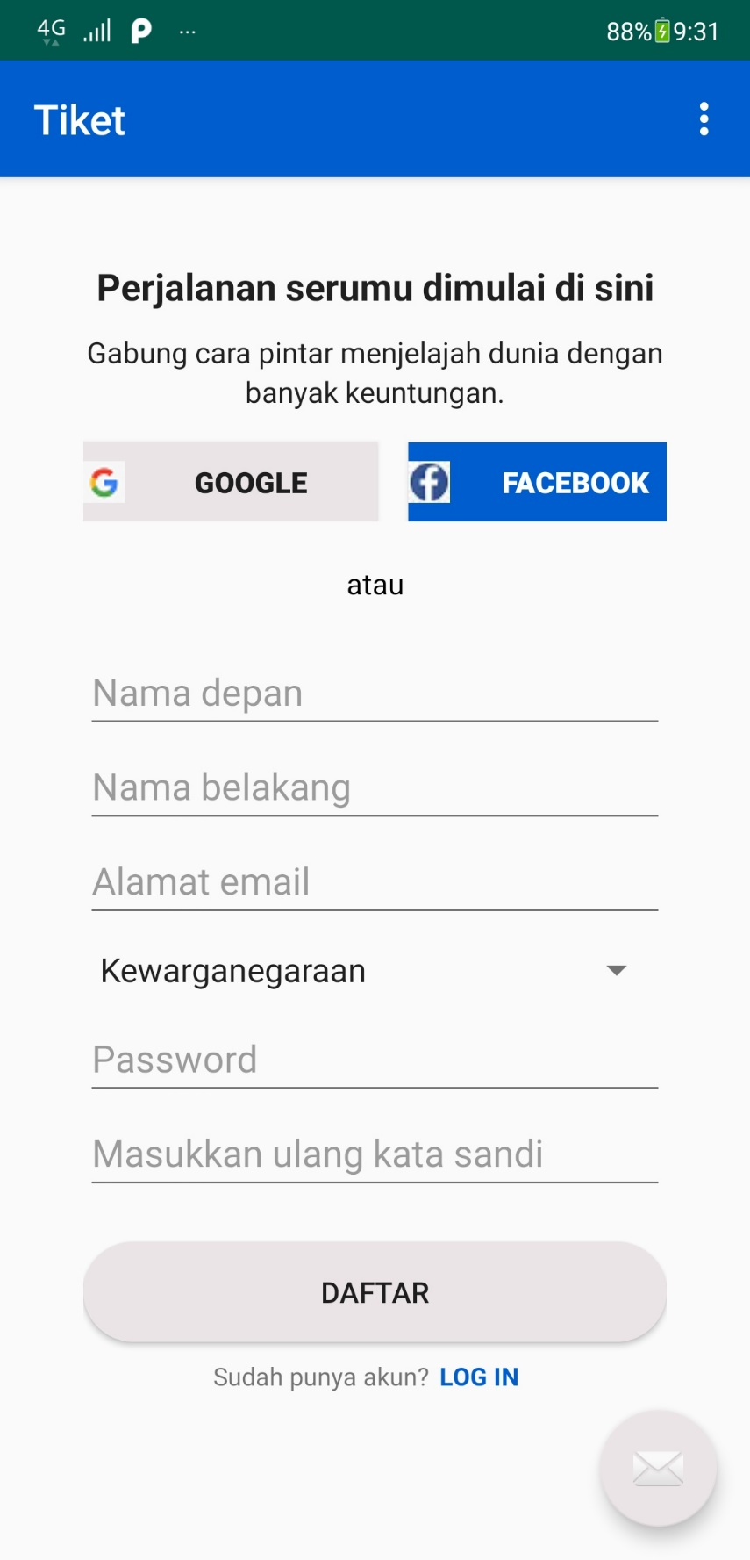

**Kode XML content_register.xml**

*<?***xml version="1.0" encoding="utf-8"***?>*<**android.support.constraint.ConstraintLayout xmlns:android="http://schemas.android.com/apk/res/android"  
 xmlns:app="http://schemas.android.com/apk/res-auto"  
 xmlns:tools="http://schemas.android.com/tools"  
 android:layout_width="match_parent"  
 android:layout_height="match_parent"  
 app:layout_behavior="@string/appbar_scrolling_view_behavior"  
 tools:context=".register"  
 tools:showIn="@layout/activity_register"**>  
  
 <**LinearLayout  
 android:layout_width="match_parent"  
 android:layout_height="match_parent"  
 android:orientation="vertical"  
 tools:layout_editor_absoluteX="1dp"  
 tools:layout_editor_absoluteY="76dp"**>  
  
 <**LinearLayout  
 android:layout_width="match_parent"  
 android:layout_height="match_parent"  
 android:layout_marginLeft="40dp"  
 android:layout_marginTop="40dp"  
 android:layout_marginRight="40dp"  
 android:layout_marginBottom="10dp"  
 android:orientation="vertical"**>  
  
 <**TextView  
 android:id="@+id/tv_judul"  
 android:layout_width="match_parent"  
 android:layout_height="wrap_content"  
 android:fontFamily="sans-serif"  
 android:text="Perjalanan serumu dimulai di sini"  
 android:textAlignment="center"  
 android:textAppearance="@style/TextAppearance.AppCompat"  
 android:textSize="18sp"  
 android:textStyle="bold"** />  
  
 <**TextView  
 android:id="@+id/tv_judul2"  
 android:layout_width="match_parent"  
 android:layout_height="wrap_content"  
 android:layout_marginTop="10dp"  
 android:text="@string/gabung_cara_pintar_menjelajah_dunia_dengan"  
 android:textAlignment="center"  
 android:textAppearance="@style/TextAppearance.AppCompat"  
 android:textSize="14sp"** />  
  
 <**TextView  
 android:id="@+id/tv_judul3"  
 android:layout_width="match_parent"  
 android:layout_height="wrap_content"  
 android:text="@string/banyak_keuntungan"  
 android:textAlignment="center"  
 android:textAppearance="@style/TextAppearance.AppCompat"  
 android:textSize="14sp"** />  
  
 <**LinearLayout  
 android:layout_width="match_parent"  
 android:layout_height="wrap_content"  
 android:orientation="horizontal"**>  
  
 <**Button  
 android:id="@+id/bt_google"  
 android:layout_width="141dp"  
 android:layout_height="38dp"  
 android:layout_marginTop="15dp"  
 android:background="@color/colorAccent"  
 android:drawableStart="@drawable/google"  
 android:text="@string/google"  
 android:textAlignment="center"  
 android:textStyle="bold"** />  
  
 <**Button  
 android:id="@+id/bt_facebook"  
 android:layout_width="141dp"  
 android:layout_height="38dp"  
 android:layout_marginLeft="15dp"  
 android:layout_marginTop="15dp"  
 android:background="@color/colorPrimary"  
 android:drawableStart="@drawable/fb"  
 android:text="Facebook"  
 android:textAlignment="center"  
 android:textColor="@android:color/background_light"  
 android:textStyle="bold"** />  
  
 </**LinearLayout**>  
  
 <**TextView  
 android:id="@+id/tv_atau"  
 android:layout_width="match_parent"  
 android:layout_height="wrap_content"  
 android:layout_marginTop="20dp"  
 android:layout_marginBottom="20dp"  
 android:text="atau"  
 android:textAlignment="center"  
 android:textColor="@android:color/black"  
 android:textSize="14sp"** />  
  
 <**EditText  
 android:id="@+id/et_nama_d"  
 android:layout_width="match_parent"  
 android:layout_height="wrap_content"  
 android:ems="10"  
 android:hint="@string/nama_depan"  
 android:inputType="textPersonName"** />  
  
 <**EditText  
 android:id="@+id/et_nama_b"  
 android:layout_width="match_parent"  
 android:layout_height="wrap_content"  
 android:autofillHints=""  
 android:ems="10"  
 android:hint="@string/nama_belakang"  
 android:inputType="textPersonName"** />  
  
 <**EditText  
 android:id="@+id/et_ae"  
 android:layout_width="match_parent"  
 android:layout_height="wrap_content"  
 android:autofillHints=""  
 android:ems="10"  
 android:hint="@string/alamat_email"  
 android:inputType="textEmailAddress"** />  
  
 <**Spinner  
 android:id="@+id/s_kewarganegaraan"  
 android:layout_width="match_parent"  
 android:layout_height="40dp"  
 android:entries="@array/Kewarganegaraan"  
 android:visibility="visible"** />  
  
 <**EditText  
 android:id="@+id/et_password"  
 android:layout_width="match_parent"  
 android:layout_height="wrap_content"  
 android:ems="10"  
 android:hint="Password"  
 android:inputType="textPassword"** />  
  
 <**EditText  
 android:id="@+id/et_sandi_ulang"  
 android:layout_width="match_parent"  
 android:layout_height="wrap_content"  
 android:ems="10"  
 android:hint="Masukkan ulang kata sandi"  
 android:inputType="textPassword"** />  
  
 <**Button  
 android:id="@+id/bt_daftar"  
 android:layout_width="match_parent"  
 android:layout_height="wrap_content"  
 android:layout_marginTop="20dp"  
 android:text="Daftar"  
 android:background="@drawable/circle"** />  
  
 <**LinearLayout  
 android:layout_width="match_parent"  
 android:layout_height="match_parent"  
 android:orientation="horizontal"**>  
  
 <**TextView  
 android:id="@+id/tv_opsi_login"  
 android:layout_width="166dp"  
 android:layout_height="wrap_content"  
 android:layout_marginTop="8dp"  
 android:text="Sudah punya akun?"  
 android:textAlignment="viewEnd"  
 android:textSize="12sp"** />  
  
 <**TextView  
 android:id="@+id/tv_login"  
 android:layout_width="265dp"  
 android:layout_height="wrap_content"  
 android:layout_marginStart="5dp"  
 android:layout_marginTop="8dp"  
 android:text="LOG IN"  
 android:textColor="@color/colorPrimary"  
 android:textSize="12sp"  
 android:textStyle="bold"** />  
  
 </**LinearLayout**>  
  
 </**LinearLayout**>  
 </**LinearLayout**>  
  
</**android.support.constraint.ConstraintLayout**>

**Kode XML activity_register.xml**

*<?***xml version="1.0" encoding="utf-8"***?>*<**android.support.design.widget.CoordinatorLayout xmlns:android="http://schemas.android.com/apk/res/android"  
 xmlns:app="http://schemas.android.com/apk/res-auto"  
 xmlns:tools="http://schemas.android.com/tools"  
 android:layout_width="match_parent"  
 android:layout_height="match_parent"  
 tools:context=".register"**>  
  
 <**android.support.design.widget.AppBarLayout  
 android:layout_width="match_parent"  
 android:layout_height="wrap_content"  
 android:theme="@style/AppTheme.AppBarOverlay"**>  
  
 <**android.support.v7.widget.Toolbar  
 android:id="@+id/toolbar"  
 android:layout_width="match_parent"  
 android:layout_height="?attr/actionBarSize"  
 android:background="?attr/colorPrimary"  
 app:popupTheme="@style/AppTheme.PopupOverlay"** />  
  
 </**android.support.design.widget.AppBarLayout**>  
  
 <**include layout="@layout/content_register"** />  
  
  
 <**android.support.design.widget.FloatingActionButton  
 android:id="@+id/fab"  
 android:layout_width="wrap_content"  
 android:layout_height="wrap_content"  
 android:layout_gravity="bottom|end"  
 android:layout_margin="@dimen/fab_margin"  
 app:srcCompat="@android:drawable/ic_dialog_email"** />  
  
</**android.support.design.widget.CoordinatorLayout**>