**Writing the final paper**

The final paper should summarize your project goals, describe the data, the experiment, and the results. The paper should include figures, tables and bibliography as needed. Manuscript file format should be Latex (tex). A Latex template is provided. The template will make it easier to get used to Latex, and you can start by just replacing the content in the template with your content. The provided template is merely a suggestion, and you can choose to use a different Latex template.

There are several tools that can be used for Latex. MikTex installed with TexWorks is a convenient and very commonly used Latex tool, and it is free to download and use. You can also use the popular Overleaf on-line service. If you use Overleaf, you do not need to install software on your computer.

MikTex is available at <https://miktex.org/>

TeXworks is available at <http://www.tug.org/texworks/>

If you choose to use Overleaf, you will need to create a free account at <https://www.overleaf.com/>

The paper should be detailed, and provide information regarding all aspects of the data analysis process. That includes the insights and discoveries that were made, and a detailed description of how they were made. The paper is not a chronological description of everything that you did, but a summary of the important insights and the way they were made. The paper should provide sufficient details to allow the reader to reproduce the results.

The final report should include an abstract, which is a summary of the project. It should also include sections that describe the data and the different types of analysis applied to the data.

The paper should be original and written by you. Please do not copy and paste paragraphs you find in other sources written by other people. You can use ideas and work done in the past by other people, but you need to describe that work in your own words (not copying-pasting), and make a reference to the source.

**References**

The bibliography should list sources (papers, books, web sites etc’) of previous work related to your project, or work that was done by others and used by you. Here we will use the APA reference format, with Bibtex. An example of how to use that format with Bibtex is available in the Latex template.

If you use Overleaf, you will need to create the file in the same folder of your Overleaf paper. In the figure below, the file “main.text” is the document file, and the file “references.bib” is the bibliography file used by BibTex. The “.bst” file is an optional file that determines the style of the bibliography. The “.cls” files are optional files that determine the formatting of the paper.

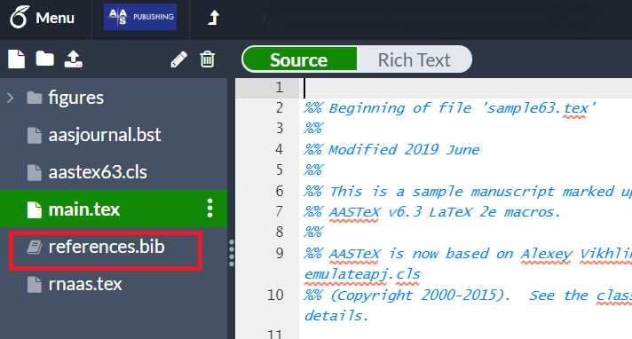

When using Bibtex, a separate file for the bibliography is needed. An example of such file is provided with the template. The easiest way to create such file is by using Google Scholar. You can search for the article in <https://scholar.google.com> by its title, and find the paper you want to cite.

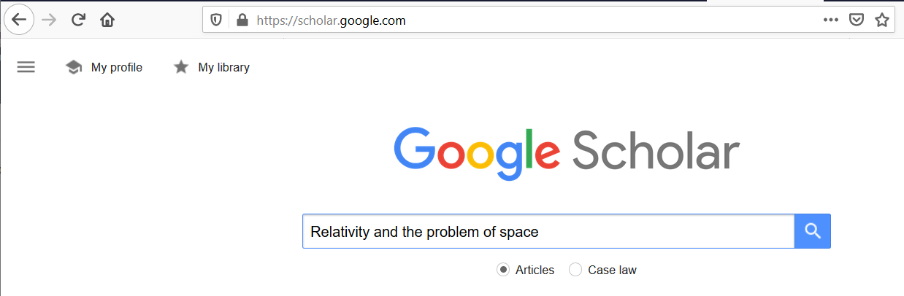

After clicking the search button, you can click the “ symbol.

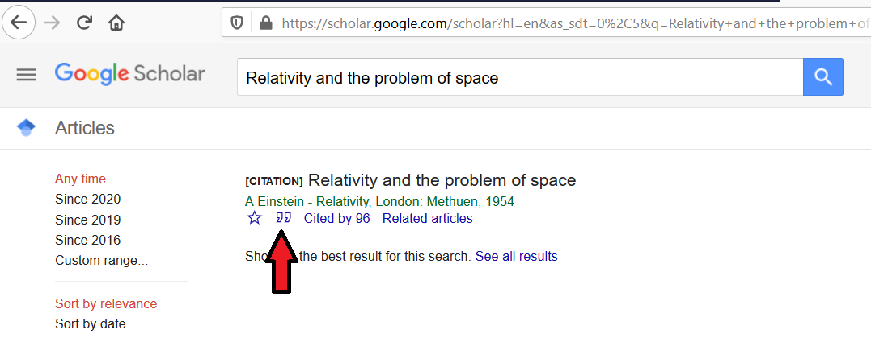

and then select the Bibtex option.

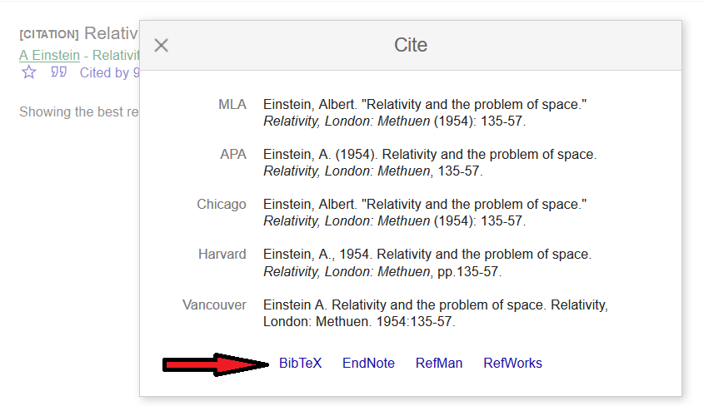

Then you can easily copy and paste the text into your .bib file.

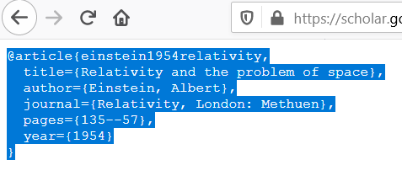

Note that all items in the bibliography should be mentioned in the body of your paper. Bibliography items not mentioned in the text will be excluded automatically from the reference list by Bibtex.

**Figures and tables**

Figures and tables are very important part of the report, and you will need to include them. Each figure and table should be numbered, and should be referenced in the text. Also, each figure or table should have a caption that briefly describes the figure or the table. The Latex template shows examples of how to use tables and figures in latex.

Figures of graphs should be in vector graphics. Please do not use screenshots for tables or graphs.