ps6.R

benjamin

2020-03-05

## 2 trosset 7.7 ex1  
#a  
a1 <- read.table(url("http://mypage.iu.edu/~mtrosset/StatInfeR/Data/sample771.dat"))  
a1v <- c(a1[,1],a1[,2],a1[,3],a1[,4],a1[,5])  
plot(ecdf(a1v),main="ECDF")

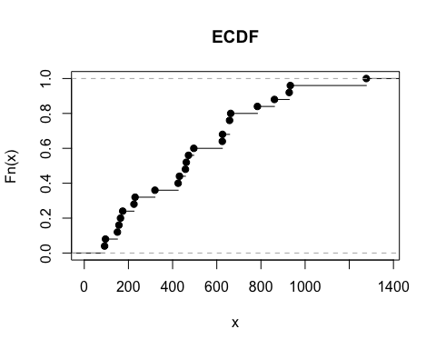

#b  
mean1 <- mean(a1v)  
var1 <- var(a1v)  
sd1 <- sqrt(var1)  
print(mean1)

## [1] 494.6

print(var1)

## [1] 94873.67

#c  
med1 <- median(a1v)  
iq1 <- qnorm(0.75, mean=mean1, sd=sd1) - qnorm(0.25, mean=mean1, sd=sd1)  
print(med1)

## [1] 462

print(iq1)

## [1] 415.5069

#e  
boxplot(a1v,main="boxplot")

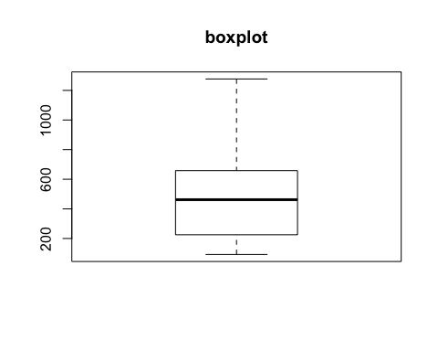

#f  
qqnorm(a1v,main="normal probability plot")

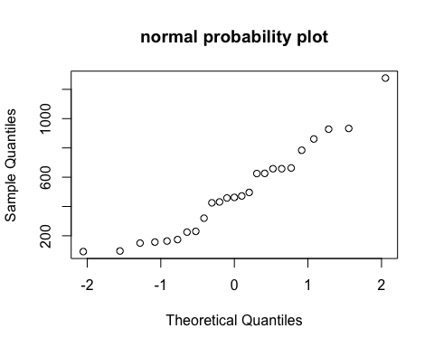

#g  
plot(density(a1v),main="kernal density estimate")

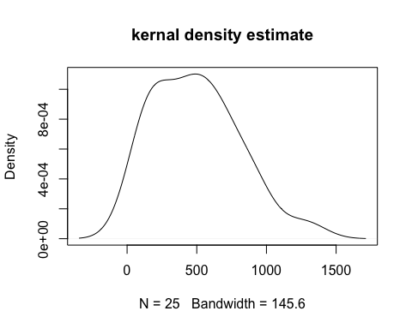

#h  
h1 = "I do not think that this sample was drawn from a normal distribtion because it looks skewed to the left."  
print(h1)

## [1] "I do not think that this sample was drawn from a normal distribtion because it looks skewed to the left."

## 3 trosset 7.7 ex2  
#a  
a2 <- read.table(url("http://mypage.iu.edu/~mtrosset/StatInfeR/Data/pulses.dat"),fill = TRUE)  
a2v <- c(a2[,1],a2[,2],a2[,3],a2[,4],a2[,5],a2[,6],a2[,7],a2[,8],a2[,9],a2[,10])  
a2v = a2v[!is.na(a2v)]  
plot(ecdf(a2v),main="ECDF")

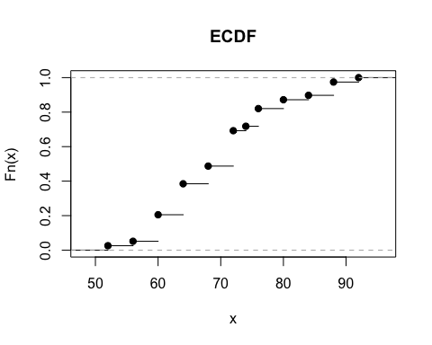

#b  
mean2 <- mean(a2v)  
var2 <- var(a2v)  
sd2 <- sqrt(var2)  
print(mean2)

## [1] 70.30769

print(var2)

## [1] 90.21862

#c  
med2 <- median(a2v)  
iq2 <- qnorm(0.75, mean=mean2, sd=sd2) - qnorm(0.25, mean=mean2, sd=sd2)  
print(med2)

## [1] 72

print(iq2)

## [1] 12.81308

#e  
boxplot(a2v,main="boxplot")

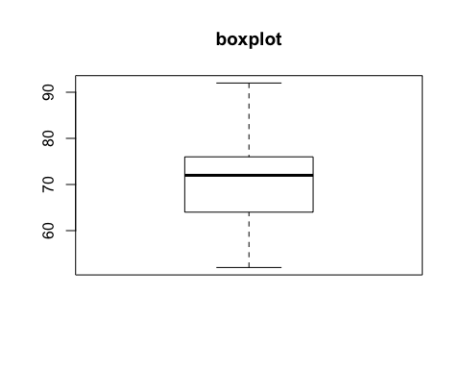

#f  
qqnorm(a2v,main="normal probability plot")

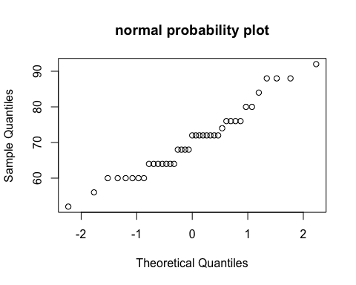

#g  
plot(density(a2v),main="kernal density estimate")

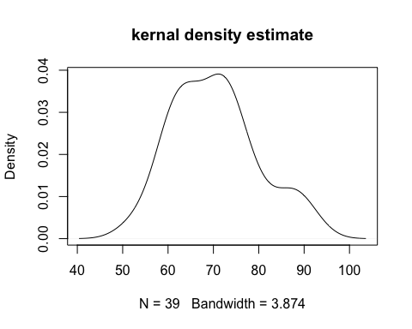

#h  
h2 = "I think that this data looks relatively normal with some outliers and a slight skew to the left. The basic structure of the bell curve, including the location of the mode and median, makes it seem slightly normal."  
print(h2)

## [1] "I think that this data looks relatively normal with some outliers and a slight skew to the left. The basic structure of the bell curve, including the location of the mode and median, makes it seem slightly normal."