Integrating Motion and Orientation Sensors

December 18, 2015

Abstract

This paper is intended to help OEMs, ODMs, and IHVs understand motion and orientation sensor capabilities and requirements for Windows 10 and earlier operating systems. The paper also shows how these capabilities are engineered and implemented on PC hardware platforms running Windows. This technology area involves 3D accelerometer, 3D magnetometer/compass, and 3D gyrometer sensor hardware.

This paper does not cover application development or sensor technology that is not directly related to orientation and motion detection.

This information applies to the following operating systems:

Windows 10 and earlier

The current version of this paper is maintained on the Web at:   
 [Integrating Motion and Orientation Sensors](http://msdn.microsoft.com/en-us/library/windows/hardware/br259127.aspx)

**Disclaimer**: This document is provided “as-is”. Information and views expressed in this document, including URL and other Internet website references, may change without notice. Some information relates to pre-released product which may be substantially modified before it’s commercially released. Microsoft makes no warranties, express or implied, with respect to the information provided here. You bear the risk of using it.

Some examples depicted herein are provided for illustration only and are fictitious. No real association or connection is intended or should be inferred.

This document does not provide you with any legal rights to any intellectual property in any Microsoft product. You may copy and use this document for your internal, reference purposes.

© 2015 Microsoft. All rights reserved.

C:\Users\jenlin\AppData\Local\Microsoft\Windows\Temporary Internet Files\Content.Outlook\KN5ONHWU\dep_MicrosoftLogotype.png

Document History

|  |  |  |  |  |
| --- | --- | --- | --- | --- |
| Date | Change |  |  |  |
| December 18, 2015 | Updated section about Filtering Data Update Events by Evaluating Effective CRI and CS values (E-CRI, E-CS) | | | |
| June 10, 2013 | Added restrictions for W component of a Quaternion | | | |
| June 5, 2013 | Moved new magnetometer text to its own section. | | | |
| June 3, 2013 | Replaced art that incorrectly depicted Y- and Z-axis. | | | |
| April 25, 2013 | Added section describing change sensitivity for the inclinometer and orientation sensors. | | | |
| March 5, 2013 | Updated section for calculating E-CRI/E-CS | | | |
| September 28, 2012 | Updated value in the Pitch Rotations table | | | |
| June 13, 2012 | Updated Word template | | | |
| September 13, 2011 | First publication | | | |

Contents

[Overview of Motion and Device Orientation 4](#_Toc358625081)

[Definitions and Terminologies 4](#_Toc358625082)

[Windows Motion and Orientation Features and Scenarios 5](#_Toc358625083)

[Windows 8 In-Box Motion and Orientation Scenarios 5](#_Toc358625084)

[Windows 8 Third-Party Motion and Orientation Application Scenarios 5](#_Toc358625085)

[Windows Sensor Requirements 5](#_Toc358625086)

[Motion/Orientation Sensor Implementation Checklists 6](#_Toc358625087)

[IHV System Sensor Development Checklist: 7](#_Toc358625088)

[Reference Frames and Common Measurement Conventions for Motion and Orientation Sensors 9](#_Toc358625089)

[Device Reference Frame 9](#_Toc358625090)

[Earth Reference Frame 15](#_Toc358625091)

[Sensor Hardware to Sensor Object Mappings 16](#_Toc358625092)

[Implementation Guidelines 18](#_Toc358625093)

[Integrating 3D Accelerometer Sensors with Windows 18](#_Toc358625094)

[Accelerometer Part Selection Guidelines 19](#_Toc358625095)

[Accelerometer Driver Specifics 19](#_Toc358625096)

[Supporting Shake Gesture Events 22](#_Toc358625097)

[Validation of 3D Accelerometer Hardware Integration 24](#_Toc358625098)

[Integrating Magnetometer Sensors with Windows 25](#_Toc358625099)

[Magnetometer Accuracy 25](#_Toc358625100)

[Integrating Compass Sensors with Windows 28](#_Toc358625101)

[Compass Technology Overview 29](#_Toc358625102)

[Magnetometer Part Selection Guidelines 29](#_Toc358625103)

[Compass Driver Specifics 30](#_Toc358625104)

[Hysteresis for Heading Reference Axis Stability 32](#_Toc358625105)

[Validation of 3D Compass Hardware Integration 35](#_Toc358625106)

[Integrating Gyrometer Sensors with Windows 36](#_Toc358625107)

[Part Selection Guidelines 36](#_Toc358625108)

[Gyrometer Axes, Data Types, Capabilities 36](#_Toc358625109)

[3D Gyrometer Driver Specifics 38](#_Toc358625110)

[Validation of 3D Gyrometer Hardware Integration 40](#_Toc358625111)

[Integrating Sensor Fusion Sensors with Windows 41](#_Toc358625112)

[Sensor Fusion Integration 41](#_Toc358625113)

[3D Inclinometer and Device Orientation Axes, Data Types, Capabilities 42](#_Toc358625114)

[Order of Rotations for Yaw, Pitch, and Roll 44](#_Toc358625115)

[Angular Ranges for Yaw, Pitch, Roll 44](#_Toc358625116)

[3D Inclinometer Sensor Driver Specifics 46](#_Toc358625117)

[Aggregated Device Orientation Sensor Driver Specifics 49](#_Toc358625118)

[Validation of Sensor Fusion Implementation 53](#_Toc358625119)

[9-Axis Data Accuracy Guidelines 53](#_Toc358625120)

[Hardware Integration Options and Guidelines 55](#_Toc358625121)

[Mechanical and Electrical Engineering Considerations 55](#_Toc358625122)

[Mechanical and Electromagnetic Considerations for Magnetometer 55](#_Toc358625123)

[Component-Level Integration Options 56](#_Toc358625124)

[Sensor Sub-Processor (MCU) Decision Workflow 56](#_Toc358625125)

[Connectivity Options 57](#_Toc358625126)

[Leveraging In-box Driver Support 60](#_Toc358625127)

[Writing a Custom Sensor Driver 62](#_Toc358625128)

[Proper Support for Time and Magnitude Thresholds (Filtering Criteria) 63](#_Toc358625129)

[Events of Interest 64](#_Toc358625130)

[Default Values for CS and CRI for Motion Sensors 65](#_Toc358625131)

[Change Sensitivity (CS) for the Inclinometer and Orientation Sensors 65](#_Toc358625132)

[Filtering Data Update Events by Evaluating Effective CRI and CS values (E-CRI, E-CS) 66](#_Toc358625133)

[Device Data Update Modes 67](#_Toc358625134)

[Power Management Best-Practices 67](#_Toc358625135)

[Testing and Validation 68](#_Toc358625136)

[Calibration 69](#_Toc358625137)

[Per-Model Calibration 69](#_Toc358625138)

[Per-System Calibration 70](#_Toc358625139)

[End-User Calibration and Continuous Auto-Calibration 70](#_Toc358625140)

[Preferred: Continuous Auto-Calibration 70](#_Toc358625141)

[Not Preferred: End User Calibration 70](#_Toc358625142)

[Appendix 70](#_Toc358625143)

[Accelerometer Measurement Conventions 70](#_Toc358625144)

[Validation of Euler Angles (Yaw, Pitch, Roll) for 3D Inclinometer 75](#_Toc358625145)

[Yaw Tests Overview 75](#_Toc358625146)

[Test Steps for Yaw 76](#_Toc358625147)

[Pitch Tests Overview 77](#_Toc358625148)

[Pitch Test Steps 78](#_Toc358625149)

[Roll Tests Overview 80](#_Toc358625150)

[Roll Test Steps 80](#_Toc358625151)

[Expected quaternion values for Euler angle rotations 83](#_Toc358625152)

[Expected values for Tilt-Compensated Compass Heading 85](#_Toc358625153)

# Overview of Motion and Device Orientation

This paper is intended to help OEMs, ODMs, and IHVs understand motion and orientation sensor capabilities and requirements for Windows 8 and also to document how these capabilities are engineered and implemented on PC hardware platforms running Windows 8. This technology area involves 3D accelerometer, 3D magnetometer/compass, and 3D gyrometer sensor hardware.

This paper does not cover application development or sensor technology that is not directly related to orientation and motion detection.

## Definitions and Terminologies

The following terms, definitions, and acronyms are used in this document.

|  |  |
| --- | --- |
| Term or Acronym | Meaning |
| 3D compass | A 3-axis magnetometer and accelerometer used to calculate tilt compensated device heading relative to either the magnetic North pole, or the true North pole. |
| Sensor fusion | The process of using multiple sensor inputs to enhance or synthesize data that is output- related to sensors.  **Example**: Using 3D accelerometer, 3D Gyro, and 3D Magnetometer data to construct compass, inclinometer, device orientation, and other forms of orientation data. |
| MCU (Micro Control Unit) | A small dedicated processor with onboard memory and other functionality. |
| Sensor sub-processor | An MCU dedicated primarily to sensor-related calculations or data throughput. |
| UMDF (User Mode Driver Framework) | A Windows driver framework that allows driver developers to rapidly develop and debug device drivers. |
| KMDF (Kernel Mode Driver Framework) | A Windows driver framework used to write device drivers that run in kernel mode. |
| Dynamic range | The span of magnitude over which a sensor can measure changes in the measured phenomenon.  **Example:** An accelerometer with a dynamic range of -3.0G to +3.0G on each axis. |

## Windows Motion and Orientation Features and Scenarios

Motion and Orientation sensors support important in-box and third-party application development scenarios. The following list covers some of these scenarios.

### Windows 8 In-Box Motion and Orientation Scenarios

1. **Screen auto-rotation**: Requires that 3D accelerometer hardware be properly integrated (follows guidelines specified in this paper and in the Windows Hardware Certification Kit).
2. **Enhanced human presence detection:** Requires that 3D accelerometer hardware be properly integrated. A sustained change in physical device orientation is used as a means to detect the presence of a user.

### Windows 8 Third-Party Motion and Orientation Application Scenarios

1. **2D casual games:**
   1. Labyrinth-style rolling ball game
2. **3D interactive games:** Device motion/orientation as input device
   1. Steering wheel-style car racing game
   2. First-person shooter style games
3. **3D augmented reality and virtual reality applications:** 
   1. 3D photo-realistic mapping application with superimposed points of interest
   2. Indoor navigation applications

## Windows Sensor Requirements

The following table outlines the various PC form-factors and corresponding motion/orientation sensor requirements.

|  |  |  |  |
| --- | --- | --- | --- |
| P1 Sensor Category | Slate / Convertible Laptop | Non-convertible Laptop | Desktop / AIO |
| 3D Accelerometer | **Required** | If Implemented | If Implemented |
| 3D Gyrometer | **Required** | If Implemented | If Implemented |
| 3D Compass | **Required** | If Implemented | If Implemented |
| Sensor Fusion | **Required** | If Implemented | If Implemented |

Please see the WLK 2.0 at <http://connect.microsoft.com> for more details regarding sensors and system logo requirements.

## Motion/Orientation Sensor Implementation Checklists

The following list represents the various development activities and validation exercises that ensure that motion and orientation sensors function properly on PC hardware running Windows 8.

OEM/ODM System Sensor Integration Checklist:

|  |  |
| --- | --- |
| Task | Description |
| 1. Check sensor support requirements for the PC form-factor being built | Based on the form-factor for the PC being built, different requirements apply for sensors being present as well as implemented capabilities.  See [Testing and Validation](#_Testing_and_Validation) for more information regarding required sensor hardware and validation. |
| 1. Use part selection guidelines to select the appropriate sensor components and any related parts | As a part of engineering the system, select parts that have the appropriate capabilities and features in order to satisfy the functionality, performance, and cost requirements for the system in question.  See the part selection guidelines in each sensor-specific section in this document for more details. |
| 1. Decide on a motion/orientation sensor driver strategy | By 3 the capabilities of the sensor components and the available of in-box sensor drivers for Windows 8, decide which drivers will be used or implemented, and follow the appropriate device firmware implementation or driver implementation guidelines.  See [Using the in-box HID Sensor Class driver](#_Leveraging_In-box_Driver)  for more information about using the in-box driver support for motion/orientation sensors in Windows 8.  See [Writing a Custom Sensor Driver](#_Writing_a_Custom) for more information regarding writing your own driver for motion/orientation sensors. |
| 1. Follow guidance when engineering the system | Make sure to follow electrical and mechanical engineering guidance in this document. In addition to the information included in this document, seek guidance from the supplying IHV partners in order to avoid issues with heat, electromagnetic interference, and other problematic conditions. Mechanical/electrical considerations such as placement of Hall effect sensor magnets and other sources of interference should be carefully designed and compensated for when performing initial calibration for sensors for a particular PC. Orientation of measurement axes should be considered when deciding placement for sensor components. |
| 1. Validate system integration and features | Confirm that sensors are oriented correctly and that in-box features perform according to the guidelines outlined in this document.  See [Testing and Validation](#_Testing_and_Validation) for more information regarding required sensor hardware and validation |
| 1. Run system logo tests as appropriate | Once a system has sensors integrated and basic functionality validated, the system logo tests need to be run to validate proper performance and functionality.  See [Testing and Validation](#_Testing_and_Validation) for more information regarding required sensor hardware and validation |
| 1. Calibration and configuration on factory floor | Work with IHV to integrate calibration and configuration activities into production process and workflow. This can include sensor self-test routines, per-unit calibration, and other configuration activities. |

### IHV System Sensor Development Checklist:

|  |  |
| --- | --- |
| Task | Description |
| 1. Work with the customer (OEM / IHV) to understand the type of system being engineered. | Consult the [Windows Sensor Requirements](#_Windows_Sensor_Requirements) table in this document and the system requirements on <http://connect.microsoft.com> in order to determine which sensors and corresponding capabilities are required. |
| 1. Establish an inventory of sensor components (such as a 3D accelerometer, 3D magnetometer, and 3D Gyrometer) | Based on the following part selection guideline sections in this document:  [3D Accelerometer](#_Accelerometer_Part_Selection)  [3D Compass](#_Compass_Part_Selection)  [3D Gyrometer](#_Part_Selection_Guidelines)  Determine which parts will be used for the system being engineered. |
| 1. Decide whether or not a sensor sub-processor (MCU) will be utilized for the sensor system in question | Decide if an MCU will be used based on cost, integration and driver specifics, power trade-offs, and other factors.  For more information, please consult the following sections:  [Sensor Sub Processor Decision Workflow](#_Sensor_Sub-Processor_(MCU)) |
| 1. Work with OEM/ODM partner to design schematic for sensor connectivity | After all components (including sensors and any MCU or related parts) are selected, determine how the sensor components will be wired up to the host and/or MCU.  Please see [Connectivity Options](#_Connectivity_Options) for more details. |
| 1. Inventory software dependencies and deliverables | Based on the type of system being implemented, make a list of the required driver and software components and establish ownership for these deliverables, including device firmware.  For more information see:  [Using the in-box HID Sensor Class driver](#_Leveraging_In-box_Driver)  [Connectivity Options](#_Connectivity_Options)  [Writing a Custom Sensor Driver](#_Writing_a_Custom) |
| 1. Write device firmware and develop any drivers needed to support sensors. | See:  [Using the in-box HID Sensor Class driver](#_Leveraging_In-box_Driver)  [Writing a Custom Sensor Driver](#_Writing_a_Custom) |
| 1. Perform basic validation of sensor data | Perform basic validation of the orientation of sensors and sensor data as integrated with the Windows Sensor Platform.  See:  [Validation of 3D Accelerometer Hardware Integration](#_Validation_of_3D)  [Validation of 3D Gyrometer Hardware Integration](#_Validation_of_3D_1)  [Validation of 3D Compass Hardware Integration](#_Validation_of_3D_2)  [Validation of Sensor Fusion Implementation](#_Validation_of_) |
| 1. Run device logo tests, certify device drivers and device via HCK process as applicable | Ensure that the sensor device(s) will pass logo testing. Obtain HCK certification for the device(s).  Consult the [Windows Sensor Requirements](#_Windows_Sensor_Requirements) table in this document and the system requirements on <http://connect.microsoft.com> in order to determine which sensors and corresponding capabilities are required. |
| 1. Run system logo tests on PC hardware | Ensure that all sensor features are properly supported for the PC form-factor being built. Obtain HCK certification for the system (OEM does this).  Consult the [Windows Sensor Requirements](#_Windows_Sensor_Requirements) table in this document and the system requirements on <http://connect.microsoft.com> in order to determine which sensors and corresponding capabilities are required. |

## Reference Frames and Common Measurement Conventions for Motion and Orientation Sensors

There are several considerations and conventions that need to be observed and implemented in order to properly expose motion and orientation sensors on Windows.

The guidance in this section of the document is in accordance with the [W3C Device Orientation Draft Specification](http://dev.w3.org/geo/api/spec-source-orientation.html). Please read the W3C device orientation document and become familiar with the measurement conventions.

All data types use the same convention for X, Y, Z axis alignment and orientation relative to each form-factor chassis. For angular measurements, the right-hand rule is exclusively used to map positive and negative angular measurements relative to the X, Y, Z axes.

The following sections describe the reference frames that are relevant to motion/orientation sensing, and also outline which sensors use which reference frames.

### Device Reference Frame

The device reference frame is defined for each PC form-factor and provides an X, Y, Z reference frame that is fixed with respect to the hardware chassis. For the slate PC, this reference frame does not change because the slate PC form factor does not convert or change configurations.

For non-slate convertible form-factors, the Slate PC mode is the “primary” mode for accelerometer. Sensors, regardless of being placed in the screen or the base, should be projected as if they were located in the screen (as in the case of the Slate PC).

For clamshell form-factors, axis orientation should be projected to be relative to the screen regardless of where the sensors were integrated. For systems unable to detect the angle of the screen, sensors should be projected as if the screen was at a 90 degree angle to the base.

For devices unable to detect the angle of the screen, there are clear mappings for convertible form factors. These mapping can be done as so:

|  |  |  |  |  |
| --- | --- | --- | --- | --- |
| **Sensor Location** | **Screen** | **Base** | **Base** | **Base** |
| **Form Factor** | N/A | Clamshell at 90 degrees | Fold-backwards Hinge | Swivel Hinge |
| **x** | x | x | x | -x |
| **y** | y | z | -y | -y |
| **z** | z | -y | -z | z |

#### Slate PC

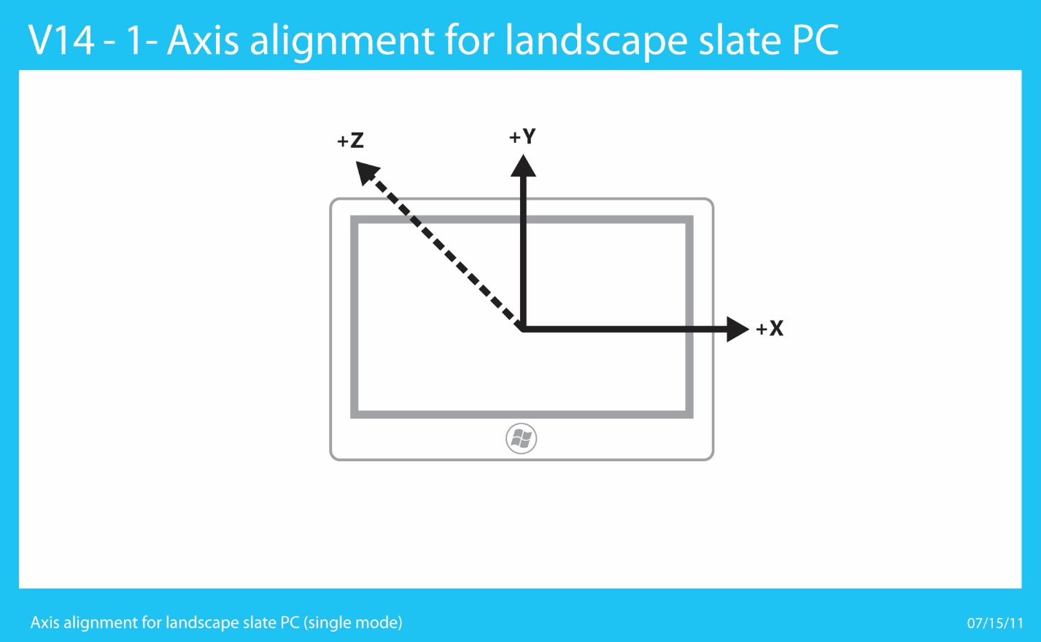

Figure 1: Landscape Slate PC (Single Mode) Chassis and Axis Convention for Motion/Orientation Sensors

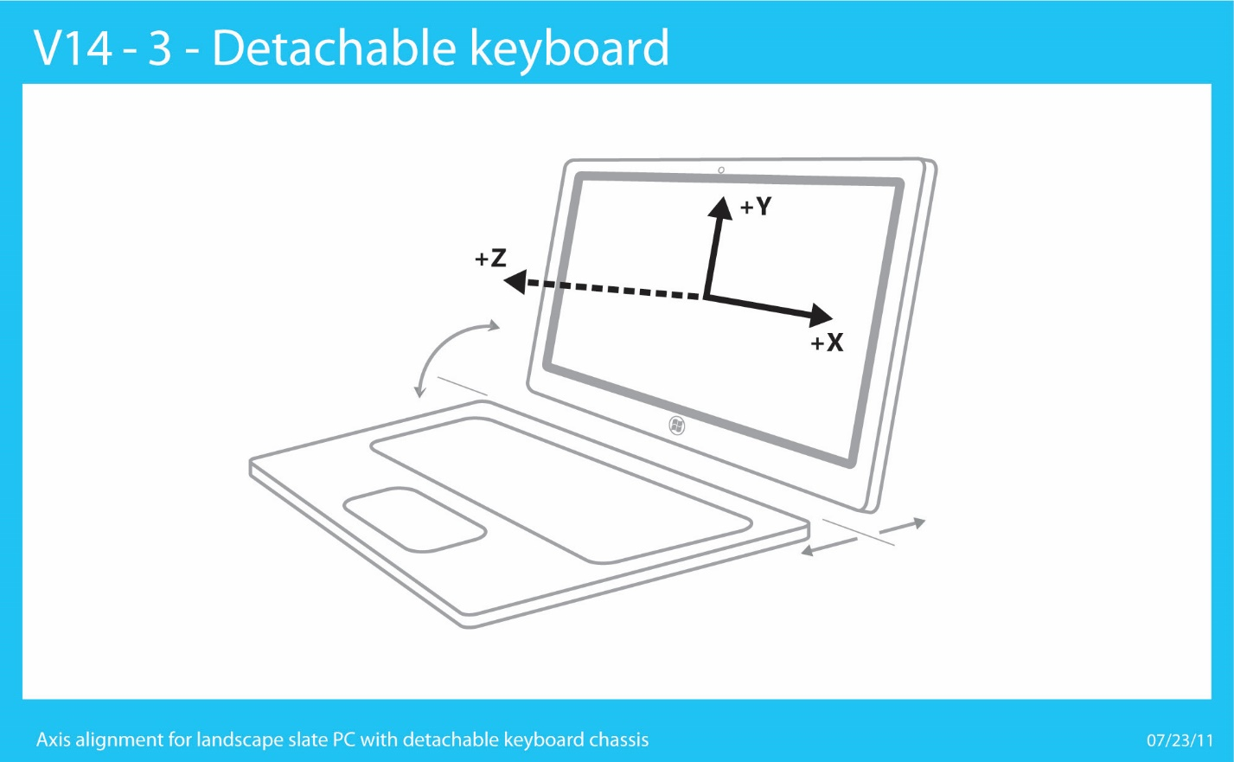

Figure 2: Landscape Slate PC with Detachable keyboard Chassis and Axis Convention for Motion/Orientation Sensors

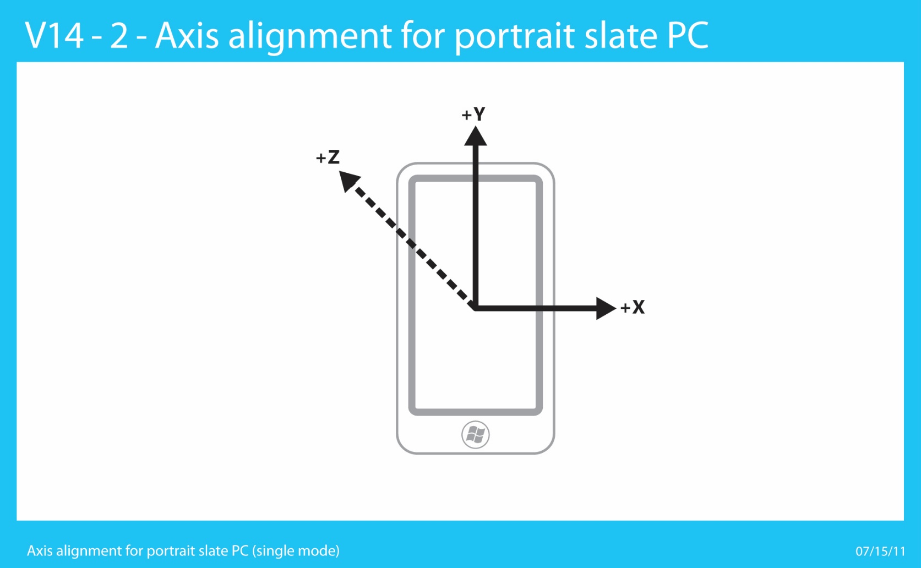

Figure 3: Portrait Slate PC (Single Mode) Chassis and Axis Convention for Motion/Orientation Sensors – Same axis convention as Windows Phone devices

#### Swivel Hinge Convertible PC

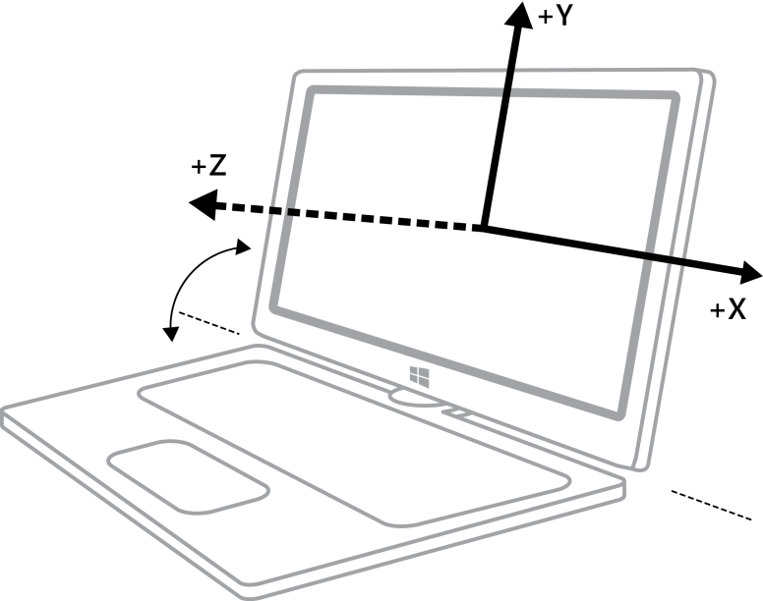

Figure 4: Swivel Hinge Convertible PC (Clamshell PC Mode) Chassis and Axis Convention for Motion/Orientation Sensors

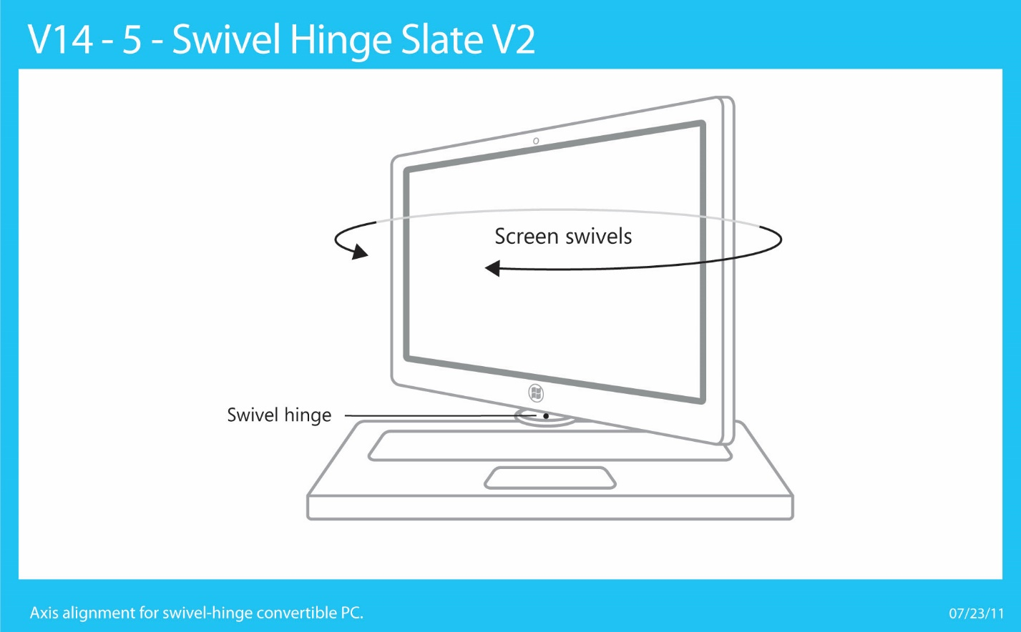

Figure 5: Swivel Hinge Convertible PC (Converting mode – axes are undefined or arbitrary) Chassis and Axis Convention for Motion/Orientation Sensors

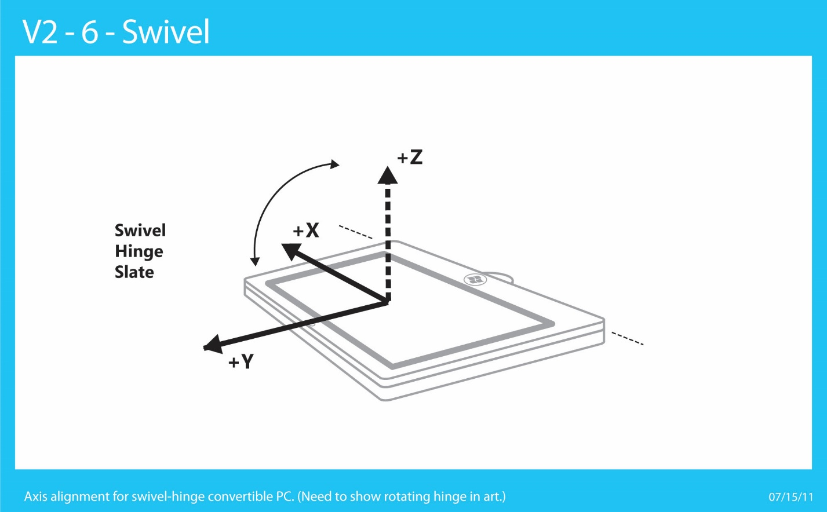

Figure 6: Swivel Hinge Convertible PC (Slate PC Mode) Chassis and Axis Convention for Motion/Orientation Sensors (Note: Windows Logo is located at the bottom of screen and +Y axis points towards the top of the screen)

#### Clamshell PC (Laptop)



Figure 7: Clamshell PC Chassis and Axis Convention for Motion/Orientation Sensors

#### Slide-out Keyboard Slate PC

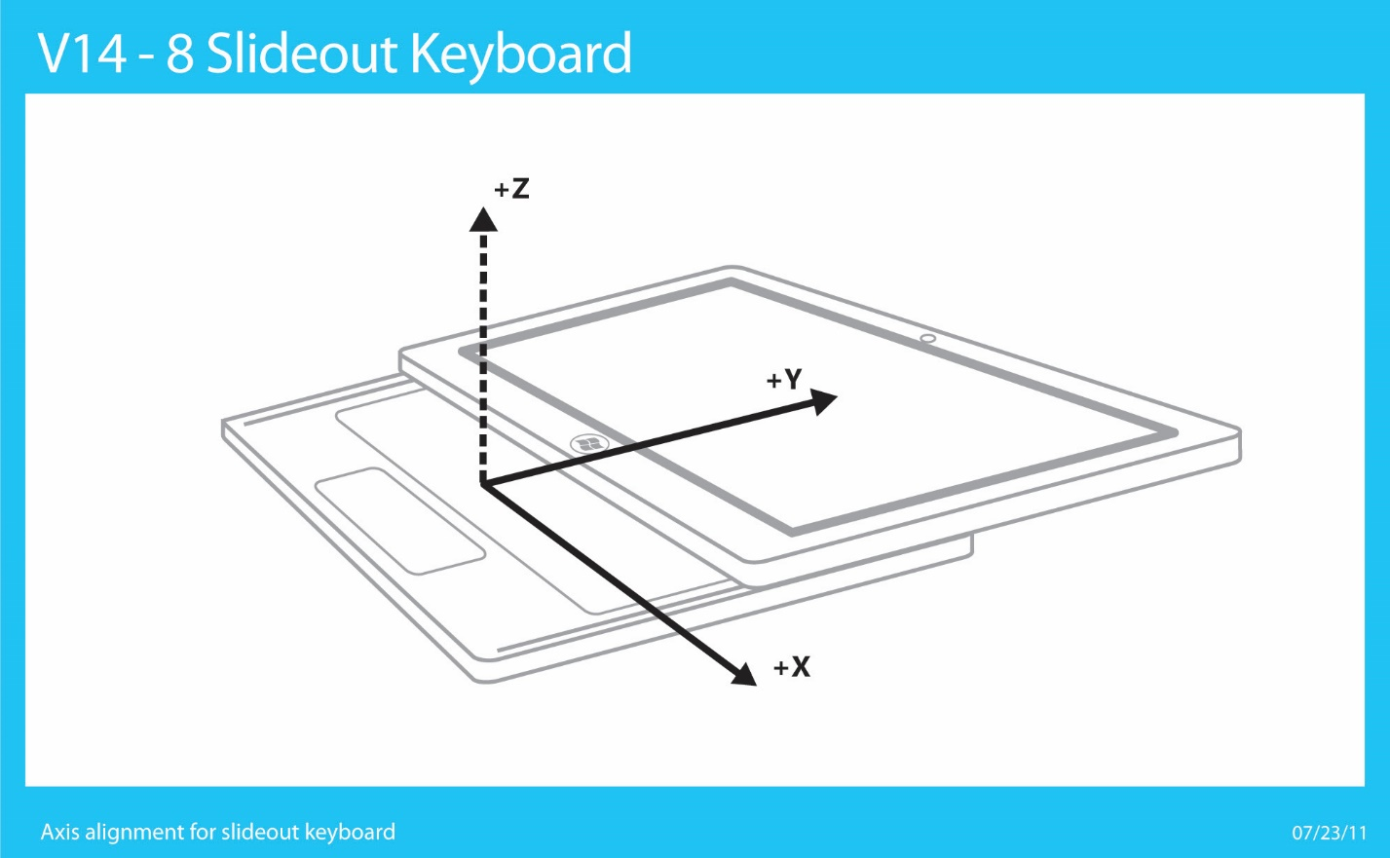

Figure 8: Slide-out Keyboard PC (Keyboard Extended Mode) Chassis and Axis Convention for Motion/Orientation Sensors

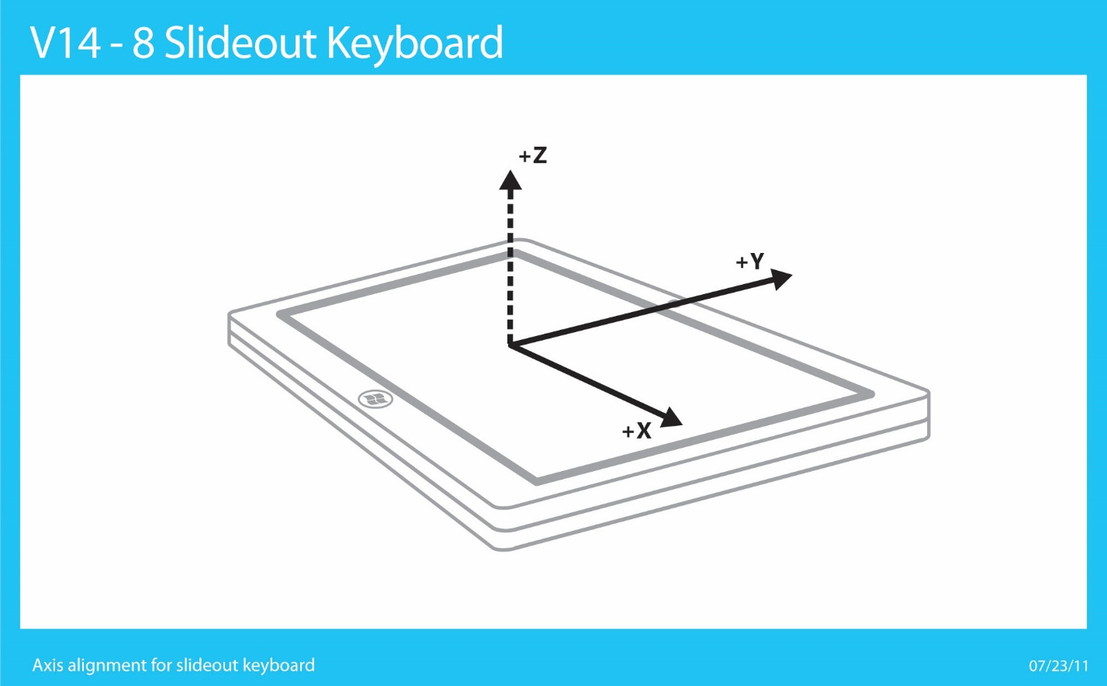

Figure 9: Slide-out Keyboard PC (Slate PC Mode) Chassis and Axis Convention for Motion/Orientation Sensors

#### Convertible Flipper PC

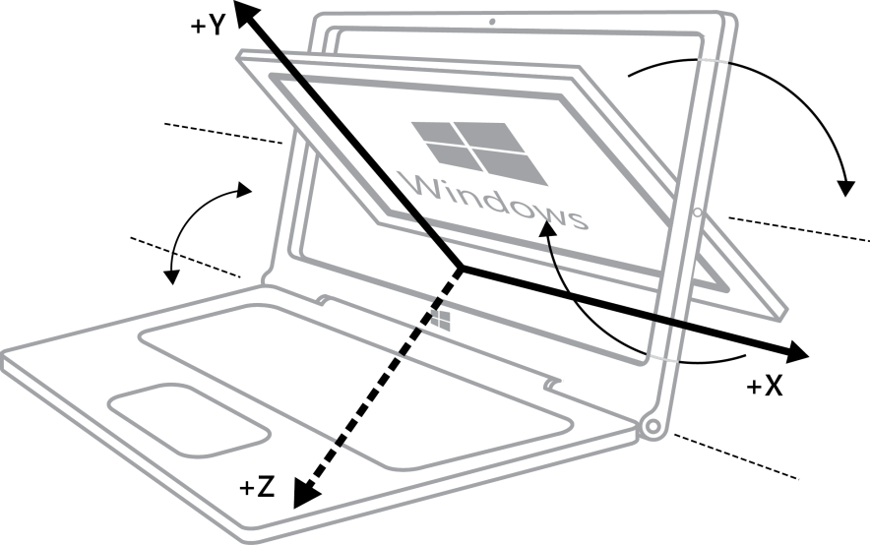

Figure 10: Convertible Flipper PC (Clamshell/Converting Mode) Chassis and Axis Convention for Motion/Orientation Sensors

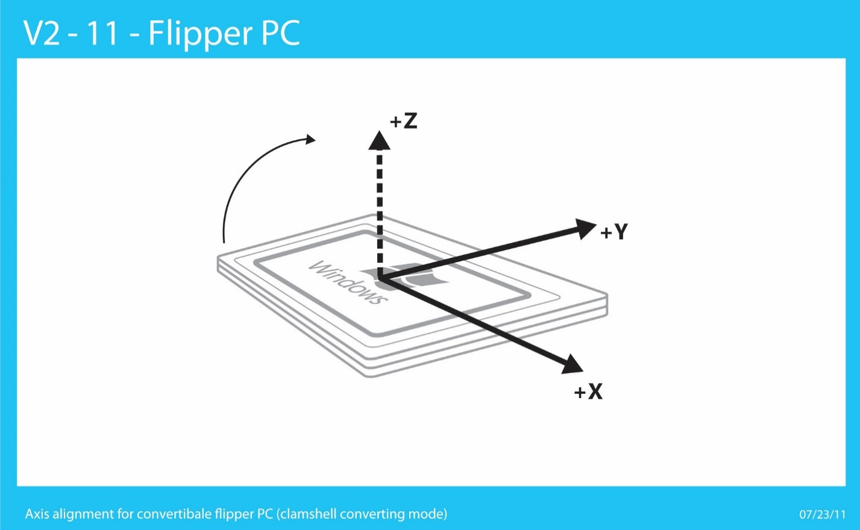

Figure 11: Convertible Flipper PC (Slate PC Mode) Chassis and Axis Convention for Motion/Orientation Sensors

### Earth Reference Frame

The earth reference frame consists of the following reference points:

1. **Ground Reference Plane:** An X, Y, Z reference frame that is represented on a level surface (plane) below the PC.
2. **North Pole:** Actual North Pole at the point around which the axis that the earth spins projects through.
3. **Magnetic North Pole:** The natural center of the magnetic field inherent to the earth above the equator.

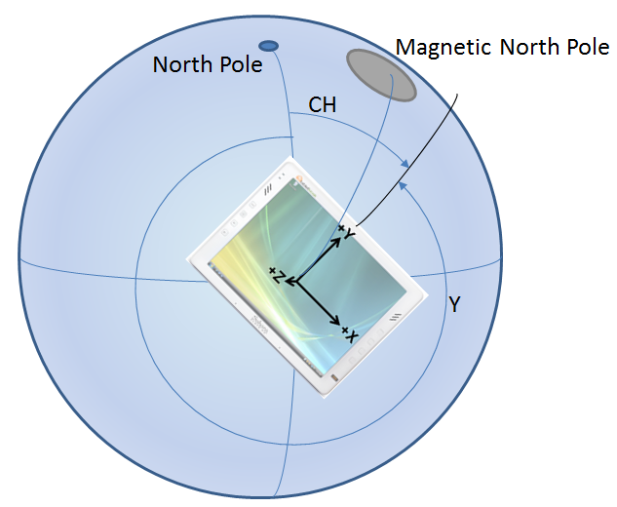

This diagram uses the following reference points:

* **North Pole:** The geometric “top” of the earth
* **Magnetic North Pole:** The upper magnetic center of the earth
* **CH:** Compass heading (relative to true North heading in this case)
* **Y:** The yaw angle of the device (360° - Compass heading). Note that yaw measurement is the rotation of the device around the axis pointing out of the screen (Z-axis). The relationship between yaw and compass heading is only applicable when the device is on a flat and level plane.

Here we see the relationship between the device reference frame (X, Y, Z axes labeled on a slate device) and the earth reference frame (level plane on earth’s surface below the device). In this case, true North heading is referenced, since the North Pole is being used to determine heading. If the Magnetic North Pole were used in instead of the North Pole, we could illustrate magnetic North heading.

### Sensor Hardware to Sensor Object Mappings

At a high level, the following diagram depicts the inputs and outputs for a full motion/orientation 9-axis sensor fusion capable implementation:



The following table lists the mapping between sensors that are exposed via the Windows sensor platform (by a sensor driver or multiple sensor drivers) and the underlying sensor hardware that is used to generate the corresponding sensor data.

|  |  |
| --- | --- |
| Sensor exposed in API | Derived from sensor hardware |
| 3D Accelerometer  Data fields:   * X Acceleration * Y Acceleration * Z Acceleration   Events:   * Shake   See [Integrating 3D Accelerometer Sensors](#_Integrating_3D_Accelerometer) for more details. | * 3D Accelerometer |
| 3D Compass  Data fields:   * Tilt compensated magnetic heading * Tilt compensated true north heading (optional; provide if location data is available to firmware or driver)   See [Integrating Compass Sensors](#_Integrating_Compass_Sensors) for more details. | * 3D Accelerometer * 3D Magnetometer * 3D Gyrometer (only required for slate) |
| 3D Gyrometer  Data fields:   * X Rotational Velocity * Y Rotational Velocity * Z Rotational Velocity   See [Integrating Gyro Sensors](#_Integrating_Gyro_Sensors) for more details. | * 3D Gyrometer |
| 3D Inclinometer  Data Fields:   * Yaw (Z-Axis) * Pitch (X-Axis) * Roll (Y-Axis)   See [Integrating Sensor Fusion Sensors](#_Integrating_Sensor_Fusion) for more details. | * 3D Accelerometer * 3D Magnetometer * 3D Gyrometer |
| Device Orientation (Rotation Matrix, Quaternion)  Data Fields:   * Rotation Matrix * Quaternion   See [Integrating Sensor Fusion Sensors](#_Integrating_Sensor_Fusion) for more details. | * 3D Accelerometer * 3D Magnetometer * 3D Gyro |

# Implementation Guidelines

The remainder of this paper provides details you’ll need when implementing the required functionality in your hardware.

## Integrating 3D Accelerometer Sensors with Windows

Accelerometers are a key hardware component for screen rotation and game/orientation application scenarios. For slate PC hardware, they also play an important role in sensor fusion (along with magnetometer and gyro data, as well). This section covers details regarding accelerometer part selection, sensor metadata, and simple validation of proper accelerometer integration.

Please refer to [Acceleration Measurement Conventions](#_Accelerometer_Measurement_Conventio) for more information about how force and acceleration is measured by accelerometers integrated with Windows PC hardware.

### Accelerometer Part Selection Guidelines

#### Types of accelerometers

Accelerometers for consumer electronics are typically either 2D (two-axis measurement device) or 3D (three-axis measurement device). In order to support orientation detection and motion/gesture detection for Windows scenarios, 3D accelerometers are required.

#### Dynamic range

The dynamic range of an accelerometer refers to the magnitude of acceleration that can be measured. In some cases the dynamic range of acceleration measurement can be configured for a particular accelerometer. If the accelerometer is configured to measure a wider range of acceleration values, the trade-off is typically lower resolution data.

* Range (as configured on system – outputs of accelerometer): +/- 4.0G

#### Accuracy and Resolution

* Non-linearity: 1.0%
* Noise: 350ug/rtHz @10Hz
* Initial calibration tolerance: +/-3%, +/-50mg

#### Sensitivity Scale Factor

* 0.12mg/LSB @ ±4g

#### Sampling rates (hardware)

* Minimum: 100 Hz
* Optimal: 200+ Hz

Note that this frequency indicates hardware sampling rate capability. Data from motion/orientation sensors (including accelerometers) should be filtered based on time (report interval) and magnitude (change sensitivity). See [Implementing a Sensor Driver](#_Writing_a_Custom) for more detail.

#### Power consumption

* Optimal: ~350uA or less

### Accelerometer Driver Specifics

See [Writing a Custom Sensor Driver](#_Writing_a_Custom) for general information and guidelines.

Accelerometers integrated with PC hardware should use the following conventions for X, Y, Z axis direction and signage.

#### 3D Accelerometer Properties

|  |  |  |
| --- | --- | --- |
| Sensor Property | Read/Write - Values/Range | Description |
| WPD\_FUNCTIONAL\_OBJECT\_CATEGORY | **Read-Only**  SENSOR\_CATEGORY\_MOTION | The sensor category |
| SENSOR\_PROPERTY\_TYPE | **Read-Only**  SENSOR\_TYPE\_ACCELEROMETER\_3D | The sensor type |
| SENSOR\_PROPERTY\_CONNECTION\_TYPE | **Read-Only**  SENSOR\_CONNECTION\_TYPE\_PC\_INTEGRATED | Describes how the sensor is connected to the PC. |
| SENSOR\_PROPERTY\_MANUFACTURER | **Read-Only**  String: <Driver or sensor manufacturer> | Describes what company manufactures the device and or provides the driver. |
| SENSOR\_PROPERTY\_PERSISTENT\_UNIQUE\_ID | **Read-Only**  This is a unique GUID for the sensor, unique as exposed on a particular machine, generated during device install time. (Reinstalling the device causes new GUIDs to be generated.) | Uniquely identifies the sensor. |
| SENSOR\_PROPERTY\_SERIAL\_NUMBER | **Read-Only**  String: <The serial number for the device> | Read only. Required, static. The sensor serial number. |
| SENSOR\_PROPERTY\_STATE | **Read-Only**  See [SensorState](http://msdn.microsoft.com/en-us/library/dd318905(v=VS.85).aspx). | The current data state for the sensor. |
| SENSOR\_PROPERTY\_MODEL | **Read-Only**  String: <Driver or sensor model> | The model of sensor or device. |
| SENSOR\_PROPERTY\_ACCURACY | **Read-Only**  Float, per data field | Accuracy of readings for each data field. |
| SENSOR\_PROPERTY\_CHANGE\_SENSITIVITY | **Read-Write**  Float, per data field | The smallest magnitude threshold that connected clients are requesting data for (or default, if no client has set this property).  This value is used by the driver to determine when a meaningful change in acceleration is detected. |
| SENSOR\_PROPERTY\_CURRENT\_REPORT\_INTERVAL | **Read-Write**  Integer (milliseconds) | The fastest interval (expressed as the period between events) at which connected clients are requesting data (or default, if no client as set this property). |
| SENSOR\_PROPERTY\_DESCRIPTION | **Read-Only**  String: <description of the sensor> | The sensor description |
| SENSOR\_PROPERTY\_RANGE\_MAXIMUM | **Read-Only**  Float, per data field | The maximum G-values reported by the accelerometer for X, Y, Z.  Example:  X = +4.0 G  Y = +4.0 G  Z = +4.0 G |
| SENSOR\_PROPERTY\_RANGE\_MINIMUM | **Read-Only**  Float, per data field | The minimum G-values reported by the accelerometer for X, Y, Z.  Example:  X = -4.0 G  Y = -4.0 G  Z = -4.0 G |
| SENSOR\_PROPERTY\_RESOLUTION | **Read-Only**  Float, per data field | The minimum change in G that the accelerometer can detect, per data-field.  Example:  X = +.001 G  Y = +.001 G  Z = +.001 G |

#### 3D Accelerometer Data Fields

|  |  |
| --- | --- |
| Sensor Data Field | Description |
| SENSOR\_DATA\_TYPE\_ACCELERATION\_X\_G | X-axis acceleration, in g's. (VT\_R8) |
| SENSOR\_DATA\_TYPE\_ACCELERATION\_Y\_G | Y-axis acceleration, in g's. (VT\_R8) |
| SENSOR\_DATA\_TYPE\_ACCELERATION\_Z\_G | Z-axis acceleration, in g's. (VT\_R8) |

#### 3D Accelerometer Events

|  |  |
| --- | --- |
| Sensor Event | Description |
| SENSOR\_EVENT\_ACCELEROMETER\_SHAKE | The event ID used when accelerometer hardware has detected that a shake event has occurred. |

### Supporting Shake Gesture Events

Use the following guidelines when implementing a shake detection algorithm in device firmware or a sensor device driver. For power management reasons, use only the accelerometer to detect shake gestures.

* **Frequency:** The oscillation frequency for shake detection should range between 200ms and 400ms period.
* **Magnitude:** The magnitude of linear acceleration change should be between ~2.0G and ~4.0G
* **Direction:** Shake gesture can be relative to any change in device direction (acceleration) and therefore, the net direction of the collective linear acceleration vector should be evaluated such that changes in direction approximating motion along a straight line (in one direction and then an opposite direction in a close to linear path) are detected.
* **Oscillation Count**: For the purposes of this algorithm, the oscillations can be broken down into individual “direction changes” (See figure 13). The number of direction changes can vary, but should be four or more.

#### Example Shake Gesture Accelerometer Data

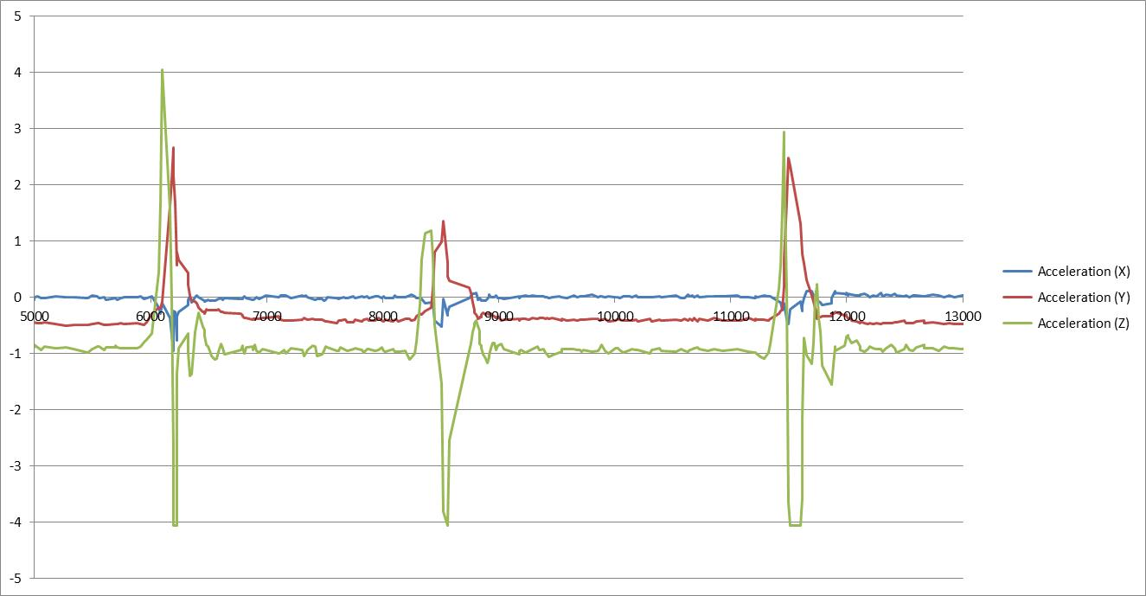

Figure 12: Typical Accelerometer Data - 3 Shakes

As shown in the diagram above, the magnitude, direction changes, oscillation count, and oscillation period can be observed for a user shaking a slate device 3 times. Actual acceleration values (with gravity) are shown here. In implementation, a high-pass filter can be used to remove the gravitational component of this accelerometer data.

If you isolate the Z-Axis accelerometer data (green), you can see a pattern in the data that can be detected in an accelerometer driver or firmware, as shown in the diagram below.

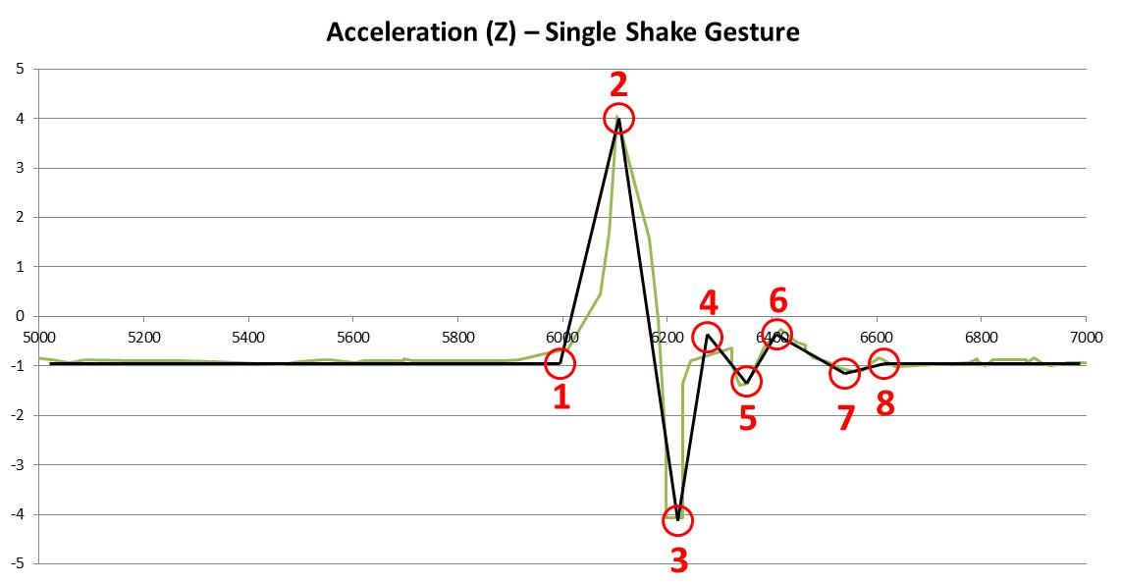

Figure 13: Acceleration direction changes for shake event

The key points of interest for this example set of data are as follows:

* First direction change (initiation of shake detection sequence)
* Second direction change
* Third direction change
* Fourth direction change (shake gesture detected)
* Fifth direction change
* Sixth direction change
* Seventh direction change
* Stabilization

This data set is an example for illustrative purposes only. In order to properly detect a shake motion sequence, the algorithm needs to be capable of detecting oscillations along the Z-axis that are similar in form to the example above. While shake detection algorithms can also incorporate X and Y axis accelerometer data, only Z-axis accelerometer data and motion is used to evaluate shake detection performance on Windows 8 systems. Note that accelerometer shake event is optional for Windows 8 sensor implementations.

### Validation of 3D Accelerometer Hardware Integration

In order to validate that accelerometer hardware is properly integrated, perform the following tests. In some cases, you should use the [Sensor Diagnostic Tool](#_Sensor_Diagnostic_Tool).

1. Use the [Sensor Diagnostic Tool](#_Sensor_Diagnostic_Tool) to examine the 3D accelerometer under test. Expand the sensors and click on the 3D accelerometer. Validate that you see data updates. For a slate PC, perform the following data integrity checks:
   1. Lay the device on a flat surface with the screen pointing up – acceleration values should be the following:  
      X = ~0.0, Y = ~0.0, Z = ~-1.0
   2. Hold the device with the right hand side pointing upwards up – acceleration values should be the following:  
      X = ~-1.0, Y = ~0.0, Z = ~0.0
   3. Hold the device with the top of the screen pointing upwards up – acceleration values should be the following:  
      X = ~0.0, Y = ~-1.0, Z = ~0.0
2. Test automatic screen rotation – Ensure that your accelerometer is active and that you have a display that is capable of rotation (check display properties, make sure “Auto” setting is active)
   1. Hold the device vertically and in portrait mode with the screen pointing towards your chest. The content on the screen should appear properly oriented.
   2. Switch the device orientation to landscape mode and wait a few seconds. The screen should rotate so that content is properly oriented.
   3. Switch the device orientation to inverted portrait mode and wait a few seconds. The screen should rotate so that content is properly oriented.
   4. Switch the device orientation to inverted landscape mode and wait a few seconds. The screen should rotate so that content is properly oriented.

Accelerometer power management and auto-rotation

Note that the accelerometer will still draw power even if the user disables the auto-rotation feature on a device. (The sensor platform requires that the accelerometer is always enabled to provide support for the SimpleOrientation sensor.)

## Integrating Magnetometer Sensors with Windows

Magnetometers are used by the compass, the inclinometer, and the orientation sensor. This section of the paper outlines key concepts related to this device.

### Magnetometer Accuracy

Magnetometer sensors are susceptible to electromagnetic field interference from the surrounding environment or the computing device itself. Because orientation sensors such as compass, inclinometer, and device orientation rely on magnetometer data, as interference increases, sensor accuracy degrades. In many cases dynamic calibration is needed to account for the changing electromagnetic environment, which requires the device to be moved around all three device axis.

The Windows Sensor Platform supports a magnetometer accuracy data field to be included in each orientation input report. Magnetometer accuracy is one of:

* unreliable
* approximate
* high

These values indicate how closely the data represents the actual heading of the device with respect to a horizontal plane. Often computing an absolute accuracy in degrees is computationally expensive or impossible as data values vary within some confidence interval.

With this data field, the consumer of the data is responsible for determining minimum acceptable accuracy and taking the appropriate action. There is no event indicating calibration is needed or complete, and there is no means to instruct the sensor to enter a special calibration mode. It is expected that the magnetometer accuracy value will change in successive data reports as calibration changes.

#### Sensor Platform Additions for Windows 8.1

The following additions have been made to Win32 Sensor Platform header files. They are also available in the Sensor Diagnostic Tool.

// MagnetometerAccuracy: represents the runtime accuracy of the // magnetic field component of a sensor's data

typedef enum MagnetometerAccuracy

{

MAGNETOMETER\_ACCURACY\_UNKNOWN = 0,

MAGNETOMETER\_ACCURACY\_UNRELIABLE,

MAGNETOMETER\_ACCURACY\_APPROXIMATE,

MAGNETOMETER\_ACCURACY\_HIGH

} MagnetometerAccuracy;

The MagnetometerAccuracy.Unknown enumeration value is present for backward compatibility and should not be used by sensor drivers.

// Magnetometer Accuracy Data Types

DEFINE\_PROPERTYKEY(SENSOR\_DATA\_TYPE\_MAGNETOMETER\_ACCURACY, 0X1637D8A2, 0X4248, 0X4275, 0X86, 0X5D, 0X55, 0X8D, 0XE8, 0X4A, 0XED, 0XFD, 22); //[VT\_I4]

The vartype is VT\_I4 and is expected to hold one of the MagnetometerAccuracy enumeration values.

#### Data Reports

Magnetometer accuracy should be included in the data reports of all magnetometer-derived sensors, including: compass, inclinometer, and device orientation. A sensor driver should return SENSOR\_DATA\_TYPE\_MAGNETOMETER\_ACCURACY for ISensorDriver::OnGetSupportedDataFields() and return SENSOR\_DATA\_TYPE\_MAGNETOMETER\_ACCURACY and its value for ISensorDriver::OnGetDataFields().

#### Calculating Magnetometer Accuracy

Magnetometer accuracy is a measure of how closely a sensor’s data fields represent the actual 2D heading of the device with respect to the earth’s surface. Compass, inclinometer, and device orientation convey heading in different representations, but the underlying meaning is the same. It is expected that the magnetometer accuracy value will be the same for all three sensors at any instant in time.

The sensor solution should report an up-to-date magnetometer accuracy in each input report, conveying the accuracy of the data with respect to heading. The data fields should not be set to VT\_NULL to indicate calibration is required.

Magnetometer accuracy is specified as unreliable, approximate, or high. In practice these denote a range of accuracies with the following values, where θ represents the difference between the current heading and the heading of a perfectly calibrated sensor in degrees.

|  |  |
| --- | --- |
| Accuracy | Range |
| HIgh | 0 ≤ θ < 10 |
| Approximate | 10 ≤ θ < 25 |
| Unreliable | 25 ≤ θ < 180 |

#### Understanding User Impact

The end goal of implementing magnetometer accuracy is to improve the user experience for applications using compass, inclinometer, and device orientation sensor data. A sensor with a frequent low accuracy will frustrate that user as he or she must continually calibrate the device. A sensor with a frequent but misrepresented high accuracy will frustrate the user because the sensor readings are less accurate than expected.

It is helpful to consider the classes of applications that may rely on different magnetometer accuracy values.

|  |  |
| --- | --- |
| Accuracy | Application type |
| HIgh | Navigation: Requires absolute heading |
| Approximate | Virtual reality: Requires relative heading |
| Unreliable | None |

Generally it is expected that a calibrated sensor will reach and maintain high accuracy in the absence of significant magnetic field interference. This allows applications depending on highly accurate data to offer a consistent and enjoyable user experience.

## Integrating Compass Sensors with Windows

### Compass Technology Overview

For Windows 8, a 3D Compass sensor is a fusion of data from a 3D magnetometer, a 3D accelerometer, and a 3D gyrometer sensor.

### Magnetometer Part Selection Guidelines

#### Dynamic Range (Gauss)

* Minimum: +/-1000uT
* Maximum:  N/A

#### Accuracy and Resolution

* Non-linearity: ±0.1 (FS ± 100uT)
* Noise: 0.5 uT / rtHz @8Hz ODR
* Offset: <300 uT

#### Sensitivity Scale Factor

* Optimal:  0.3uT / LSB

#### Sampling rates (hardware)

* 8hz +

#### Power consumption

* Acceptable: 350uA

### Compass Driver Specifics

See [Writing a Custom Sensor Driver](#_Writing_a_Custom) for general information and guidelines. A 3D Compass driver is responsible for assembling and integrating data from a 3D magnetometer sensor (which exposes magnetic field strength readings on 3 axes) and from a 3D accelerometer (which exposes acceleration readings on 3 axes), and finally from the Gyrometer sensor (which exposes angular velocity on 3 axes) in order to produce tilt-compensated heading readings relative to a level surface on the ground.

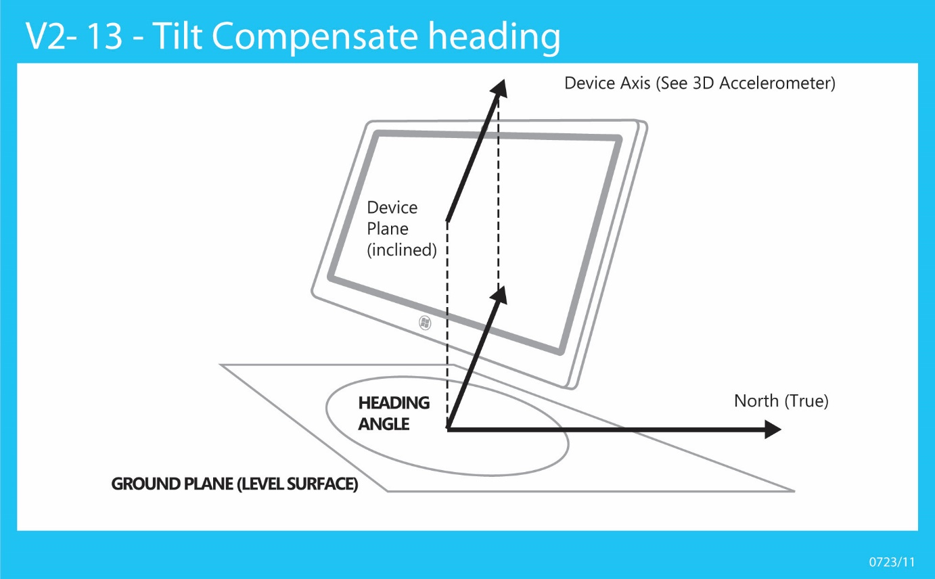Figure 14: Example of tilt compensated heading measurement

In this diagram, the heading measurement (on ground plane) is referenced to “True North,” which is the North Pole. Note that “Magnetic North” measurement is also performed, which is relative to the Magnetic North Pole rather than the actual North Pole. If location data is available to the 3D Compass sensor driver, both data fields (see list below) should be exposed. The Magnetic North heading must always be exposed.

The tilt compensated compass heading is represented as the projection of one of the device chassis axes (X or Y) onto a flat plane on the surface of the earth. Which axis and convention is used is dependent on the tilt of the Z-axis of the device compared to vertical. This angular tilt measurement is represented by the following diagram.



Figure 15: Side view of tablet PC showing the Z-axis tilt angle

This diagram illustrates the following:

* V1 = Vector 1 = Force due to gravity
* V2 = Vector 2 = -Z axis of device chassis (points out of back of screen)
* Θi = Tilt angle (inclination) = angle between –Z axis of device chassis and gravity vector

Depending on the orientation of the device (Θi), different device chassis vectors are used as projections onto the level ground plane in order to determine tilt compensated heading values. The following table outlines these relationships.

|  |  |  |  |
| --- | --- | --- | --- |
| Simple device orientation | Logical orientation (Windows) | Logical orientation (Windows Phone) | Reference axis for compass heading |
| NotRotated | Landscape | Portrait | -Z |
| Rotated90 | PortraitFlipped | LandscapeFlipped | Y |
| Rotated180 | LandscapeFlipped | PortraitFlipped  (undefined) | Z\* |
| Rotated270 | Portrait | Landscape | Y |
| FaceUp | Face up | Face up | Y |
| FaceDown | Face down | Face down | Y |

\* only deviation from Windows Phone 8 guidance

### Hysteresis for Heading Reference Axis Stability

In order to minimize the number of transitions between reference axes used for tilt compensated heading calculation, a hysteresis threshold should be used in order to stabilize the heading data exposed by the compass. The recommended value for this hysteresis threshold is +/- 20°. This means that when a reference axis transition occurs, the Z-axis angle (Θi) needs to change by more than 20° before another reference axis transition would occur.

#### 3D Compass Properties

|  |  |  |
| --- | --- | --- |
| Sensor Property | Read/Write - Values/Range | Description |
| WPD\_FUNCTIONAL\_OBJECT\_CATEGORY | **Read-Only**  SENSOR\_CATEGORY\_ORIENTATION | The sensor category |
| SENSOR\_PROPERTY\_TYPE | **Read-Only**  SENSOR\_TYPE\_COMPASS\_3D | The sensor type |
| SENSOR\_PROPERTY\_CONNECTION\_TYPE | **Read-Only**  SENSOR\_CONNECTION\_TYPE\_PC\_INTEGRATED | Describes how the sensor is connected to the PC. |
| SENSOR\_PROPERTY\_MANUFACTURER | **Read-Only**  String: <Driver or sensor manufacturer> | Describes what company manufactures the device and provides the driver. |
| SENSOR\_PROPERTY\_PERSISTENT\_UNIQUE\_ID | **Read-Only**  This is a unique GUID for the sensor, unique as exposed on a particular machine, generated during device install time. (Reinstalling device will cause new GUIDs to be generated.) | Uniquely identifies the sensor. |
| SENSOR\_PROPERTY\_SERIAL\_NUMBER | **Read-Only**  String: <The serial number for the device> | Read only. Required, static. The sensor serial number. |
| SENSOR\_PROPERTY\_STATE | **Read-Only**  See [SensorState](http://msdn.microsoft.com/en-us/library/dd318905(v=VS.85).aspx). | The current data state for the sensor |
| SENSOR\_PROPERTY\_MODEL | **Read-Only**  String: <Driver or sensor model> | The model of sensor or device |
| SENSOR\_PROPERTY\_ACCURACY | **Read-Only**  Float, per data field | Accuracy of readings for each data field |
| SENSOR\_PROPERTY\_CHANGE\_SENSITIVITY | **Read-Write**  Float, per data field | The smallest magnitude threshold that connected clients are requesting data for (or default, if no client as set this property). |
| SENSOR\_PROPERTY\_CURRENT\_REPORT\_INTERVAL | **Read-Write**  Integer (milliseconds) | The fastest interval (expressed as period between events) at which connected clients are requesting data (or default, if no client as set this property). |
| SENSOR\_PROPERTY\_DESCRIPTION | **Read-Only**  String: <description of the sensor> | The sensor description |
| SENSOR\_PROPERTY\_RANGE\_MAXIMUM | **Read-Only**  Float, per data field | The maximum heading values reported.  Example:  True North: 360.0  Magnetic North: 360.0 |
| SENSOR\_PROPERTY\_RANGE\_MINIMUM | **Read-Only**  Float, per data field | The minimum heading values reported.  Example:  True North: 0.0  Magnetic North: 0.0 |
| SENSOR\_PROPERTY\_RESOLUTION | **Read-Only**  Float, per data field | The minimum change in heading which the compass can detect – per data-field.  Example:  True North: 1.0  Magnetic North: 1.0 |

#### 3D Compass Data Fields

|  |  |
| --- | --- |
| Sensor Data Field | Description |
| SENSOR\_DATA\_TYPE\_MAGNETIC\_HEADING\_COMPENSATED\_MAGNETIC\_NORTH\_DEGREES | Compensated compass heading relative to magnetic North in degrees. This compensation causes the measurement of the heading angle to be represented as if a compass device is lying flat on level ground where the PC is located. (VT\_R8) |
| SENSOR\_DATA\_TYPE\_MAGNETIC\_HEADING\_COMPENSATED\_TRUE\_NORTH\_DEGREES | Compensated compass heading relative to true North in degrees. This compensation causes the measurement of the heading angle to be represented as if a compass device is lying flat on level ground where the PC is located. (VT\_R8) |
| SENSOR\_DATA\_TYPE\_MAGNETIC\_FIELD\_STRENGTH\_X\_MILLIGAUSS (Optional) | Magnetic field strength as measured by the 3D magnetometer sensor (X-axis). |
| SENSOR\_DATA\_TYPE\_MAGNETIC\_FIELD\_STRENGTH\_Y\_MILLIGAUSS (Optional) | Magnetic field strength as measured by the 3D magnetometer sensor (Y-axis). |
| SENSOR\_DATA\_TYPE\_MAGNETIC\_FIELD\_STRENGTH\_Z\_MILLIGAUSS (Optional) | Magnetic field strength as measured by the 3D magnetometer sensor (Z-axis). |

#### 3D Compass Events

N/A

### Validation of 3D Compass Hardware Integration

In order to validate that compass hardware is properly integrated, perform the following tests. In some cases you should use the [Sensor Diagnostic Tool](#_Sensor_Diagnostic_Tool).

Use the [Sensor Diagnostic Tool](#_Sensor_Diagnostic_Tool) to examine the 3D compass under test. Expand the sensors and click on the 3D compass. Validate that you see data updates. For a slate PC, perform the following data integrity checks:

1. With the device lying on a flat table, point the top of the screen approximately North. You should see a compass heading that is approximately 0.0 (+/- 20 degrees or so depending on interference, etc.).
2. Incline the device so that the top of the screen is pointing up. Validate that the heading does not change by more than about 20 degrees.
3. With the device lying on a flat table, point the top of the screen approximately South. You should see a compass heading that is approximately 180.0 (+/- 20 degrees or so depending on interference, etc.).
4. Incline the device so that the top of the screen is pointing up. Validate that the heading does not change by more than about 20 degrees.
5. With the device lying on a flat table, point the top of the screen approximately East. You should see a compass heading that is approximately 90.0 (+/- 20 degrees or so depending on interference, etc.).
6. Incline the device so that the top of the screen is pointing up. Validate that the heading does not change by more than about 20 degrees.
7. With the device lying on a flat table, point the top of the screen approximately West. You should see a compass heading that is approximately 270.0 (+/- 20 degrees or so depending on interference, etc.).
8. Incline the device so that the top of the screen is pointing up. Validate that the heading does not change by more than about 20 degrees.
9. Repeat these tests inclining the device by 45 degrees (instead of 90 degrees) where the top of the screen is pointing up.

## Integrating Gyrometer Sensors with Windows

### Part Selection Guidelines

#### Dynamic range

The dynamic range of a gyrometer refers to the magnitude of rotational velocity which can be measured. In some cases the dynamic range of rotational velocities can be configured for a particular gyrometer. If the gyrometer is configured to measure a wider range of rotational velocities, the trade-off is typically lower resolution data.

* Minimum: -720dps to +720dps
* Optimal: -2000dps to +2000dps

#### Accuracy and Resolution

* Non-linearity: 0.2%
* Noise: 0.05dps-rms@100Hz
* Sensitivity scale factor tolerance @25degC: +/-3%,
* ZRO @ 25degC: +/-20dps

#### Sensitivity Scale Factor

* 16.4 LSB/dps @ ±2000dps
* 32.8 LSB/dps @ ±1000dps
* 65.5 LSB/dps @ ±500dps
* 131 LSB/dps @ ±250dps

#### Sampling rates (hardware)

* Recommended: 100hz+

#### Power consumption

* Recommended: 7000uA or less

### Gyrometer Axes, Data Types, Capabilities

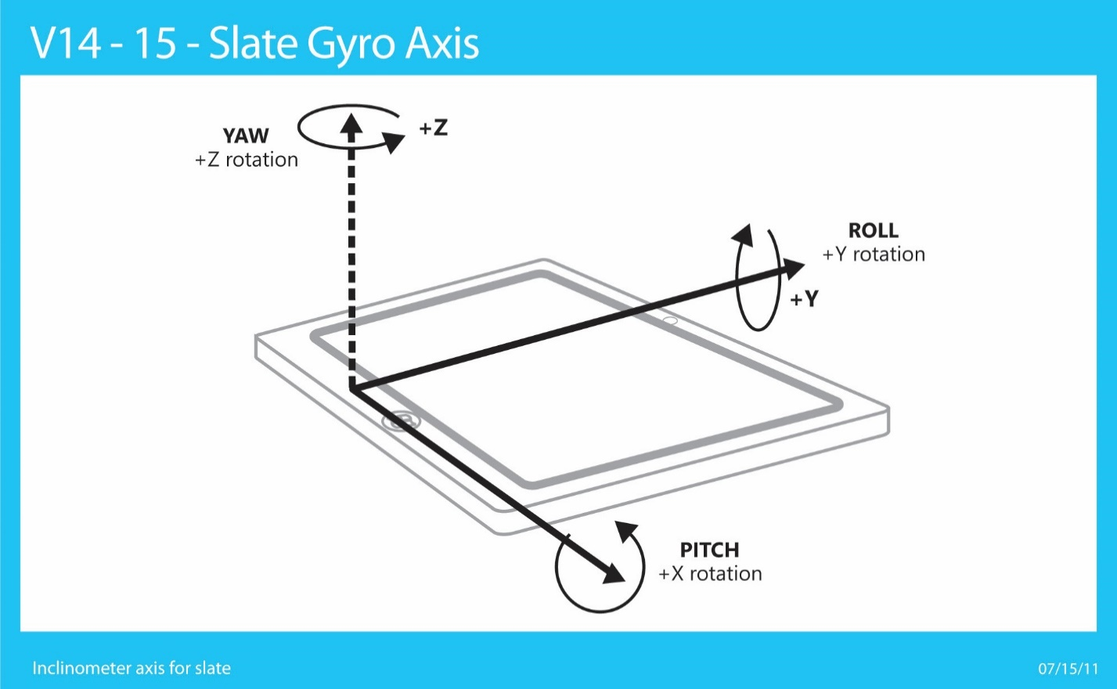

Figure 16: Gyrometer Axis Definitions and Rotation Directions (Slate) – Shares axis and angular measurement convention with Inclinometer

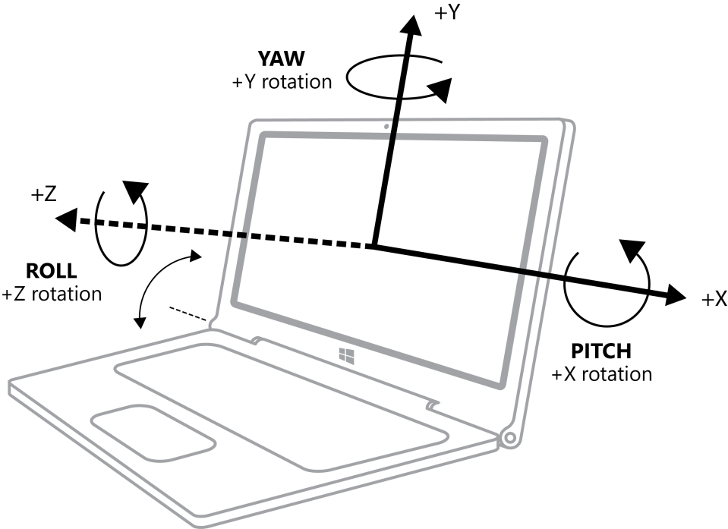

Figure 17: Gyrometer Axis Definitions and Rotation Directions (clamshell) – Shares axis and angular measurement convention with Inclinometer

### 

### 3D Gyrometer Driver Specifics

See [Writing a Custom Sensor Driver](#_Writing_a_Custom) for general information and guidelines.

The Windows convention for rotational velocity measurement (gyrometer sensor data) is consistent with the W3C Device Orientation specification.

#### 3D Gyrometer Properties

|  |  |  |
| --- | --- | --- |
| Sensor Property | Read/Write - Values/Range | Description |
| WPD\_FUNCTIONAL\_OBJECT\_CATEGORY | **Read-Only**  SENSOR\_CATEGORY\_MOTION | The sensor category |
| SENSOR\_PROPERTY\_TYPE | **Read-Only**  SENSOR\_TYPE\_GYROMETER\_3D | The sensor type |
| SENSOR\_PROPERTY\_CONNECTION\_TYPE | **Read-Only**  SENSOR\_CONNECTION\_TYPE\_PC\_INTEGRATED | Describes how the sensor is connected to the PC. |
| SENSOR\_PROPERTY\_MANUFACTURER | **Read-Only**  String: <Driver or sensor manufacturer> | Describes what company manufactures the device and provides the driver. |
| SENSOR\_PROPERTY\_PERSISTENT\_UNIQUE\_ID | **Read-Only**  This is a unique GUID for the sensor, unique as exposed on a particular machine, generated during device install time. (reinstalling device will cause new GUIDs to be generated) | Uniquely identifies the sensor. |
| SENSOR\_PROPERTY\_SERIAL\_NUMBER | **Read-Only**  String: <The serial number for the device> | Read only. Required, static. The sensor serial number. |
| SENSOR\_PROPERTY\_STATE | **Read-Only**  See MSDN document for [SensorState](http://msdn.microsoft.com/en-us/library/dd318905(v=VS.85).aspx) | The current data state for the sensor |
| SENSOR\_PROPERTY\_MODEL | **Read-Only**  String: <Driver or sensor model> | The model of sensor or device |
| SENSOR\_PROPERTY\_ACCURACY | **Read-Only**  Float, per data field | Accuracy of readings for each data field |
| SENSOR\_PROPERTY\_CHANGE\_SENSITIVITY | **Read-Write**  Float, per data field | The smallest magnitude threshold that connected clients are requesting data for (or default, if no client as set this property). |
| SENSOR\_PROPERTY\_CURRENT\_REPORT\_INTERVAL | **Read-Write**  Integer (milliseconds) | The fastest interval (expressed as the period between events) at which connected clients are requesting data (or default, if no client as set this property). |
| SENSOR\_PROPERTY\_DESCRIPTION | **Read-Only**  String: <description of the sensor> | The sensor description |
| SENSOR\_PROPERTY\_RANGE\_MAXIMUM | **Read-Only**  Float, per data field | The maximum rotation velocity values reported.  Example:  X: 2200.0 deg/s  Y: 2200.0 deg/s  Z: 2200.0 deg/s |
| SENSOR\_PROPERTY\_RANGE\_MINIMUM | **Read-Only**  Float, per data field | The minimum rotation velocity values reported.  Example:  X: -2200.0 deg/s  Y: -2200.0 deg/s  Z: -2200.0 deg/s |
| SENSOR\_PROPERTY\_RESOLUTION | **Read-Only**  Float, per data field | The minimum change in rotational velocity that the Gyrometer can detect, per data-field.  Example:  X: 0.01 deg/s  Y: 0.01 deg/s  Z: 0.01 deg/s |

#### 3D Gyrometer Data Fields

|  |  |
| --- | --- |
| Sensor Data Field | Description |
| SENSOR\_DATA\_TYPE\_ANGULAR\_VELOCITY\_X\_DEGREES\_PER\_SECOND | Rotational velocity about the X axis as measured by a gyroscope (VT\_R8) |
| SENSOR\_DATA\_TYPE\_ANGULAR\_VELOCITY\_Y\_DEGREES\_PER\_SECOND | Rotational velocity about the Y axis as measured by a gyroscope (VT\_R8) |
| SENSOR\_DATA\_TYPE\_ANGULAR\_VELOCITY\_Z\_DEGREES\_PER\_SECOND | Rotational velocity about the Z axis as measured by a gyroscope (VT\_R8) |

#### 3D Gyrometer Events

N/A

### Validation of 3D Gyrometer Hardware Integration

In order to validate that gyrometer hardware is properly integrated, perform the following tests. In some cases you need to use the [Sensor Diagnostic Tool](#_Sensor_Diagnostic_Tool).

Use the [Sensor Diagnostic Tool](#_Sensor_Diagnostic_Tool) to examine the 3D gyrometer under test. Expand the sensors and click on the 3D gyrometer. Validate that you see data updates. For a slate PC, perform the following data integrity checks:

1. With the device lying on a flat table, rotate the device clockwise at a constant rate. Validate that the following rotational data is observed: X = ~0.0 degrees/second, Y = ~0.0 degrees/second, Z = negative degrees/second rate (depending on how quickly device is rotated).
2. With the device lying on a flat table, rotate the device counter-clockwise at a constant rate. Validate that the following rotational data is observed: X = ~0.0 degrees/second, Y = ~0.0 degrees/second, Z = positive degrees/second rate (depending on how quickly device is rotated).
3. With the device held in a stand on a flat surface with the top of the screen pointing upwards, rotate the device clockwise at a constant rate. Validate that the following rotational data is observed: X = ~0.0 degrees/second, Y = negative degrees/second rate (depending on how quickly device is rotated), Z = ~0.0.
4. With the device held in a stand on a flat surface with the top of the screen pointing upwards, rotate the device counter-clockwise at a constant rate. Validate that the following rotational data is observed: X = ~0.0 degrees/second, Y = positive degrees/second rate (depending on how quickly device is rotated), Z = ~0.0.
5. With the device held in a stand on a flat surface with the right-hand side of the screen pointing upwards, rotate the device counter-clockwise at a constant rate. Validate that the following rotational data is observed: X = positive degrees/second rate (depending on how quickly device is rotated) Y = ~0.0 degrees/second, Z = ~0.0 degrees/second.
6. With the device held in a stand on a flat surface with the right-hand side of the screen pointing upwards, rotate the device clockwise at a constant rate. Validate that the following rotational data is observed: X = negative degrees/second rate (depending on how quickly device is rotated) Y = ~0.0 degrees/second, Z = ~0.0 degrees/second.

## Integrating Sensor Fusion Sensors with Windows

### Sensor Fusion Integration

Windows supports 9-axis sensor fusion derived from the data in 3D Accelerometer, 3D Gyroscope, and 3D Magnetometer in order to derive 3D Compass, 3D Inclinometer, and Quaternion.

Starting with Windows 8.1, the Sensor stack will derive both 3D Compass and 3D Inclinometer at the WinRT level from the Win32 Quaternion. This impacts development insofar as ARM systems will only be required to derive the Quaternion in their driver/FW while x86/64 systems will still need to provide Quaternion, 3D Inclinometer, and 3D compass in their driver/FW.

This is due to x86 systems being capable of accessing both WinRT APIs as well as Win32 APIs, whereas ARM systems can only access WinRT APIs.

The structure moving forward is shown below:

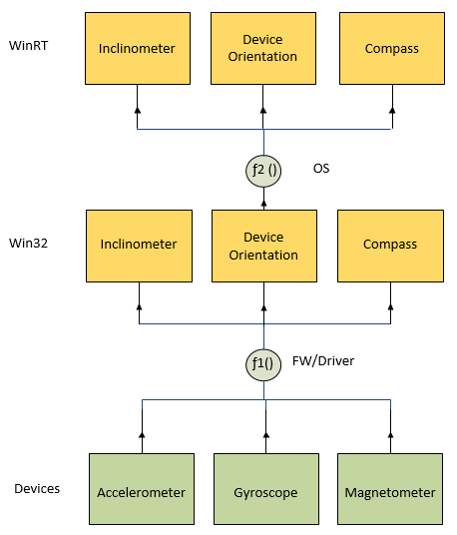

### 3D Inclinometer and Device Orientation Axes, Data Types, Capabilities

The following illustration shows the axis orientation for a 3-axis inclinometer.



Figure 18: Inclinometer Axis Definitions and Rotation Directions (Slate)



Figure 19: Inclinometer Axis Definitions and Rotation Directions (clamshell)

#### Sensor Fusion Measurement Specifics

#### Inclinometer Measurement Specifics – Euler Angles - Yaw, Pitch, Roll

The measurement of yaw, pitch, and roll are fundamental to the definitions of various device orientation types including the following sensors:

1. 3D inclinometer
   1. Exposes yaw, pitch, and roll data fields.
2. Device Orientation
   1. Rotation Matrix contains trigonometric rotation data derived from yaw, pitch, and roll rotations.
   2. Quaternion uses direction/axis/rotation conventions consistent with yaw, pitch, roll measurement guidelines outlined here.
3. 3D Compass (tilt compensated)
   1. Heading angles (true North and magnetic North) use same reference plane and convention as yaw, but angle is measured in opposite direction.

Here, all rotations are specified in reference to the X, Y, Z axes relative to the device chassis, and all rotations follow the right-hand rule. Note that the ENU “East North Up” convention is observed for all Windows device orientation implementations.

### Order of Rotations for Yaw, Pitch, and Roll

In order to properly describe the orientation of the device in 3D-space, the Euler angles are applied in the following order, starting with the device lying on a flat surface and the +Y axis pointing due North (towards the North Pole):

1. The device is rotated by the Yaw angle about its Z-axis (opposite rotation direction about Z-axis compared to heading).
2. The device is rotated by the Pitch angle about its X-axis.
3. The device is rotated by the Roll angle about its Y-axis.

### Angular Ranges for Yaw, Pitch, Roll

The following ranges are used for the representation of Yaw, Pitch, and Roll:

* 0.0° ≤ Yaw < 360.0°
* -180.0° ≤ Pitch < 180.0°
* -90.0° ≤ Roll < 90.0°

Once the Euler angle rotations are applied in this order, the device orientation representation is accurate, given the constraints of “gimbal lock” when dealing with Euler angle device orientation representations. For more information about gimbal lock please refer to the [Wikipedia article](http://en.wikipedia.org/wiki/Gimbal_lock) on the subject.

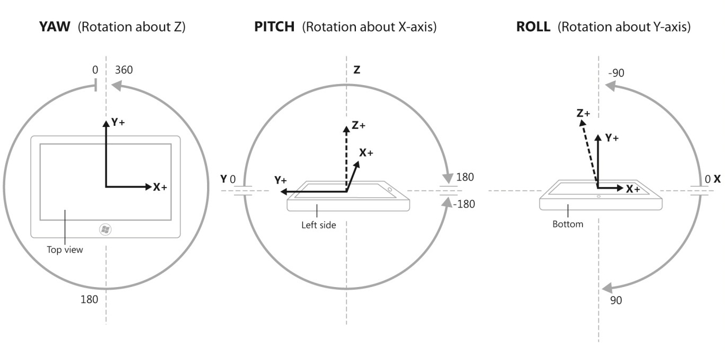

Figure 20 : Angular Ranges for Yaw, Pitch, Roll

#### Yaw, Pitch, Roll Visualization for Principal Axis Rotations

The following diagram illustrates the relationship between yaw, pitch, and roll for complete rotations around the X (pitch), Y (roll), and Z (yaw) axes. For more information about how 3D inclinometers are tested in the Windows Hardware Certification Kit (HCK), please see [Validation of Euler Angles (Yaw, Pitch, Roll) for 3D Inclinometer](#_Validation_of_Euler) for more information.

#### Device Orientation Measurement Specifics: Rotation Matrix and Quaternion

The calculation of Quaternion data is based on formulas that are widely adopted in robotics and computer graphics/game environments.

For more information about Quaternions and Quaternion calculations, please see <http://en.wikipedia.org/wiki/Quaternion>.

Rotation matrices are 3x3 matrix structures which contain trigonometric components of the Euler angle (Yaw, Pitch, Roll) representations of the spatial orientation of an object in 3-space. For more information about Rotation Matrix data and calculations, please see <http://en.wikipedia.org/wiki/Rotation_matrix>.

### 3D Inclinometer Sensor Driver Specifics

See [Writing a Custom Sensor Driver](#_Writing_a_Custom) for general information and guidelines.

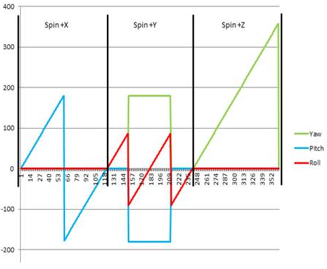

Figure 21: Visualization of Yaw, Pitch, Roll values for single rotations about X, Y, and Z axes

#### 3D Inclinometer Properties

|  |  |  |
| --- | --- | --- |
| Sensor Property | Read/Write - Values/Range | Description |
| WPD\_FUNCTIONAL\_OBJECT\_CATEGORY | **Read-Only**  SENSOR\_CATEGORY\_ORIENTATION | The sensor category |
| SENSOR\_PROPERTY\_TYPE | **Read-Only**  SENSOR\_TYPE\_INCLINOMETER\_3D | The sensor type |
| SENSOR\_PROPERTY\_CONNECTION\_TYPE | **Read-Only**  SENSOR\_CONNECTION\_TYPE\_PC\_INTEGRATED | Describes how the sensor is connected to the PC. |
| SENSOR\_PROPERTY\_MANUFACTURER | **Read-Only**  String: <Driver or sensor manufacturer> | Describes what company manufactures the device and provides the driver. |
| SENSOR\_PROPERTY\_PERSISTENT\_UNIQUE\_ID | **Read-Only**  This is a unique GUID for the sensor, unique as exposed on a particular machine, generated during device install time. (reinstalling device will cause new GUIDs to be generated) | Uniquely identifies the sensor |
| SENSOR\_PROPERTY\_SERIAL\_NUMBER | **Read-Only**  String: <The serial number for the device> | Read only. Required, static. The sensor serial number. |
| SENSOR\_PROPERTY\_STATE | **Read-Only**  See MSDN document for [SensorState](http://msdn.microsoft.com/en-us/library/dd318905(v=VS.85).aspx) | The current data state for the sensor |
| SENSOR\_PROPERTY\_MODEL | **Read-Only**  String: <Driver or sensor model> | The model of sensor or device |
| SENSOR\_PROPERTY\_ACCURACY | **Read-Only**  Float, per data field | Accuracy of readings for each data field |
| SENSOR\_PROPERTY\_CHANGE\_SENSITIVITY | **Read-Write**  Float, per data field | The smallest magnitude threshold that connected clients are requesting data for (or default, if no client has set this property). |
| SENSOR\_PROPERTY\_CURRENT\_REPORT\_INTERVAL | **Read-Write**  Integer (milliseconds) | The fastest interval (expressed as the period between events) at which connected clients are requesting data (or default, if no client as set this property). |
| SENSOR\_PROPERTY\_DESCRIPTION | **Read-Only**  String: <description of the sensor> | The sensor description |
| SENSOR\_PROPERTY\_RANGE\_MAXIMUM | **Read-Only**  Float, per data field | The maximum rotation angle values reported.  Example:  X: 180.0 deg  Y: 90.0 deg  Z: 360.0 deg |
| SENSOR\_PROPERTY\_RANGE\_MINIMUM | **Read-Only**  Float, per data field | The minimum rotation angle values reported.  Example:  X: -180.0 deg  Y: -90.0 deg  Z: 0.0 deg |
| SENSOR\_PROPERTY\_RESOLUTION | **Read-Only**  Float, per data field | The minimum change in rotational angle that the Inclinometer can detect, per data-field.  Example:  X: 0.01 deg  Y: 0.01 deg  Z: 0.01 deg |

#### 

#### 3D Inclinometer Data Fields

|  |  |
| --- | --- |
| Sensor Data Field | Description |
| SENSOR\_DATA\_TYPE\_TILT\_X\_DEGREES | Inclinometer x-axis angle, in degrees (VT\_R4) |
| SENSOR\_DATA\_TYPE\_TILT\_Y\_DEGREES | Inclinometer x-axis angle, in degrees (VT\_R4) |
| SENSOR\_DATA\_TYPE\_TILT\_Z\_DEGREES | Inclinometer x-axis angle, in degrees (VT\_R4) |

#### 3D Inclinometer Events

N/A

### Aggregated Device Orientation Sensor Driver Specifics

See [Writing a Custom Sensor Driver](#_Writing_a_Custom) for general information and guidelines.

#### Aggregated Device Orientation Sensor Properties

|  |  |  |
| --- | --- | --- |
| Sensor Property | Read/Write - Values/Range | Description |
| WPD\_FUNCTIONAL\_OBJECT\_CATEGORY | **Read-Only**  SENSOR\_CATEGORY\_ORIENTATION | The sensor category |
| SENSOR\_PROPERTY\_TYPE | **Read-Only**  SENSOR\_TYPE\_AGGREGATED\_DEVICE\_ORIENTATION | The sensor type |
| SENSOR\_PROPERTY\_CONNECTION\_TYPE | **Read-Only**  SENSOR\_CONNECTION\_TYPE\_PC\_INTEGRATED | Describes how the sensor is connected to the PC. |
| SENSOR\_PROPERTY\_MANUFACTURER | **Read-Only**  String: <Driver or sensor manufacturer> | Describes what company manufactures the device and provides the driver. |
| SENSOR\_PROPERTY\_PERSISTENT\_UNIQUE\_ID | **Read-Only**  This is a unique GUID for the sensor, unique as exposed on a particular machine, generated during device install time. (Reinstalling device will cause new GUIDs to be generated.) | Uniquely identifies the sensor. |
| SENSOR\_PROPERTY\_SERIAL\_NUMBER | **Read-Only**  String: <The serial number for the device> | Read only. Required, static. The sensor serial number. |
| SENSOR\_PROPERTY\_STATE | **Read-Only**  See [SensorState](http://msdn.microsoft.com/en-us/library/dd318905(v=VS.85).aspx). | The current data state for the sensor |
| SENSOR\_PROPERTY\_MODEL | **Read-Only**  String: <Driver or sensor model> | The model of sensor or device |
| SENSOR\_PROPERTY\_ACCURACY | **Read-Only**  Float, per data field | Accuracy of readings for each data field |
| SENSOR\_PROPERTY\_CHANGE\_SENSITIVITY | **Read-Write**  Float, per data field | The smallest magnitude threshold that connected clients are requesting data for (or default, if no client has set this property).  For the rotation matrix data field, the units for change sensitivity are degrees (corresponding to degrees of Euler angle movement). This change sensitivity value is expressed as a floating point value (VT\_R4).  For the quaternion data field, the units for change sensitivity are degrees (corresponding to change in the quaternion vector direction). This change sensitivity value is expressed as a floating point value (VT\_R4). |
| SENSOR\_PROPERTY\_CURRENT\_REPORT\_INTERVAL | **Read-Write**  Integer (milliseconds) | The fastest interval (expressed as the period between events) at which connected clients are requesting data (or default, if no client as set this property). |
| SENSOR\_PROPERTY\_DESCRIPTION | **Read-Only**  String: <description of the sensor> | The sensor description |
| SENSOR\_PROPERTY\_RANGE\_MAXIMUM | **Read-Only**  Float, per data field | N/A |
| SENSOR\_PROPERTY\_RANGE\_MINIMUM | **Read-Only**  Float, per data field | N/A |
| SENSOR\_PROPERTY\_RESOLUTION | **Read-Only**  Float, per data field | N/A |

#### Aggregated Device Orientation Sensor Data Fields

|  |  |
| --- | --- |
| Sensor Data Field | Description |
| SENSOR\_DATA\_TYPE\_ROTATION\_MATRIX | Counted array representing the orientation of the device in 3D space as a 3x3 rotation matrix (VT\_VECTOR|VT\_UI1).  Data for vector types is always serialized as VT\_UI1 (an array of unsigned, 1-byte characters). This data field must contain each value as a single-precision float (VT\_R4).  Expressed as a matrix:  Expressed as these values are ordered in the rotation matrix data field array:  M11,M12,M13,M21,M22,M23,M31,M32,M33  *\*\*Note that for devices implementing support for the in-box Windows 8 HID sensor class driver, this data field is optional. If only SENSOR\_DATA\_TYPE\_QUATERNION is implemented, SENSOR\_DATA\_TYPE\_ROTATION\_MATRIX will be calculated and populated for each data report sent. Devices not using the in-box HID sensor class driver need to calculate and expose both SENSOR\_DATA\_TYPE\_QUATERNION and SENSOR\_DATA\_TYPE\_ROTATION\_MATRIX sensor data fields.* |
| SENSOR\_DATA\_TYPE\_QUATERNION | The x, y, z, w values of a quaternion representing the orientation of the device in 3D space. (VT\_VECTOR|VT\_UI1).  Data for vector types is always serialized as VT\_UI1 (an array of unsigned, 1-byte characters).  This data field must contain each value as a single-precision float (VT\_R4).  The order of the values in this array is as follows:  [x,y,z,w]  The W value of a quaternion is limited to [0,1] instead of the full [-1, 1].  All rotations must be stated in the forward direction (and not the reverse).  \*\*Note: The output of quaternion should be in normalized format. When quaternions are expressed in normalized format, the values will satisfy the following: |

#### Aggregated Device Orientation Sensor Events

N/A

### Validation of Sensor Fusion Implementation

In order to validate that sensor fusion is properly integrated and that all sensors required for sensor fusion are properly integrated/installed, the following simple tests should be performed. In some cases the [Sensor Diagnostic Tool](#_Sensor_Diagnostic_Tool) needs to be used.

Use the [Sensor Diagnostic Tool](#_Sensor_Diagnostic_Tool) to examine the 3D inclinometer and aggregated device orientation sensor under test. Expand the sensors and click on the 3D Inclinometer and then the Aggregated Device Orientation sensor. Validate that you see data updates. For a slate PC, perform the following data integrity checks:

See [Validation of Euler Angles (Yaw, Pitch, Roll) for 3D Inclinometer](#_Validation_of_Euler).

## 9-Axis Data Accuracy Guidelines

The following table indicates the goals for data output accuracy 9-axis motion and orientation implementations on Windows 8. Some of these guidelines are requirements, and some are suggestions based on the corresponding application and system-level features and scenarios.

HCK = Hardware Certification Kit (Logo Requirement)

|  |  |  |  |  |
| --- | --- | --- | --- | --- |
| Sensor | Data field(s) | Accuracy Goal (General) | HCK Accuracy Requirement | Notes |
| 3D Accelerometer | X,Y,Z (G) | +/- 5 mg (0.005 G) | - | HCK tests cover rotation scenarios |
| 3D Gyrometer | X,Y,Z (DPS) | 5 degrees/second | - |  |
| Compass | Magnetic Heading, True North Heading\* | +/-10 degrees | +/-10 degrees | \*If implemented (only magnetic North required) |
| Inclinometer | Yaw, Pitch, Roll | +/- 5 degrees\* | - | \*+/- 10 degrees accuracy allowed on heading axis |
| Device Orientation | Quaternion | +/- 5 degrees\* \*\* | - | \*Actual quaternion vector should deviate no more than +/- 5 degrees from expected quaternion vector (tolerance compared against angle formed between quaternion vectors)  \*\*+/- 10 degrees accuracy allowed on heading axis direction |
| Device Orientation | Rotation Matrix | +/- 5 degrees\* \*\* | - | \*Rotation matrix values are converted to quaternion values for accuracy validation. The calculated quaternion vector should deviate no more than +/- 5 degrees from expected quaternion vector (tolerance compared against angle formed between quaternion vectors)  \*\*+/- 10 degrees accuracy allowed on heading axis direction |

For additional information regarding the full list of logo requirements, please visit the [Windows Dev Center - Hardware site](http://msdn.microsoft.com/en-us/windows/hardware/gg236587).

## Hardware Integration Options and Guidelines

### Mechanical and Electrical Engineering Considerations

When integrating motion and orientation sensors into PC hardware, please consult with the IHV partners who supply sensor parts for primary guidance regarding how to properly integrate these components.

General concepts for motion sensor integration:

1. Locate motion sensing sensor components as close to the geometric center of the device as possible.
2. Place Magnetometer sensors as far away as possible from magnets (Hall Effect sensors or other magnetic components) and other sources of electromagnetic fields or interference (see [Mechanical and Electromagnetic Considerations for Magnetometer](#_Mechanical_and_Electromagnetic)).
3. Mount sensors on a plane that is parallel to the primary plane of the chassis (for example, mount an accelerometer on a plane that is parallel to the plane of the motherboard).

### Mechanical and Electromagnetic Considerations for Magnetometer

The following list of specific considerations should be evaluated when performing system design activities related to magnetometer hardware:

* **System casing** and mainboard (hard iron and soft iron proximity)
  + Cover: Avoid use of metals that are high in ferromagnetic materials (Fe, Co, Ni).
  + Screws: Avoid use of metals that are high in ferromagnetic materials (Fe, Co, Ni).
* **Power** 
  + Power lines: Avoid use of power lines within 1cm of compass circuitry (10mA+). For circuitry with larger current values, more space is required between traces/wires and magnetometer.
  + Power reservoirs: Avoid use of power capacitors/inductors and ferrite beads within 10mm of compass circuitry.
  + Battery: Besides checking current, keep battery connector far from sensor in case it contains ferromagnetic materials.
  + High-Frequency Signals: Avoid high-frequency signal lines in close proximity of the magnetometer as this can impose interference for the magnetometer.
* **Antenna Placement**: Avoid any wireless antenna placement within 1cm of the compass circuitry.
* **LCD Back-panel**: Avoid use metals that are high in ferromagnetic materials (Fe, Co, Ni).

### Component-Level Integration Options

There are an infinite number of ways to hook up sensors to system buses, MCU devices, etc. This section examines a few different ways that motion and orientation sensors can be “wired up” to PC controllers and buses, and also discusses the pros and cons for each approach.

### Sensor Sub-Processor (MCU) Decision Workflow

There are two primary ways in which motion/orientation sensor systems can be integrated with PC hardware running Windows 8:

1. Custom driver approach
2. HID firmware in device or MCU

Each of these approaches has pros and cons. The following table outlines these tradeoffs.

|  |  |  |
| --- | --- | --- |
|  | Custom Driver | HID Sensor Class Driver |
| Driver Development | Must write UMDF driver or multiple drivers that communicate directly with sensor hardware, perform sensor fusion, integrate with Windows sensor platform | No driver work required |
| Device Logo Tests | IHV must pass HCK certification (run device logo tests) | Not required |
| System Logo Tests | Must pass system logo tests (system logo tests run by OEM) | Must pass system logo tests (system logo tests run by OEM) |
| Power | Likely to consume more power | Likely to save power |
| Performance | Consumes measureable CPU bandwidth | Consumes minimal CPU bandwidth |
| Hardware cost | Minimal | MCU adds to system cost (BOM for PC) |
| Sensor Part Dependencies | Specific to particular hardware components - requires updated drivers to swap out sensor components | Requires only minor firmware changes in order to swap out sensor components |

### Connectivity Options

The following sections outline some of the possibilities for sensor part connectivity for Windows 8 systems. Please note that in addition to the busses shown here (USB and I2C), there are other options and buses that can also be used for connecting sensors.

#### 9-Axis Combo Chip with Onboard Integration/Fusion



Figure 22: Example 9-Axis Motion/Orientation Sensor Part Connectivity (raw data sensor hardware shown here)

Using this connectivity approach, this system will be fully supported by the in-box Windows 8 HID sensor class driver if the device firmware is properly written.

Please see [Leveraging in-box Driver Support](#_Leveraging_In-box_Driver) for more details regarding the sensor software stack for this type of hardware connectivity.

#### Individual Components with Sensor Sub-Processor Integration/Fusion



Figure 23: Example Sub-Processor Motion/Orientation Sensor Part Connectivity (raw data sensor hardware shown here)

Using this connectivity approach, this system will be fully supported by the in-box Windows 8 HID sensor class driver if the device firmware is properly written.

Please see [Leveraging in-box Driver Support](#_Leveraging_In-box_Driver) for more details regarding the sensor software stack for this type of hardware connectivity.

#### Individual Components with Driver-Level Integration/Fusion



Figure 24: Example Individual Motion/Orientation Sensor Part Connectivity

##### Third-Party Motion Orientation Driver Components

There are many different ways that sensor drivers for motion/orientation can be supported.

The following illustration shows one driver stack for a single third-party driver (actually two drivers) that can be implemented to support motion/orientation sensors connected over simple peripheral buses. In some cases multiple sensor drivers would be written, but in this case, a single driver communicates with all sensors and performs sensor fusion.



Figure 25: Example driver stack for I2C connected motion/orientation sensors (Blue boxes in-box for Windows 8, sensor fusion performed in UMDF sensor driver in this case)

For more information, please see [Writing a Custom Sensor Driver](#_Writing_a_Custom).

## Leveraging In-box Driver Support

Windows 8 provides an in-box sensor driver for HID-connected sensor devices. In addition, Windows 8 also provides a driver for HID over I2C for devices that are I2C-connected that implement HID support for sensors. The following diagrams demonstrate how these types of systems should be implemented and which components are required (in-box and third-party) in order to take advantage of the in-box HID sensor class driver.

The in-box HID sensor class driver implements much of the logic described in [Writing a Custom Sensor Driver](#_Writing_a_Custom) including client tracking for the Current Report Interval (CRI) property and the Change Sensitivity (CS) property. These values are evaluated each time client state changes, and these filtering criteria are passed via HID to the device firmware that allows for advanced power management (powering down individual sensors when not needed, controlling data rates, etc.) at a low level. The HID sensor class driver therefore acts as both a client monitor and a pass-through mechanism, forwarding data and other events when raised in the device firmware.



Figure 26: Example of device that uses in-box HID sensor class driver (Blue boxes in-box for Windows 8)

This diagram shows an example of a device that implements firmware-level support for HID sensors, and therefore leverages the in-box HID sensor class driver.

Figure 27: Example of device that uses Windows HID sensor class driver (I2C connected in this case - Blue boxes in-box for Windows)

## Writing a Custom Sensor Driver

The best place to start for conceptual information when writing a Windows sensor driver is the [Sensor Devices](http://msdn.microsoft.com/library/windows/hardware/ff545682) topics in the Windows Driver Kit.

Another source of invaluable information for sensor driver developers is the WDK (Windows Driver Kit) samples for sensor drivers:

[SensorsHIDDriverSample](http://code.msdn.microsoft.com/windowshardware/Sensors-HID-Driver-Sample-1a440438)

[SpbAccelerometerSample](http://code.msdn.microsoft.com/windowshardware/SpbAccelerometer-b0eeac64)

[SensorsGeolocationDriverSample](http://code.msdn.microsoft.com/windowshardware/Sensors-Geolocation-Driver-5f2a11d6)

These samples can serve as a starting point for your driver. Please refer to the WDK sample documentation for more details.

After you have become familiar with the basic concepts of writing a sensor driver and have reviewed the WDK sensor driver samples, please use the following guidelines to ensure your motion/orientation sensor driver is optimized for Windows.

### Proper Support for Time and Magnitude Thresholds (Filtering Criteria)

In order to optimize data throughput/traffic for sensors, filtering criteria must be used to “throttle” data updated events so that they are raised only when needed by applications. This results in better system performance (less CPU utilization due to sensor throughput) and less power consumption (sensor part and CPU power).

#### Terminologies Related To Filtering Criteria

|  |  |
| --- | --- |
| Term | Meaning: |
| Current Report Interval (CRI) | The rate expressed as the period (not frequency) in milliseconds at which a client wishes to receive data updates when meaningful change in magnitude is occurring.  This field is expressed as the minimum period between events if meaningful change has occurred (in measured sensor phenomenon). The period will vary but never be shorter than this, based on the occurrence of meaningful change.  This value is per sensor. |
| Change Sensitivity (CS) | The change in measured phenomenon that constitutes a meaningful change. This can be expressed as linear magnitude (for example, .05 G for an accelerometer reading) or as a non-linear magnitude (5% for an ambient light sensor reading).  This value is per sensor data field. |
| Effective Current Report Interval (E-CRI) | The CRI value calculated at any given point in time and used by the device driver to filter data update event delivery based on:   * CRI values set by clients (if any) * The default CRI for the device (as implemented by driver as default behavior) * The ability of the hardware to respect the requested CRI   This value is per sensor. |
| Effective Change Sensitivity (E-CS) | The CS value calculated at any given point in time and used by the device driver to filter data update event delivery based on:   * CS values set by clients (if any) * The default CS for the device (as implemented by driver as default behavior) * The ability of the hardware to respect the requested CS   This value is per sensor data field. |

### Events of Interest

The following events should be monitored and should initiate the evaluation of the current effective CRI and CS values.

For each client being tracked, the following data should be stored.

Client container item fields:

* Per sensor
* Client file pointer (identifies client)
* CRI
* Per sensor data field
* CS values (one per data field

|  |  |
| --- | --- |
| Event of interest | Event handler activities |
| ISensorDriver::OnClientConnect() | * Add client item to client container * Read CRI and CS values as appropriate, store in client container |
| ISensorDriver::OnClientDisconnect() | * Remove client from client container |
| ISensorDriver::OnSetProperties() | * If CS or CRI properties are set, update appropriate client container fields |
| IFileCallbackCleanup::OnCleanupFile() | * The client has crashed or stopped responding. The client should be removed from the client container |

Example: 3D accelerometer container representing four connected clients (table is container, each row is a container item, and each cell with a value is a container item field). The default values are used for a particular value when no client currently has set a value for CS/CRI value in question.

|  |  |  |  |  |
| --- | --- | --- | --- | --- |
| **Client File Handle** | **CRI** | **CS (X)** | **CS (Y)** | **CS (Z)** |
| Defaults | 100 | 0.02 | 0.02 | 0.02 |
| FF80A267 | 0 | **0.001** | **0.001** | **0.001** |
| FF802489 | 70 | 0.02 | 0.02 | 0.02 |
| FF80D345 | **15** | NULL | NULL | NULL |
| FF803287 | 100 | 0.005 | 0.005 | 0.005 |

After evaluation of this set of connected clients, the following values are used:

* E-CRI: 15ms
* E-CS values: (could collapse to single value using smallest threshold)
  + X: .001
  + Y: .001
  + Z: .001

### Default Values for CS and CRI for Motion Sensors

If no application clients have set the CS or CRI properties, default values should be used. The following table outlines the values that should be used by default by a driver supporting motion/orientation sensors.

|  |  |  |
| --- | --- | --- |
| Hardware | Current Report Interval | Change Sensitivity |
| Accelerometer | 100ms | 0.02 G (X,Y,Z) |
| Gyro | 100ms | 0.5 DPS (X,Y,Z) |
| Compass | 100ms | 0.2 Degrees (magnetic north and true north) |
| Inclinometer | 50ms | 0.5 Degrees (X,Y,Z) |
| Device Orientation | 50ms | 0.5 Degrees (X,Y,Z) |

### Change Sensitivity (CS) for the Inclinometer and Orientation Sensors

Change sensitivity for the inclinometer and orientation sensor should be calculated as the angle between two quaternions. Mathematically, this expressed as:

2\*cos-1 (dot product(q1, q2))

This calculation ensures consistency across various tablet (or device) orientations.

### Filtering Data Update Events by Evaluating Effective CRI and CS values (E-CRI, E-CS)

Once the current E-CRI and E-CS values have been determined (and are updated as sensor connection states change or when CRI/CS properties are set by clients), these values can be used to throttle/filter events that are raised to connected client applications.

There is a basic principle for filtering events using both the current E-CRI and current E-CS values as filtering criteria for events that will be raised. These filtering values are compared against the difference between the current data values and the previous data values in order to determine when events should be raised. If the magnitude thresholds (E-CS) have been exceeded for a time period equal to or greater than the time threshold (E-CRI), then and only then should a data event be raised. It is recommended to raise a data event on driver startup when the initial values have been obtained so that clients can receive the proper notification. In addition this implementation should not wake up the CPU more often than the requested report interval, to conserve power.

The following diagram demonstrates how time filtering of raw sensor data is evaluated in order to determine when data events should be raised.



Here, the red data in the lower portion of the diagram represents the raw sensor data. The green line represents data that would be returned to clients that poll for data (one of many ways to implement this behavior) and the “**X**” values represent when data events are fired. Blue lines are the thresholds for the E-CS boundaries (+/- E-CS relative to last data event value).

By implementing this event filtering logic, the number of data updated events can be greatly reduced, and applications can still get notified when meaningful changes in sensor data occur.

### Device Data Update Modes

A device should support the three data update modes described in the following table: off, polling mode, and continuous eventing mode.

|  |  |  |
| --- | --- | --- |
| Hardware mode | Description | Active when |
| Off | Sensors are not powered up and data is not available. | * No connected clients |
| Polling mode (synchronous hardware access only) | Individual sensors are powered up as needed and data is sampled but not reported to the driver asynchronously. But only retrieved when a client requests new data. | * At least one connected client * No subscribed clients (no event sinks set) * CRI not set |
| Continuous eventing mode  (asynchronous hardware data updates only) | Individual sensors are powered up as needed, data is sampled, and the driver is updated with data based on the current E-CRI and E-CS values as calculated by the driver and pushed down to the sensor devices. | * At least one connected client * At least one event sink set or CRI set by at least one client |

### Power Management Best-Practices

Power management is a key aspect of optimizing sensor implementations on portable PCs such as slate PCs. Here are some general guidelines for power management of sensors:

1. Power down individual sensors when they are not needed (see table below). This is detected based on the connected client count for each sensor. One or more connected clients means that the sensor is in use; zero (0) connected clients means sensors can be powered down.
2. When on, actively manage power state, duty cycle, and reporting interval to minimize power consumption (while satisfying application preferences for data rates and filtering).

The following table shows individual component sensor power state based on the presence of a connected client for a particular type of sensor.

|  |  |  |  |  |  |
| --- | --- | --- | --- | --- | --- |
|  | **Sensors objects in Sensors API: At least one client connected** | | | | |
| **Hardware:** | **Accelerometer** | **Gyro** | **Inclinometer** | **Compass** | **Device Orientation** |
| **Accelerometer** | On | Off | On | On | On |
| **Gyro** | Off | On | On | On | On |
| **Magnetometer** | Off | Off | On | On | On |

**Note:** This power management also applies to device firmware (not just driver development) if an MCU is used for sensor fusion.

## Testing and Validation

For Windows 8, the Sensor Diagnostic Tool (available with the WDK) allows the user to view what sensors are present on a particular system and monitor sensor data, properties, and events. This tool can be used to log sensor data to a CSV file as well, which can be useful for data integrity checks and diagnostics.

#### Sensor Diagnostic Tool

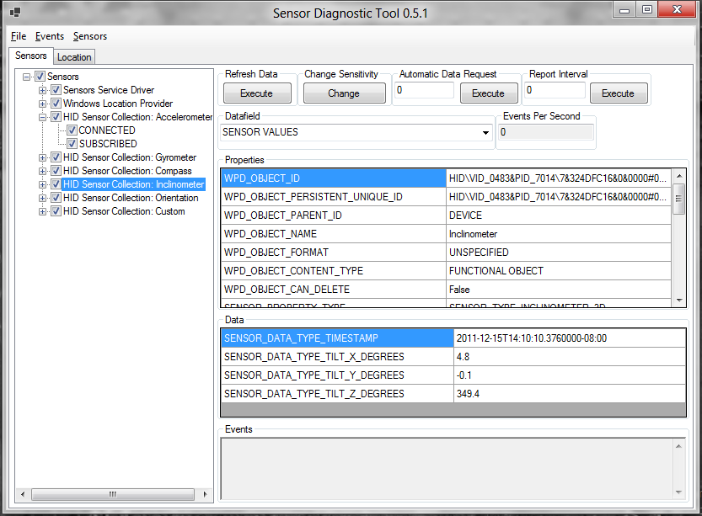

For more information about this tool, please see the WDK documentation.

# Calibration

There are two main classes of sensor calibration: per-model calibration and per-system calibration

## Per-Model Calibration

Per-model calibration corresponds to the corrections and tuning that are performed for a sensor or sensor system on a per model (PC SKU basis). This calibration can account for the electromagnetic characteristics of the chassis (for the magnetometer for hardware or compass algorithm for software/firmware), and also some offset calibration and sensitivity calibration. Every effort should be taken to gather data on a per-system basis and correct/calibrate as much as possible on a per-system level in order to minimize or eliminate the per-system calibration requirements and activities.

## Per-System Calibration

In some cases it may be required to calibrate systems on a per-unit basis at the production facility. This should be avoided if possible in order to decrease the time and space requirements during production.

For more information about per-model calibration versus per-system calibration, please consult with the IHV partners supplying motion and orientation sensors and software.

## End-User Calibration and Continuous Auto-Calibration

This section covers calibration activities and mechanisms that are optionally employed after the factory production process.

### Preferred: Continuous Auto-Calibration

If possible, calibration and interference compensation should occur in device firmware or driver code in such a way that optimal calibration can be adjusted in real-time if adjustment or calibration is required after the factory production process. The specifics of these mechanisms are beyond the scope of this paper.

### Not Preferred: End User Calibration

In some cases, calibration of sensors requires the user to move the device in a particular way. Windows 8 does not provide support (APIs or user interface) for this scenario. If end-user calibration is required, the trigger and user interface need to be implemented by the IHV or OEM.

#### Inquiries

Sensor-related inquiries: <mailto:sensext@microsoft.com>

## Appendix

### Accelerometer Measurement Conventions

Accelerometers are transducers that convert mechanical force into a signal that is proportional to the magnitude of the force being measured.

#### Force and Acceleration

Before getting into any specifics regarding accelerometer technology or guidelines for integrating accelerometer hardware into Windows PC hardware, it is important to first cover the principles of physics. This will result in an accurate and consistent conceptual representation of these devices and a consistent nomenclature.

Perhaps the most important set of observations regarding force, mass, and acceleration were stated by Sir Isaac Newton in his first, second, and third laws of motion (paraphrased here):

1. *An object in motion will tend to stay in motion unless an external force is applied.*
2. *The relationship between mass (M), Force (F), and acceleration (A) can be expressed in relation to each other by the following equation: F = M\*A*
3. *For every action, there is an equal and opposite reaction*

In the remainder of this paper, these principles listed are referred to as Newton’s first, second, and third laws, respectively.

#### Theory of Accelerometer Mechanics

In order to understand a simplified representation of an accelerometer, first consider an object that is sitting at rest on a flat surface.

#### Objects in Static Equilibrium



Figure 28: Object at rest on flat level surface (side view)

In this diagram, F1 is the force due to gravity (pointing towards the center of the earth), and F2 is the *ground reaction force* acting in a direction away from the center of the earth. These forces are equal in magnitude (since the object is in static equilibrium) and opposite in direction.

Now, take a look at the mechanical analog of a single axis (measuring acceleration in only one direction) accelerometer. While this representation typically consists of a damped mass on a spring, we’ll omit the damper since it is not applicable to the conversation.



Figure 29: Simple accelerometer analogy: mass suspended by a spring (side view)

Assume that the entire assembly is at rest, you then know that F1 (force due to gravity) is of the same magnitude as F2 (ground reaction force). You also know that the spring is deflected by some distance (δ in the above diagram). The accelerometer would in turn generate a signal that is proportional to the deflection of the spring, and convert that signal into a measurement of acceleration.

The accelerometer can be configured to output a signal that is proportional to and in the same direction as either F1 (force due to gravity) or F2 (the ground reaction force). This is a matter of convention.

|  |
| --- |
| ***Accelerometers exposed via the Windows Sensor and Location Platform expose acceleration values that are proportional to and in the same direction as the force due to gravity\*\****  ***\*\*F1 in the above diagrams, the BLUE arrow*** |

#### Interactions with Gravity and External Forces

Now that we’ve covered the acceleration measurement convention, let’s examine some common interactions that we can use to illustrate what acceleration sensor data will look like for common scenarios.

#### Scenario 1: 1D Accelerometer pointed towards the center of the earth



Figure 30: Force due to gravity acting on accelerometer (side view)

In this diagram, the single-axis (1D) accelerometer is pointed towards the center of the earth, and the resultant acceleration measurement is +1.0G (+9.8 m/s2 or +32.2 ft/s2, depending on the units and convention used). In this document, acceleration is measured in G (relative to the gravitational constant). Here the blue arrow is the force of gravity acting on the accelerometer.

|  |
| --- |
| ***Using the Windows acceleration measurement convention, if you point the + axis of an accelerometer towards the center of the earth, you will register a positive acceleration along the corresponding accelerometer axis.*** |

#### Scenario 2: Applying a force to the accelerometer

According to Newton’s third law, every action has an equal and opposite reaction. If you apply a force to the accelerometer assembly (shown here as a mass hanging from a spring suspended in a frame), the reaction of the accelerometer is equal and opposite. As in the other scenarios, the reaction of the accelerometer is modeled as a deflection of the spring.

Consider the accelerometer lying on a flat level surface with an external force applied, as shown in this diagram.



Figure 31: External force acting on accelerometer (top view)

Here we have an external force applied to the accelerometer (such as a person pushing on the accelerometer enclosure) represented by F1 (green arrow). Think of this force as the *action*. There is also a *reaction*, which is the spring extending to do the inertia of the mass suspended by the spring. The resultant acceleration measurement (F2, blue arrow) is proportional to the external force (F1, green arrow) but opposite in magnitude. Based on the orientation of the + and – axes for this accelerometer, the resultant acceleration is negative. At first, this may not seem intuitive, but if you think of the measurement corresponding to the direction of the extension of the spring in this diagram, this concept becomes clearer.

|  |
| --- |
| ***Using the Windows acceleration measurement convention, if you apply an external force to an accelerometer, the measured acceleration will be in the opposite direction (opposite sign) compared to the direction of the force applied to the accelerometer.*** |

## Validation of Euler Angles (Yaw, Pitch, Roll) for 3D Inclinometer

### Yaw Tests Overview

|  |  |  |  |  |  |  |  |
| --- | --- | --- | --- | --- | --- | --- | --- |
|  |  | X (Pitch) | | Y (Roll) | | Z (Yaw) | |
| Test | Yaw | Min | Max | Min | Max | Min | Max |
| 1 | 0 | -10 | 10 | -10 | 10 | [0 to 10] | [350 to 360] |
| 2 | 90 | -10 | 10 | -10 | 10 | 80 | 100 |
| 3 | 180 | -10 | 10 | -10 | 10 | 170 | 190 |
| 4 | 270 | -10 | 10 | -10 | 10 | 260 | 280 |

### Test Steps for Yaw

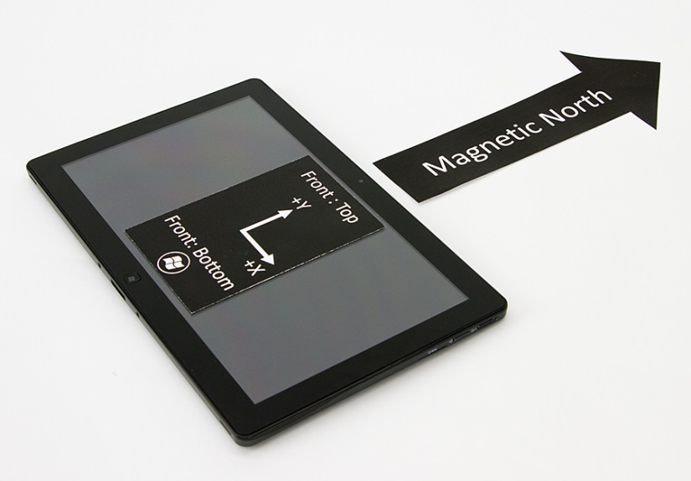

Figure 32: Yaw Test 1 – Yaw = 0°

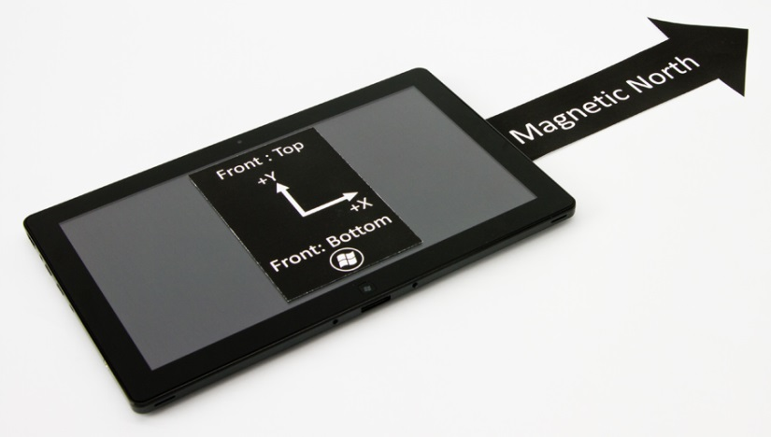

Figure 33: Yaw Test 2 – Yaw = 90°

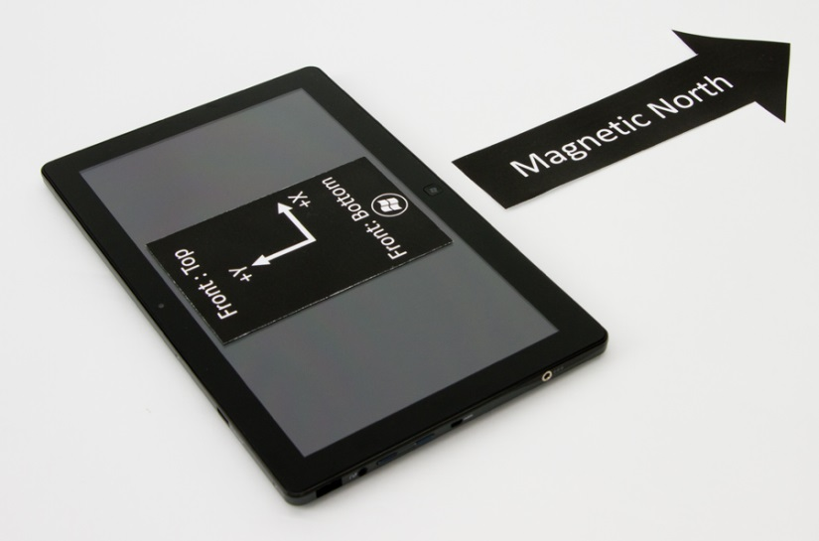

Figure 34: Yaw Test 3 – Yaw = 180°

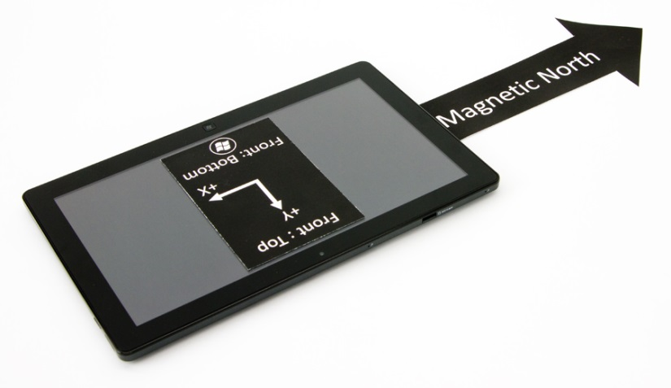

Figure 35: Yaw Test 4 – Yaw = 270°

### Pitch Tests Overview

|  |  |  |  |  |  |  |  |
| --- | --- | --- | --- | --- | --- | --- | --- |
|  |  | X (Pitch) | | Y (Roll) | | Z (Yaw) | |
| Test | Pitch | Min | Max | Min | Max | Min | Max |
| 1 | 0 | -10 | 10 | -10 | 10 | [0 to 10] | [350 - 360] |
| 2 | 90 | 80 | 100 | -10 | 10 | [0 to 10] | [350 - 360] |
| 3 | 180 | [-180 to -170] | [170 to 180] | -10 | 10 | [0 to 10] | [350 - 360] |
| 4 | 270 | -100 | -80 | -10 | 10 | [0 to 10] | [350 - 360] |

### Pitch Test Steps



Figure 36: Pitch Test 1 – Pitch = 0°

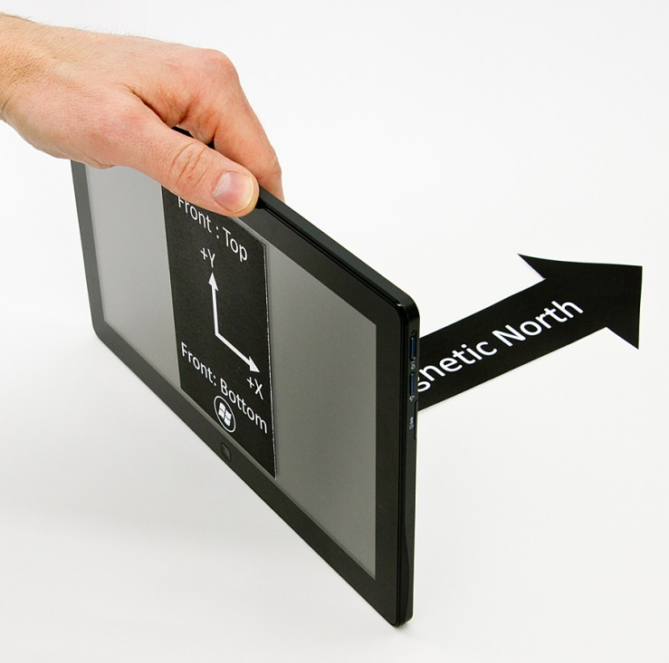

Figure 37: Pitch Test 2 – Pitch = 90°

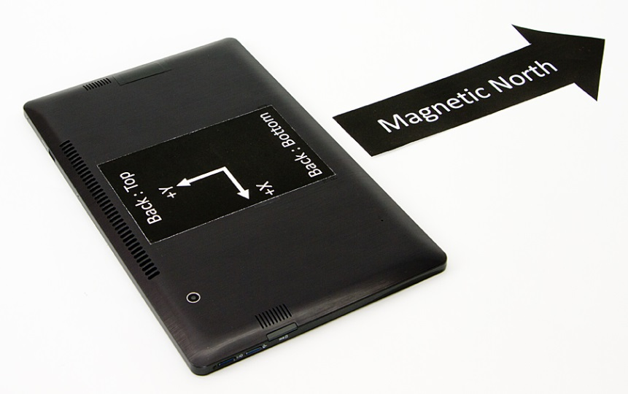

Figure 38: Pitch Test 3 – Pitch = 180°

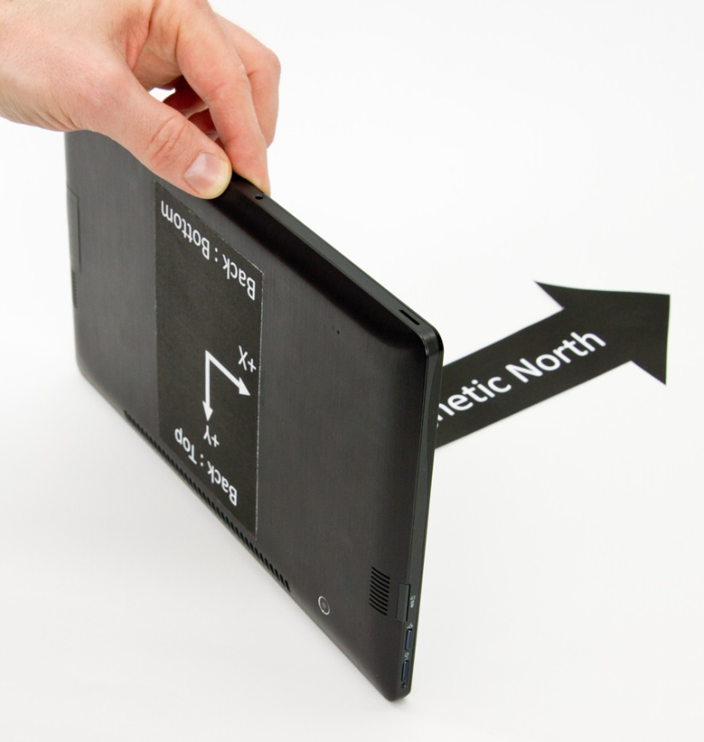

Figure 39: Pitch Test 4 – Pitch = 270°

### Roll Tests Overview

|  |  |  |  |  |  |  |  |
| --- | --- | --- | --- | --- | --- | --- | --- |
|  |  | X (Pitch) | | Y (Roll) | | Z (Yaw) | |
| Test | Roll | Min | Max | Min | Max | Min | Max |
| 1 | 0 | -10 | 10 | -10 | 10 | [0 to 10] | [350 - 360] |
| 2a1\* | 90 | -10 | 10 | 80 | 90 | [0 to 10] | [350 - 360] |
| 2b1\* | 90 | [-180 to -170] | [170 to 180] | -90 | -80 | 170 | 190 |
| 3 | 180 | [-180 to -170] | [170 to 180] | -10 | 10 | 170 | 190 |
| 4a2\* | 270 | -10 | 10 | -90 | -80 | [0 to 10] | [350 - 360] |
| 4b2\* | 270 | [-180 to -170] | [170 to 180] | 80 | 90 | 170 | 190 |

\*Note that the tests shown in gray represent problematic test angles where multiple discontinuities for Euler angle data create unique validation challenges. These specific values are not validated in Windows HCK tests due to these problematic phenomena.

### Roll Test Steps



Figure 40: Roll Test 1 – Roll = 0°

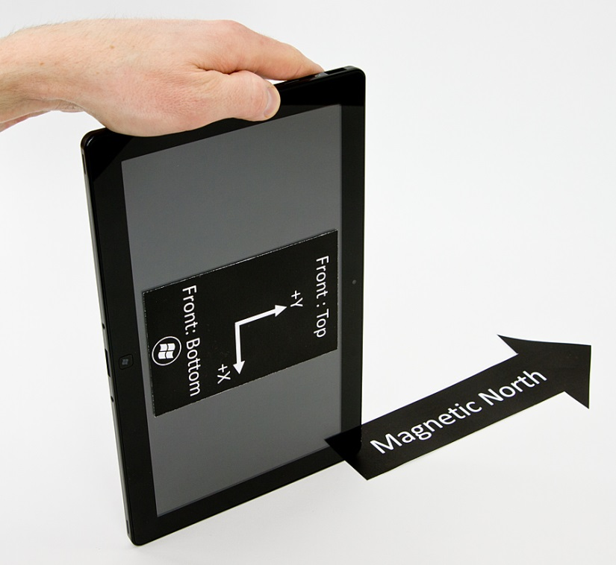

Figure 41: Roll Test 2 – Roll = 90°

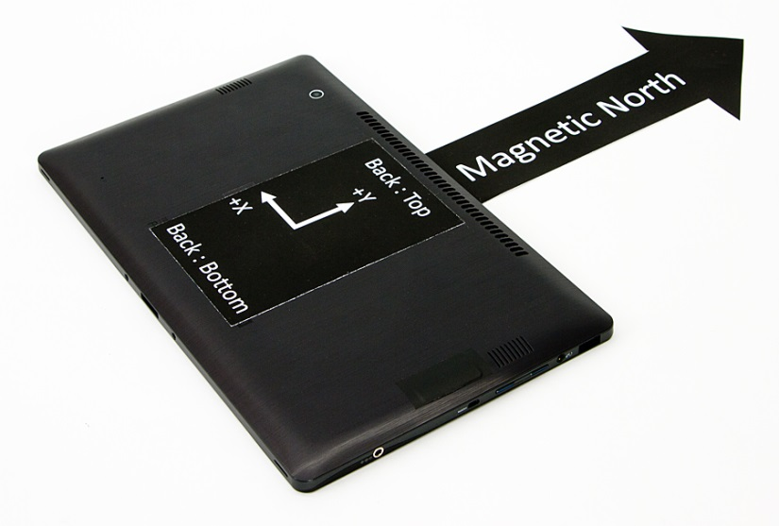

Figure 42: Roll Test 3 – Roll = 180°

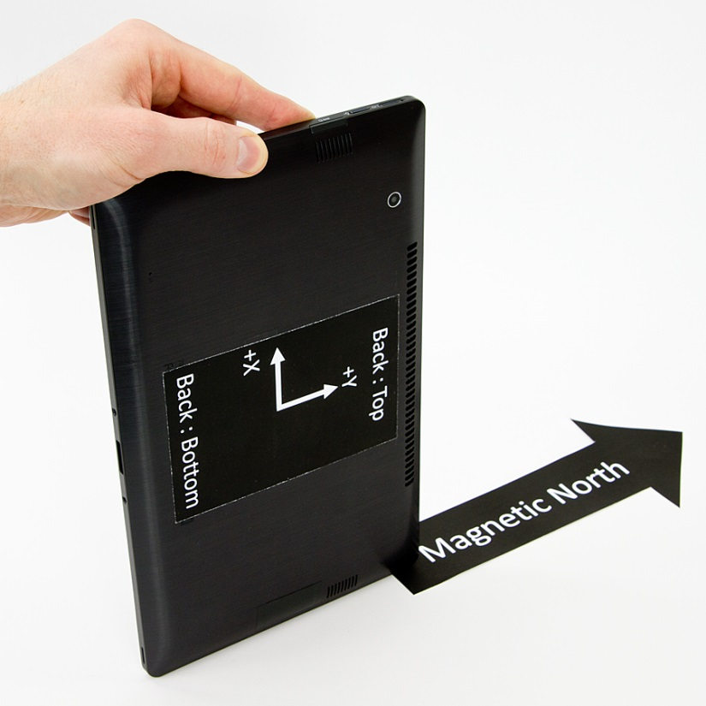

Figure 43: Roll Test 4 – Roll = 270°

# Expected quaternion values for Euler angle rotations

Please reference rotations for yaw, pitch, and roll from the Euler angle tests section.

|  |  |  |  |  |  |  |
| --- | --- | --- | --- | --- | --- | --- |
| Yaw Rotations | Test Angle (Yaw) | X | Y | Z | W | Expected Rotation Matrix |
| 1 | 0 | 0 | 0 | 0 | 1 | |  |  |  | | --- | --- | --- | | 1 | 0 | 0 | | 0 | 1 | 0 | | 0 | 0 | 1 | |
| 2 | 90 | 0 | 0 | 1/√2 | 1/√2 | |  |  |  | | --- | --- | --- | | 0 | -1 | 0 | | 1 | 0 | 0 | | 0 | 0 | 1 | |
| 3 | 180 | 0 | 0 | -1 | 0 | |  |  |  | | --- | --- | --- | | -1 | 0 | 0 | | 0 | -1 | 0 | | 0 | 0 | 1 | |
| 4 | 270 | 0 | 0 | -1/√2 | 1/√2 | |  |  |  | | --- | --- | --- | | 0 | 1 | 0 | | -1 | 0 | 0 | | 0 | 0 | 1 | |
|  |  |  |  |  |  |  |
| Pitch Rotations | Test Angle (Pitch) | X | Y | Z | W | R |
| 1 | 0 | 0 | 0 | 0 | 1 | |  |  |  | | --- | --- | --- | | 1 | 0 | 0 | | 0 | 1 | 0 | | 0 | 0 | 1 | |
| 2 | 90 | 1/√2 | 0 | 0 | 1/√2 | |  |  |  | | --- | --- | --- | | 1 | 0 | 0 | | 0 | 0 | -1 | | 0 | 1 | 0 | |
| 3 | 180 | -1 | 0 | 0 | 0 | |  |  |  | | --- | --- | --- | | 1 | 0 | 0 | | 0 | -1 | 0 | | 0 | 0 | -1 | |
| 4 | 270 | -1/√2 | 0 | 0 | 1/√2 | |  |  |  | | --- | --- | --- | | 1 | 0 | 0 | | 0 | 0 | 1 | | 0 | -1 | 0 | |
|  |  |  |  |  |  |  |
| Roll Rotations | Test Angle (Roll) | X | Y | Z | W | R |
| 1 | 0 | 0 | 0 | 0 | 1 | |  |  |  | | --- | --- | --- | | 1 | 0 | 0 | | 0 | 1 | 0 | | 0 | 0 | 1 | |
| 2 | 90 | 0 | 1/√2 | 0 | 1/√2 | |  |  |  | | --- | --- | --- | | 0 | 0 | 1 | | 0 | 1 | 0 | | -1 | 0 | 0 | |
| 3 | 180 | 0 | -1 | 0 | 0 | |  |  |  | | --- | --- | --- | | -1 | 0 | 0 | | 0 | 1 | 0 | | 0 | 0 | -1 | |
| 4 | 270 | 0 | - 1/√2 | 0 | 1/√2 | |  |  |  | | --- | --- | --- | | 0 | 0 | -1 | | 0 | 1 | 0 | | 1 | 0 | 0 | |

Note that there is a discontinuity at 180 degree rotations where the axis is inverted, so the value of the rotation axis component skips from +1 to -1.

The W value of a quaternion is limited to [0,1] instead of the full [-1, 1].

All rotations must be stated in the forward direction (and not the reverse).

# Expected values for Tilt-Compensated Compass Heading

Please reference rotations for Yaw, Pitch, Roll from the Euler angle tests section

|  |  |  |
| --- | --- | --- |
| Yaw Rotations | Test Angle (Yaw) | Compass Heading |
| 1 | 0 | 0 (North) |
| 2 | 90 | 270 (West) |
| 3 | 180 | 180 (South) |
| 4 | 270 | 90 (East) |

|  |  |  |
| --- | --- | --- |
| Pitch Rotations | Test Angle (Pitch) | Compass Heading |
| 1 | 0 | 0 (North) |
| 2 | 90 | 0 (North) |
| 3 | 180 | 180 (South) |
| 4 | 270 | 180 (South) |

|  |  |  |
| --- | --- | --- |
| Roll Rotations | Test Angle (Roll) | Compass Heading |
| 1 | 0 | 0 (North) |
| 2 | 90 | 270 (West) |
| 3 | 180 | 0 (North) |
| 4 | 270 | 90 (East) |