C.diff Pet’s Study

Jeffrey Berinstein

11/15/2018

## Figure 1: Flow Diagram

n = ‘r nrow(cdi1)’ were contacted by letter or phone call This was made up of ‘r cdi_total_by_cdi_status’ where 0 = CDI- and 1 = CDI+

n= ‘r nrow(mtable1)’ answered the survey This was made up of ‘r mtable %>% sort_by(cdi_status) %>% summarize(total=n()))’ where 0 = CDI- and 1 = CDI+

3 patients where removed due to incomplete data 6 patients where removed due to duplicates

‘r nrow(cdi1)- nrow(mtable1)’ where removed due to lack of response

‘r nrow(mtable3)’ was removed due to being included as a negative control based on our institutional EMR, however discussion with patient reveiled prior history of CDI

‘r (nrow(cdi1)- nrow(mtable1))- nrow(mtable3)’ is the number of patients remaining

‘r svy_com_status_final’ final numbers where 0 = CDI- and 1 = CDI+

##Table One

library(tableone)  
library(magrittr)  
  
listVars <- c("gender", "age", "race", "antibiotics3mo","ppi","h2ra", "adl_total")   
catVars <- c("gender", "race", "antibiotics3mo","ppi","h2ra", "adl_total")  
table2 <- CreateTableOne(listVars, mtable4, catVars, strata = c("cdi"))

## Error in is.data.frame(data): object 'mtable4' not found

table2

## Error in eval(expr, envir, enclos): object 'table2' not found

## Table 1

summary(cars)

## speed dist   
## Min. : 4.0 Min. : 2.00   
## 1st Qu.:12.0 1st Qu.: 26.00   
## Median :15.0 Median : 36.00   
## Mean :15.4 Mean : 42.98   
## 3rd Qu.:19.0 3rd Qu.: 56.00   
## Max. :25.0 Max. :120.00

## Including Plots

You can also embed plots, for example:

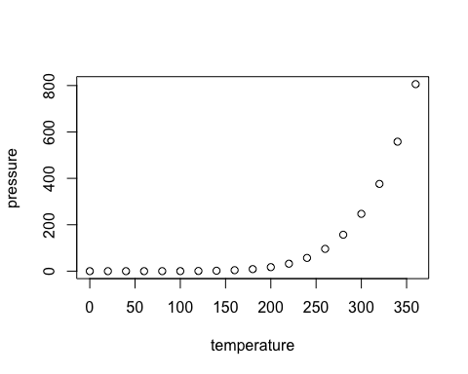

Note that the echo = FALSE parameter was added to the code chunk to prevent printing of the R code that generated the plot.