**Deliverable 1:**

The tuning parameter on the inferred ridge regression coefficients.

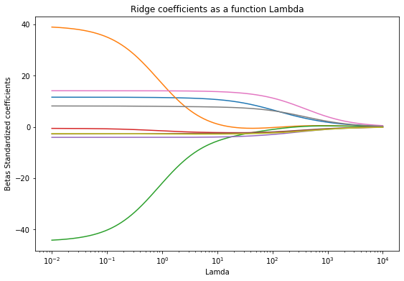

As lambda increases the betas converge to zero.

A closer view at beta =2.

**Deliverable 2:**

Effect of the tuning parameter on the cross validation error.

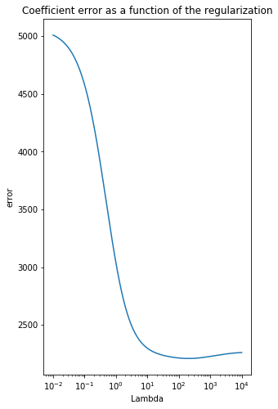

**Deliverable 3:**

Best CV(5) error is generated by the set (x1_train, x2_train) at Lambda =100. CV5=1.023

**Deliverable 4:**

the parameter estimates are:

[[-1.38885482]

[ 1.16016442]

[ 1.15346869]

[-0.04737006]

[ 0.04373921]

[-0.02499739]

[ 0.05143742]

[ 0.41116838]

[-0.00605765]]

After formatting and normalizing the data, there are three main functions:

RidgeGradientDescent(x, y, alpha, iters, L) returns the values of Betas and take the following parameters data, output(balance), number of iteration and the value of lambda.

RidgeAutoTune(x,y,alpha) returns the MSE, optimal value of beta, and MSE and lambda combined. It takes the following parameters data, output, and the learning rate.

RidgeAnalytical(x,y,L) rcomputes the MSE and Betas for a fix value of lambda. It takes the following parameters data, output and lambda.