Termulator v1.4

This terminal emulator is not evil like most of the others. It includes the bare essentials you need for interacting with a remote device and nothing more. In particular there are no essential configuration options. For talking with OBIS and Phoenix devices it should do everything that you need and want.

# Installing

There is no install script. The program files may be found on the N: drive:

**N:\POR\Eng\SPLC\RGBX\Software\Termulator\Termulator.zip**

The Zip file contains a folder named *Termulator*. Unzip this folder somewhere on your computer. The recommended location is

**C:\Program Files (x86)\Coherent\Termulator**

But any place you like is fine. After saving the files to your disk, open the folder in explorer. You’ll see that the folder contains a program named, *Termulator.exe*.

Make a link to the program on your desktop. To do this, click on the .exe file, and drag the mouse to a place on your desktop. Before letting go of the mouse button, also press the control and shift keys; make sure the prompt says “create link” not “copy” or “move” the file before you let go of the mouse button. Voila! You created a link. When you update the folder with new versions of the software, your link will automatically access the new software.

# Operation

When you launch Termulator for the first time you should see something like the following:

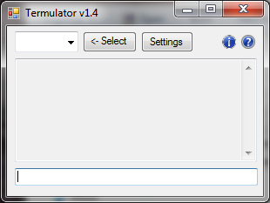

You can move and resize the window to suit your taste. With the mouse, grab any corner or edge and slide in the direction you like. There are limits on how small you can make the window.

Size and position will be remembered when you exit the app, and be restored next time you launch the app.

## Combo Box

The combo box allows you to change the com port used. You may change it any time.

Clicking the down-arrow on the combo box and selecting a port automatically opens the selected port.

From the previous example, opening the COM3 port will result in the following:

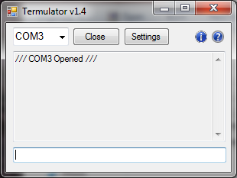

By popular demand I added an explicit button to close and open the port. It says “Close” when the port is open and “Open” when the port is closed. Here it is closed.

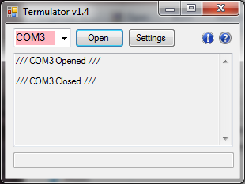

A short message is appended to the Transcript window so the listing will annotate the listing each time a port is opened or closed.

Note the text in the combo box also turns pink when the port is closed.

Your port selection will be restored and reopened each time you launch the app.

The combo box will only show com ports visible to the software at the time it was started. In particular, USB ports appear after they are connected to the computer, and disappear when they are unplugged. If the app is running when you plug in the USB port, it will not show in the combo box. Best practice is to connect all your USB devices before launching the app. If you insist on hot-swapping USB devices, you may have to restart Termulator each time you do.

## Transcript Window

The big panel in the middle is a transcript of your activity. It includes both commands you send to the device and responses returned by the device. Sent commands are echoed in the transcript window (prefixed by “Send: “), followed by whatever response generated by the device.

## Command Entry

The text box at the bottom is where you enter commands.

Unlike most other terminal emulators (which forward each character to the device as you type), commands are sent line at a time. Nothing is sent until you press Enter.

In particular, you can backspace to edit your command before sending it. This edit feature alone motivated me to write this app. Most of the common terminal emulators don’t allow you to correct typos, making them a royal pain in the ass to use.

## Command History

The app remembers the commands you send to the device. Up- and down-arrows scroll through the history of previous commands. When you see the command you want in the window, simply press enter to send it again. Or you can edit the command with left/right arrows, backspace and regular typing to change the command before sending the revised version.

When you scroll back to retrieve a historical command, it is removed from the history list and becomes the new most recent history item.

As of version 1.3, history is retained indefinitely. That is, history is restored after you exit and restart the app. History is presently limited to 100 items.

Version 1.3 also added a list of “Favorite” commands. That is commands you intend to use frequently may be added to a separate list and invoked without scrolling through ancient history. These are retained until manually removed.

Finally version 1.3 added menu controls to access and edit command *Favorites* and *History*. See below.

## Settings Button

The settings button brings up a dialog which allows you to change the RS-232 settings for the currently selected COM port. To use it, select the port you want and press *Settings*. The *OBIS Mode* button changes all the settings to ones that work for normal OBIS devices connected via RS-232 (as shown below).

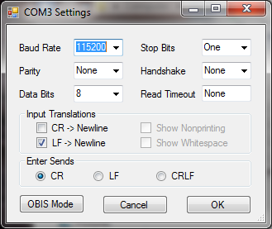

COM port settings are saved and restored on a per-port basis. So you should only have to set them once for each unique port.

## RS-232 Settings

The upper three rows are RS-232 settings. Except the *Read Timeout*, they only apply to RS-232 ports, and are ignored for USB devices.

The *Input Translators* and *Enter Sends* sections apply to the behavior of the app itself, regardless of whether the port is USB or RS-232.

## Input Translators

Affect the translation of byte character data from the device to what is displayed in the Transcript window.

|  |  |
| --- | --- |
| ***Label*** | ***Explanation*** |
| CR -> Newline | Generate a new line in Transcript window upon receipt of a Carriage Return character |
| LF -> Newline | Generate a new line in Transcript window upon receipt of a Line Feed (aka Newline) character |
| Show Nonprinting | Show special symbols for control characters ***[not implemented]*** |
| Show Whitespace | Show special symbols for whitespace characters ***[not implemented]*** |

## Enter Sends

Selects what character sequence to send to the device when enter is pressed in the Command Entry window.

|  |  |
| --- | --- |
| Selection | Sequence |
| CR | Carriage return |
| LF | Line feed aka Newline |
| CRLF | Carriage Return followed by Line Feed |

## Help and About Buttons

You can open a help file and see an about box by pressing the two buttons right of the *Settings* button.

|  |  |
| --- | --- |
|  | Help |
|  | About |

## Command Window Pop-up Menu

Right-click in the command window you’ll be prompted as follows:

|  |  |
| --- | --- |
| **History…** | Access history commands and clear all history |
| **Favorites…** | Access and edit favorite commands. |

Clicking on **History…**

|  |  |
| --- | --- |
| **Clear History** | Clear all history |
| **Older…** |  |
| <one or more previous commands> | Command history labeled by the command itself. Click on the entry to send the command. |

The **History…** menu item is disabled if there is no history. If you have a lot of history, the menu will cascade, with each level showing increasingly older items. Each level includes an **Older…** sub-menu item, except the last one (or the only one if there isn’t much history).

Clicking on **Favorites…**

|  |  |
| --- | --- |
| **Edit Favorites…** | Access Favorites sub-menu |
| <one or more previous commands> | Favorite commands labeled by the command itself. Click on the entry to send the command. |

Clicking on **Edit Favorites…**

|  |  |
| --- | --- |
| **Add Most Recent Command** | Access Favorites sub-menu |
| **Add From History…** | Sub menu lists history items, which when selected adds the command to the favorites list |
| **Remove Favorite…** | Sub-menu lists favorites, , which when selected removes the command from the favorites list. |

## Transcript Window Pop-up Menu

If you right-click in the transcript panel, you’ll see a menu, as follows:

|  |  |
| --- | --- |
| ***Menu Item*** | ***Meaning*** |
| Clear All | Clear the contents of transcript window. |
| Select All | Select the entire contents of transcript window. |
| Copy Selection to Clipboard | Copy whatever selection you have made in the Transcript window to the clipboard. |
| Copy All to Clipboard | Copy the entire contents of the transcript window to the clipboard; same as *Select All* followed by *Copy.* |
| Auto Scroll To End | Check-box item – if checked, the app scrolls the Transcript window to keep the latest info from the com port visible at the bottom. If unchecked, incoming data from the port does not cause the window to scroll. |
| Decode Binary | Someday will translate binary (non-text) into a human-readable format. [WORK IN PROGRESS] |
| Load Commands From File… | Read commands from text file and send them to the com port. Default extension is “.txt”. |
| Save All to File | Copy the entire contents of the transcript window to a file. Default extension is “.txt”. |
| Unicode Unit Test | Test stub for some code to implement Decode Binary, but the result of the experiment were that it doesn’t work with Forms. |

## Things to watch out for

* Com port selection is retained for next time you run the app. However, USB COM ports may *disappear* when disconnected from your computer. If a device is disconnected then it won’t show in the combo box, and Termulator won’t be able to open it. There’s presently no command to “refresh” the list of port choices. If devices are added or removed you need to restart the app to see them in the combo box (which is deemed adequate). Best practice is to exit the app before unplugging a connected USB device, and to make sure all relevant USB devices are plugged in before starting the app.
* Transcript content is discarded when the app exits, unless you remembered to save it with one of the above commands before hand.