# GSCS Weekly News and Updates

This week’s notes on Blockchain and legal smart contracts industry

|  |  |
| --- | --- |
| Participants | [ctinnen@gmail.com](mailto:ctinnen@gmail.com), [mrbarker2@gmail.com](mailto:mrbarker2@gmail.com)  [jbesq777@gmail.com](mailto:jbesq777@gmail.com) |
| Dial-in Number  Participant Access Code | [641-715-3272](tel:641-715-3272)  317998# |
|  |  |
|  |  |

# Technology Trends Web2 to Web3

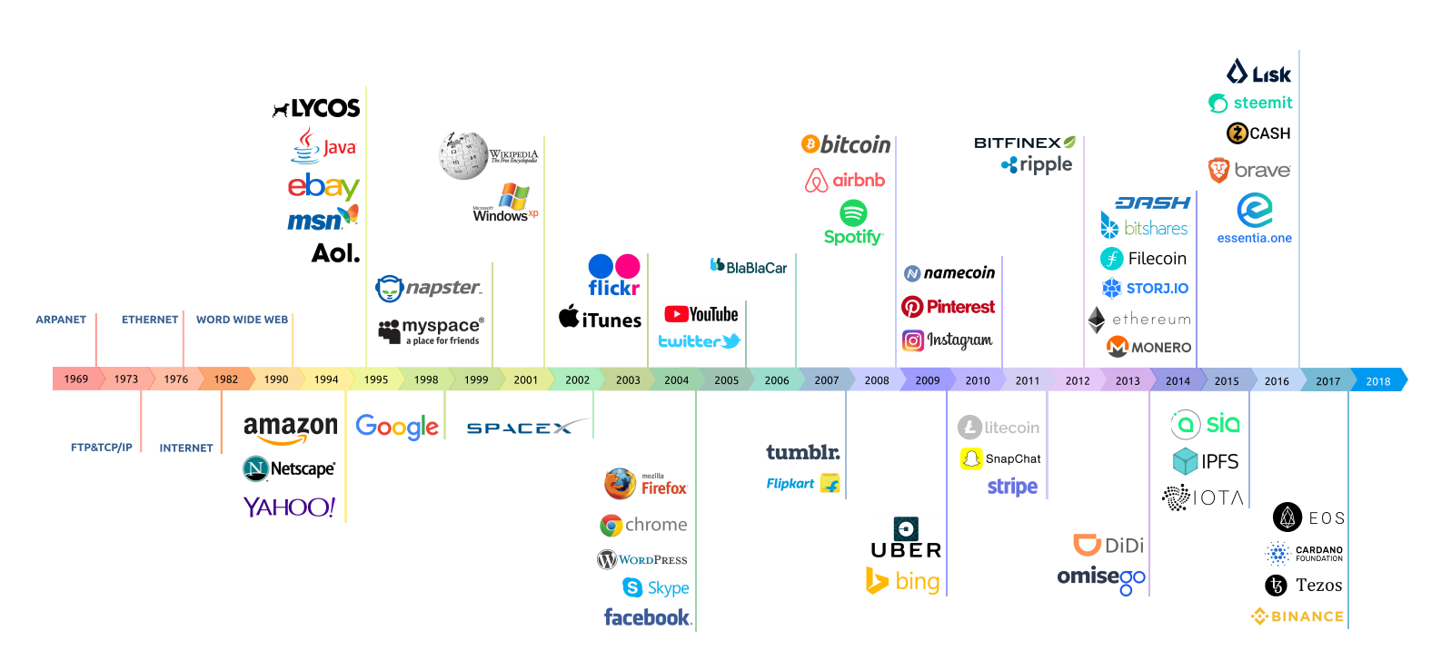

# Latest News

See notes on this weeks

# Banking

Amber Baldet, a key executive of JPMorgan’s blockchain business, is stepping down for greener pastures. Baldet was the architect of JPMorgan’s blockchain strategy, having sat at the helm of the bank’s Blockchain Center of Excellence. She is reportedly leaving to launch her own firm on the heels of reports suggesting that JPMorgan may be spinning off its enterprise [blockchain project](https://www.ccn.com/jpmorgan-reportedly-mulls-spinning-off-quorum-blockchain-project/) dubbed Quorum, which Baldet was basically the face of.

The latest executive shakeup suggests there could be more defections to come at the bank, whose CEO Jamie Dimon infamously rebuffed bitcoin last year (but later backpedaled.)

JPMorgan didn’t waste any time in naming Baldet’s successor. According to an internal JPMorgan memo obtained by Reuters, she will be replaced by fellow Blockchain Center of Excellence official and senior product manager Christine Moy, who incidentally was hired by Baldet, [according to Fortune](http://fortune.com/2018/04/02/chase-blockchain-jpmorgan-amber-baldet/).

The memo said Baldet was leaving for an “entrepreneurial opportunity” but didn’t say whether it was blockchain related. It was penned by Umar Farooq, who [earlier this year](https://www.ccn.com/jpmorgans-farooq-bitcoin-must-evolve-blockchains-not-a-threat/) boasted about the inroads JPMorgan’s blockchain business was making.

Baldet’s departure appears to be on good terms, with JPMorgan spokesperson telling Reuters: “We respect her desire to start her own venture and we wish her nothing but the best.”

## **Quorum Spinoff More Likely Than Ever**

JPMorgan was considering the spinoff of Quorum, saying then it was unclear what the impact of such a move would have on staff. It also presciently suggested Baldet’s future was uncertain. The latest executive departure suggests that the bank is headed in the direction of separating Quorum from the bank.

JPMorgan considers Quorum the “enterprise-focused version of Ethereum.” It’s for the clearing and settling of interbank payments, something financial institutions are increasingly looking to the blockchain for.

Unlike the public ledger that fuels bitcoin, **Quorum is a private ledger** that bolsters transaction times and whose validation is dependent on participants in the contract, not volunteers. It’s been in development for the past couple of years, and spinning it off would create more possibilities for the technology, even beyond banking.

**Quorum competes with the likes of R3’s Corda**, whose bank-fueled consortium JPMorgan was part of until recently. R3’s CTO Richard Brown said in a[December blog post](https://www.r3.com/blog/2017/12/04/corda-is-the-future-of-enterprise-software/) that since JPMorgan’s Quorum is basically a fork of Ethereum, it inherited both the advantages and disadvantages of the second biggest blockchain network. He says of Quorum’s “confidential contract” –

“As soon as you need to prove provenance of one piece of data in a confidential contract to somebody else, you have to show them everything in that contract. Game over.”

It wasn't long ago that your average enterprise wouldn't even mention bitcoin, ethereum, or any number of cryptocurrencies in public.

Instead of using the cryptographically secure tokens to streamline workflows - or even talking about doing so - some of the most [recognizable](https://www.coindesk.com/enterprise-blockchain-may-finally-ready-breakout/) [enterprises](https://www.coindesk.com/hyperledger-tech-heats-ahead-blockchain-software-debuts/) in blockchain have largely confined themselves to uses of blockchain as a new decentralized database, absent any digital assets.

Slowly however, over the past several years that has started to change. Executives at large corporations have shown themselves to be increasingly willing to take public stances both [for](https://www.coindesk.com/morgan-stanley-ceo-bitcoin-just-fad/) (and [against](https://www.coindesk.com/jamie-dimon-bitcoin-fraud/)) what is now a $300 billion token market.

But if 2017 was the year that companies began talking about crypto, it wasn't until recently that enterprises have been willing to publicly use cryptocurrencies in both [early-stage prototypes](https://www.coindesk.com/words-real-companies-talk-ripple-xrp-pilots/) and live [applications](https://www.coindesk.com/ibms-stellar-move-tech-giant-use-lumen-cryptocurrency-payments-rail/).

Now, it would seem the floodgates are prepared to open, with the $140 **billion IBM has been meeting with executives from commodities trading platforms, large corporations, and perhaps most importantly, central banks, to explore how cryptocurrencies can help save them money and generate revenue.**

At the moment, that work is largely being pursued using the public Stellar platform, and its native cryptocurrency, the lumen (XLM), a partnership made public [last October](https://www.coindesk.com/ibms-stellar-move-tech-giant-use-lumen-cryptocurrency-payments-rail/).

But in interview, Lund said IBM is interested in expanding the business applications of cryptocurrencies in a number of ways.

**IBM has met with 20 central banks exploring the**[**potential**](https://www.coindesk.com/end-of-inflation-the-radical-vision-of-futures-backed-cryptocurrency_central_banks/)**benefits of issuing their own fiat cryptocurrency on a blockchain.** largely comprised of banks from the G20, an international forum with members including China, Russia, the U.S. and the EU.

In December 2017, the Riksbank published a [white paper](https://www.riksbank.se/globalassets/media/rapporter/e-krona/2017/handlingsplan_ekrona_171221_eng.pdf) see <https://www.riksbank.se/globalassets/media/rapporter/e-krona/2017/handlingsplan_ekrona_171221_eng.pdf> detailing its interest in moving Sweden's cash supply to a digital platform, though it didn't mention blockchain specifically.

## Beyond currency

But IBM's work with assets issued on a blockchain goes beyond central bank-sanctioned cryptocurrency.

By using the same technology that is allowing an [increasing](https://www.coindesk.com/why-a-39-million-ico-chose-stellar-over-ethereum/) number of startups to raise capital on the Stellar platform, IBM is exploring a wide range of other tokens.

## Beyond Stellar

So far, IBM's work with cryptocurrencies has been largely confined to the Stellar network and its native lumen cryptocurrency, which it has used largely in cross-border payments trials.

The company itself is [running](https://dashboard.stellar.org/) nine Stellar nodes that help confirm those transactions based in locations around the world, such as Australia, Brazil, Hong Kong and the U.S. However, going forward, IBM is open to working with any number of blockchains.

The most serious of that work appears to be with the Sovrin Foundation that [contributed](https://www.coindesk.com/hyperledger-tech-heats-ahead-blockchain-software-debuts/) the original codebase of Hyperledger Indy, and is now preparing to issue a crypto asset in an ICO.

While Lund didn't reveal details about that work, he indicated there is an early-stage partnership forming with the non-profit organization. More news, he said, is expected shortly.

From there, IBM's work with cryptocurrencies even further converges on its work with permissioned blockchains.

In January, IBM Research [published](https://arxiv.org/pdf/1801.10228v1.pdf) a detailed white paper that described their work to apply a transaction model used by bitcoin into Hyperledger Fabric's underlying chaincode.

Designed for purely experimental purposes to help compare transaction through-puts in the permissioned blockchain to those on public ledgers, the "Fabric Coin" effort resulted in improvements that were included in the **Hyperledger Fabric 1.1** [released](https://www.hyperledger.org/blog/2018/03/20/hyperledger-fabric-v1-1-released) earlier this month.

See, <https://www.hyperledger.org/blog/2018/03/20/hyperledger-fabric-v1-1-released>

# Insurance

Two of the largest health insurance providers in the U.S. announced Monday that they would pursue a blockchain pilot aimed at improving the quality of healthcare data.

UnitedHealth Group and Humana - who are largely rivals in the health insurance industry - said that they would develop the pilot in cooperation with MultiPlan and Quest Diagnostics. UnitedHealth Group will participate through two of its subsidiaries, UnitedHealthcare and Optum.

According to a [statement](http://www.unitedhealthgroup.com/Newsroom/Articles/Feed/Optum/2018/0402HumanaMultiplanOptumUHCBlockchain.aspx?r=1) released by the companies involved:

*"The pilot will examine how sharing data across health care organizations on blockchain technology can improve data accuracy, streamline administration and improve access to care."*

It's not clear at this time whether the pilot would involve an existing platform or the development of a wholly new one. UnitedHealth and Humana did not immediately respond to requests for further information.

Still, the pilot is targeting a key pain point in the healthcare industry, data reconciliation, which according to one estimate costs as much as $2.1 billion in annual spending. And firms like UnitedHealth have eyed blockchain for potential applications in the past; last week, a group of insurers and reinsurers [launched a new commercial venture](https://www.coindesk.com/blockchain-insurance-consortium-b3i-pivots-full-fledged-startup/) that grew out of an existing consortium effort.

# Law Firms and Smart Contracts

<http://www.euromoneyseminars.com/articles/3570160/derivatives-body-isda-part-of-smart-contract-blockchain-group.html>

1st of April, 2018, United Kingdom – [SMRT](https://smartstartuptoken.tech/)  see <https://smartstartuptoken.tech/> describes itself as a “vending machine for legal documents” that are then secured in the blockchain. The need to create contracts can be extremely onerous for start-ups, in terms of both money and time. Blockchain offers the opportunity to make enforcement cheaper and easier. However, few small businesses have the resources or understanding of blockchain technology to utilize it. The [SMRT](https://smartstartuptoken.tech/) templates will cover the contractual areas that startups and small businesses encounter, such as shareholder and intellectual property agreements. They will also cover finance and trading agreements in the way the Ethereum blockchain was originally designed for.

*“Established trading marketplaces could benefit enormously from our smart contracts, as buyers and sellers will have automatically enforced agreements to transfer money for goods and services. They also open the way for many new decentralised marketplaces, where the smart contracts are the enforcements of trade. Small businesses would be able to buy bundles of our smart contract templates to facilitate their sell/buy trades.”*

*“The technology offers some very exciting opportunities but as legislators internationally, we must also make sure that consumers have trust in it. Blockchain and smart contracts will be a game changer for startups.”*

**Website** : [https://smartstartuptoken.tech](https://smartstartuptoken.tech/)  
  
**WhitePaper –** <https://smartstartuptoken.tech/smrt-whitepaper-v1.pdf>

# EtherParty

Clyde pointed us at <https://www.artificiallawyer.com/2017/10/11/etherparty-promises-to-be-legalzoom-of-smart-contracts/> https://etherparty.io/

A new smart contract company, [Etherparty](https://etherparty.io/), is launching a system that allows anyone to create legally binding, self-executing contracts that will be placed on the Ethereum blockchain, in what could eventually challenge traditional forms of contract creation. In a company statement, Etherparty said: ‘**Much like**[Legalzoom](http://www.legalzoom.com/)**and**[Docusign](http://www.docusign.com/)**before it, Etherparty [wishes] to make otherwise complicated contractual agreements and processes simple and accessible**, while enabling infrastructure for authentication and automation.’ The move follows similar efforts by smart contract start-ups, [BlockCat](http://www.blockcat.io/) and [Agrello](https://www.agrello.org/). It also signals that while lawyers debate the merits of certain standards for smart contracts and blockchain use, the rest of the world is moving on and already creating them. For example, [**AXA**](https://www.artificiallawyer.com/2017/09/19/insurance-giant-axa-launches-self-executing-smart-contracts/)the global insurance company last month launched a commercial smart insurance contract for flight delays. In this case, Etherparty seeks to break down the coding barrier by not needing to use the Solidity language, that makes building a smart contract a challenge for those without technical skills. Instead of having to code the start-up provides templates that are designed to be legally compliant to your local jurisdiction.

At present the model contracts are few and cover non-mainstream areas such as crowdfunding agreements, but the Vancouver, Canada-based company plans to move into broader commercial contracts and property transactions.

It also sees the use of blockchain to store commercial contractual data as a huge step forward in data security, transparency and retention of key information.

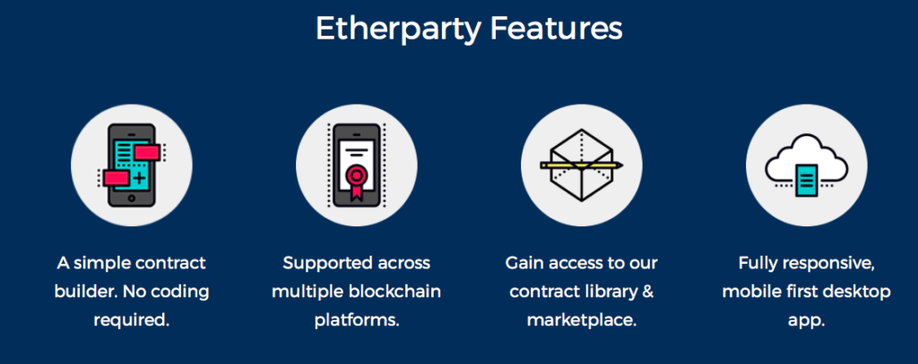

# OpenLaw

### Dynamic, Next Generation Legal Agreements

Contracts Are Changing: It is now possible to model all or parts of legal agreements using code (smart contracts), decreasing the cost and friction of creating, securing, and generating binding legal agreements.   
  
No Comprehensive Tool: Lawyers lack basic tools to build these dynamic, “smart” contracts in a way that is enforceable and understandable to a legal professional.

www.openlaw.io

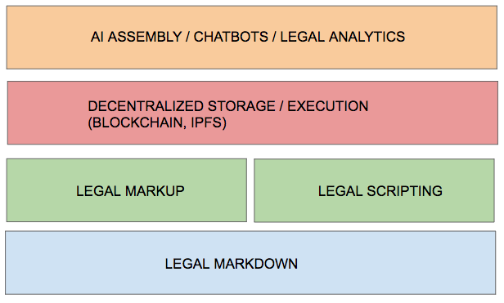

# Accord Project

Smart legal contracting needs fundamental standards. The Accord Working Groups are comprised of leading lawyers, and organizations that help establish best practices and legal standards for smart legal contracts. Technical Standards. The Accord Project develops technical standards such as data schemas, models,etc ..

The Accord Project was formed by US-based smart contract pioneer, [**Clause**](http://www.clause.io/), and has sought to build collaborative relationships with global standards bodies and a variety of blockchain companies, and also put some of Clause’s software in the public domain to encourage development in this area.

As mentioned in previous Artificial Lawyer stories on this theme, the reality is that although there are many smart contracts in use for relatively simple agreements on platforms such as Ethereum, the self-executing elements remain in a grey area for legal and technical issues. This has prevented smart contracts being adopted for more complex commercial matters. The Accord Project hopes to solve that problem by creating global standards, just as the banking community did for international electronic payments several decades ago.

For example, Accord works with standards bodies the IEEE and the International Association for Commercial and Contract Management; and blockchain systems R3 and Hyperledger.

<https://www.accordproject.org/>

Clause.io

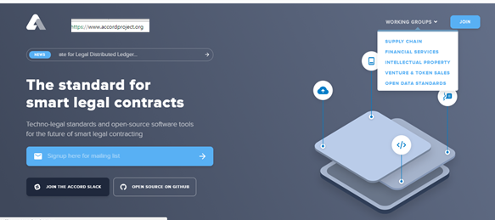

# The JURA Natural legal Language RENAMED to ERGO

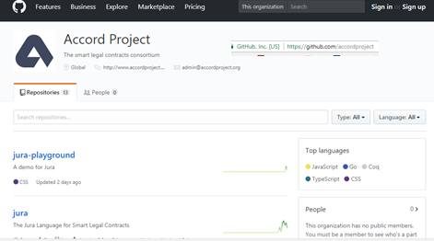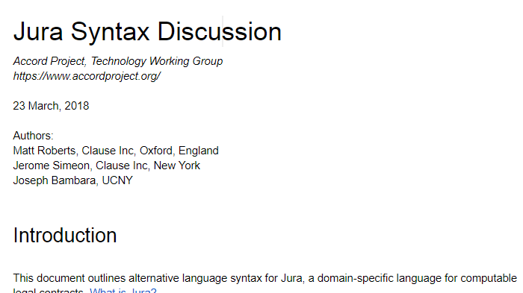

# Accord Project: Law firm members

# https://www.artificiallawyer.com/wp-content/uploads/2018/03/Screen-Shot-2018-03-28-at-07.27.01.png