Joel-Cedric Beugre

Documentation Page

For this project on the London 1854 cholera epidemic, my first idea was to create only one Scalable Vector Graphics (SVG) and insert the map and the timeline graph inside this SVG. But advancing in the project makes me realize that this approach will be complicated when I would need to implement the cluster or the distribution of the gender and age. So, I had to come with another design that I draw before starting the new version. The idea was to create multiple SVG and then make them interact. The following image is my first drawing of my new design.

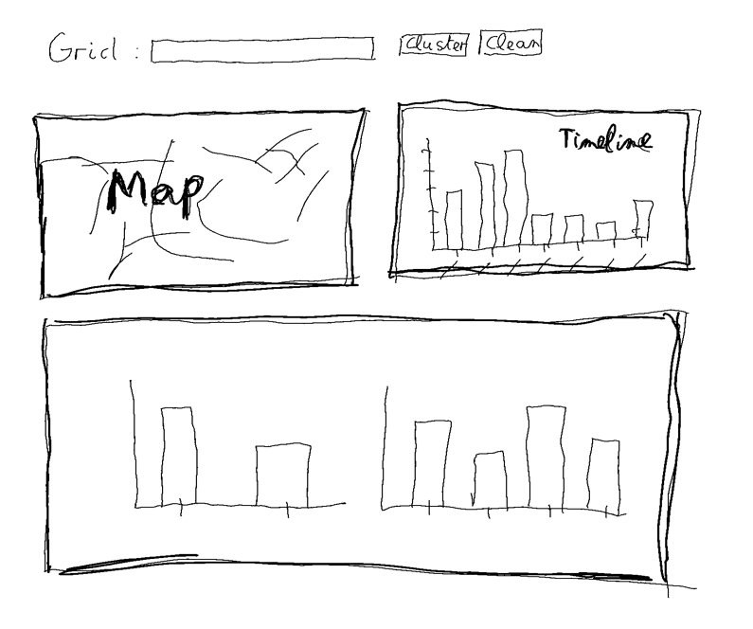

Fortunately, the final result is very different and look better than this drawing and I also added a box to show the age and the gender of each point on the map when the cursor is over them.

For the map, I had to use polylines instead of lines, because some of the data had more than 2 points. To build the map I had to create a nested loop that identify how many points are in a record and then plot it based on the previous check. I also had to do a data transformation because the map generated was different than the real map and to make it similar, I multiplied the y value by -1 and add 570 to be able to see them on the map SVG.

For the death point positions, I had to match the data transformation of the map. After that, I had to filter the point and make it easier to see the different gender on the map. Firstly, I used blue and red for male and female, but after implementing the cluster, I realize that I was hard to see the number of deaths in the grids so I add to replace them with lighter blue and red.

The timeline graph and the distribution based on gender and age was quite similar. Firstly, they delete all points on the map, then replace them with data points that have been filtered by a statement. When the user mouses is not on a bar anymore, the new points are deleted and the initial points are inserted again.

The timeline graph has two parts. The first part counts the number of deaths during and before the date selected and then plot the first data points based on the number of deaths that we got previously. Unlike the first part, the second part let the user select a date range by clicking on two dates under the horizontal axis. To make it possible, the code count the previous death and then plot only the death in the date range thanks to a logical statement that help plotting only data in the date range.

The color on the distribution graph based on gender match with the data point and have been checked using a google chrome extension called Colorblind - Dalton for Google Chrome to be sure people with color blindness could make the difference between them.

The first approach to build the cluster was to use it only for the original graph or click every time on the cluster to update the grid value. After testing this approach, I realize it will be impossible for users to put cluster data point representing only man or woman for example. So, I had to change the approach completely. So, I create a status variable to solve this problem. When the cluster status is true. Every action of the user on the different graph will update the cluster.

Finally, from this data visualization project, there’s a lot of detail that can help us understand and maybe prove John snow theories on the London cholera epidemic 1854.

Using a date range, we can easily identify the position of the first case. We can notice that the first 9 cases are around the broad street and each one of them are really close to the pump. This zone also seems to be very important because with time, we can clearly see that the London epidemic spread from this area and around this area.

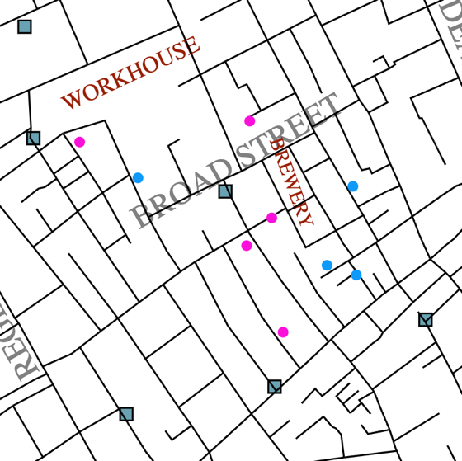

Another important fact is that the first cases are either children or elder. An information that can mean that at the beginning of the cholera epidemic the illness was severe for people with weak immune system. This discovery is also proved by the fact that more than 200 people died from cholera in those age groups in this timeframe. The other age groups have considerably less victims of cholera.

