Swarmed Parallel Interpreter for Numerical Analysis with Collaborated Hosts



PLOTTING MODULE

B-SPECIFICATION
Version 4.0

JAGADISH PRADEEP BEZAWADA
12/06/2009

Rohan Pandit

Uma Mahesh
Rushabh Gandhi

Architecture:
The plotting module comes in the context as shown in fig1.0. The plotting module has the inputs of data structures, save command from the interpreter core module and user interface module respectively. The bitmap image file reference (containing the plot), the save of a file on the local disk, and errors during the processing are the outputs from the module.
The plotting module is further divided into three sub processes. The receiver process, paint process and the plot manager process. The receiver process gets the command including parameters which are parsed to identify the command name and the dataset which are passed to the paint process, where in the specific algorithms generate the plots needed to be plotted and the subplots are handled by the plot manager. The plot manager even plots the general 2D, 3D datasets and resizes the container by interpreting the subplots. It even generates the bitmap file image and then returns the file pointer, errors.

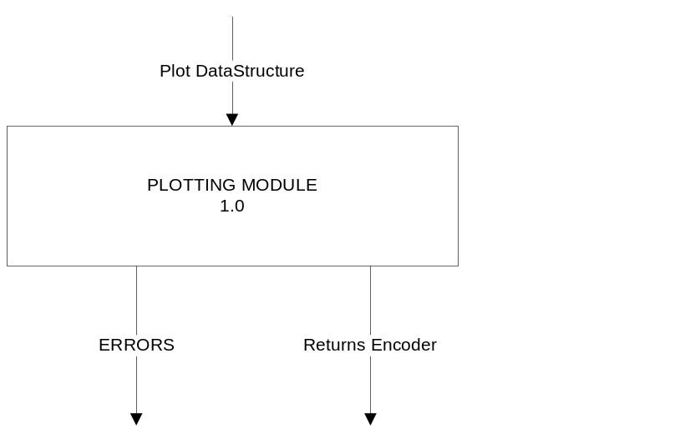

Fig .1.0 PLOTTING

CONTEXT DIAGRAM

Reference Documents

Customer A-Specification
Author: Phil Pratt Szeliga
Swarmed Parallel Interpreter for Numerical Analysis with Collaborated Hosts, 09/25/09
Author: Yehong Wang
Architectural Concept Document, 10/05/09

Reusable Software
Windows Presentation Form API .net 3.5 framework classes
C#.net API .net 3.5 framework classes

- FUNCTIONAL REQUIREMENTS:
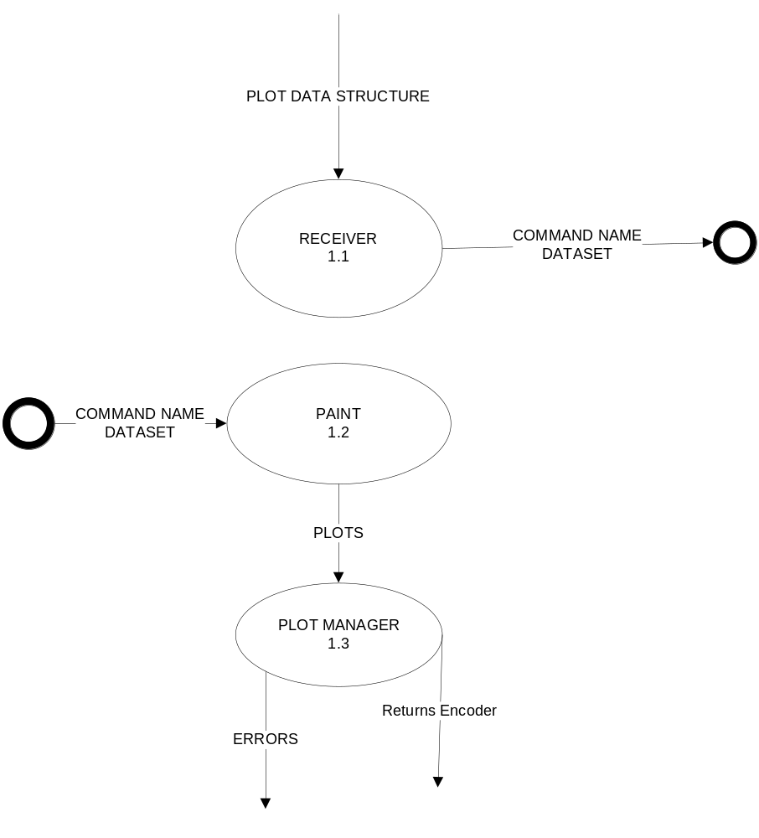
Fig.2.0 PLOTTING PROCESS

  - RECEIVER PROCESS:
The Receiver process is responsible for the input for the plotting module. The input obtained is data structures, which is a combination of data sets and commands to operate on those data sets.
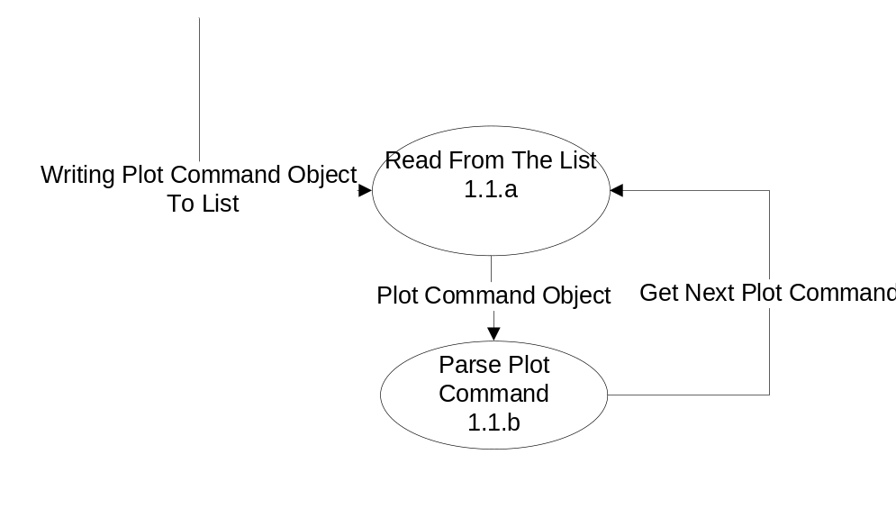
Fig.3.0.PlotReceiver Process
    - Input:
- Data structure containing the command name and dataset obtained from interpreter core module as “PLOT” object.
    - Processing:
- The data structure obtained as input shall have entities such as command name, dataset for some plot commands. This shall contain other parameters required for specific commands which require axes scaling factor, axistitle. The command name tells which type of plot to make, and the data set of double values gives us the data for the plot itself. This shall also accept negative values for plotting.

    - Output:
- Data sets of the plot and Commands which operate on the dataset which are sent to the Paint Process.

3.2 PAINTING PROCESS:

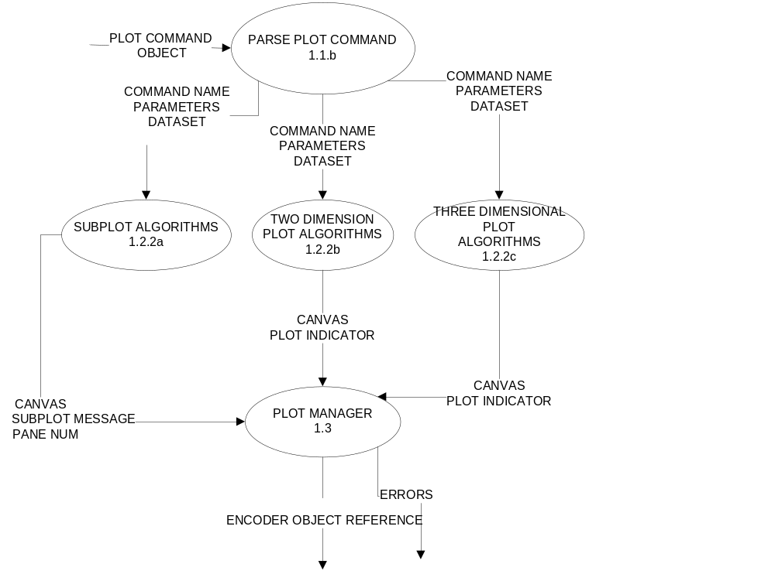

Fig.4.0. PAINT PROCESS

From the dimensions field this process shall decide number of axis it needs to have it on a panel.
1D- One axis
2D- Two axis x, y
3D- Three axis x, y, z
1D- Shall plot a single point on a axis.
2D plane- shall plot an index of each point on x axis and value of each point on a y axis and then shall join those points. So index of first point will be 1 and then for next points it will be 2, 3, 4 etc. So these indexes would be the x-axis and the y-axis would be the points.
3D- shall plot coordinates of each point on x, y using indexes and z axis using the value correspondingly and join those points to form a 3Dimage. shall perform this procedure for modes (terrain, vector, mode where 2D image but the color of pixel shows the height on z axis) selected by a user. The vector field mode has vectors for the values of the dataset with magnitude
and dataset equal

Axis Scaling: The axis scaling shall be on both X-axis and Y-axis for two-dimensional plots and no z-axis scaling for three dimensional plots. The terrain mode does not support any kind of axis scaling( no x-axis, y-axis, z-axis scaling for terrain mode). The plot titles shall not be present for the terrain mode.

3.2.1 PARSE COMMANDS:
Parser takes the plot commands as the input and determines the dimension of the input and passes them to required algorithm for plots.

3.2.1.1.INPUTS:
- Plot Command Object

3.2.1.2.PROCESSING:
The parser shall get an input in the form of data set which contains all the coordinates of the points that has to be plotted. It also shall get the command name by which the data set is passed to the required algorithm. In case of improper command, it shall report error to the user interface.
3.2.1.3.OUTPUT:
- Algorithm specific command names and its parameters
- Data set
- Error messages
- Subplot message.

3.2.2. ALGORITHM PROCESSING:
Algorithm processing contains the sequence of instructions to be followed to support a particular drawing required by the user.
3.2.2.1.INPUTS:
The inputs to the algorithm process are the command name and the data set containing the points needed to be plotted.
3.2.2.2.PROCESSING:
Depending upon the kind of drawing say two dimensional or three dimensional plots, the particular algorithm shall generate the points to be plotted on the panel which is on a container. Shall support two dimensional and three dimensional datasets of double and int type.
3.2.2.3.OUTPUT:
The output of this is the points drawn on the canvas and also the pane number which will be handled by plot manager.
3.3. PLOT MANAGER: 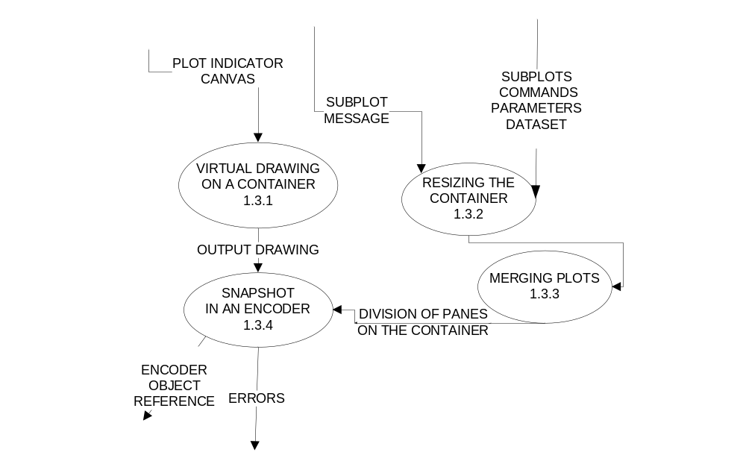

Fig.5.0. EXPANDING PLOT MANAGER

3.3.1 VIRTUAL DRAWING ON CONTAINER (VDC):
VDC data process contains plots from a corresponding algorithm process and shall draw it on a suitable canvas in windows presentation foundation. The canvas shall contain the following
3.3.1.1 Inputs:
- Plots contained in the canvas.
- Coordinates of each point.
- various objects like lines, textblocks , triangles.
- Type of scaling (Linear/logarithmic/default/user customizable) for two-dimensional modes.
- Axis and plot titles.

3.3.1.2.Processing:
The VDC process shall get a canvas and pane number. It shall then select suitable canvases from
the list of canvases that are maintained in the plotmanager to display on the Plot window.
3.3.1.3.Outputs:
-A panel (like canvas) which contains the corresponding plots.
3.3.2.RESIZING THE CONTAINER (RTC):
It shall take the subplots commands, message for pane number and divides the entire panel accordingly to small parts.
3.3.2.1 Inputs:
- subplot commands from the parse process
- commands
- parameters
3.3.2.2.Processing:
RTC shall get subplot commands from the paint process and shall divide the panel containing the plots accordingly.
RTC then shall draw the corresponding plot for each subplot command in the respective parts of the panel.
So RTC shall plot the subplot command in the panel basing on the pane number, and the
Subplots panes supported are not more than four.
In case user wants to do subplot on n^{th} pane RTC shall check if that is possible in the divided pane and if not it will give the error message saying the ‘subplot could not be plotted’.
3.3.2.3.Outputs:
-The panel showing subplots for each subplot commands given by the user, axis titles, scaled axis.
3.3.3.MERGING PLOTS (MP):
This sub process takes all subplots as a input and merge them on a single panel.It then pass this panel to STE process.
3.3.3.1.Inputs:
- All subplots which are to be merged and put on a single panel.
3.3.3.2.Processing:
MP process shall get all the subplots from RTC process .It positions them on a single canvas according to their pane number and shall report errors if any. Before that it checks whether all the subplots are of the same size or not.
3.3.3.3.Outputs:
-A panel containing all the subplots.
3.3.4.SNAPSHOT IN AN ENCODER (SIE):
STE process gets a panel containing plot or subplots from VDC and MP process to which it will convert to a bitmap image and store it in a file. After getting a saving command from display team it will store this file to a local disk.
3.3.4.1.Inputs:
-Panel containing a plot from VDC process or a panel containing subplots from a RTC process.
-Saving command from a Display team.
3.3.4.2.Processing:
STE shall get a panel containing plot or subplots from VDC or RTC respectively. It shall then render this plot to bitmap format using WPF class. STE shall then create a file stream which will store this image along with a reference to that file. This reference will be send to a display team. After getting a save command from display team STE shall save this file containing image to the local disk ( done by UI ).
3.3.4.3.Outputs:
-Encoder Object Reference to a file which contains the image.
-Error messages ex: File is open already, exceptions etc.,

Process Requirements
These requirements specify physical structure of the code developed and the environment where it must operate.

Physical Structure
The plotting module shall consist of more than one module. A module in C# is a single .cs file. The executive is only a single file with main in it. The other modules are the server modules that help the executive in achieving the result by fulfilling the requirements. A server module has both the declaration and implementation in a single
file. So it makes it easy for the compilation and linking much easy.

The module shall contain the following elements:
- A module contains the namespaces that it uses ( using the language features)
- A manual page containing a prologue, a paragraph describing module operations, and a list of the public interface with interpretations to help the designer to use the module
- a maintenance page describing the build process, specifically naming the required files and compilation commands
- a main function

The main function in each server module shall be enclosed by preprocessor statements preventing compilation unless the preprocessor detects a directive of the form TEST_MODULENAME, where MODULENAME is the name of the module with no extension.

The file containing both the header and the implementation shall begin with a prologue that contains descriptions of the following elements:
- file name with a few word summary
- version number
- language of implementation
- platform
- application
- author with address, telephone number, and e-mail account

4.2. Development Environment
The plotting module shall compile and link from the command line using WPF application, in Visual Studio, version 9.0, and shall operate under the Windows VISTA operating system, home premium edition, service pack 1

- Data Dictionary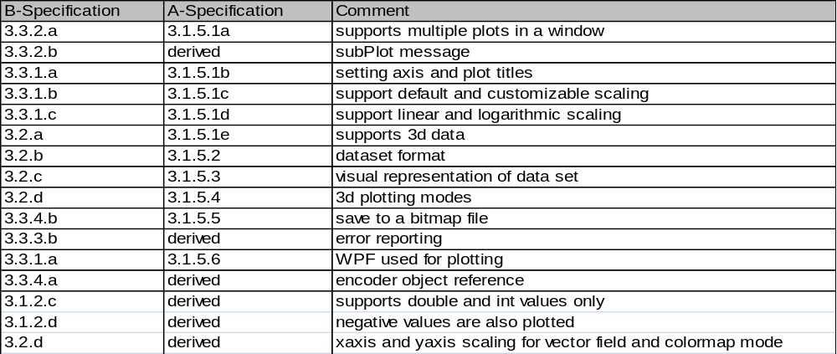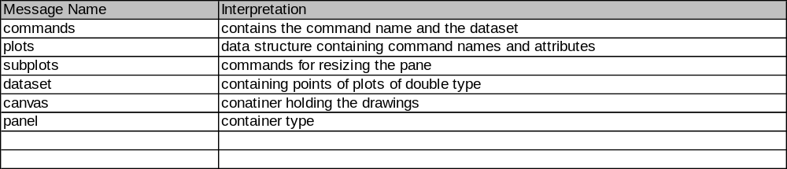
- Requirements Traceability matrix

- Notes:
All the code in the plotting module would be developed using the WPF .net 3.5 framework and this would not create any problem to the other modules as we just
send the user interface the encoder object reference.

