class4.R

jbgarza

2024-01-23

# My First R script  
  
x <- 1:50  
plot(x, sin(x))

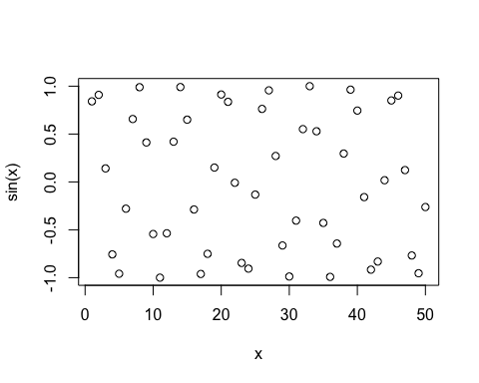

plot(x, sin(x), typ="l", col="blue", lwd=2.5, xlab="Hello")

