# Bamazon

bamazonManager.js

Amazon-like storefront using Node and MySQL

*Manager Module*

Welcome Screen: Choose to View Products for Sale (All Products), View Low Inventory < 50 units, Add to Inventory (existing inventory), and Add New Inventory (a new product not currently in the db).

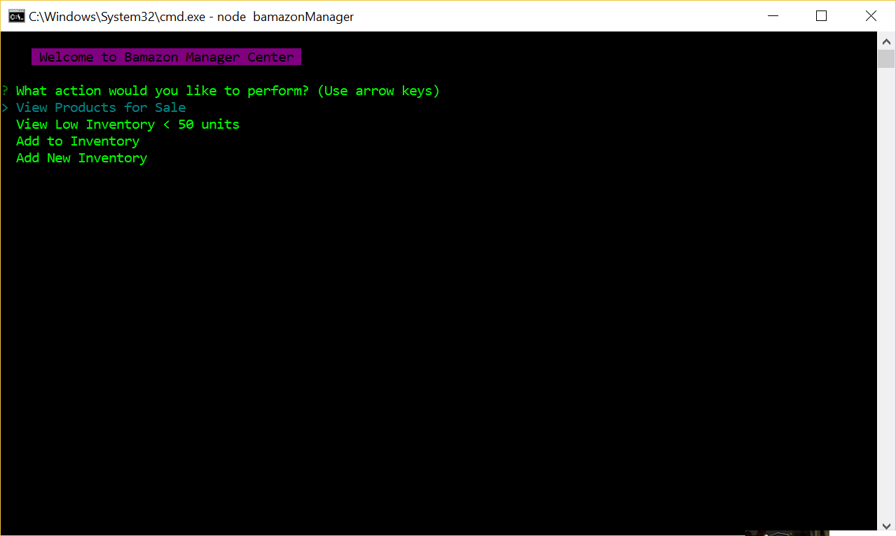

Option: View Products for Sale

List all products and shows total number of records/products:

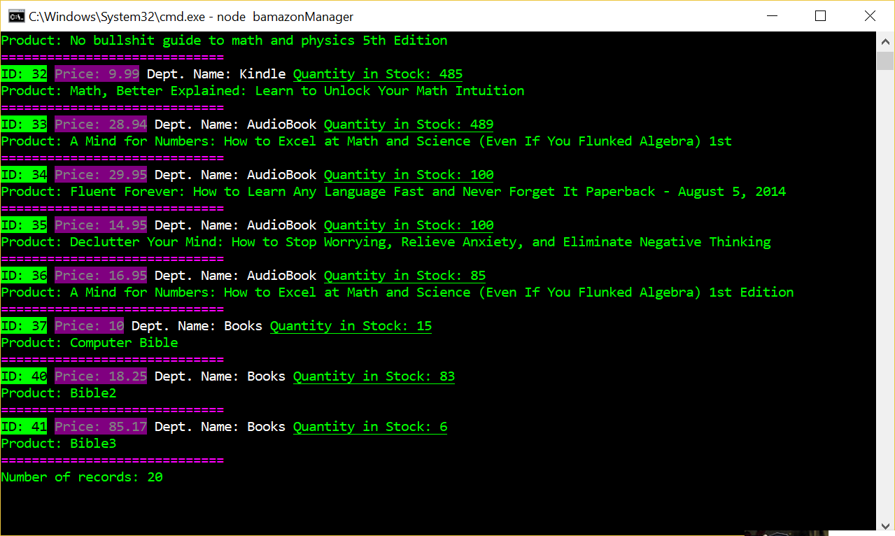

Option: View Low Inventory < 50 Units

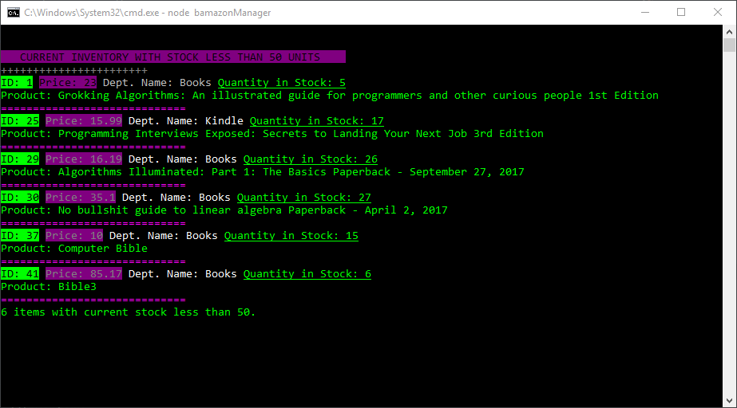

Option: Add to Inventory

Takes in product id and quantity and updates the db.

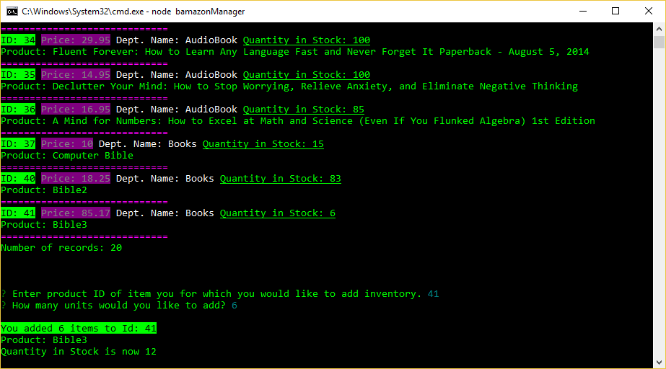

Option: Add New Inventory

Adds a completely new item into the db. It first uses an inquirer list to pick between Books, Kindle, and Audiobooks. Then it prompts for the book name, price, and number of units (stock_quantity). On number of units it defaults to 1 if you don’t enter anything. It recaps what you entered and updates the db.

