1. Forecast the global average temperatures through year 2100. There are concerns about global temperatures raising by 2 degrees Celsius, and possibly even by 4 degrees by then. Do your analyses provide support for or against these concerns?

Answer: To find out the forecast for global average temperatures through year 2100, we started with decomposing historical data using “stl” function. Our finding was as following:

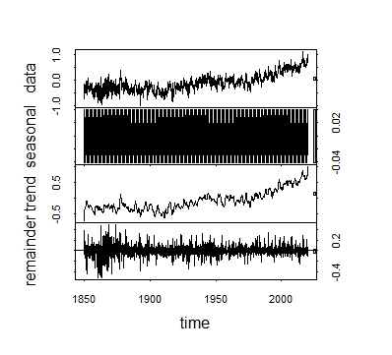Here we noticed there is an upward trend with small slope. We also noticed presence of seasonality which is very reasonable as we are using month-wise temperature. Considering the presence of seasonality, we decided to develop “ETS AAA” and “TBATS” model and compare these two models. Our findings from the “ETS AAA” and “TBATS” models are as following:

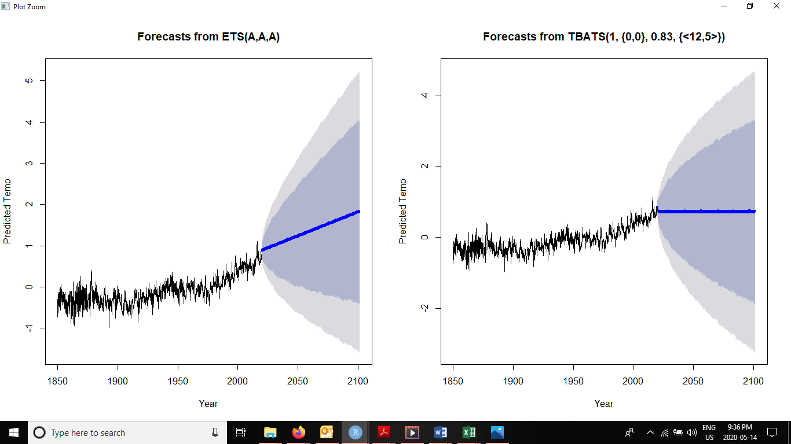

Here we noticed TBATs model dumped the trend to some extent, 17% to be exact, dampened each period. Again from the ETS (AAA) model, we noticed beta~0, which means this model captured stable trend and gamma is .036 which indicates seasonal indices are also stable. In addition, our historic data is not stationary and our ETS (AAA) model captured data which changed gradually without any sudden/period beginning/period ending increase or decrease. Considering the above analysis, we decided to use ETS (AAA) model for our final forecast calculation.

Our temperature forecasting for the year 2100 is as following using Metdata:



Having temperature forecast for year 2100, we then compared the forecasted temperature with 2019 temperature. Findings are as following.



The average temperature increase in year 2100 compared to 2019 is 1.095 degrees Celsius.

Our analysis shows temperature will rise and there is 80% probability that temperature may rise up to 4 degrees Celsius in 2100 from 2019.

1. What are your point predictions, as well as the 90% confidence intervals for the global average temperatures for January and July 2030, 2050 and 2100?

Answer: Our forecast for the mentioned periods are as following:



1. What are the quantities from Q2 for the Kingston, ON (postal code K7L3N6)?

Answer: We used the same approach to develop our model for Kingston, ON (postal code K7L3N6) and we finally used ETS (AAA) model to forecast the temperature. Our findings are as following:



