To SECURE COPY a file from your laptop to the pi use “scp <file> <destination>” to go over network use [pi@192.168.1.113:/home/pi](mailto:pi@192.168.1.113:/home/pi). To copy over a whole folder or a specific folder/fileextension use “scp -r camera_slider/*.py [pi@192.168.1.113:/home/pi/camera_slider](mailto:pi@192.168.1.113:/home/pi/camera_slider)” This will copy any file ending in “.py” in the camera_slider folder on your computer into the camera_slider folder on the pi.

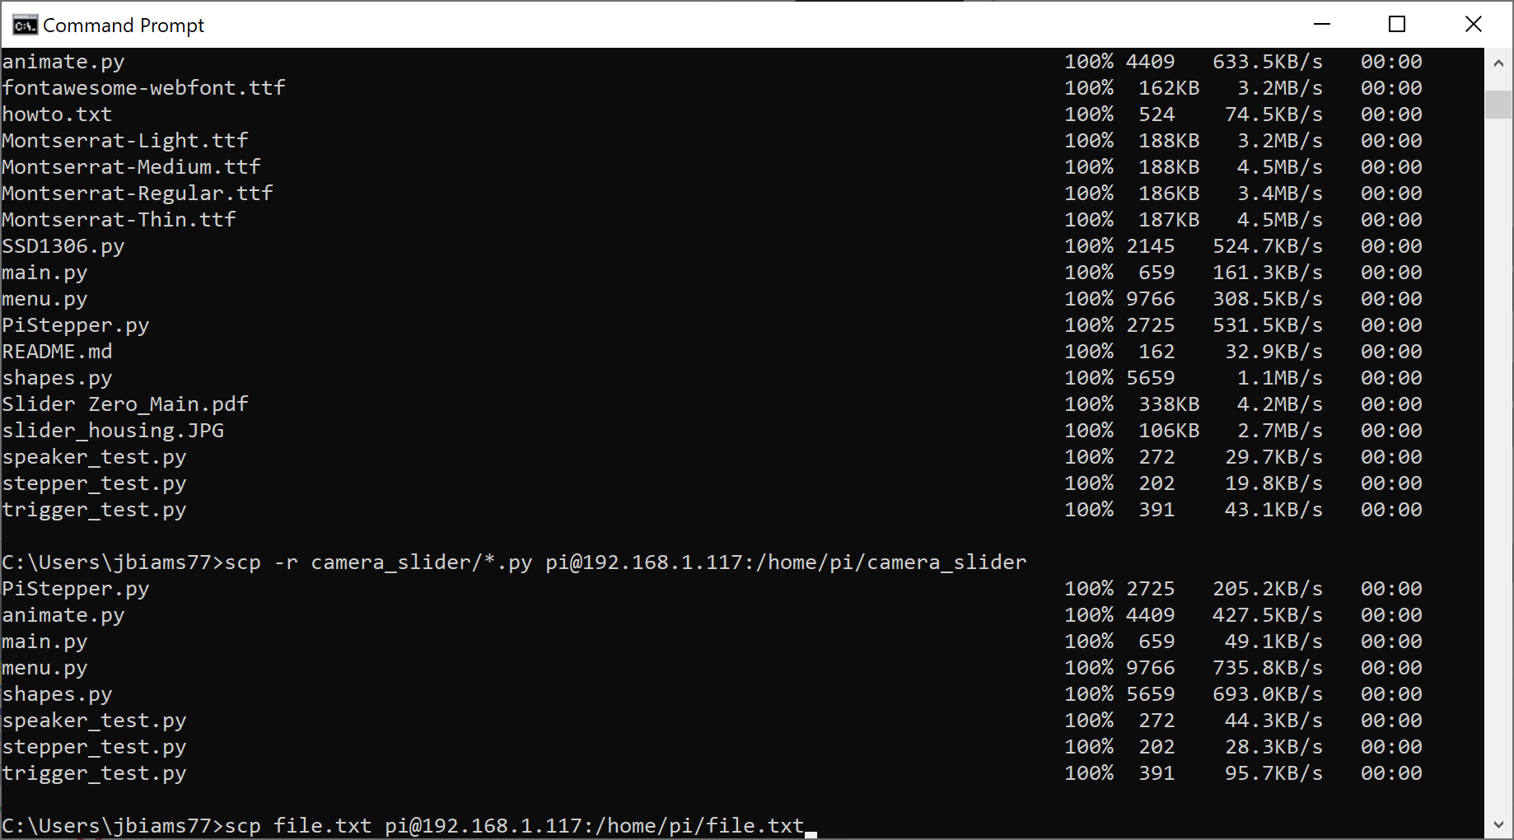

To log on to the pi use “ssh [pi@192.168.1.113”](mailto:pi@192.168.1.113”). Since your public key for this laptop is stored on the pi under “/home/pi/.ssh/authorized_keys” it should not ask for a password. This is how you can execute python code on the pi itself.

