Jason Hatfield – 29163434

CSE 473 Programming Assignment #1

Due: 6/20/17

Problem #1 – 1D and 2D Convolution on Images

1. Gx:  
     
   Gy:

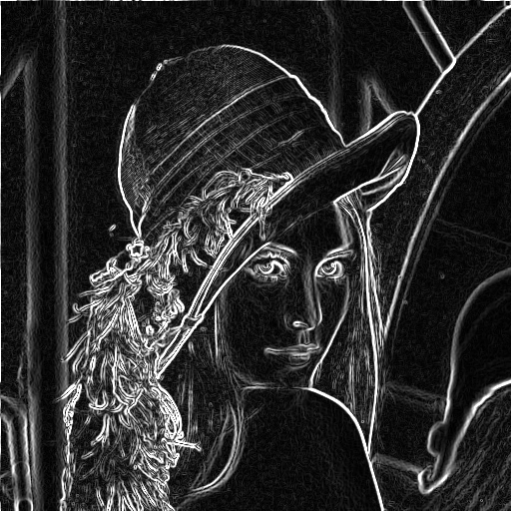  
G:

1. Gx_2:  
     
     
     
     
     
   Gy_2:  
     
   Comparing the results to the 2Dfilter application we can confirm that the 1D convolution is indeed equivalent to the 2D convolution.
2. If we are given an M x N matrix and a P x Q filter we can clearly see which algorithm has a better time complexity. We can assume that 2D convolution runs in time, and in the average case we can expect square matrices for both input thus resulting in time. Separable 1D convolution can be assumed to run in time ant using the same assumptions as 2D convolution we have which is most definitely faster than 2D.

Problem #2: Histogram Equalization

Resulting images and plots are as follows:

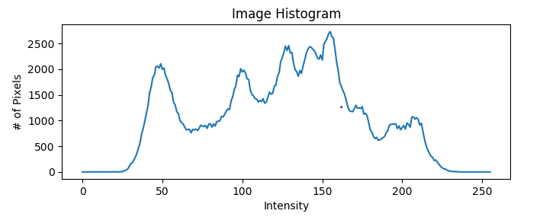

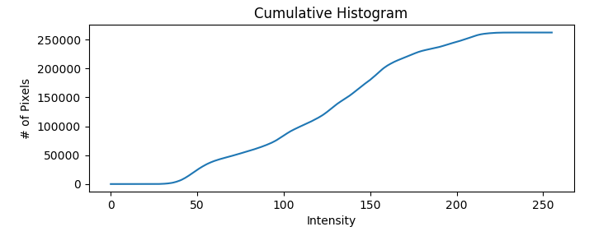

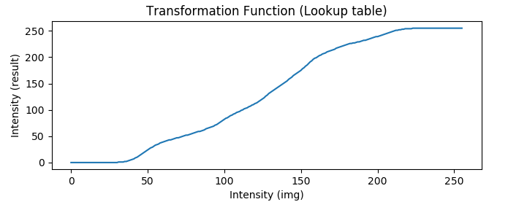

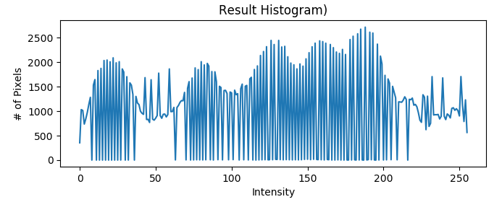

Original Enhanced

