Wi-daq GUI Preview
12/26/2012

Main Operations
The main screen contains five tabs: Connect, Scan, Stats, Ping and Setup. These tabs contain all the status displays and operational controls required to make and maintain a connection, including viewing the WiFi environment and debugging connection problems.

Connect Tab
This tab provides a drop-down list control that allows the user to select a wireless network from a list of configured networks. There is also an “Auto” checkbox to put the device in an automatic mode where it chooses networks from list as needed to make a connection. This list box is at the top of the screen, as seen below.

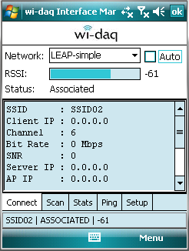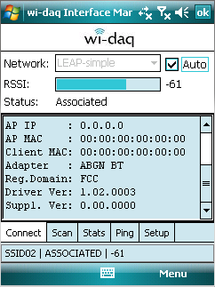

The rest of the tab contains status information about the connection. RSSI and connection status are always visible just beneath the network list control. Several other status items are listed in a scrollable text box that allows this tab to display more status fields than would otherwise fit.

Scan Tab
This tab displays a basic WiFi scan list showing access points in the area that are within reach of the device’s radio. The “Refresh” button and “Auto” checkbox allow for manual and automatic refresh of the list. The “Connect” button can be used to attempt a connection to the currently highlighted item.

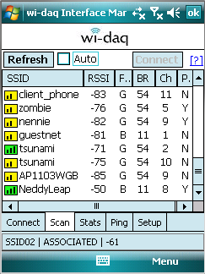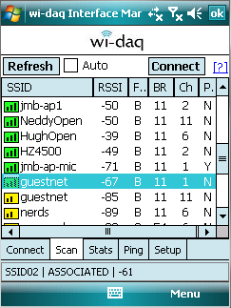

The columns headings are: SSID, signal strength (RSSI), frequency band (FB), maximum bit rate (BR), channel number (Ch) and protected access (P). A colored icon appears to the left of each SSID name to provide a quick indication of whether the signal strength is good (green), fair (yellow) or poor(red.)

Note that the Connect button is only highlight when a network profile exists with an SSID matching the currently selected list item.

Statistics (Stats) Tab
This tab shows a continuously updating display of network statistics.

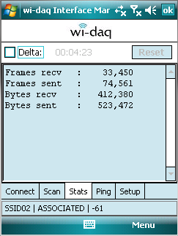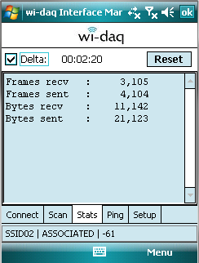

When the “Delta” checkbox is checked, a snapshot of the current statistics values is saved and then afterwards future updates show the change (or delta) between the saved values and the current values. A hours-minutes-seconds displays shows the real time since the last snapshot was taken, and the “Reset” button can be used to take a new snapshot.

Ping Tab
The ping test tab provides the ability to run a basic ping test. User must provide a target IP address and either specify a count value or check the “Continuous” checkbox. They then click the “Start” button to begin the test. When a test is in progress, the “Start” button becomes the “Stop” button.

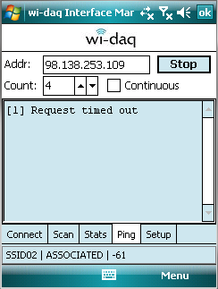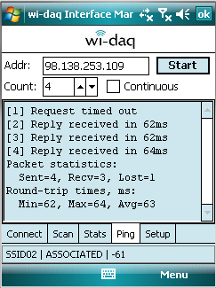

The output is similar to what you would see from a command-line ping utility. About once a second a line of text indicating the results of a ping attempt is added to the text box until the test is ended. At the end of the test a short summary is printed.

When a long test is performed (large count value or “Continuous”) the text box will hold only the last 100 lines of output.

Configuration Settings
The setup screens provide access to the radio and network configuration options. Access to the setup screens is password-protected.

Accessing the Setup Screens
The setup screens are accessed via the Setup tab on the main screen, which is normally not visible as seen below.

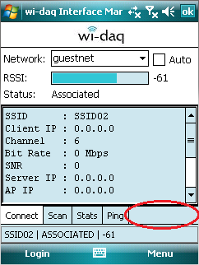

To unlock access to the setup screens, the user must click the “Login” menu in the lower-right corner of the screen, which will bring up the login screen shown below.

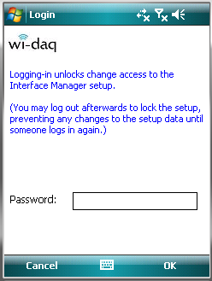

Once the user has entered the password and pressed OK the device will return to the main screen, which will now have a Setup tab.

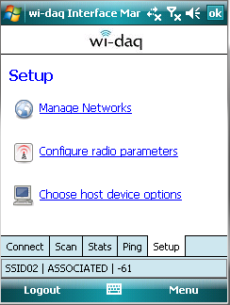

The “Login” menu is replaced with a “Logout” menu, which will lock the configuration again and remove the Setup button. The user may logout at any time without entering a password.

The Setup Screens
All radio and network configuration options are accessed through the Setup tab. There are three setup screens: Network Setup, Radio Parameters and Host Setup.

Networks Setup
The Networks tab shows the list of configured networks. From here the user may add, edit or delete networks, and select the ones that should be included in the automatic network selection process when that feature is enabled.

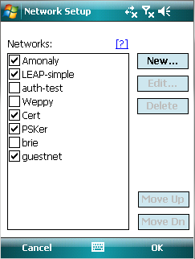

When a new network is added, or an old one is selected for editing, a dialog screen opens that allows the user to specify the name, SSID and type of security of the network to be configured. There are many security options available. Secondary tabs for WEP keys and authentication parameters are added based on the selected security type.
Below are some examples.

Open: PSK:
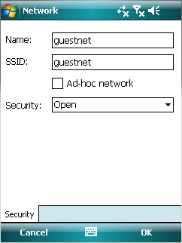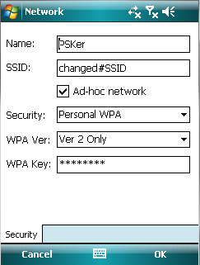

Static WEP
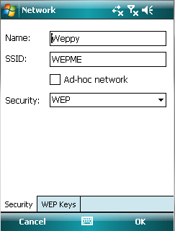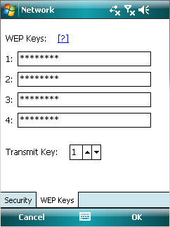

Simple LEAP authentication.
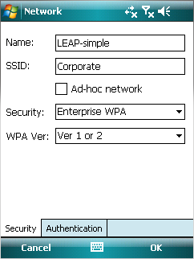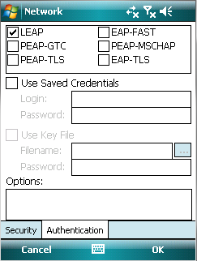

EAP-TLS with a certificate:
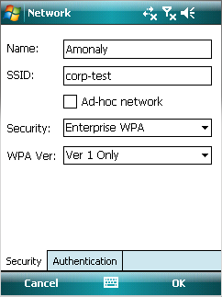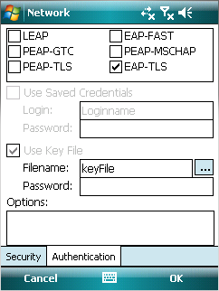

Multiple-Authentication type setup:
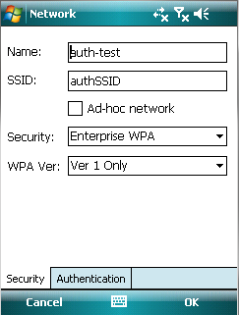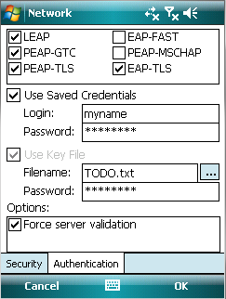

Radio Setup
This screen provides access to various radio settings.

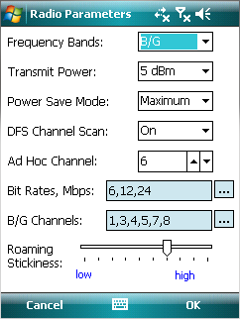

The “Bit Rates” and “B/G channels” values are selected via multiple-select controls on other dialog boxes, shown below.

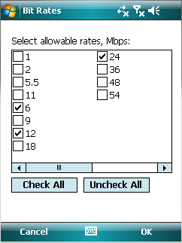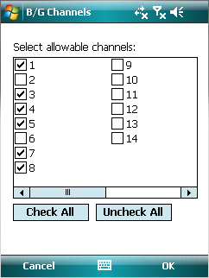

Host Setup
This screen allows the user to set a name for the device, the location of certificate files, and disable the application’s connection management function.

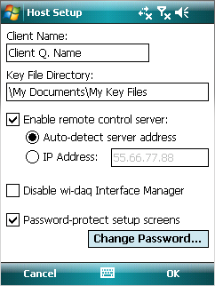

The “Change Password” button opens another dialog box, shown below – once with empty fields and once with all fields entered, but incorrectly.

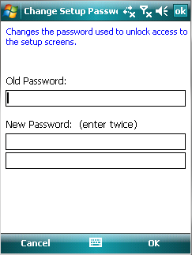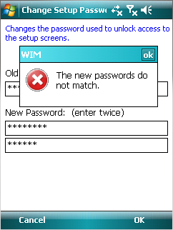

Other GUI Features
The bottom of the main screen contain two areas that are visible no matter what tab is selected: the connection status summary bar and the menus.

Connection Summary Bar
This bar near the bottom of the display always shows the SSID of the current network, the connection status and the signal strength of the connection.

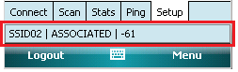

Menus
At the very bottom of the display is the menu bar, which contains the Main menu as well as the Login/Logout menu (when password-protected setup screens is selected.)

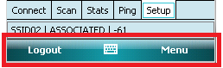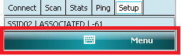

The Login/Logout menus are used to lock and unlock the configuration data, as described above. The Main Menu is used to access other features of the application, such as Help, the About Box, and the Options dialog box.

Main Menu

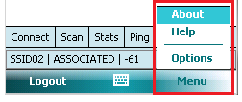

About Box
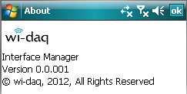

Help - TBD

Options Dialog
This tab allows the user to control two sources of debugging information:

- Enable WIM debug logging – checking this box enables logging of internal application errors and other debugging information to log files in the WIM directory.
- Enable connection activity logging – checking this box turns on output messaging from the supplicant and/or the driver related to establishing and maintaining network connections. Output can be sent to a file or the serial port.
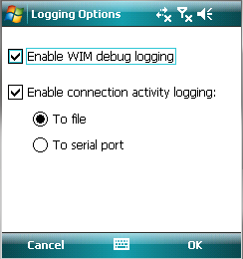

Appendix A: Screens for Android
Main Screen (MainActivity) Connection Status (via Details button)
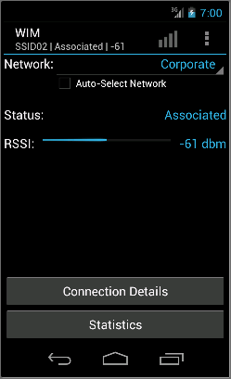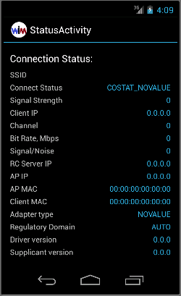

Main Menu (Logged out) Main Menu (Logged in)
