Федеральное государственное автономное образовательное учреждение

высшего образования

Санкт-Петербургский политехнический университет Петра Великого

Институт компьютерных наук и технологий

Высшая школа «Киберфизические системы и управление»

**Отчет №2**

по дисциплине «Базы данных»

|  |  |  |
| --- | --- | --- |
| Выполнил:  студент гр. 3530902/00201 | ________________ | Позолотин О. В. |
|  | <*подпись*> |  |
|  |  |  |
|  |  |  |
| Руководитель:  Кандидат т.н. | ________________ | Нестеров С. А. |
|  | <*подпись*> |  |

«___» __________ 2022 г.

Санкт-Петербург

2023

**Oracle Baseball League Store Database**

**Project Scenario:**

You are a small consulting company specializing in database development. You have just been awarded the contract to develop a data model for a database application system for a small retail store called Oracle Baseball League (OBL).

The Oracle Baseball League store serves the entire surrounding community selling baseball kit. The OBL has two types of customer, there are individuals who purchase items like balls, cleats, gloves, shirts, screen printed t-shirts, and shorts. Additionally customers can represent a team when they purchase uniforms and equipment on behalf of the team. Teams and individual customers are free to purchase any item from the inventory list, but teams get a discount on the list price depending on the number of players. When a customer places an order we record the order items for that order in our database. OBL has a team of three sales representatives that officially only call on teams but have been known to handle individual customer complaints.

**Business rule:**

Teams and individual customers are free to purchase any item from the inventory list, but teams get a discount on the list price depending on the number of players. When a customer places an order we record the order items for that order in our database.

**Assumption:**

OBL has a team of three sales representatives that officially only call on teams but have been known to handle individual customer complaints.

**Problem:**

OBL has a team of three sales representatives that officially only call on teams but have been known to handle individual customer complaints.

**Relational Database**

**1. Identify the possible tables and associated fields from the given scenario:**

Book.com is an online virtual store on the Internet where customers can browse the

catalog and select products of interest.

a. Every book has a title, ISBN, year and price. The store also keeps the author and

publisher for any book.

Books table.

* Fields:
* Title
* ISBN
* Year
* Price
* Author
* publisher

b. For authors, the database keeps the name, address and the URL of their

homepage.

Authors table.

Fields:

* Name
* Address
* URL
* ID

c. For publishers, the database keeps the name, address, phone number and the

URL

of their website.

Publishers table.

Fields:

* Name
* Address
* Phone number
* URL
* id

d. The store has several warehouses, each of which has a code, address and phone

number.

Warehouse table.

Fields:

* Id (code)
* Address
* Phone number

e. The warehouse stocks several books. A book may be stocked at multiple

warehouses.

WarehouseStorage table.

Fields:

* Name
* Warehouse id
* Book id
* Books quantity

f. The database records the number of copies of a book stocked at various

warehouses.

BooksQuantity table.

* Fields:
* Book id
* Number of copies
* Warehouse id

g. The bookstore keeps the name, address, email-id, and phone number of its

customers.

Customers table.

Fields:

* Name
* Id
* Address
* Email-id
* Phone number

h. A customer owns several shopping carts. A shopping cart is identified by a

Shopping_Cart_ID and contains several books.

ShoppingCarts table.

Fields:

* Card id
* Owner id
* Books ids
* Number of books

i. Some shopping carts may contain more than one copy of same book. The

database

records the number of copies of each book in any shopping cart.

Shopping Carts Products table.

Fields:

* Card id
* Owner id
* Book id
* Number of books

j. At that time, more information will be needed to complete the transaction.

Usually,

the customer will be asked to fill or select a billing address, a shipping address, a

shipping option, and payment information such as credit card number. An email

notification is sent to the customer as soon as the order is placed.

Transaction table.

Fields:

* Name
* Transaction id
* Customer id
* Cart id
* Billing Address
* Shipping Option
* Card number
* Linked e-mail

2. ABC Ltd plans to computerize its sales ordering and stock control system. A feasibility study has strongly suggested that a relational database system be installed. The details of ABC's sales and stock control are as follows:

Order

* Order id
* Customer id
* Product id
* quantity

Warehouse

* Warehouse name
* Warehouse id
* Address
* Phone number

Warehouse Products

* Warehouse id
* Product id
* Product quantity

Products

* Product id
* Provider
* Description

Bills

Bill ID

* Customer id
* Billing address
* Shopping address

Bills Compound

* Bill id
* Product id
* Quantity

Payment

* Bill ID
* Transaction id
* Transfer amount

**2.2 Conceptual and Physical Data Models**

**Provide five reasons for creating a conceptual data model.**

* helps developers to start making database
* simplifies the understanding of relationships between entities
* forms ideal situation documentation
* prevents misunderstanding between developers
* makes discussions easier

**List two examples of conceptual models and physical models.**

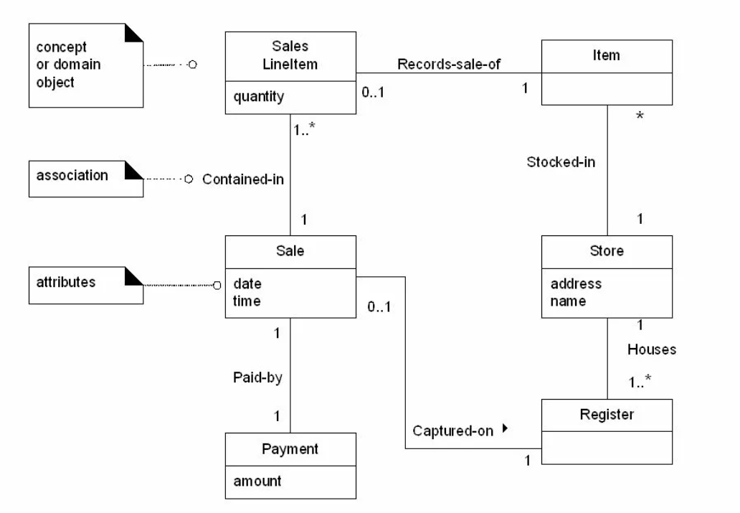

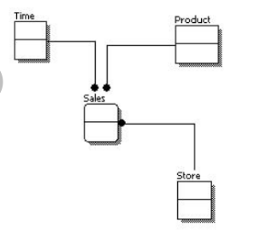

**Physical models**

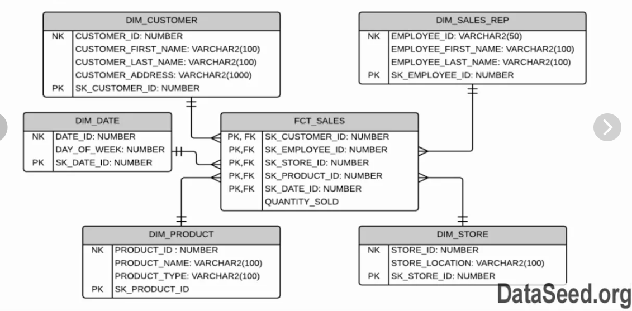

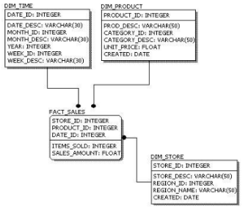

**2-3 : Entities and Attributes Practices**

**With the information provided above, identify and create the entities for the School Management System.**

* Course
* department
* student
* faculty
* academic session
* parent information
* exam

**Exercise 2: Identify and add Attributes and corresponding Mandatory and Optional notation to ERD**

Add the appropriate attributes as well as the optionality (*, °) to all the entities of the Academic Database.

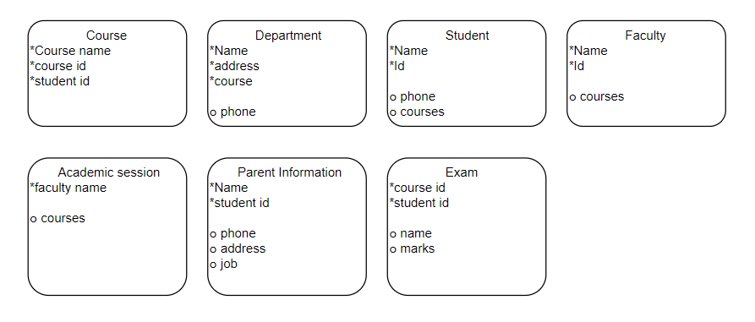**2_3_1 project**

Using text analysis on the given scenario identify any potential entities that will

have to be represented in a relational database system. Entities are usually the

nouns in the scenario description however not every noun becomes an entity so

think carefully but remember you are identifying potential entities not creating a

definitive list.

Entities:

* Customer
* Item
* Team Order
* Seller

**2_3_2 project**

Using text analysis on the given scenario identify any potential attributes that will

be used to store information about the previously identified entities. Attributes are

normally found by identifying nouns that describe other nouns (our entities).Customer:

Name

* address
* phone number
* email
* status
* balance
* customer ID

Team

* Name
* number of players

Sales Representative

* Name
* Address
* Phone
* email

Order

* Date
* item purchased
* size
* color
* number of units
* price
* customer ID

Item

* Name
* color
* size
* category
* price
* item ID

Inventory List

* Quantity

**2_3_3 project**

Using the interview transcript and the already identified entities and attributes from the previous lesson mark which ones you think will be mandatory (*) or optional (o). Remember optional attributes can be blank unlike mandatory ones which must have a value. Check if any of the attributes could be described as volatile, if they can then change them to a non-volatile equivalent.

Customer:

* Name(*)
* address(*)
* phone number(*)
* email(*)
* status(*)
* balance(o)
* ID(*)

Team

* Name(*)
* number of players(o)

Sales Representative

* Name(*)
* address(*)
* phone(*)
* email(*)

Order

* Date(*)
* item ID(*)
* size(o)
* color(o)
* quantity(*)
* price(*)
* customer ID(*)

Item

* Name(*)
* color(o)
* size(o)
* category(o)
* price(*)
* item ID(*)

Inventory List

* Quantity(*)

**2_3_4 project**

Use Barker notation to display the information represented by the entities and attributes identified.

To help make each softbox clearer to understand place the attributes in their logical order as well as placing all of the mandatory attributes before the optional ones.

