Федеральное государственное автономное образовательное учреждение

высшего образования

Санкт-Петербургский политехнический университет Петра Великого

Институт компьютерных наук и технологий

Высшая школа «Киберфизические системы и управление»

**Отчет №3**

по дисциплине «Базы данных на английском языке»

|  |  |  |
| --- | --- | --- |
| Выполнил:  студент гр. 3530902/00201 | ________________ | Позолотин О. В. |
|  | <*подпись*> |  |
|  |  |  |
|  |  |  |
| Руководитель:  Кандидат т.н. | ________________ | Нестеров С. А. |
|  | <*подпись*> |  |

«___» __________ 2023 г.

Санкт-Петербург

2023

**Ход работы**

**Exercise 1: Identify the Unique Identifier and corresponding Primary keys**

**Tasks**

1. How do you find a particular song in the whole collection? What would be a unique identifier for SONG?

#singer_name

#song_name

1. Think about all the students in the classroom. Each student is described by several traits or attributes. Which attribute or attributes allow you to pick a single student from the rest of the class?

#number_in_list

1. For each entity, select the attribute that could be the unique identifier of each entity.

Entity: STUDENT

Attributes: student ID, first name, last name, address

# student ID

Entity: MOVIE

Attributes: title, date released, producer, director

# title

Entity: LOCKER

Attributes: size, location, number

#number

1. Use the Academic Database ERD from the previous exercises to identify the following:

a. Unique Identifiers

b. Candidate Unique Identifiers

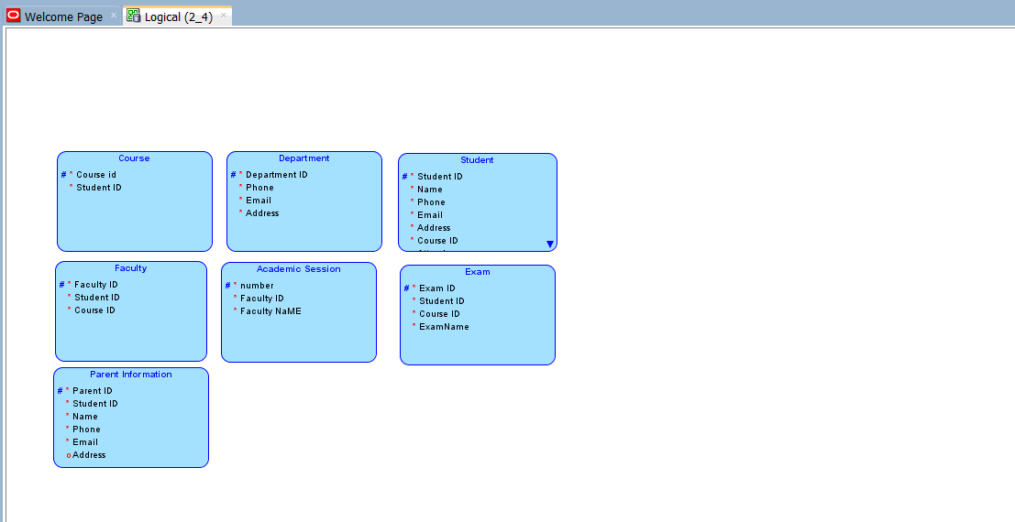

**2_4_1**

**Identifying Unique Identifiers (UIDs) (S2L4 Objective 1)**

Using the Barker notation softboxes, created in the previous exercise, identify any potential candidate keys (attributes that can be used to uniquely identify an entity) that exist within the entities.

• If you can identify any information bearing (natural) UID’s then place a # sign as that attribute’s optionality and move it to the top of the attribute list.

• If there is more than one attribute (composite) that combined makes the entity unique then place the # sign before each of the attribute names and move all of them to the top of the list.

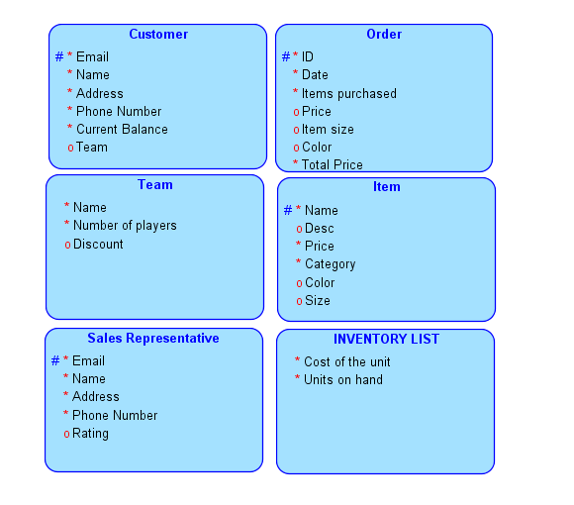

**2_4_2**

**Identifying Artificial Unique Identifiers (UIDs) (S2L4 Objective 2)**

Using the Barker notation softboxes created previously identify and assign the unique identifiers that will be used to uniquely identify the given entities.

* If no information bearing identifier has been assigned then assign an artificial one. Normally we use id or number as the name for the artificial identifier.
* If an information bearing identifier has been identified then you need to choose if you will use that as the primary unique identifier or as a secondary one. If you are going to use it as a secondary identifier then create an artificial identifier and enclose the information bearing identifier # sign in brackets.

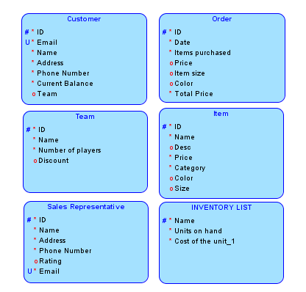

**2_5**

1. Read the relationship. Which text corresponds to the diagram?

Answer: b;

1. Read each relationship in the model below. For each relationship, write the ERD statement and your comments. Use your knowledge of normal people and towns in your comments

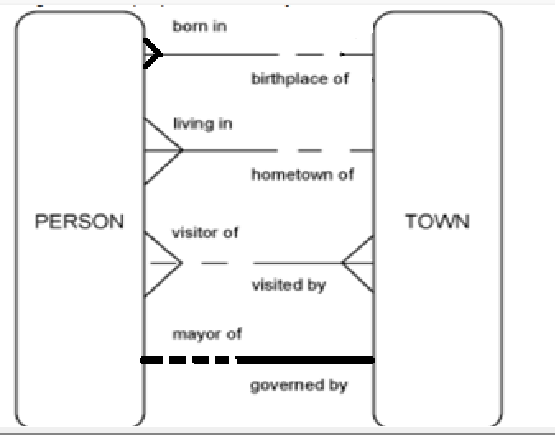

• Each person must be born in one and only one city; one or more people can may born in a city

• Each person must live in only one city; one or many people may live in a city

• Each person may visit one or more cities; each city must be visited by one or more people

• Only one person must be the mayor of a city; a city must have one and only one mayor

1. Write the ERDish for each of the relationships in the Academic Database including relationship names, optionality and cardinality. Draw the ERD including the relationships.

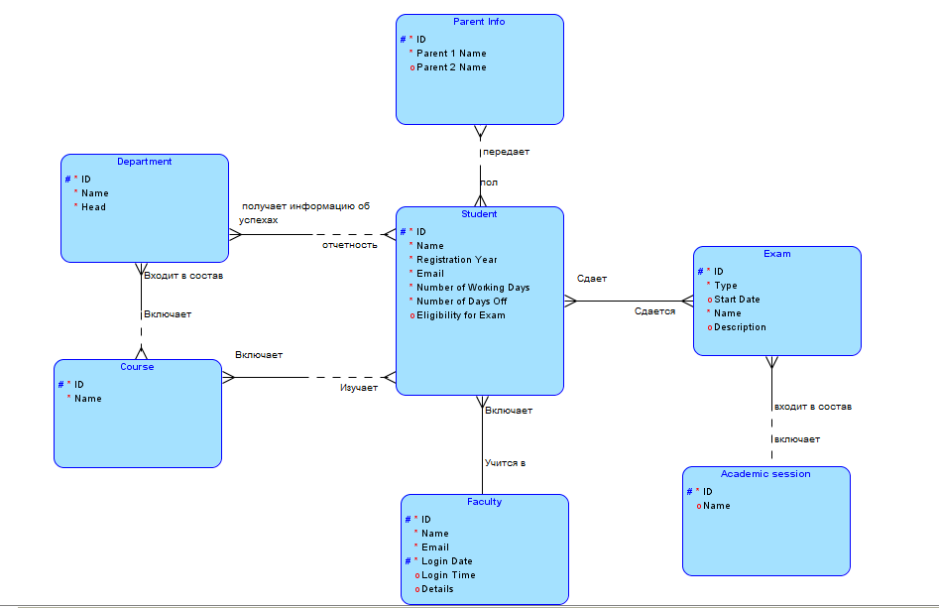

**Recognize Examples of Relationships (S2L5 Objective 1)**

Relationships represent an association between two or more entities. Using the business rules, identified previously in this project and listed below, identify potential associations between your entities.

Business Rules:

• Customers can be either individual or represent a team

• Customers can purchase items from the inventory list

• Teams get discounts based on their number of players

• Customers purchases are stored as orders in the database

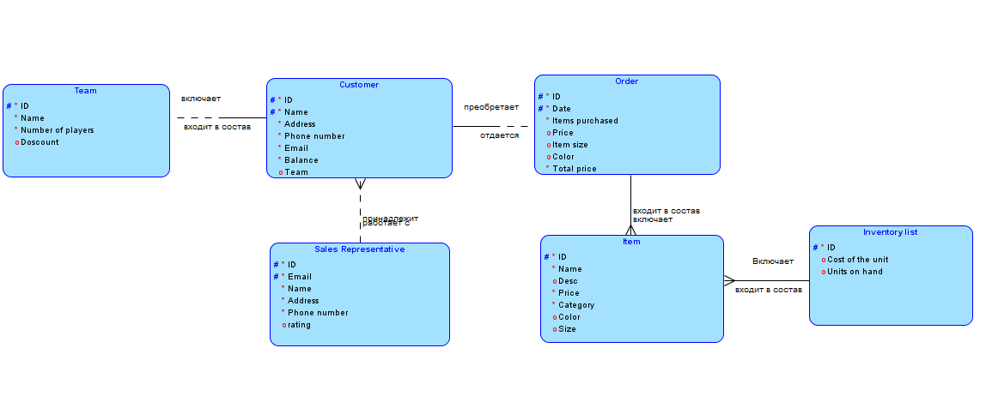• Sales representatives mainly work with team customers but can also deal with individual customers.

**2_5_2**

Identify the Optionality of Relationships (S2L5 Objective 2)

Relationships are bi directional and must either be mandatory or optional.

Part 1 :

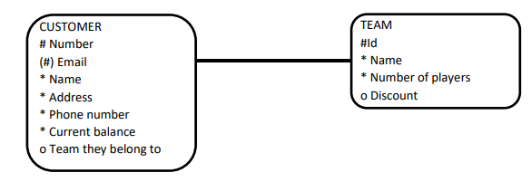For the relationships identified in the previous exercise write the optionality of the relationship between both entities (remember the relationship exists in both directions), the first one has been completed for you.

* Left to right

Каждый customer может представлять team

* Right to left

Team д.б. представлена customer

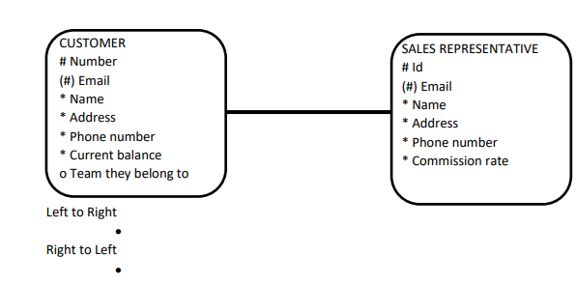

* Left to right

Каждый customer может связаться с sales representative

* Right to left

Sales representative может работать с клиентами

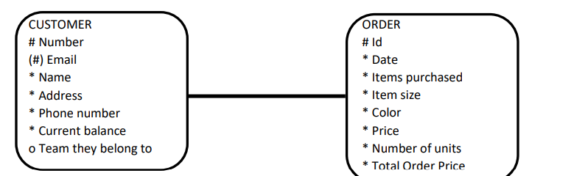

* Left to right  
  Каждый customer может сделать order
* Right to left  
  Каждый order должен быть записан для customer

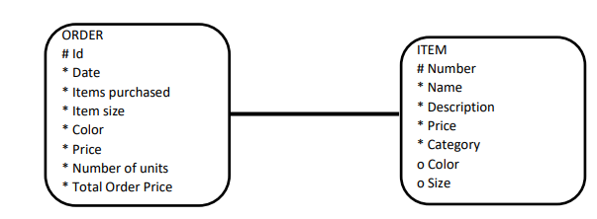

* Left to right  
  Каждый order должен содержать item
* Right to left  
  Каждый item может быть заказан и записан в order

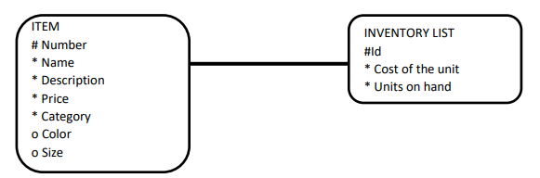

* Left to right  
  Каждый item должен быть учтен в inventory list
* Right to left  
  Inventory list должен хранить информацию о каждом Item

Part 2:

Relationship lines represent a bi-directional relationship between two entities therefore you should think of it as two separate lines that originate from their entity and meet in the middle. Using the descriptions that you wrote in part 1 complete the relationship lines to represent the optionality of each relationship, the first one has been completed for you.

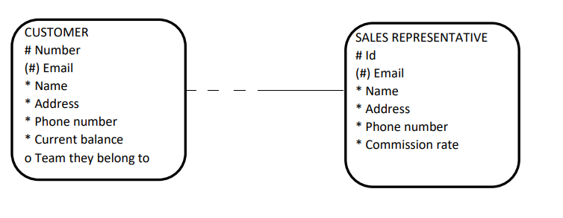

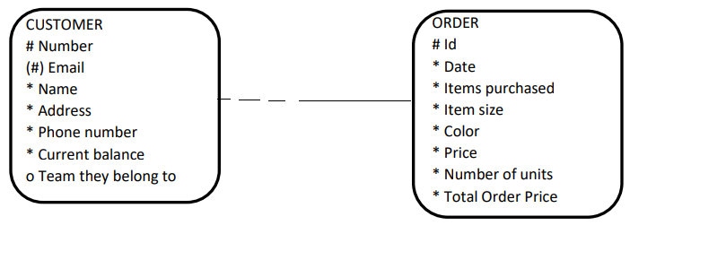 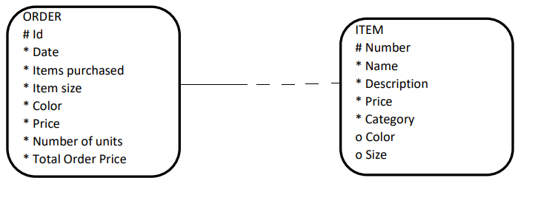 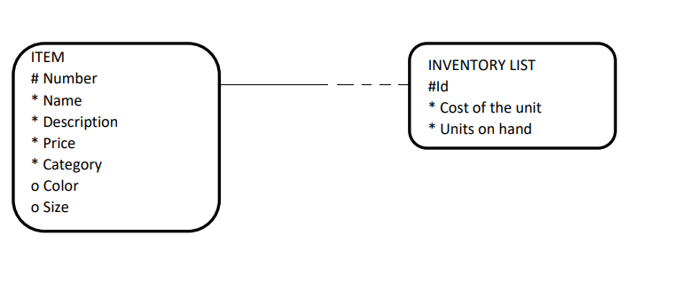

**2_5_3**

**Identify the Cardinality of Relationships (S2L5 Objective 3)**

For the relationships identified in the previous exercise determine the cardinality by analyzing the description given for each relationship. If the description uses “a” or “an” then it should be a 1 relation (single toe) however if it says “many” or “one or more” then it should be a M relation (crow’s foot). Add the cardinality to the following entities by adding any required crow’s foot notation.

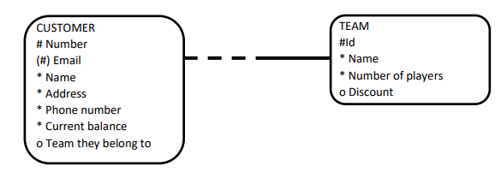

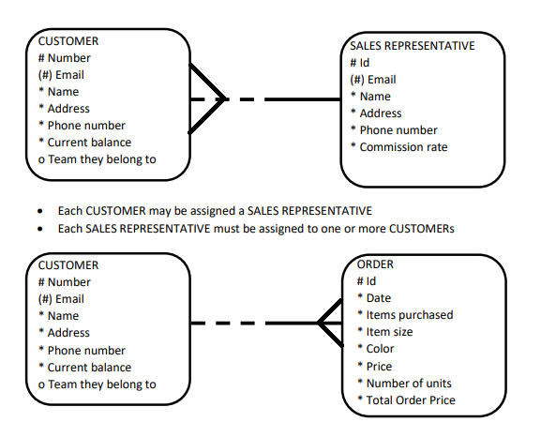

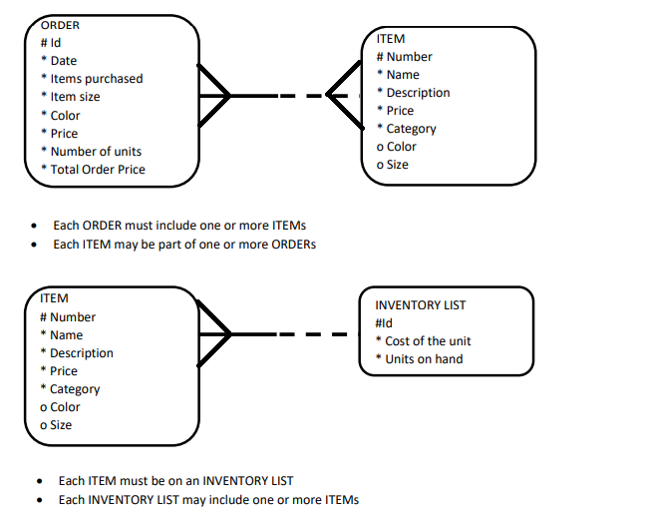

**2_5_4**

Using a Relationship Matrix (S2L5 Objective 5)

A relationship matrix shows if and how each row entity on the left side of the matrix is related to each column entity shown across the top of the matrix.

* If a row entity is related to a column entity, the name of that relationship is shown in the intersection box.
* If a row entity is not related to a column entity, the intersection box is empty.
* Recursive relationships can be represented by placing the name of that relationship on the diagonal.

|  |  |  |  |  |  |  |
| --- | --- | --- | --- | --- | --- | --- |
|  | customer | Team | Sales representative | Order | item | Inventory list |
| Customer |  | represent | assigned | place |  |  |
| Team | Represented by |  |  |  |  |  |
| Sales representative | Assigned to |  |  |  |  |  |
| order | Placed by |  |  |  | include |  |
| Item | Part of |  |  |  |  | On |
| Inventory list | Include |  |  |  |  |  |

Part 2:

Use the names that you added to the intersection boxes of the relationship matrix add the correct labels to the appropriate relationships of your ERDs.

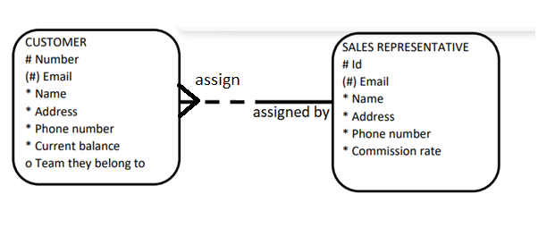

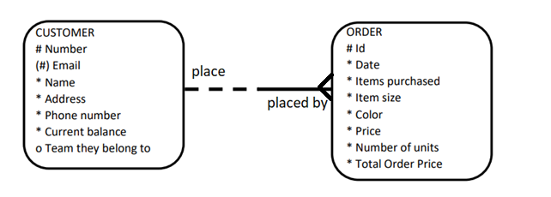

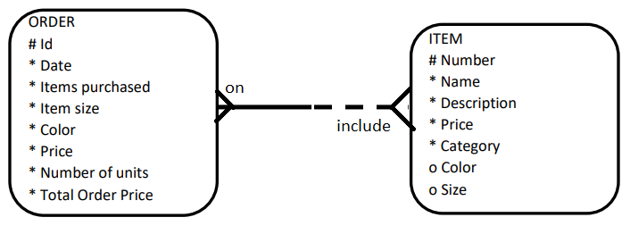

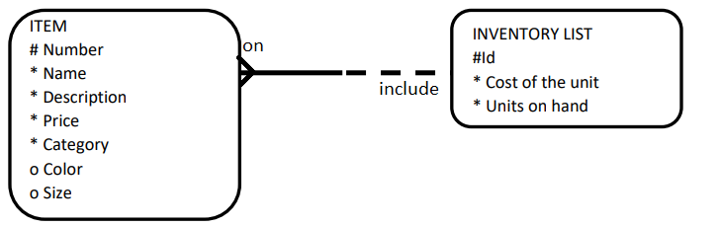

**2_6**

1. Identify the possible Entities and Attributes from the given scenario.

A company has several departments. Each department has a supervisor and at least one employee. Employees must be assigned to at least one, but possibly more departments. At least one employee is assigned to a project, but an employee may be on vacation and not assigned to any projects. The important data fields are the names of the departments, projects, supervisors and employees, as well as the supervisor and employee number and a unique project number.

Department: ID, Name

Employees: Id, name, contacts, supervisorID, DepartmentID

Supervisor:ID, name, contacts, EmployeesID

Project:ID, name, imployees

1. Read the given business scenario. Draw the entities HAIRSTYLIST and CLIENT. List the attributes associated with each entity and specify whether they are mandatory or optional. Identify the UIDs. Follow the diagramming conventions discussed. State the ERDish for the relationships.

“In our salon, we have a number of hairstylists. They are all salaried employees, so we keep a record of their first name, last name, address, phone number, social-security number, and salary. During the course of a day, a hairstylist may see several clients. On a slow day, a hairstylist may not work on anyone at all. We have several walk-in clients, and they each get assigned to one hairstylist. We just ask for their first name. We also have customers who call to make an appointment. When they do this, we ask for their first name, last name, and phone number. We also ask if they would like a specific hairstylist. If they have no preference, we assign one for them. Of course, they are allowed to switch to another hairstylist for their next visit to the salon. We are interested in tracking the daily appointments -- which stylist works on which client during a given day.”

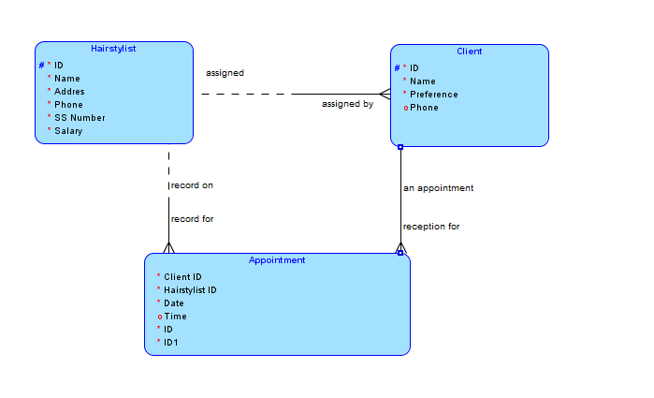

3.

“We have several teachers at our school. A teacher can be assigned up to three classes per semester. If a teacher is on sabbatical, he doesn’t teach that semester. We keep a record of the teacher’s first name, last name, address, phone number, and email address.

Our school offers many courses -- such as Data Modeling, Introduction to SQL, Trigonometry, Physics, and Biology. Each course has a code. For example: Data Modeling would be DM001, Trigonometry would be TR004, etc. During each semester, a course may be taught in several classes -- so there could be two classes of Physics, three classes of Biology, etc. Each class can be taught by only one teacher. We assign a unique ID for each class, and we also keep track of the day it is taught, the time, and the classroom.”

**Section 2 Lesson 6 Exercise : Entity Relationship Modeling (S2L6 Objective 5)**

As you have already Identified the entities, their attributes and the relationships between the entities you can now begin to construct the finalised ERD that will show how the system is linked together.

Using the information you have already gathered throughout this project construct an ERD that adheres to the four goals specified above. Construct your ERD following diagramming convention.

