Министерство образования и науки РФ
Санкт-Петербургский политехнический университет Петра Великого
Институт компьютерных наук и технологий
Высшая школа киберфизических систем и управления

ЛАБОРАТОРНАЯ РАБОТА 11
по дисциплине «Базы данных»

Выполнил:
студент гр.3530902/00201 _________________Супонькин Р.А.

Руководитель:
к.т.н.,доцент ___________________Нестеров С.А.

Санкт-Петербург 2023
6-7: Restricting Data Using SELECT Statement
Practices
1. Display the course details for the Spring Session.
SELECT * FROM COURSES
WHERE " SESSION_ID" = 100;
2. Display the details of the students who have scored more than 95.
SELECT GRADE FROM STUDENT_COURSE_DTA
WHERE GRADE>95;
3. Display the details of the students who have scored between 65 and 70.
SELECT GRADE FROM STUDENT_COURSE_DTA
WHERE GRADE BETWEEN 65 AND 70;
4. Display the students who registered after 01-Jun-2012.
SELECT * FROM STUDENTS
WHERE REGISTRATION_YEAR>'01-JUN-2012';
5. Display the course details for departments 10 and 30.
SELECT * FROM COURSES
WHERE ("DEPT_ID" = 10 OR "DEPT_ID" = 30);
6. Display the details of students whose first name begins with the letter "J".
SELECT * FROM STUDENTS
WHERE FIRST_NAME LIKE 'J%';
7. Display the details of students who have opted for courses 190 or 193.
SELECT * FROM STUDENTS
WHERE COURSE IN (190,193);
8. Display the course details offered by department 30 for the Fall Session (Session ID 200).
SELECT * FROM COURSES
WHERE ("SESSION_ID " = 200 AND "DEPT_ID" = 30);
9. Display the course details of courses not being offered in the summer and fall session (Session ID 200 and 300).
SELECT * FROM COURSES
WHERE ("SESSION_ID" != 200 AND " SESSION_ID " != 300);
10. Display the course details for department 20.
SELECT * FROM COURSES
WHERE ("DEPT_ID" = 20);
Section 6 Lesson 7 Exercise 1: Restricting Data Using WHERE
Part 1: Using the WHERE Clause.
1. Using the unique customer number in the where clause display all columns for Maria Galant.
SELECT *
FROM CUSTOMERS
WHERE CTR_NUMBER='c01986';
2. Display the first name, last name and customer number for all customers who have a current balance of greater than 100. Use an appropriate alias for your column headings.
SELECT FIRST_NAME, LAST_NAME,CTR_NUMBER
FROM CUSTOMERS
WHERE CURRENT_BALANCE>100;
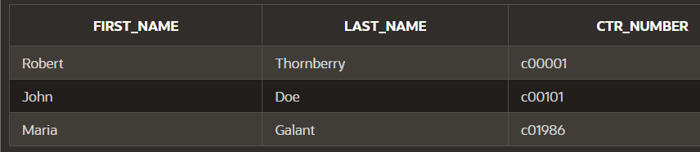
3. Display the order id, date and time of all orders that were placed before the 28th of May 2017. Use an appropriate alias for your column headings.
SELECT ID, ODR_DATE, ODR_TIME
FROM ORDERS
WHERE ODR_DATE<'MAY-28-2017' ;
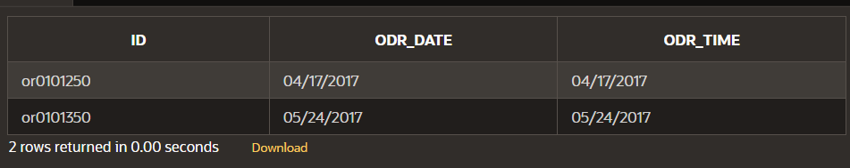
Part 2: Range Conditions: BETWEEN Operator
1. Display the inventory id, cost and number of units using appropriate aliases for all items that have a trade cost of between 3.00 and 15.00.
SELECT ID, COST, UNITS
FROM INVENTORY_LIST
WHERE COST BETWEEN 3 AND 15;
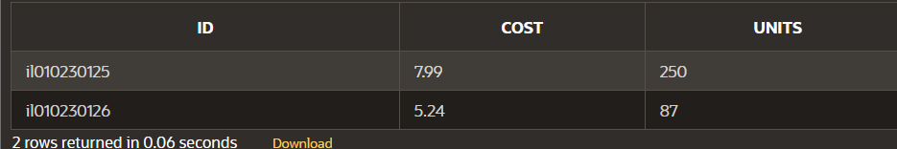
Part 3: Membership Conditions: IN Operator
1. Display the inventory id, cost and number of units using appropriate aliases for all items that have 50, 100, 150 or 200 units in stock.
SELECT ID, COST, UNITS
FROM INVENTORY_LIST
WHERE UNITS IN (50,100,150,200);
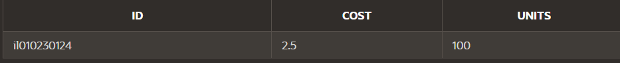
Part 4: Membership Conditions: NOT IN Operator
1. Display the inventory id, cost and number of units using appropriate aliases for all items that do not have 50, 100, 150 or 200 units in stock.
SELECT ID, COST, UNITS
FROM INVENTORY_LIST
WHERE UNITS NOT IN (50,100,150,200);
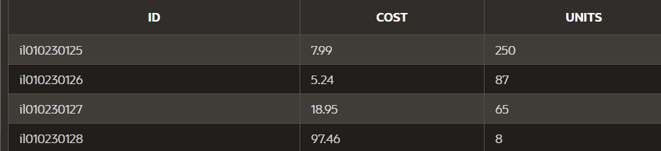
Part 5: Pattern Matching: LIKE Operator
1. Display item number and name of all items that have a name that begins with g. Use an appropriate alias for your column headings.
SELECT ITM_NUMBER, NAME
FROM ITEMS
WHERE NAME LIKE 'g%';
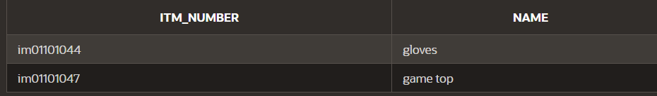
Part 6 : Pattern Matching: Combining Wildcard Characters with the LIKE Operator
1. Display item number and name of all items that have a name that contain a lowercase o. Use an appropriate alias for your column headings
SELECT ITM_NUMBER, NAME
FROM ITEMS
WHERE NAME LIKE '%o%';
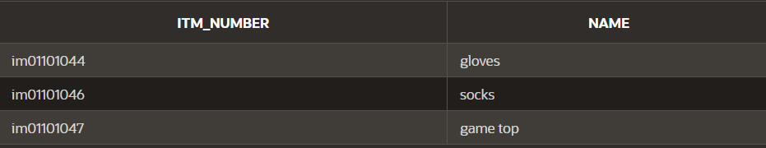
Section 6 Lesson 7 Exercise 2: Restricting Data Using WHERE
Part 1: Using the NULL Conditions
1. Write a query that will display information for teams that don’t receive a discount in the following format:
The Rovers team has 25 players and does not receive a discount.
Use Team Information as the column alias.
SELECT 'The '||Name||' has '||NUMBER_OF_PLAYERS||' players and does not receive the discount' AS TEAMSINFO
FROM TEAMS
WHERE DISCOUNT IS NULL;
2. Write a query that will display information for only teams that receive a discount in the following format:
The Rockets team has 25 players and receives a discount of 10 percent.
Use Team Information as the column alias.
SELECT 'The '||NAME||' has '||NUMBER_OF_PLAYERS||' receives a discount of '||DISCOUNT||' percent' AS TEAMSINFO
FROM TEAMS
WHERE DISCOUNT IS NOT NULL;

Part 2: Logical Operators: AND
1. Write a query that will display the customer number, address line 1 and postal code for customers that live in the starford area of Liverpool. Use Customer Number, Street Address and Postal Code as the column aliases.
SELECT CTR_NUMBER AS "Customer Number", ADDRESS_LINE_1 AS "Street Address", ZIP_CODE AS "Postal Code"
FROM CUSTOMERS_ADDRESSES
WHERE ADDRESS_LINE_2 = 'Starford' AND CITY = 'Liverpool';
Part 3: Logical Operators: OR
1. Write a query that will display the customer number, address line 1 and postal code for customers that live in either starford or Liverpool in general. Use Customer Number, Street Address and Postal Code as the column aliases.
SELECT CTR_NUMBER AS "Customer Number", ADDRESS_LINE_1 AS "Street Address", ZIP_CODE AS "Postal Code"
FROM CUSTOMERS_ADDRESSES
WHERE ADDRESS_LINE_2 = 'Starford' OR CITY = 'Liverpool';
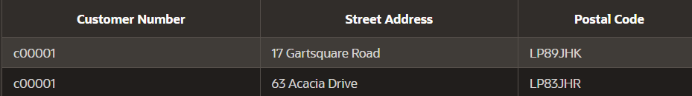
Part 4: Logical Operators: NOT Equal To 1.
Write a query that will display the customer number, address line 1 and postal code for customers that do not live in Liverpool. Use Customer Number, Street Address and Postal Code as the column aliases.
SELECT CTR_NUMBER AS "Customer Number", ADDRESS_LINE_1 AS "Street Address",ZIP_CODE AS "Postal Code"
FROM CUSTOMERS_ADDRESSES
WHERE CITY NOT LIKE 'Liverpool';
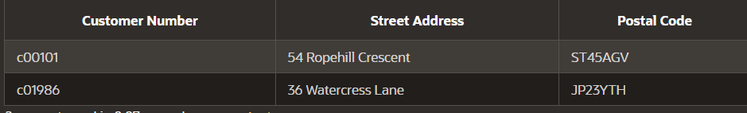
6-8: Sorting Data Using ORDER BY
1. Display all fields for each of the records in ascending order for the following tables:
a. AD_STUDENTS ordered by REG_YEAR
SELECT*
FROM STUDENTS
ORDER BY REG_YEAR;
b. AD_EXAM_RESULTS ordered by STUDENT_ID and COURSE_ID
SELECT*
FROM XAM_RESULTS
ORDER BY STUDENT_ID, COURSE_ID;
c. AD_STUDENT_ATTENDANCE ordered by STUDENT_ID
SELECT*
FROM STUDENT_ATE
ORDER BY STUDENT_ID;
d. AD_DEPARTMENTS ordered by the department ID
SELECT*
FROM DEPARTMENTS
ORDER BY DEPARTMENT_ID;
2. Display the percentage of days students have taken days off and sort the records based on the percentage calculated.
SELECT (NUM_DAYS_OFF*100)/NUM_WORK_DAYS AS "PERCENT DAYS OFF"
FROM STUDENT_ATE
ORDER BY (NUM_DAYS_OFF*100)/NUM_WORK_DAYS;
3. Display the top 5 students based on exam grade results.
SELECT ROWNUM AS "RESULTS", STUDENT_ID, GRADE
FROM (SELECT STUDENT_ID, GRADE
FROM STUDENT_COURSE_DTA
ORDER BY GRADE DESC)
WHERE ROWNUM <= 5;

4. Display the parent details ordered by the parent ID.
SELECT*
FROM PNT_INF
ORDER BY ID;

Section 6 Lesson 8 Exercise 1: Sorting Data Using ORDER BY
1. Display the team name and number of players alphabetically in order of team name. Use an appropriate alias for your column headings.
SELECT NAME, NUMBER_OF_PLAYERS
FROM TEAMS
ORDER BY NAME;
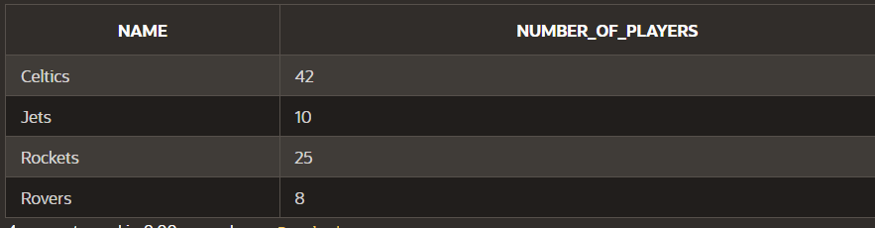
2. Display the team name and number of players in descending order of number of players. Use an appropriate alias for your column headings.
SELECT NAME, NUMBER_OF_PLAYERS
FROM TEAMS
ORDER BY NUMBER_OF_PLAYERS DESC;
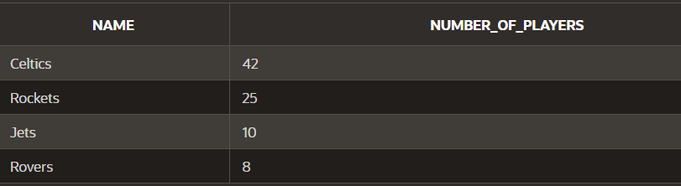
3. Display the team name and number of players alphabetically in order of team name. Use Team Name for the name alias and Players for the number of players. Sort the output in descending order of name using the alias in the ORDER BY clause.
SELECT NAME AS "TEAM NAME", NUMBER_OF_PLAYERS AS "PLAYERS"
FROM TEAMS
ORDER BY NAME DESC;
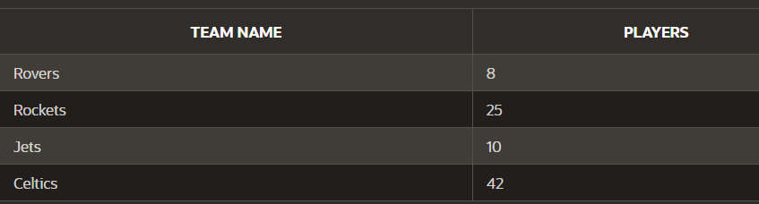
Section 6 Lesson 8 Exercise 2: Sorting Data Using ORDER BY
Part 1 : TOP-N-ANALYSIS (S6L8 Objective 3)
1. The customers are numbered sequentially with each new customer being assigned a higher customer number. Use TOP-N-ANALYSIS to only show the First and last name of the first three customers. Show the customers first and last name in the same column using Customer Name as the column alias.
SELECT ROWNUM AS "CLIENT NUMBER", FIRST_NAME||' '||LAST_NAME AS "CUSTOMER NAME"
FROM (SELECT FIRST_NAME, LAST_NAME
FROM CUSTOMERS
ORDER BY CTR_NUMBER)
WHERE ROWNUM<=3;
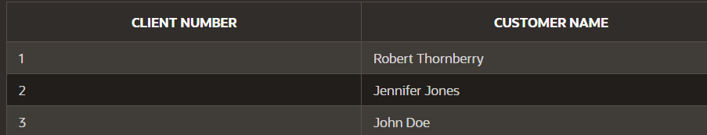
Part 2 : Using a Substitution Variable (S6L8 Objective 4)
1. Use a substitution variable that will allow you to enter the commission rate for the sales representatives. The first and last names should be displayed to screen for any sales representatives that earn that commission rate and the output should be ordered by their last name. Use an appropriate alias for your column headings.
SELECT FIRST_NAME || ' ' ||LAST_NAME AS "SALES REPRESENTATIVE DETAILS"
FROM SALES_REPRESENTATIVES
WHERE COMMISSION_RATE = :COMMISSION_RATE
ORDER BY LAST_NAME;
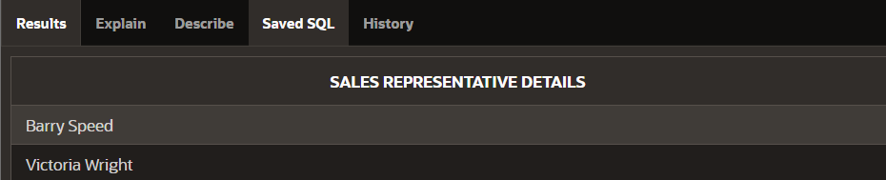

ЛАБОРАТОРНАЯ РАБОТА № 1 (SQL SERVER) ДВЕНАДЦАТОЙ НЕДЕЛИ КУРСА «УПРАВЛЕНИЕ ДАННЫМИ».
Для созданной ранее базы данных по учету компьютеров напишите запросы, возвращающие данные в соответствии с приведенными ниже заданиями.
1. Список без повторения компьютеров с двумя процессорами.
SELECT DISTINCT CompName
FROM dbo.Comp
WHERE ProcNumber = 2;

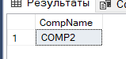
2. Список без повторения компьютеров, на которых установлены две и более различные операционные системы.
SELECT CompName
FROM dbo.Comp INNER JOIN dbo.Comp_OS ON dbo.Comp.CompID = dbo.Comp_OS.CompID
GROUP BY dbo.Comp.CompID, dbo.Comp.CompName
HAVING COUNT(DISTINCT OSName) >= 2
3. Список компьютеров, таких, что на компьютере ОС Windows 7 и суммарный объем жестких дисков компьютера не превышает 500 Гб (у компьютера может быть более 1 диска).
SELECT dbo.Comp.CompName
FROM ((dbo.Comp INNER JOIN dbo.Comp_OS ON dbo.Comp.CompID = dbo.Comp_OS.CompID)
INNER JOIN dbo.Comp_HDD ON dbo.Comp_HDD.CompID = dbo.Comp.CompID)
INNER JOIN dbo.HDD ON dbo.HDD.HDDModelID=dbo.Comp_HDD.HDDModelID
WHERE OSName='Windows 7'
GROUP BY dbo.Comp.CompID, dbo.Comp.CompName
HAVING SUM(dbo.HDD.HDDSizeGB * dbo.Comp_HDD.HDDNumber) <= 500;

4. Список компьютеров и пользователей, работающих за ними.
SELECT DISTINCT dbo.Comp.CompName, dbo.TUser.UserLogin
FROM (dbo.Comp INNER JOIN dbo.Comp_User ON dbo.Comp.CompID = dbo.Comp_User.CompID)
INNER JOIN dbo.TUser ON dbo.Comp_User.UserID = dbo.TUser.UserID;
5. Список без повторения пользователей, работающих только за одним компьютером.
SELECT DISTINCT dbo.TUser.UserLogin
FROM dbo.Comp_User INNER JOIN dbo.TUser ON dbo.Comp_User.UserID = dbo.TUser.UserID
GROUP BY dbo.TUser.UserID, dbo.TUser.UserLogin
HAVING COUNT(dbo.Comp_User.CompID) = 1;
6. Список без повторения пользователей, работающих за всеми компьютерами организации.
SELECT DISTINCT dbo.TUser.UserLogin
FROM dbo.Comp_User INNER JOIN dbo.TUser ON dbo.Comp_User.UserID = dbo.TUser.UserID
GROUP BY dbo.TUser.UserID, dbo.TUser.UserLogin
HAVING count(dbo.Comp_User.CompID)=(SELECT count(*) FROM dbo.Comp);
7. Список без повторения сетевых устройств (идентификатор и название), к которым непосредственно не подключен компьютер с названием comp1.
SELECT DISTINCT NetDeviceName
FROM dbo.NetDevice
WHERE NetDeviceID NOT IN (
SELECT NetDeviceID
FROM dbo.NetInterface INNER JOIN dbo.Comp ON dbo.NetInterface.CompID = dbo.Comp.CompID
WHERE CompName = 'COMP1');
8. Список компьютеров, в именах которых встречается символ подчеркивания «_».
SELECT CompName
FROM dbo.Comp
WHERE CompName LIKE '%!_%' ESCAPE '!';
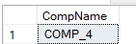

ЛАБОРАТОРНАЯ РАБОТА (Oracle) ДВЕНАДЦАТОЙ НЕДЕЛИ КУРСА «УПРАВЛЕНИЕ ДАННЫМИ». ВЫБОРКА ДАННЫХ: ПОДЗАПРОСЫ, ОПЕРАТОРЫ ДЛЯ РАБОТЫ СО МНОЖЕСТВАМИ ЗАПИСЕЙ

1. Продолжайте использовать соединение с базой данных для пользователя HR. Если вы не выполняли лабораторную работу прошлой недели, создайте соединение по аналогии с тем, как это было сделано в видео к лабораторным по Oracle 9-й недели.

2. Сформируйте запрос для определения номеров, фамилий, идентификаторов должности и окладов сотрудников, руководитель которых носит фамилию ' Mourgos'
SELECT employee_id, last_name, job_id, salary
FROM employees
WHERE manager_id IN (SELECT employee_id FROM employees WHERE last_name = ' Mourgos');
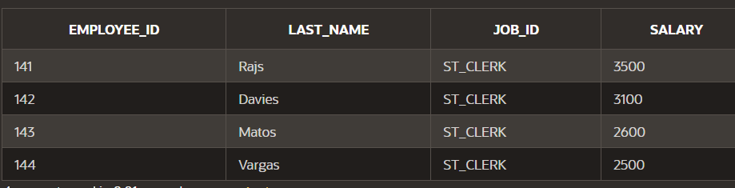4. Используя многостолбцовый подзапрос, сформируйте запрос, возвращающий номера, фамилии, идентификаторы должности и оклад для тех сотрудников, чей оклад совпадает с максимальным по их должности.
SELECT employee_id, last_name, job_id, salary
FROM employees
WHERE (job_id, salary) IN (SELECT job_id, max_salary FROM jobs);
5. Создайте подзапрос для получения номеров и фамилий сотрудников, не являющихся руководителями других сотрудников. Используйте оператор ALL для сравнения с результатами подзапроса.
SELECT employee_id, last_name
FROM employees
WHERE employee_id != ALL (SELECT manager_id FROM employees WHERE manager_id IS NOT NULL);
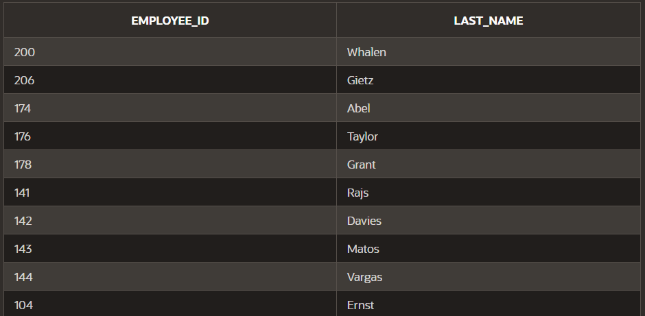
7. Используйте раздел WITH при формировании запроса для определения наименования и фондов заработной платы (суммы окладов всех сотрудников) таких отделов, размер фондов которых больше 1/8 от общего фонда заработной платы всей компании.
WITH
deptsal AS
(SELECT department_name, SUM(salary) sumsal
FROM employees JOIN departments USING(department_id)
GROUP BY department_id, department_name),
compsal AS
(SELECT SUM(salary) sumsal FROM employees)
SELECT department_name, sumsal
FROM deptsal
WHERE sumsal*8 > (SELECT sumsal FROM compsal);
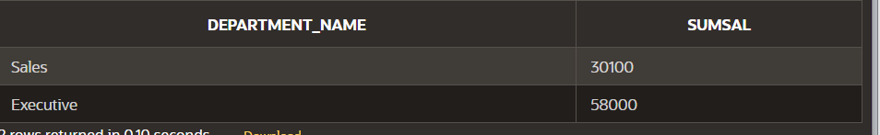
8. Используя SET-оператор, создайте запрос для определения номеров и идентификаторов должностей сотрудников, чья текущая должность совпадает с когда-либо занимаемой им ранее. Отсортируйте результат по убыванию номера сотрудника.
SELECT employee_id, job_id
FROM employees
INTERSECT
SELECT employee_id, job_id
FROM job_history
ORDER BY employee_id DESC;
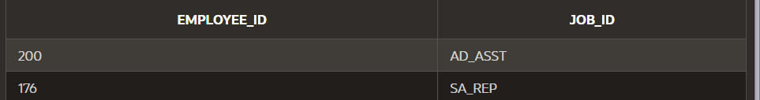
9. (*немного повышенная сложность) Используя SET-оператор и коррелированный подзапрос в разделе SELECT, создайте запрос для вывода фамилий и имён всех сотрудников. Если сотрудник является руководителем какого-либо отдела, в третьем столбце для него необходимо вывести название этого отдела, если нет – строку «не является руководителем отдела». В последней строке результата выведите общее количество сотрудников, являющихся руководителями отделов.
SELECT last_name, first_name ,NVL((SELECT department_name FROM departments d WHERE e.employee_id = d.manager_id),
'не является руководителем отдела') deptname
FROM employees e
UNION ALL
SELECT 'Общее число ', 'руководителей отделов:', TO_CHAR(COUNT(*))
FROM employees e JOIN departments d ON (e.employee_id = d.manager_id);
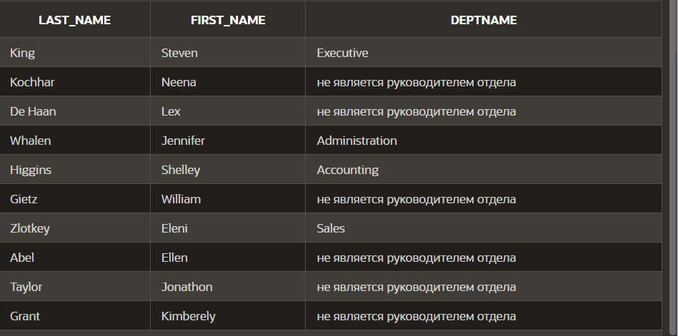
11. Создайте таблицу EMP_DEPT на основе содержимого таблиц EMPLOYEES и DEPARTMENTS. Таблица должна содержать 5 столбцов: номер сотрудника, фамилия, номер отдела, к которому он приписан, наименование отдела, квартал и год, в котором сотрудник был принят на работу. Столбцы с номерами сотрудника и отдела должны иметь названия empno и deptno соответственно, последний столбец - hire_quarter
CREATE TABLE emp_dept AS
SELECT employee_id empno, last_name, department_id deptno, department_name, to_char(hire_date, 'yyyy-q') hire_quarter
FROM employees LEFT JOIN departments USING(department_id);

