Url： <https://www.bilibili.com/video/BV14c411X74k/?share_source=copy_web&vd_source=fe40eb197bc01ef1afa5eb0e20ecd649>

Visit Website:

Open your web browser (e.g. Chrome, Firefox, etc.).

Enter the URL of the website (e.g. https://www.example.com) in the address bar and press Enter.

The homepage of the website will load and appear in your browser, allowing you to browse the content of the website.

Site Layout:

Homepage: This is the main page of the website, where we can see the navigation bar of several other pages and the functional overview of the entire web page, because we are doing a Yu-Gi-Oh card website, so what catches our eyes is the classic cards of the past dynasties, followed by the latest cards and the most popular cards, and the next is the latest Yu-Gi-Oh news and upcoming events.

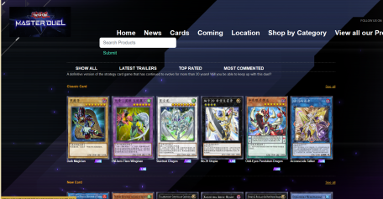

Product details page: Click on the card image or name to enter the detailed enlarged image, showing the card details, effects, and types.

Use of website features:

Browse cards: Browse the product list on the homepage or product page, and click on the product image or name to view the details.

Search for cards: Enter a keyword in the search box and press the search button to search for cards.

Contact the website: Find the contact information in the footer and get in touch with the website by phone, email or online message.

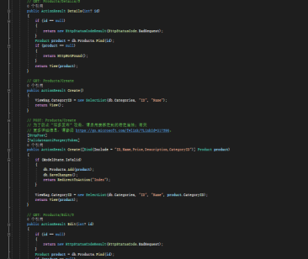

This code implements a basic product management function, including the following:

Index Method:

Displays a list of products, and supports filtering and display by category, search keyword, sort by, and pagination

Details Method:

Displays the details of a specific product.

Create method:

Displays the form page for creating a product, and processes the submitted data to add the new product to the database.

Edit method:

Displays the form page for editing products, and processes the submitted data, updating the information for existing products in the database.

Delete 方法:

Delete method:

These features cover the basic management needs of a product, including viewing a list of products, viewing product details, creating new products, editing existing products, and deleting products. At the same time, the code also includes features to validate and secure requests, such as preventing over-publishing attacks.

The implementation of search, filtering, sorting, and pagination can be found in the Index method:搜索功能:

Search function:

Filter through the list of products by accepting the search parameter (search keyword) to show only products that contain the search keyword.

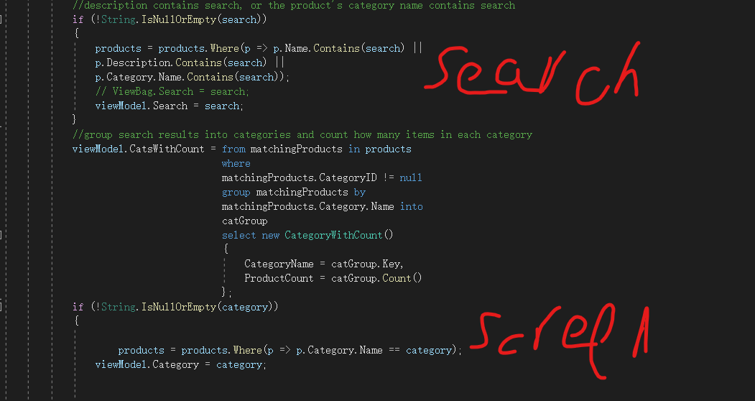

Filtering Features:

By accepting the parameter category, filter through the list of products to show only the products in the specified category.

Sorting function:

Sort in the list of products by accepting the parameter sortBy to sort the products in the specified way.

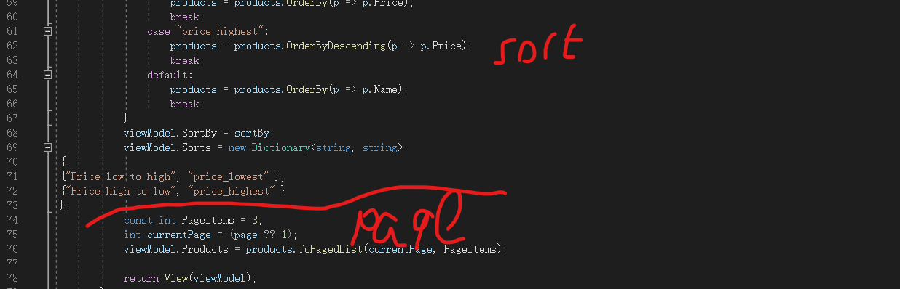

Pagination features:

By accepting the parameter page (page number), the list of products is displayed in pagination, with a specified number of products displayed on each page.

These features enable users to search, filter, sort, and paginate products according to their needs, improving product management flexibility and user experience.

CSSreport：

Model: In this controller, a model called Product is used. This model contains the product ID, name, price, description, and category ID. In addition, there is a model called Category that represents the category of the product. These models are described in assignment2. Models namespace.

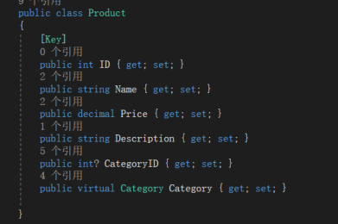

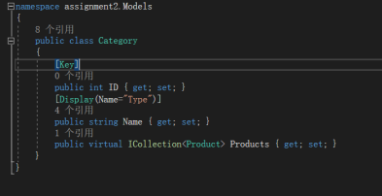

CSS: In this controller, there is no direct involvement in the definition of CSS styles. Typically, styling is done in a CSS file in the front-end code of your website. These styles define the look and layout of the website, including colors, fonts, spacing, and more.

JavaScript: Again, in this controller, there is no implementation of JavaScript code that is directly involved. JavaScript is often used for interactive features of websites, such as form validation, dynamic loading of content, responding to user actions, etc. This JavaScript code is usually defined in a JavaScript file in the front-end code of a website.

Functional Implementation: In this controller, key functions such as search and sorting are implemented. The search feature allows users to search based on product name, description, or category, while the sort feature allows users to sort products by price in ascending or descending order. In addition, a pagination function has been implemented for pagination in the product list.

