Source script output:
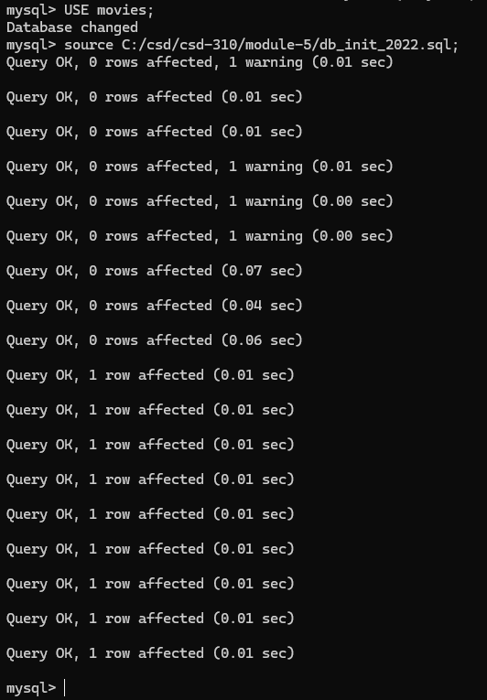

SHOW TABLES output:
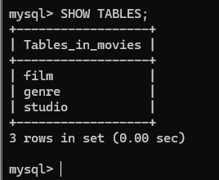
Python connection success message:
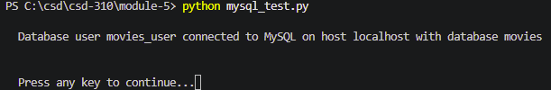

https://github.com/jbkb12/csd-310

