Initial database connection
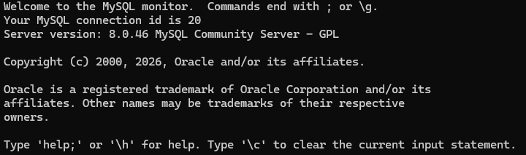
SHOW DATABASES;
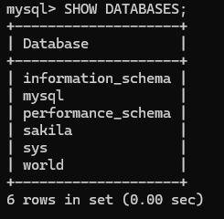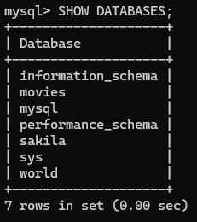

UCASE()
The UCASE() function converts a string to uppercase. It's useful when you need to standardise text output for display purposes, or when comparing strings without worrying about inconsistent capitalisation in your data.
Alias: uppercase_text
SELECT UCASE('hello world') AS uppercase_text;
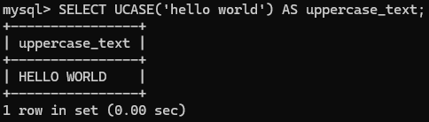
NOW()
The NOW() function returns the current date and time. It's commonly used to automatically record when a record was created or last updated, making it valuable for audit trails and activity logging.
Alias: query_time
SELECT NOW() AS query_time;
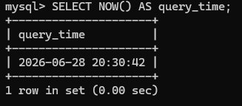

ROUND()
The ROUND() function rounds a numeric value to a specified number of decimal places. It's particularly useful when working with financial data or measurements where you need to present numbers in a clean, consistent format.
Alias: rounded_value
SELECT ROUND(3.14159, 2) AS rounded_value;
