GitHub Pages
Link to github repository
https://github.com/jbkb12/csd-340
HTML validation
No errors or warning
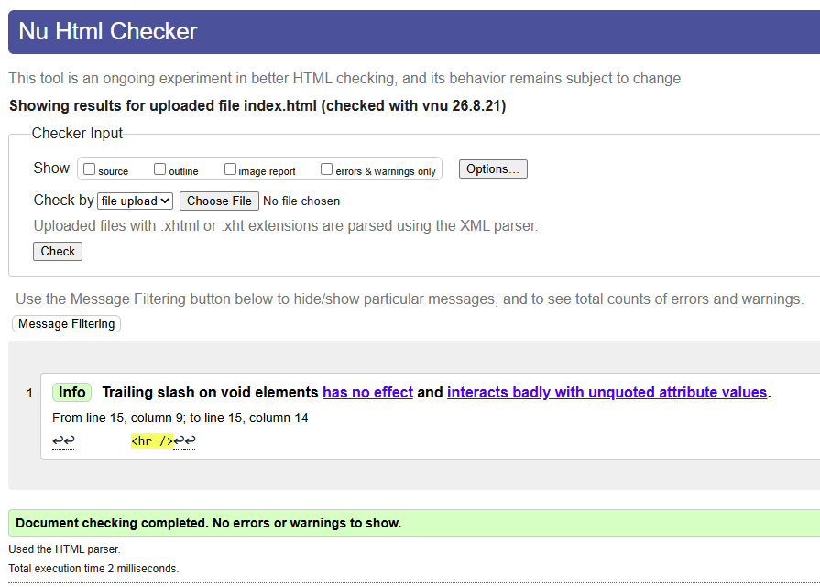

CSS validation
No errors found, validates as CSS level 3
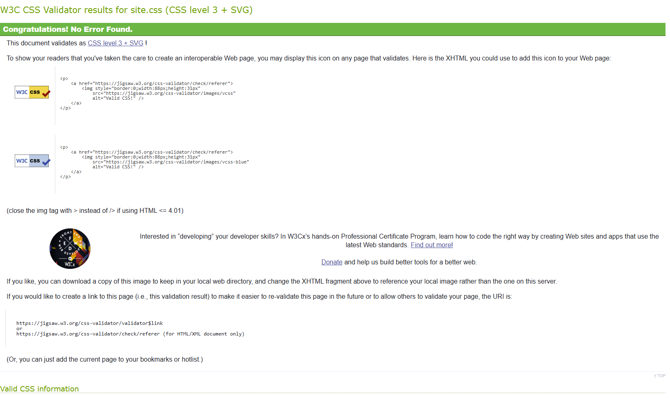
Browser rendering
Opened in browser, showing the landing page layout, color scheme, and links.
