Building a Web Page Exercise, Part 1
Link to my github repository:
https://github.com/jbkb12/csd-340.git
Screenshot 1:
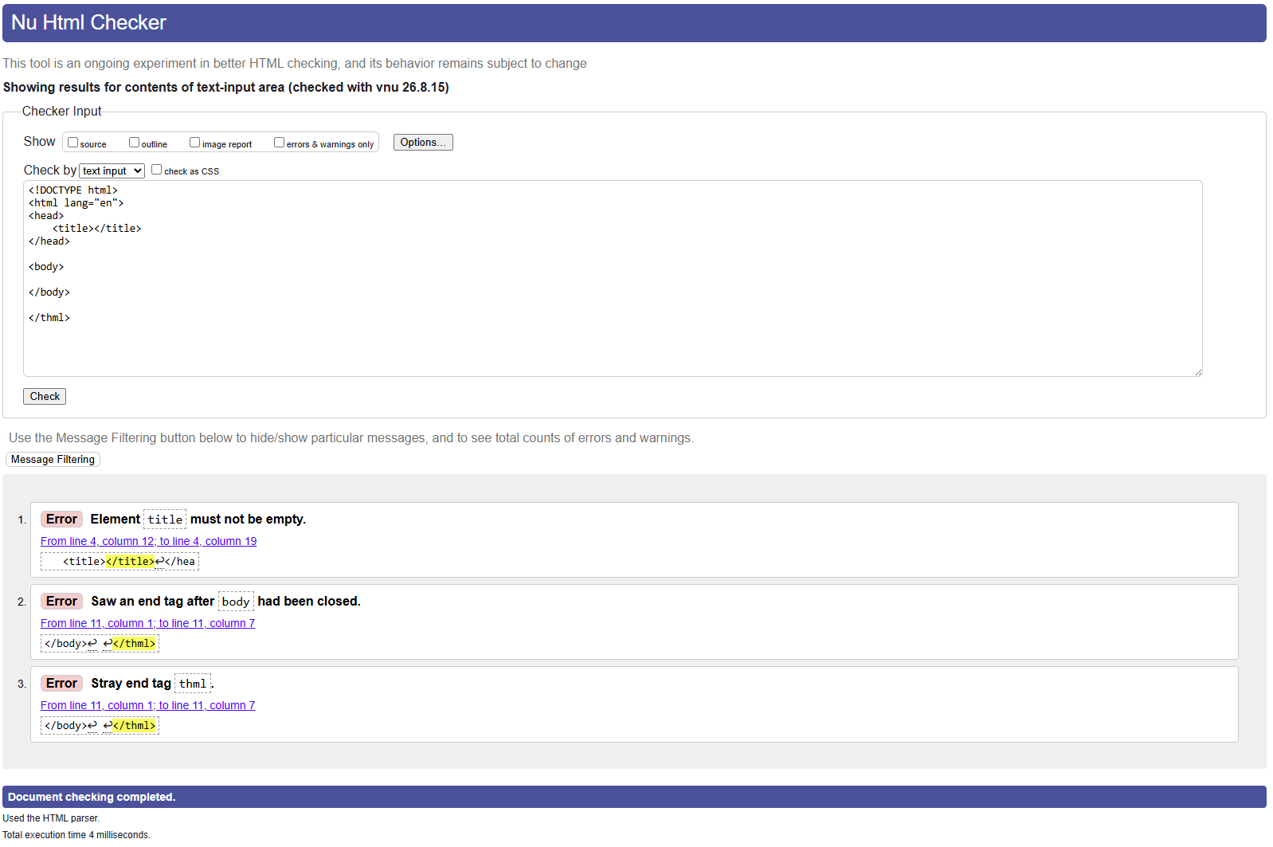
Screenshot 2:
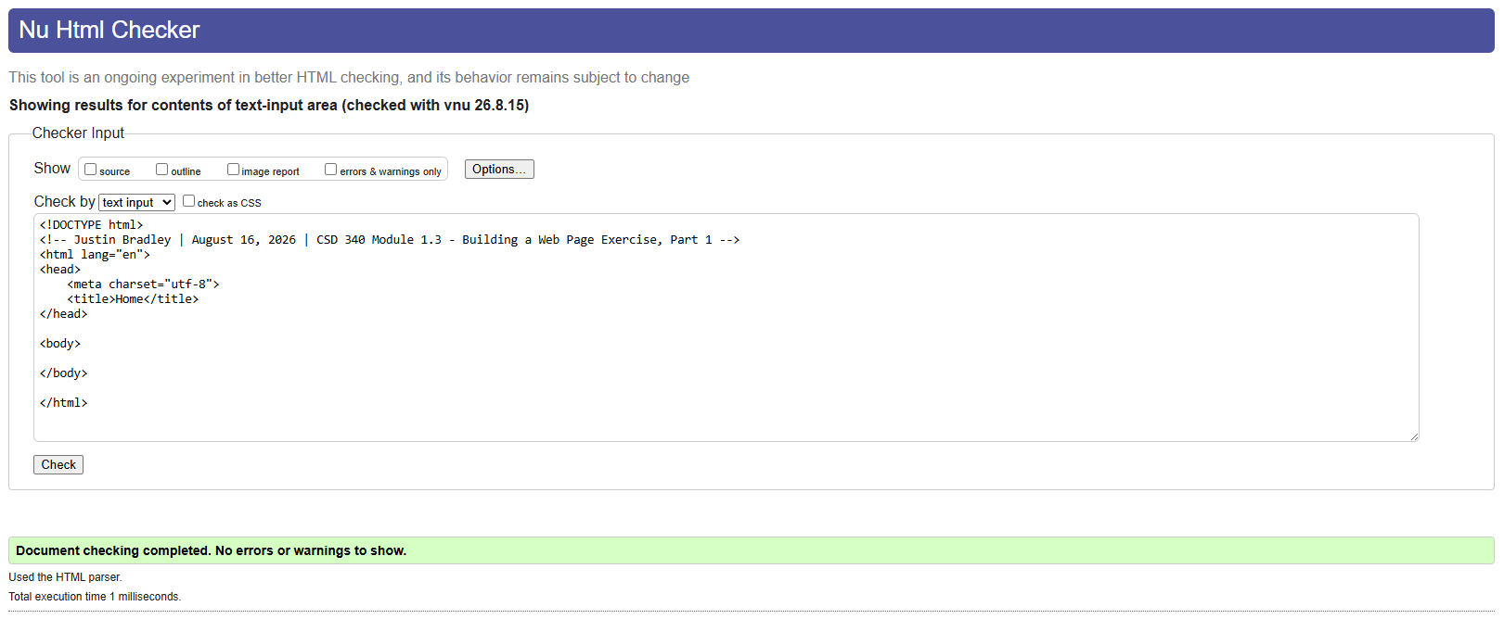
Screenshot 3:
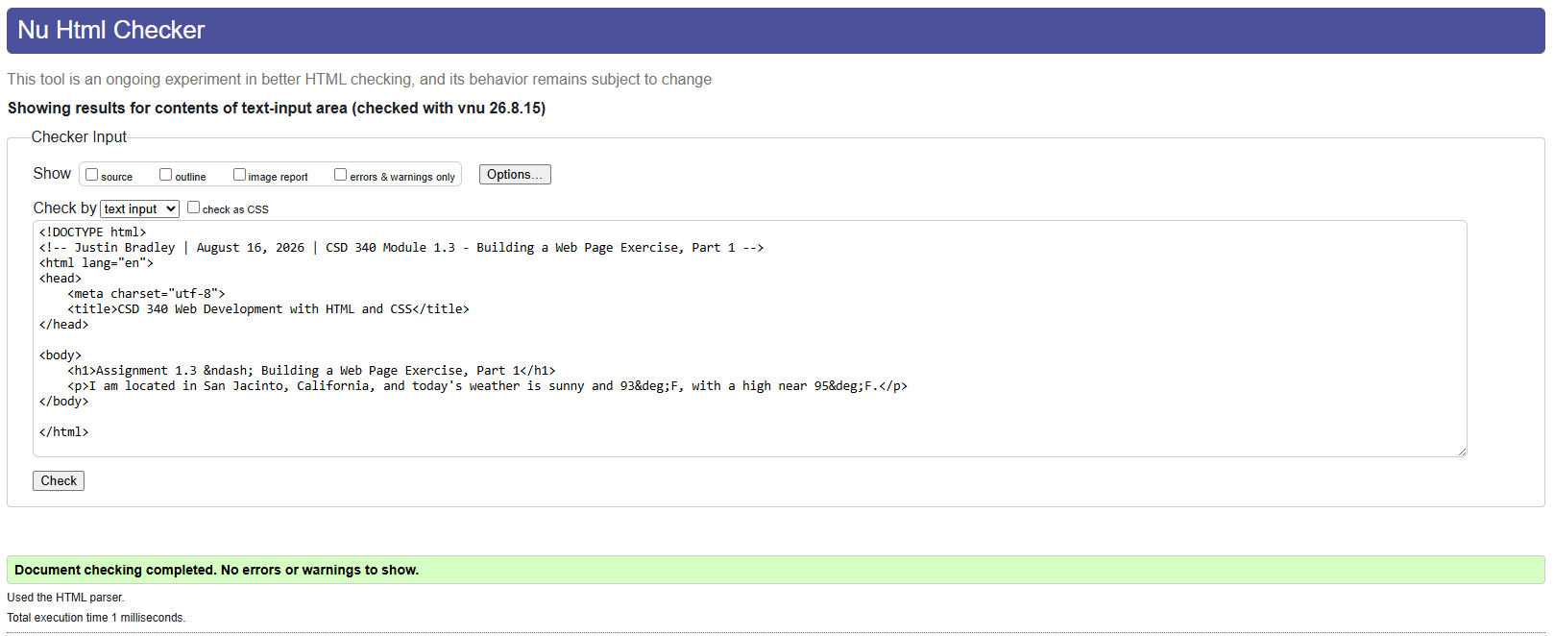
Screenshot 4:
