Github Repository Setup
Link to github repository:
https://github.com/jbkb12/csd-340
Screenshot 1:
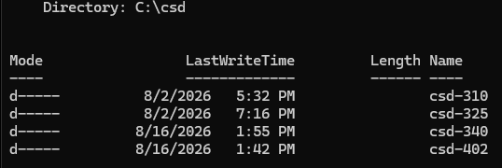
Screenshot 2:
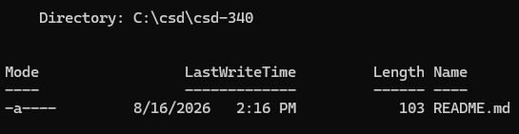
Screenshot 2 (bonus):
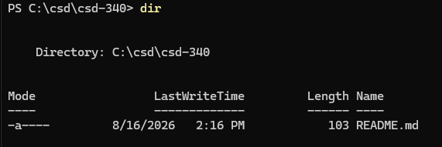

Screenshot 3:
