Water Heating Energy Calculator
Screenshot 1
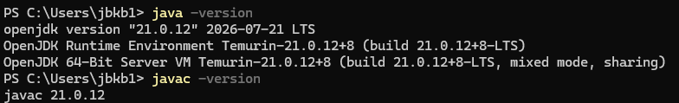
Screenshot 2
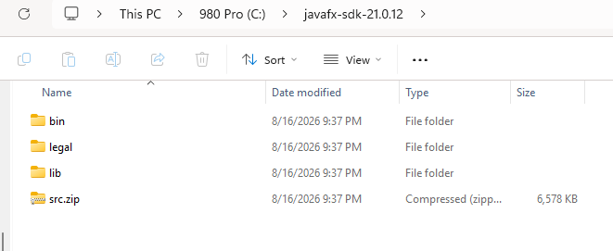
Screenshot 3
