GitHub Repository Link
https://github.com/jbkb12/csd-420

Screenshot: Java Version

Screenshot: JavaFX SDK Library
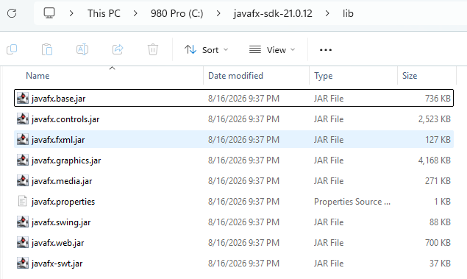

Screenshot: Program Running
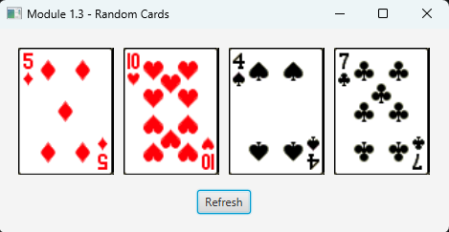

Screenshot: After Clicking Refresh
