GitHub Repository Link
https://github.com/jbkb12/csd-420

Screenshot: GitHub Repository
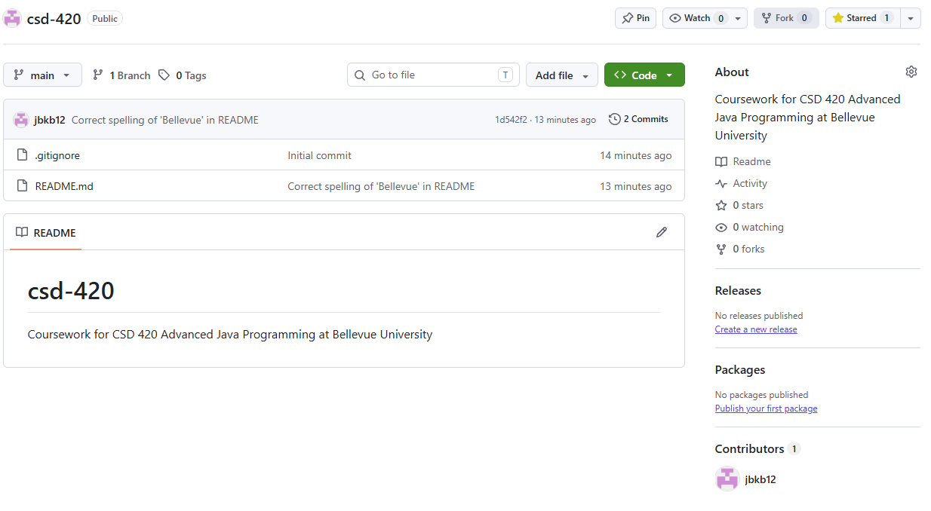
Screenshot: Local Directory
