GitHub Repository Link
https://github.com/jbkb12/csd-420

Screenshot: Java Version
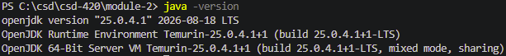

Screenshot: JavaFX SDK Library
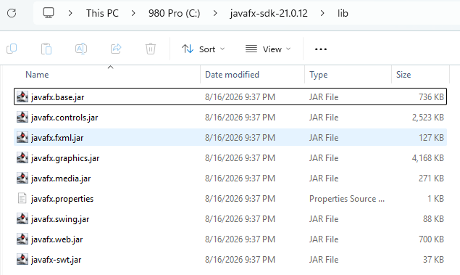

Screenshot: Program Test Run
