Table below shows the number of tracts that participated in the FWS easement over different decades. There are 341 tracts in the FWS dataset without an acquisition date. The acres column represents the acreage of easement.
Decade | Number of Tracts | Acres | Cumulative Acres
1960s | 7,094 | 493,560.5 | 493,560.5
1970s | 4,412 | 256,087.2 | 749,647.7
1980s | 356 | 20,693.0 | 770,340.7
1990s | 354 | 21,617.6 | 791,958.3
2000s | 847 | 59,911.7 | 851,870.0
2010s | 1,672 | 114,218.7 | 966,088.7
2020s | 659 | 43,483.6 | 1,009,572.3
No date | 341 | 22,600.7 | 1,032,173.0
Total | 15,735 | 1,032,172.9

The following maps show the distribution of eased wetlands. The polygons are the whole parcels that wetlands sit in. The tracts without the acquisition date are mapped separately.
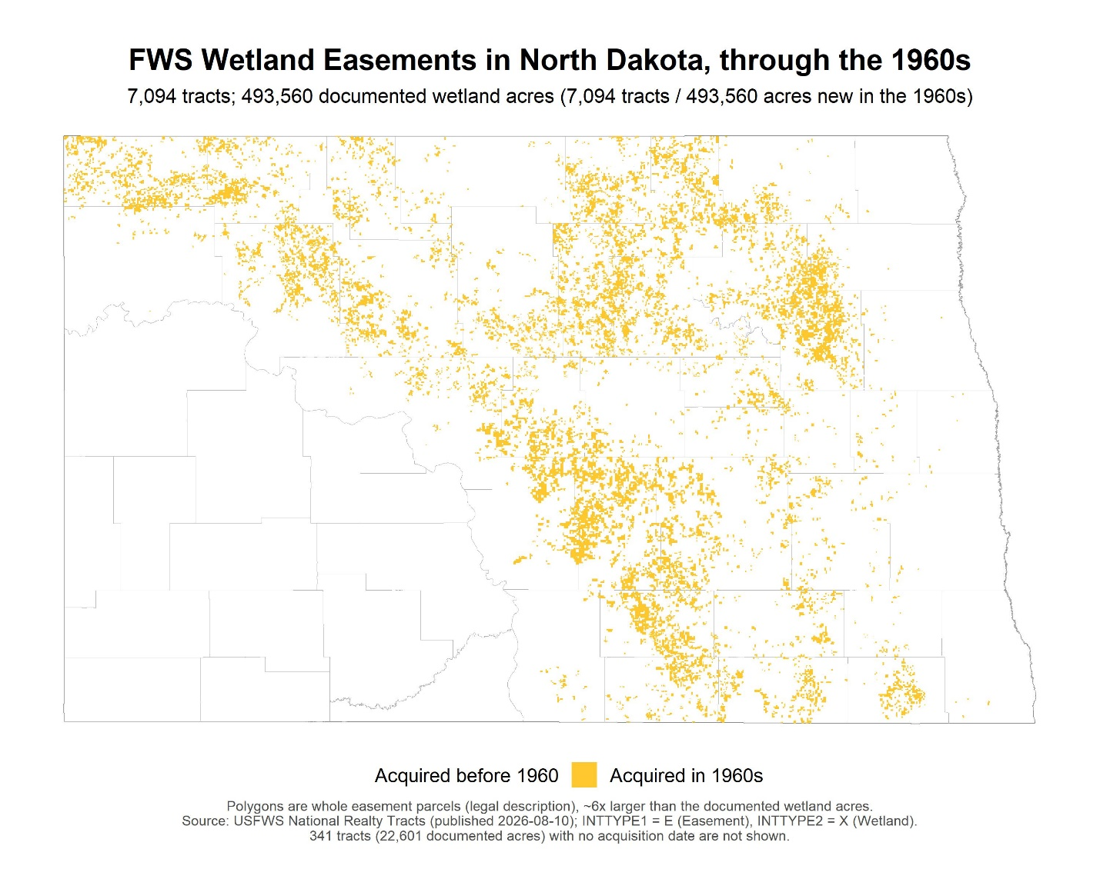
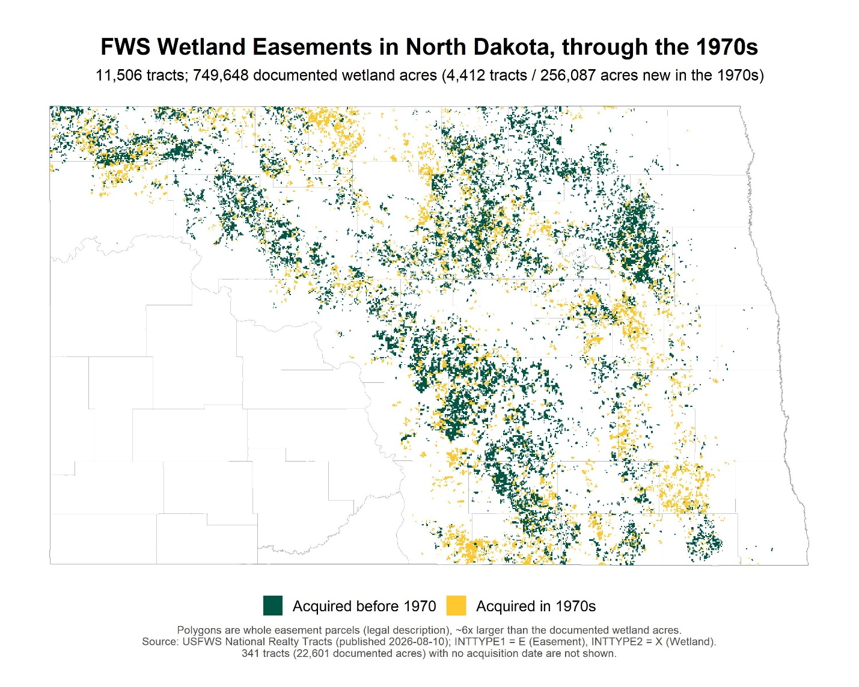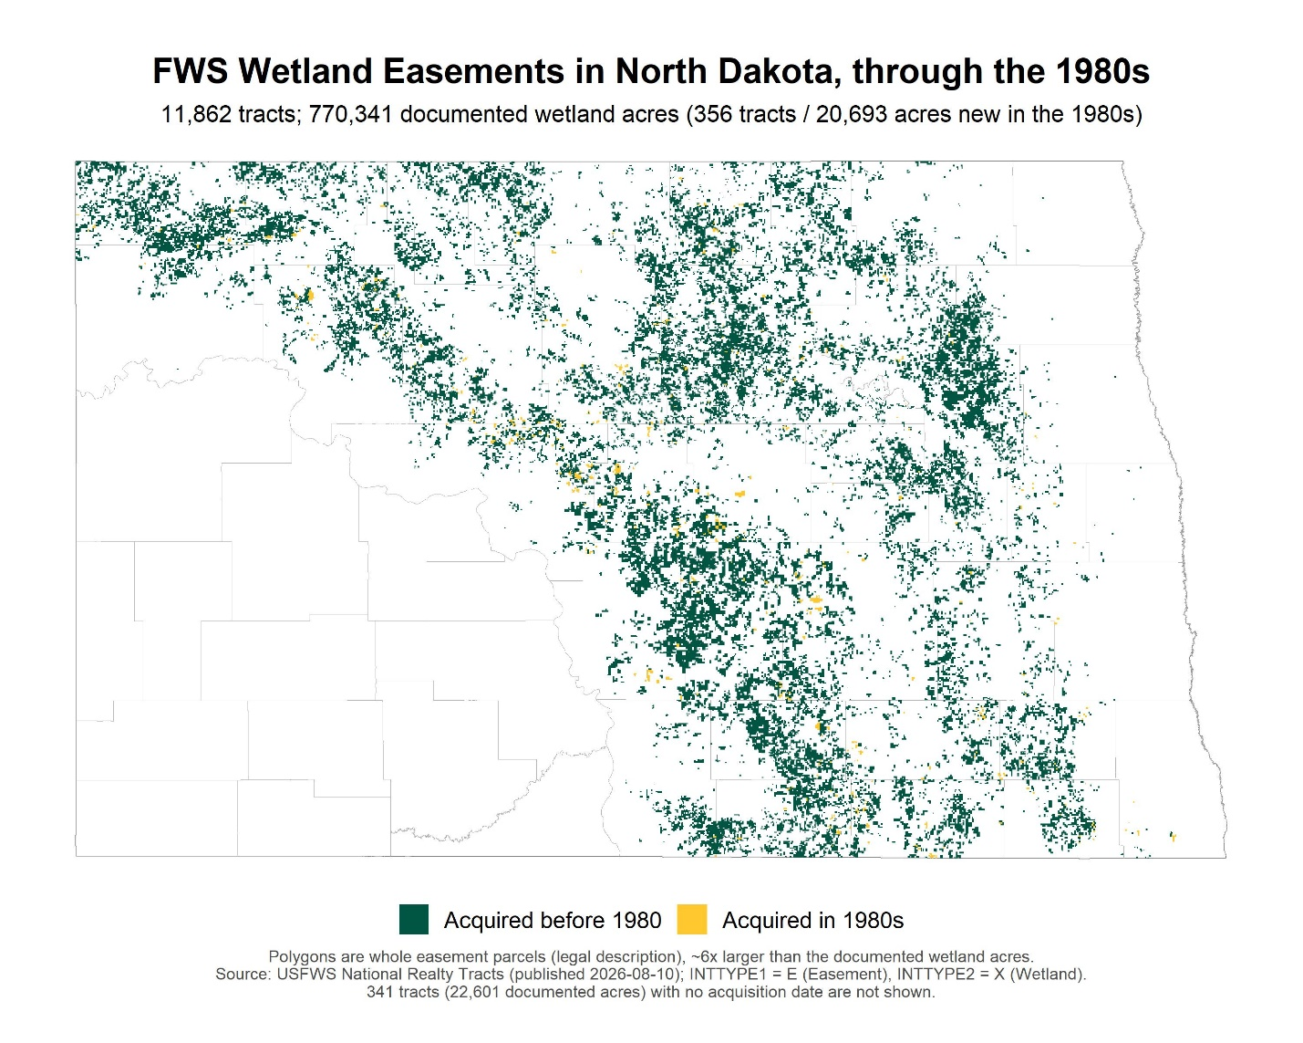
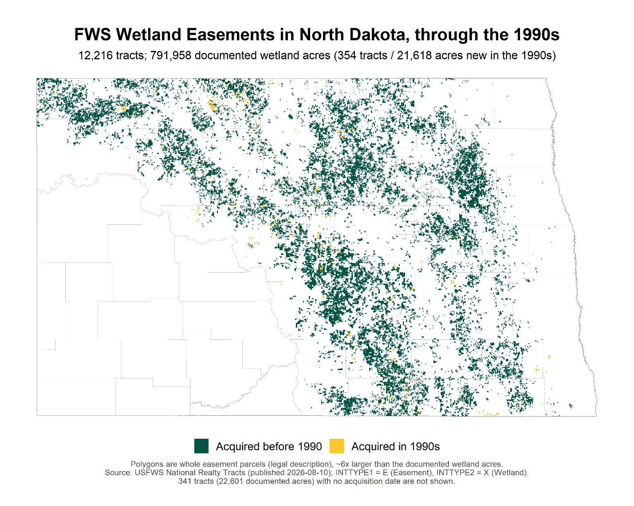
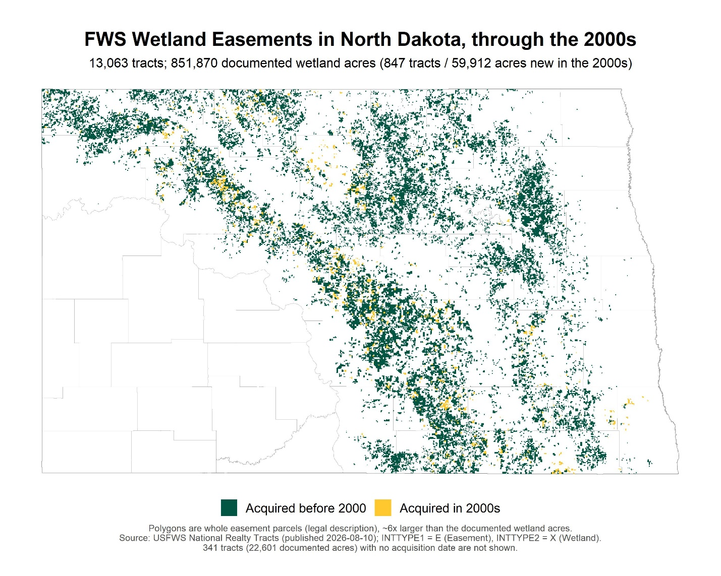
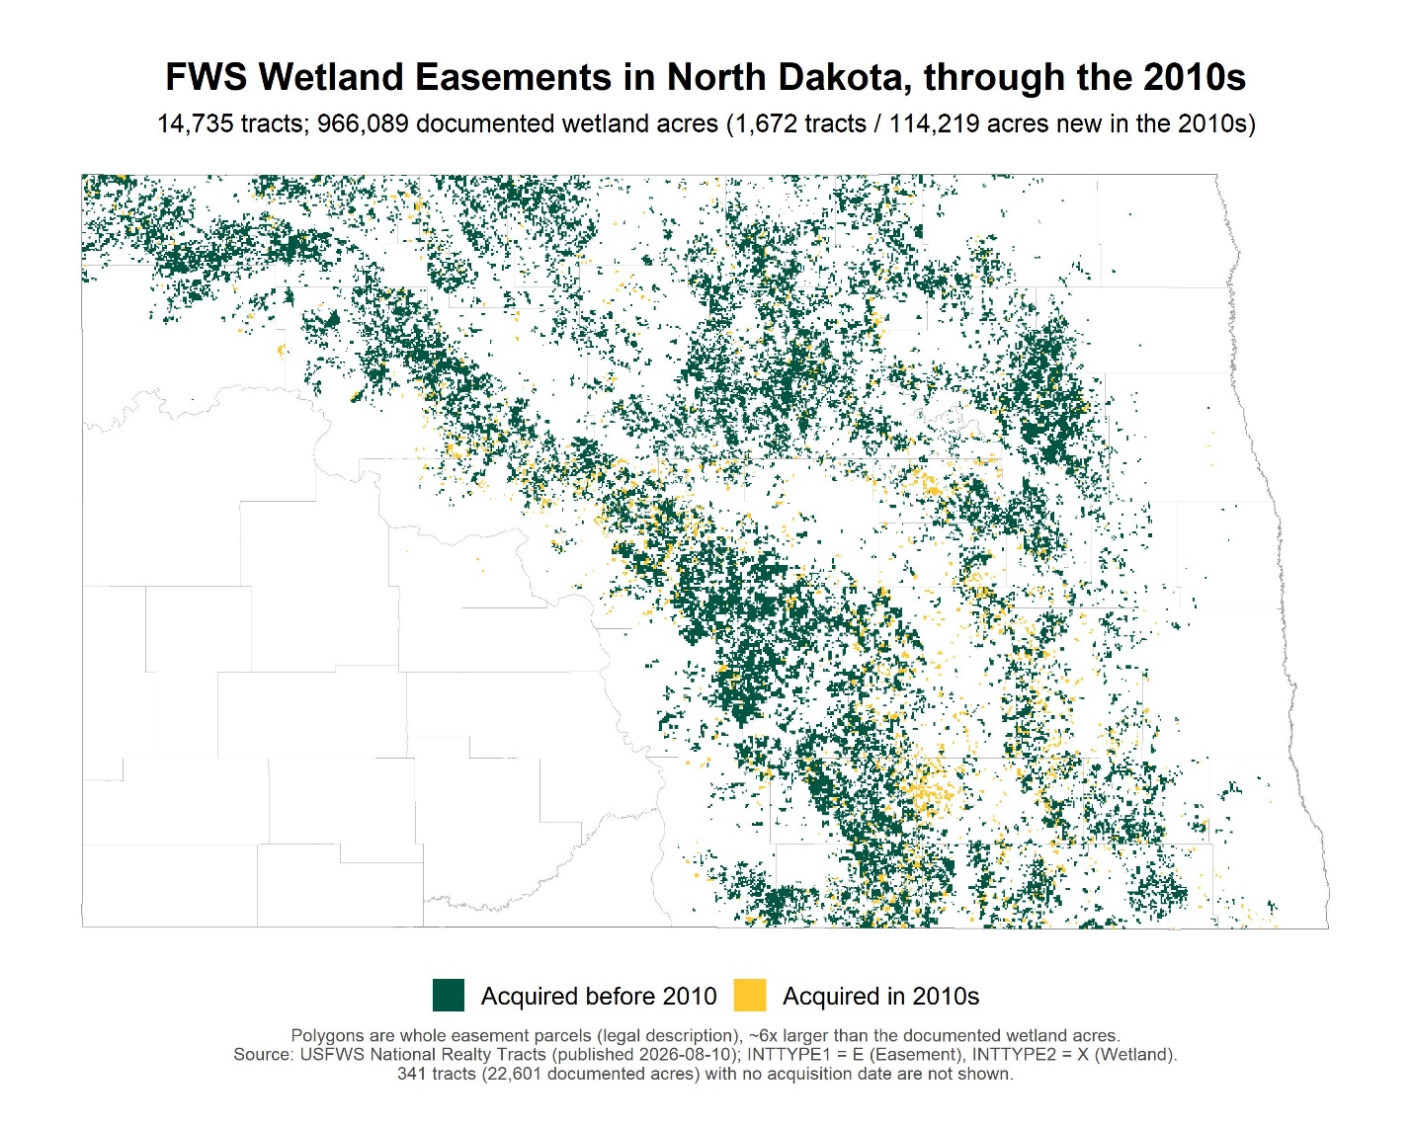
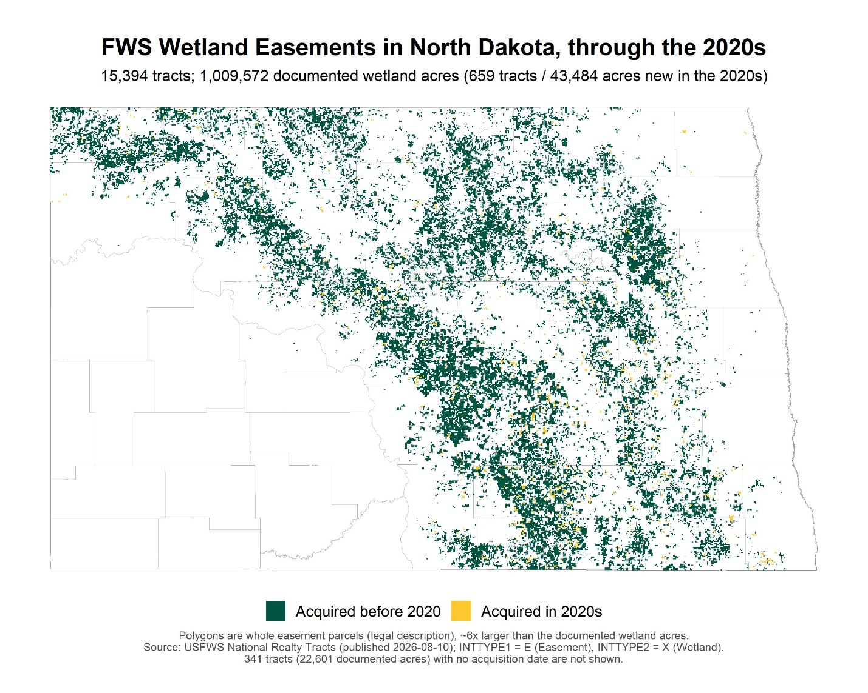

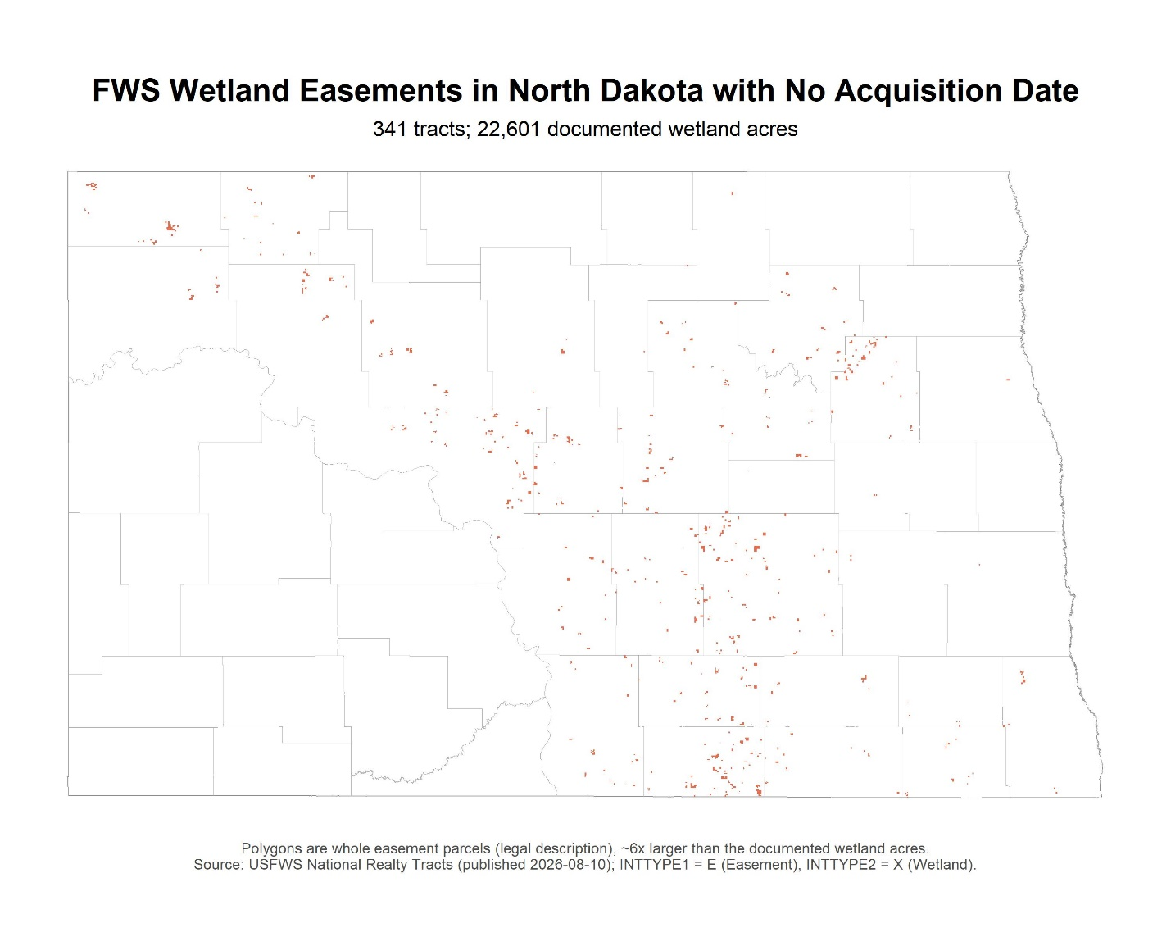
The following map shows the wetland acreage. Different colors correspond to different wetland systems. 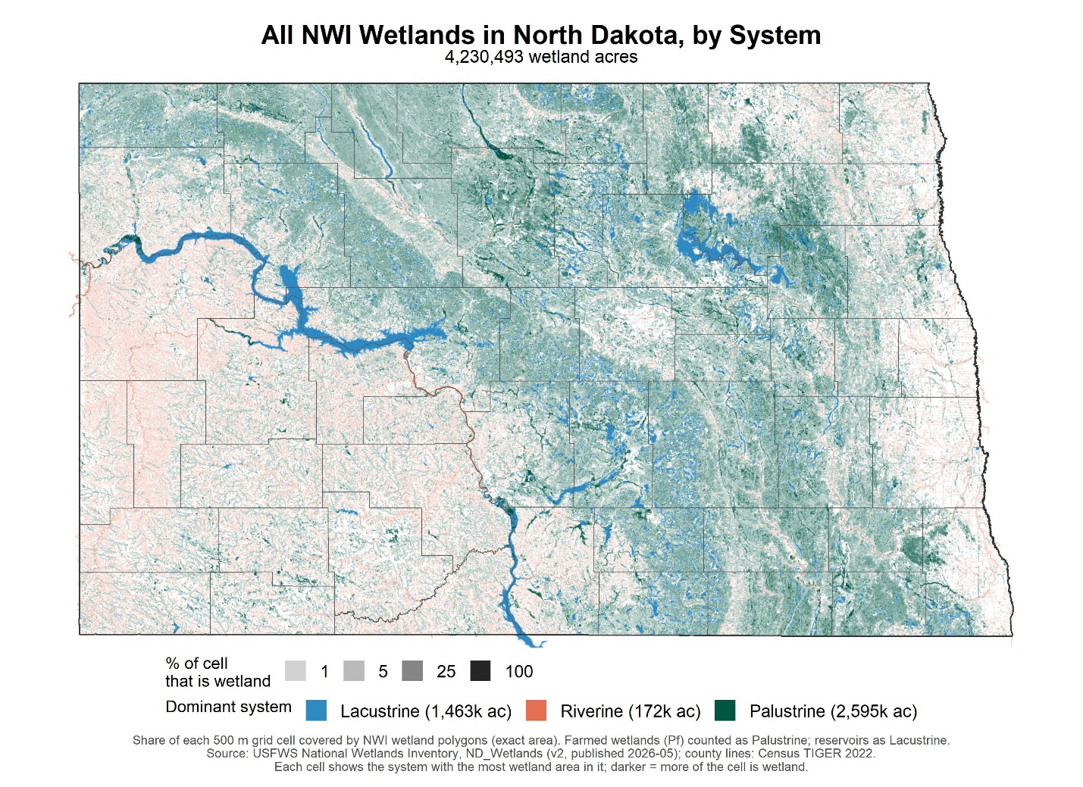

The following map shows the eased wetlands overlaid on top to the wetland polygons in Stutsman County. Note that the yellow polygons show the parcels with easement, so the exact location of the eased lands are not visible.
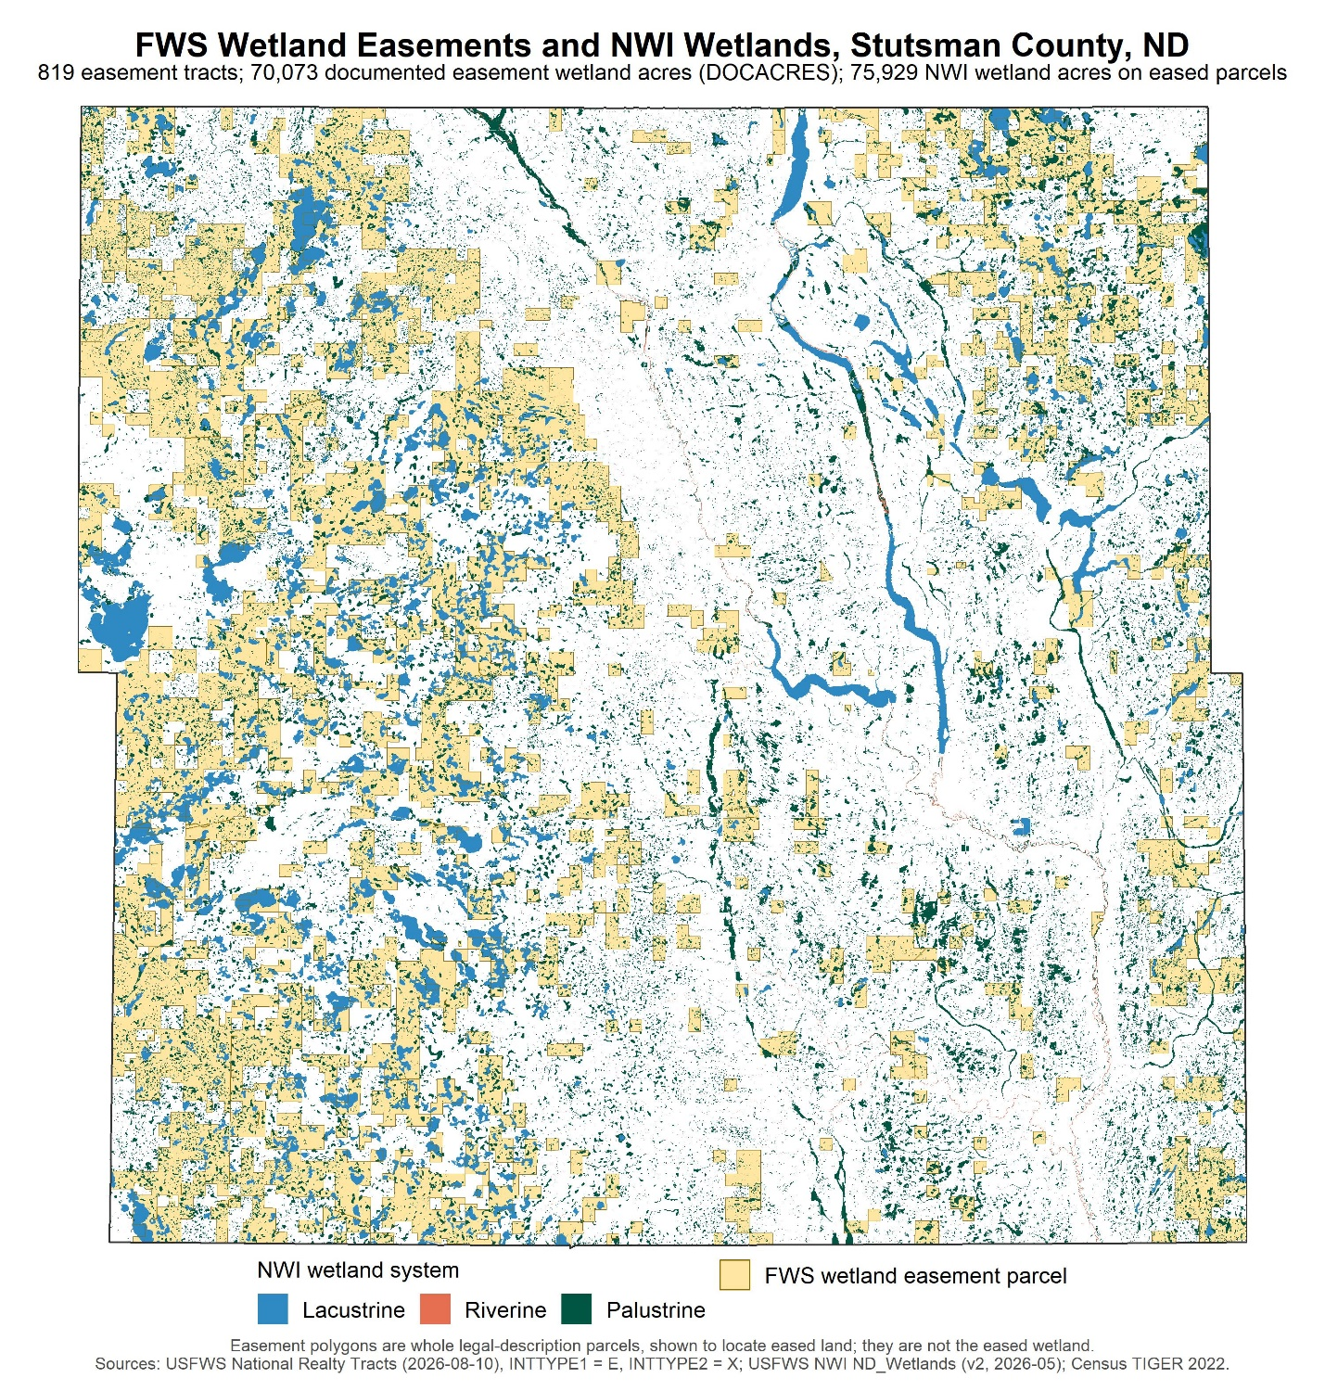

It would be very informative if we could overlay the farm polygons on this map.

